|  |
| --- |
|  |
| Capstone Project Document |

**FIRST AID**

|  |  |  |
| --- | --- | --- |
| **FIRST AID** | | |
| **Group Members** | Đàm Huy Hùng | SE02585 |
| Nguyễn Duy Anh | 01525 |
| Mai Trung Kiên | SE02994 |
| Nguyễn Tiến Dũng | SE03272 |
| Nguyễn Phúc An | SE03118 |
| **Supervisor** | Mr. Nguyễn Văn Sang | |
| **Project code** | FAVN | |

**- Hanoi, 12/2016 -**

***Acknowledgements***

*We would like to thank Mr. Nguyen Van Sang, our supervisor, for his encouragement and assistance at various stages of the project.*

*We also acknowledge and are grateful for his instruction of technique and teamwork in an official project as well.*

*We would also like to thank 115 Emergency Center for their expertise*

*in reviewing specific content areas. Their welcome to a friendly and professional working environment did help us to complete the project successfully.*

*Eventually, we highly appreciate all the support as well as inspiring*

*from our friends and family in the time of the project.*

TABLE CONTENTS

1 INTRODUCTION 6

1.1 Purpose 6

1.2 Acronyms and Definitions 6

1.3 Abstract 6

1.4 Literature Review 6

1.4.1 Cẩm nang sơ cứu 7

1.4.2 Hướng dẫn sơ cứu 8

1.4.3 First Aid 9

1.5 Proposal 10

1.5.1 The idea 10

1.5.2 The objective 10

1.5.3 Brief description about system 10

1.5.4 System features 11

1.6 Benefits from Project 13

1.6.1 For our group 13

1.6.2 For Community 14

1.7 Critical Assumption and Constraints 14

1.8 Potential Risks 14

2 PROJECT MANAGEMENT 15

2.1 Introduction 15

2.1.1 Purpose 15

2.1.2 Definitions and Acronyms 15

2.2 Project Overview 15

2.2.1 Project Description 15

2.2.2 Scope and Purpose 16

2.2.3 Assumptions and Constraints 17

2.2.4 Project Objectives 18

2.2.5 Critical Dependencies 19

2.2.6 Project Risk 20

2.3 Project Development Approach 20

2.3.1 Project Process 20

2.3.2 Requirement Change Management 22

2.3.3 Quality Management 22

2.4 Estimation 25

2.4.1 Size 25

2.4.2 Effort 25

2.4.3 Schedule 26

2.4.4 Resource 29

2.4.5 Infrastructure 29

2.4.6 Training Plan 30

2.4.7 Finance 30

2.5 Project Organization 30

2.5.1 Organization Structure 30

2.5.2 Project Team 31

2.6 Communication & Reporting 33

3 SOFTWARE REQUIREMENT 35

3.1 Introduction 35

3.1.1 Purpose 35

3.1.2 Definitions and Acronyms 35

3.2 User Requirement Specification 35

3.2.1 Product Features 35

3.2.2 User characteristic 36

3.2.3 Functional Requirements 37

3.2.4 Non-functional Requirement 38

3.3 Software Requirements Specification 39

3.3.1 Overall Description 39

3.3.2 Functional Specification 43

3.3.3 Non-Functional Specification 103

4 SOFTWARE DESIGN 105

4.1 Introduction 105

4.1.1 Purpose 105

4.1.2 Definitions, Acronyms, Abbreviations 105

4.2 Architecture design 105

4.2.1 Choice of Architecture Design 105

4.2.2 Architecture Representation 110

4.2.3 Architectural Goals and Constraints 112

4.2.4 Logical View 113

4.2.5 Process view 121

4.2.6 Deployment View 126

4.3 Detail Design 127

4.3.1 Package 127

4.3.2 Function 131

4.4 Data design 167

4.4.1 Entity Relationship Diagram 167

4.4.2 Table Diagram 169

4.5 Screen Design 178

4.5.1 First Aid 178

4.5.2 Ambulance 191

4.5.3 Dispatcher 196

4.5.4 Admin 199

5 SOFTWARE TESTING 204

5.1 Introduction 204

5.1.1 Purpose 204

5.1.2 Definitions and Acronyms 204

5.1.3 Scope of testing 204

5.1.4 Constraints 206

5.2 Test plan 206

5.2.1 Test type 206

5.2.2 Test stages 207

5.2.3 Test model 208

5.2.4 Acceptance test criteria. 209

5.2.5 Resources 210

5.2.6 Test milestones 211

5.2.7 Deliverables 211

5.3 Test case 212

5.4 Test Report 212

5.4.1 Test report 212

5.4.2 Defect report 212

6 USER MANUAL 213

6.1 Introduction 213

6.1.1 Purpose 213

6.1.2 Environment 213

6.2 Installation Guideline 213

6.2.1 Install First Aid Application 213

6.2.2 Install Ambulance Application 216

6.2.3 Install Dispatcher Application 218

6.2.4 Install Admin/Expert Application 222

6.3 User Guideline 223

6.3.1 First Aid 223

6.3.2 Ambulance 236

6.3.3 Admin 242

6.3.4 Dispatcher 249

7 PROJECT RESULT REPORT 252

7.1 Product Judging 252

7.1.1 Advantage of First Aid system 252

7.1.2 Current Limitations 252

7.1.3 Expectation in Future 252

7.2 Project Summary 253

7.3 Lesson Learnt 254

8 REFERENCES 255

# INTRODUCTION

## Purpose

This document is created as the introduction for project First Aid – our Capstone Project at FPT University. In this document, we will describe the initial idea for our project, overview some existing systems, describe our expected system as well as to give some critical assumptions, constrains and potential risks. Moreover, this document also shows opportunities that it offers to users.

## Acronyms and Definitions

|  |  |
| --- | --- |
| Acronym & Abbreviation | Definition |
| FA | First Aid |
| FU | FPT University |
| Q&A | Question and Answer |

1. Definitions and Acronyms

## Abstract

In daily life, illness or injury can occur suddenly. There are many situations that require first aid to stop the situation becoming worse, even save lives and reduce injuries. The first aid does not necessarily require complicated techniques or special knowledge. However, not many people in Vietnam have sufficient knowledge and necessary skills enough for the aid. There are a lot of specific training materials in hard and soft copies, but its disadvantage is hard to comply with the right method of first aid immediately without visual information. There are also other mobile applications for first aid on the market but they have barriers for users such as language and the lack of effective interaction.

In addition, the supports emergency system of Hanoi 115 emergency center in particular and almost provinces of Vietnam in general have currently limitations. The receiving of information from the victim to call is done by pen and paper; dispatchers of the 115 center contact to the emergency team via phone or walkie-talkie. The victim's location is determinate via their description. There have many cases in which the victim describes wrong location or the driver goes in wrong way that leads to cause wasted-time and the critical status of victim’s life.

With the expectations of helping people to cope with the limitations that mentioned above, we propose to build an application that can provide users with simple instructions on first aid and a dispatch ambulance system for the Hanoi 115 emergency center.

## Literature Review

Nowadays, there are some first aid applications on the market. However, according our research, these applications are not really useful for Vietnamese people. In this section, we are focusing on the three top rating applications which are considered as our rivals.

### Cẩm nang sơ cứu

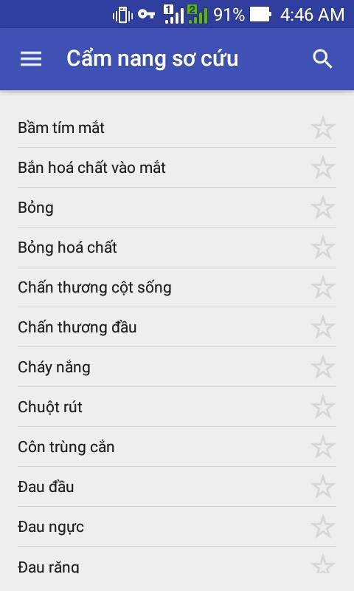

Figure 1‑1: App Cẩm nang sơ cứu

“Cẩm nang sơ cứu”is the only topdownload application that provides knowledge about first aid instructions that developed on the Android platform for the Vietnamese.

* **Advantages:**
* Has Vietnamese language: “Cẩm nang sơ cứu” was developed by Vietnamese developers so this application has Vietnamese language, easy to use for Vietnamese users.
* A lot of first aid guide: Comparing to the vietnam’s applications, the instructions of first aid in this application covers many medical fields such as insect bites, cramps…
* The searching function: Because this application has lots of first aid guidelines, so the searching function is quite useful to help users easily to search for the appropriate guidance in case of emergency.
* **Disadvantages:**
* Lack of visualization: The structure of the application has not been arranged logically, first aid guidelines are not sorted into groups, sometimes confusing for users.
* Instructions are difficult to follow: The contents of the first aid instructions are sketchy, the illustrations as well as the guide’s step is not really useful.

### Hướng dẫn sơ cứu

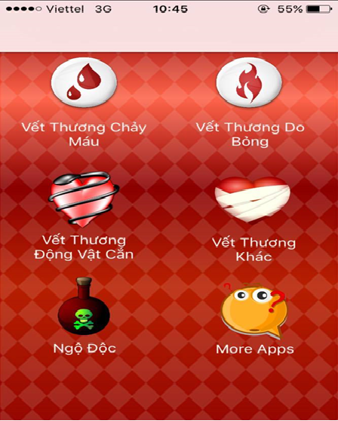

Figure 1-2: App Hướng dẫn sơ cứu

“Hướng dẫn sơ cứu” is the top application that provides knowledge about first aid instructions that developed on the iOS platform for the Vietnamese.

* **Advantages:**
* Has Vietnamese language: “Hướng dẫn sơ cứu” was developed by Vietnamese developers so this application has Vietnamese language, easy to use for Vietnamese users.
* First aid methods are grouped by topics: The method of first aid instructions are reassembled according to topic, quite intuitive and logical.
* **Disadvantages:**
* A few first aid guide: The first aid instructions are not many, the contents of the first aid manual as the first aid steps, the illustrations are quite sketchy or may not have.
* Without searching function: The functions are quite sketchy, morever this application does not have “ Search” function so difficult to look up to appricatioe guide.
* In the first aid instructions, the source of information is not really realiable.

### First Aid

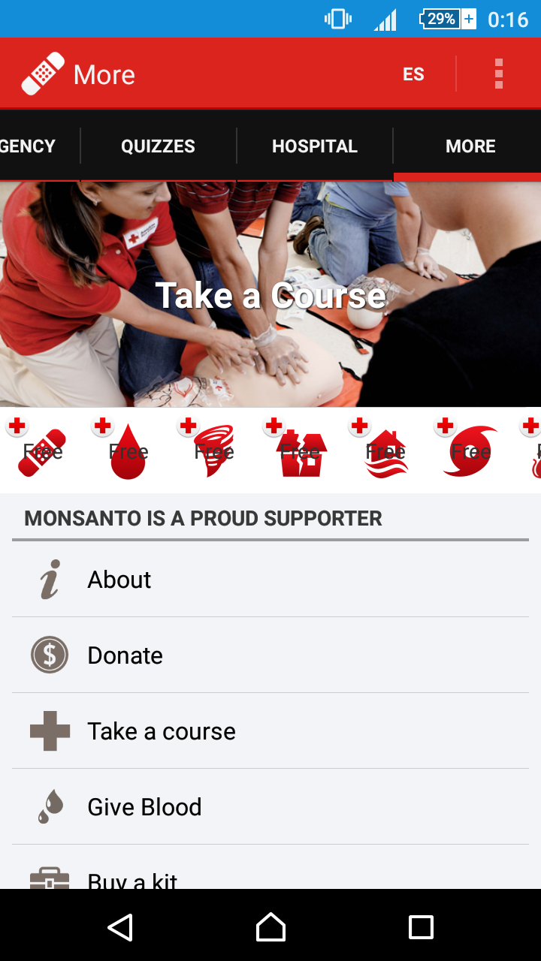

Figure 1‑2: App First Aid

First Aid is the biggest application for first aid guide created by American Red Cross, users can look up and learn about first aid, watch videos, take quizzes.

* **Advantages:**
* Simple step-by-step instructions guide you through everyday first aid scenarios.
* Fully integrated with 9-1-1 so you can call EMS from the app at any time.
* Videos and animations make learning first aid fun and easy.
* Preloaded content means you have instant access to all safety information at any time, even without reception or an Internet connection.
* First Aid has friendly interface, clear instructions.
* **Disadvantages:**
* Just have English and Spanish language.
* It is not popular in Vietnam.
* Without searching function.

## Proposal

### The idea

With the aim of providing the best supported health service for Vietnamese people, we want to develop an application that allows users can look up and perform first aid guide and selectively synthesized under step by step format in the easiest way. This application also supports users to search medical facilities around their location. Besides we also want to develop an emergency switchboard system for Hanoi 115 emergency center. It means that this system can connect to aid applications through SOS calling with reducing talking time as well as providing maximum necessary information. In addition, the system also has admin/expert application for managing, automatic functions connected to software on an ambulance in order to shorten the time to contact and distance traveled; functional navigation map and directions to emergency help achieve maximum efficiency.

### The objective

This project is the Capstone Project in FPT University studying program.

The project is responsible for all team members. So, we have to complete all requests from teachers and the university. In terms of IT expertise, by implementing of the project, we expect to be able to learn how to develop a project, how to manage the project, how to communicate better among members in groups, how to control the time, how to implement effective teamwork. Moreover, besides the knowledge of IT learnt from school, we want to study deeply new technologies, new techniques for serving the process of implementation of the project. Therefore, we believe that this project is a great opportunity for us to enhance the skills and knowledge. This also makes our CV better after graduation from FPT University. This is also an opportunity for us to demonstrate our competence with employers.

In term of social-meaning, with First Aid projects, we will support the best health service for people that need the help in aid issues. Via this application users can have better understanding about aid and the importance of first aid. Beyond that, the community will have good software that can help them protect their lives and health more safely. Also, for Hanoi 115 Emergency Center, we want to build for them an automatic ambulance coordination system to resolve their current problems, to improve the quality of medical management.

### Brief description about system

The First Aid system includes “First Aid” mobile application and “Ambulance” application developed on the Android platform, an emergency switchboard system for Hanoi 115 center and data management system developed on the web platform. The most useful feature of this application is to help users easily perform first aid through step-by-step instructions. It also provides a number of features needed for emergencies such as finding the nearest medical facility, making phone calls and sending information to the dispatch system of 115 center. It will provide the nearest ambulance to the patient automatically. The Ambulance applications can get quick tasks from the switchboard, identify the exact location of the victim on the road map and the closest to the victim. Last but not least, the data management system will give the functions of data management as well as user management, this system is called “Admin/Expert”.

The technology used to develop the First Aid: Java, Android, Bootstrap, and Laravel - PHP framework.

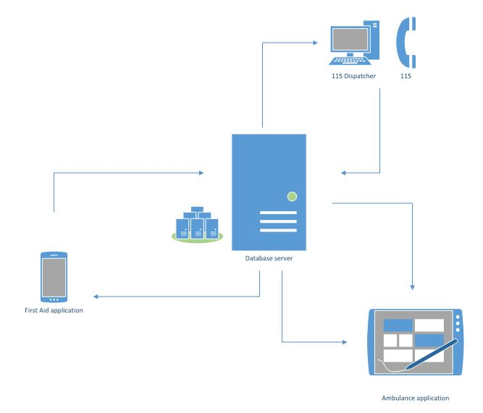

Figure 1‑3: Brief descriptions diagram of First Aid

### System features

In our system, First Aid mobile app is the most prominent application that provides you the first aid methods in concise step-by-step, easy to understand, easy to implement. It has special features such as determining your locate on a map to and supporting medical facilities within a specific radius, direct hotline to call, the location of health facilities and guide the way to there. You can also ask questions about health issues and get answers from experts. Besides the above functions, we also support interactive functions with the 115 emergency center to shorten the duration of your emergency call.

When using our app to call 115, your personal information (including phone number and your location) will be sent to the dispatch system of the 115 center (also developed by us) is called “Dispatcher”. There are two ways to call 115 from this app. You can call 115 from the main screen of this app as well as from the instruction steps screen which is located in the list of injuries. Specially, if you call from the instruction steps screen, your symptom will also be sent to the switchboard, the dispatcher can rely on this information to give the right emergency advice to your case. From that information, the dispatcher can conduct an ambulance to pick you up by car automatic functions of our system. The ambulance pick you up will be the car that is nearest to your location.

The ambulance will also have a software is called “Ambulance” application can show your location and directs to it through the electric map. It helps to reduce the wrong direction cases. The ambulance status is also constantly updated, the dispatcher can fully know the location of it and its ready status or not in order to manage the most effectively.

In addition, the features of the user comments are used to communicate with the administrator. Data management features allow administrators to manipulate and manage data such as database of First Aid applications, opinions of users. User management features allow administrators to manage the account dispatcher, ambulance staff and medical experts.

#### First aid application features

* **List of injuries:** List of common injuries will be displayed in main screen when users launch in First Aid application
* **Instruction steps of injury:** Instructions steps first aid of an injury will be shown when users tap on an injury’s name.
* **Searching:** Users search the related keywords of injury and results will be displayed in the screen.
* **Reading steps of instructions:** Read steps of instructions for users. Users can perform first aid and listen to steps of instructions at the same time.
* **Call 115:** This feature will help users to call 115. In an emergency that need to call 115, this feature can send to operator the user information including phone numbers and coordinates.
* **Current location:** Users can get their exact location via the map. In case there is no exact address, the users can get the nearest locations.
* **Finding nearby health facilities:** Users can find list of the nearest health facilities and see address, distance, phone number, and directions to the health facilities.
* **Learning:** Information about instructions of each injury will be explained more clearly than the instruction steps first aid in emergency screen. This feature will help users to have more knowledge about first aid in injury situations.
* **FAQs:** Users can see FAQs about an injury and send questions about injuries
* **More:** This feature is a collection of some other popular features for users :
  + Send feedback.
  + View first aid course.
  + Sharing.

#### Ambulance application features

* **Login/Logout:** Ambulance staff need to login to use the account. The staff account can be given by administrators.
* **Notify task:** Ambulance staff can receive the task automatically from the coordinator without making a phone call or using walkie-talkie like traditional way.
* **Location of caller:** Ambulance staff will determine the caller’s location exactly and know the shortest way from the location of ambulance to the location of caller.
* **Report to Dispatcher:** Ambulance can report to dispatcher after picking up victim to hospital.
* **Status:** Ambulance will report to dispatcher about the ambulance status of implementing task or not.

#### Dispatcher application features

* **Login/Logout:** Dispatcher need to login to use the account. Dispatcher’s account is given by administrator.
* **Dispatch ambulance:** Dispatcher receives information from users including their status and their coordinates, then dispatcher will dispatch the ambulance to the victim’s location. The system will automatically choose the nearest available ambulance.
* **Show direction from ambulance to caller:** dispatcher will know the nearest way from ambulance’s location to victim’s location and follow ambulance’s moving.
* **View ambulance information:** Dispatcher can know about the available of ambulance .
* **Cancel emergency case:** In case the victim doesn’t need ambulance, dispatcher can cancel task.

#### Admin/Expert Application

* **User management:** Admin can create new account for dispatcher, ambulance staff and health expert, update, delete and search account.
* **Data Management:** Medical expert can delete, update, or add new information about first aid.
* **Users’ questions management:** Admin and expert will receive notifications when there are comments or questions from users and answer them.

## Benefits from Project

### For our group

After developing and implementing this project, our group will get some benefits:

* Have more experiences of software project management how to manage plan, time, member and risk.
* Have more knowledge and skills about HTML/ CSS , Android and PHP programming.
* Know how to communicate with team members and how to make teamwork more effective.
* If this application is approved, we will get a good mark in Capstone Project. It makes our grade better.

### For Community

With only mobile device, users can easily search and follow the instructions of first aid in case of emergency. If it is done properly and timely, victims can minimize the damage and faster recovery. In particular, in many cases, this can save lives.

If First Aid mobile application is widespread, we hope to contribute to raise the awareness of Vietnamese people of the importance of understanding of basic aid skills. It is the way to protect people’s health and life.

Besides, by proposing the construction of a coordination system and mobile applications on the central ambulance for 115, we believe that if the FA applications is applied for real, the system will solve a lot of these shortcomings and limitations to the 115 emergency center.

## Critical Assumption and Constraints

* **Critical assumption:**
  + For the Technical training: we assumed web developers can study about PHP and mobile developers can train about application development for Android platform in one week. Besides, testers also have enough knowledge about software testing process.
  + For the human resources: we assumed all members have a good healthy to do their task sand meet the project plan's deadline.
* **Constraints:**
  + Time and deadline: we have to work 5 hours/day and 5 days/week **to** submit weekly report on time for the supervisor and finish entire project in 14 weeks.
  + Quality: We need to ensure that our product could be run well on android mobile devices with android OS version 5.0 or higher.
  + Process: We have to follow the software processing of FPT Software
  + Human resources: There are 5 member in our team, each member have to study 2 subjects (Japanese and JIT) at school.

## Potential Risks

After studying about this project, we find out some problem that we may be encountered:

* Under-estimate scope and time or miss deadline because lack of experience in group working, managing and controlling work.
* Loss data, source code before uploading data to server because of careless.
* Equipment got broken because of careless or accident.
* Human resources: Team member cannot complete their works because of health reasons, key member leave team or un-cooperating on team.
* Change requirements: Requirement changed when some functions cannot be completed or some technologies is not suitable.

# PROJECT MANAGEMENT

## Introduction

### Purpose

This part is the project management plan of First Aid Vietnam (FAVN) Project – our Capstone Project in FPT University. It is included the project overview, project organization, tools and infrastructures, schedule of this project.

### Definitions and Acronyms

|  |  |  |
| --- | --- | --- |
| Acronym | Definition | Note |
| CM | Configuration Management |  |
| FAVN | First Aid Vietnam |  |
| DEV | Developer |  |
| DES | Designer |  |
| PIC | Person in charge |  |
| PM | Project Manager |  |
| PTL | Project Technical Leader |  |
| PDL | Project Design Leader |  |
| TL | Test Leader |  |
| SRS | Software Requirement Specification |  |
| UTC | Unit Test Case |  |
| KLOC | Thousands of lines of code |  |
| FAQs | Frequently asked questions |  |
| Q&A | Question and Answer |  |

Table 2‑1: Definitions and acronyms

## Project Overview

### Project Description

|  |  |  |  |
| --- | --- | --- | --- |
| Project Code | FAVN | Contract Type | None |
| Customer | FPT University | 2nd Customer | None |
| Project Level | Group | Project Rank | None |
| Application Type | Mobile Application and Web Application | Project Manager | Dam Huy Hung |
| Project Category | Development | Business Domain | Health Care |

Table 2‑2: Project Description

### Scope and Purpose

#### Purpose

With the aim of providing the best supported health service for Vietnamese people, we want to develop an application that allows users can look up and perform first aid guide and selectively synthesized under step by step format in the easiest way. This application also supports users to search medical facilities around their location. Besides we also want to develop an emergency switchboard system for Hanoi 115 emergency center. It means that this system can connect to aid applications through SOS calling with reducing talking time as well as providing maximum necessary information. In addition, the system also has automatic functions connected to software on an ambulance in order to shorten the time to contact and distance traveled; functional navigation map and directions to emergency help achieve maximum efficiency.

#### Scope

This project covers all processes from planning, requirement specification, design, development, testing to quality management.

#### The functions of Project

These are the functions of FAVN’s project:

##### First Aid Application features.

* **List of injuries:** List of common injuries will be displayed in main screen when user launch in First Aid application
* **Instruction steps of injury:** Instructions steps first aid of an injury will be shown when user tap on an injury’s name.
* **Searching:** Users search the related keywords of injury and results will be displayed in the screen.
* **Reading steps of instructions:** Read steps of instructions for users. Users can perform first aid and listen to steps of instructions at the same time.
* **Call 115:** This feature will help users to call 115. In an emergency that need to call 115, this feature can send to operator the user information including phone numbers and coordinates.
* **Current location:** Users can get their exact location via the map. In case there is no exact address, the users can get the nearest locations.
* **Finding nearby health facilities:** Users can find list of the nearest health facilities and see address, distance, phone number, and directions to the health facilities.
* **Learning:** Information about instructions of each injury will be explained more clearly than the instruction steps first aid in emergency screen. This feature will help users to have more knowledge about first aid in injury situations.
* **FAQs:** Users can see FAQs about an injury and send questions about injuries
* **More:** This feature is a collection of some other popular features for users :
  + Send feedback.
  + View first aid course.
  + Sharing.

##### Ambulance Application features

* **Login/Logout:** Ambulance staff need to login to use the account. The staff account can be given by administrator.
* **Notify task:** Ambulance staff can receive the task automatically from the coordinator without making a phone call or using walkie-talkie like traditional way.
* **Location of caller:** Ambulance staff will determine the caller’s location exactly and know the shortest way from the location of ambulance to the location of caller.
* **Report to Dispatcher:** Ambulance can report to dispatcher after picking up victim to hospital.
* **Status:** Ambulance will report to dispatcher about the ambulance status of implementing task or not

##### Dispatcher Application features

* **Login/Logout:** Dispatcher need to login to use the account. Dispatcher’s account is given by administrator.
* **Dispatch ambulance:** Dispatcher receives information from users including their status and their coordinates, then dispatcher will dispatch the ambulance to the victim’s location. The system will automatically choose the nearest available ambulance.
* **Show direction from ambulance to caller:** dispatcher will know the nearest way from ambulance’s location to victim’s location and follow ambulance’s moving.
* **View ambulance information:** Dispatcher can know about the available of ambulance
* **Cancel emergency case:** In case the victim doesn’t need ambulance, dispatcher can cancel task

##### Admin/Expert Application features

* **User management:** Admin can create new account for dispatcher, ambulance staff and health expert, update, delete and search account.
* **Data Management:** Medical expert can delete, update, or add new information about first aid.
* **Users’ questions management:** Admin and expert will receive notifications when there are comments or questions from users and answer them

### Assumptions and Constraints

|  |  |  |
| --- | --- | --- |
| No | Description | Note |
| Assumptions | | |
| 1 | Reviewers will get one day to approve a milestone document. If no comments are received within this time period, it will be considered as approved. | External Interfaces |
| Constraints | | |
| 1 | This project must be completed and delivered before 16/12/2016 | Schedule |
| 2 | In doing project processing, PM must submit report (include 6 reports) on certain date. | Schedule |
| 3 | Project Plan and SRS Document and must be completed within 14 days since 12/09/2016  Deadline: 28/09/2016 | Schedule |
| 4 | Design Document (include Architecture Design, Screen Design, Database Design) must be completed within 13 days since 26/09/2016  Deadline: 14/10/2016 | Schedule |
| 5 | Integration and System Test Plan (include test plan and test case…) must be completed within 6 days since 17/10/2016  Deadline: 25/10/2016 | Schedule |
| 6 | Completed coding activity and have unit test result within 28.5 days since 17/10/2016  Deadline: 24/11/2016 | Schedule |
| 8 | Create report about User manual, software package and installation guide on 8 days since 25/11/2016  Deadline: 06/12/2016 | Schedule |
| 9 | Complete all of document and application before finishing the project on 16/12/2016 | Schedule |
| 10 | Project contains 5 members | Resource |

Table 2‑3: Project Description

### Project Objectives

#### Standard Objectives

|  |  |  |  |  |
| --- | --- | --- | --- | --- |
| Metics | Unit | Committed | Re-committed | Note |
| Start Date |  | 05-09-2016 |  |  |
| End Date |  | 16-12-2016 |  |  |
| Duration | Day | 75 |  |  |
| Team Size | Person | 5 |  |  |
| Billable Effort | Person-day | 375 |  | 1 Person-day = 5 hours |
| Calendar effort | Person-day | 375 |  | 1 Person-day = 5 hours |
| Effort Usage | % | 100 |  | 1 Person-day = 5 hours |

Table 2‑4: Standard Objectives

|  |  |  |
| --- | --- | --- |
| Metrics | Unit | Basic for setting Goals |
| Average |
| Customer Satisfaction | Point | 9.5 |
| Leakage | Wdef/mm | 5 |
| Effort Efficiency | % | 95 |
| Timeliness | % | 100 |

Table 2‑5: Standard Objectives 2

#### Specific Objectives

|  |  |  |  |
| --- | --- | --- | --- |
| Metrics | Unit | Basic for setting Goals | |
| Plan | Actual |
| Training technology: Java, Bootstrap, Laravel –PHP framework | Person-day | 15 | 15 |
| Execute group review | Person-day | 5 | 5 |
| Training requirements, process before coding | Person-day | 5 | 5 |

Table 2‑6: Specific Objectives

### Critical Dependencies

|  |  |  |  |
| --- | --- | --- | --- |
| No | Dependency | Expected delivery date | Note |
| 1 | This project must be completed and delivered to FPT University. | 16/12/2016 |  |
| 2 | Project Plan and SRS must be completed and delivered to Supervisor. | 28/09/2016 |  |
| 3 | User manual, Software Package and Installation Guide must be completed and delivered to Supervisor and FPT University. | 06/12/2016 |  |
| 4 | Beside Capstone Project, Team members have to joining in Japanese class and Japanese Fundamental Exam class. | 05/09/2016 |  |

Table 2‑7: Critical Dependencies

### Project Risk

PM identifies risks in the Risk Management Plan. The document is updated to trigger each milestone, each event also. The document is updated weekly by the PM, Risk Management Plan will be notified to all of the stakeholders affected. Status of risk is reported to supervisor at Project Milestones Report.

Reference to FAVN_Risk Management Plan_v1.0_EN.xlsx

## Project Development Approach

### Project Process

Process of this project is performed follow to Software Development Process of FPT Software.

#### FPT Software Process Model



1. FPT Software process model

The software lifecycle is broken into *cycles*, each cycle working on a new generation of the product. The FPT Software process divides one development cycle in six consecutive *phases*:

1. Initiation phase
2. Definition phase
3. Solution phase
4. Construction phase
5. Transition
6. Termination

#### Project Life Cycle

Basing on FPT Software process and real-world project, we decided to divide the project into 4 phases: Initiation, Solution, Construction, and Termination:

* **Initiation Phase:** This is the explanatory phase of the project. Project objective and description is described at this stage. The purpose of this phase is to collect and understand business requirements, detail the project plan and agree upon a high level statement of work. Our primary objectives are complete project identification and project plan. After these are completed, the project is checked against the following criteria:
  + Identify business functions of the system
  + Determining the scope, conditions and limitations of the project
  + List the main functions of the system
  + List one or more suitable architecture for the system
  + Identify project risks
  + Complete Report #1, and Report #2
* **Solution Phase**: In this phase, the architecture of the system is designed. The goal is to translate requirements and specification into a technical solution to produce Technical Design.
  + Ourprimaryobjectivesare completeRequirement Specification, Architecture Design and Database Design.
  + Finally, the plan must be provided (including estimates of cost and time) for the construction phase. The plan must ensure proper and accurate based on experience.
  + Complete Report #3 and Report #4
* **Construction Phase**: This is the longest phase of a project life cycle.
  + In this phase, all functions of the system will be installed. The installation will be divided into small stages, each stage of the installation a few functions. The results of each phase will be the release of the module function can be executed.
  + Construction and improvement of products until the final product is ready to deliver to the user. During this phase, all the components and other features of the application is developed and integrated into the product.
  + This phase emphasizes the resource management and control operations to optimize cost, time and quality.
  + Complete software packages and Report #5, Report #6
* **Termination Phase**: This is the final phase in the life cycle of a project.
  + Their products will be deployed to the client. The feedback received during the transfer process will be recorded and put on the new functional requirements or functionality enhancements in the next version of the product.
  + Phase transfer switch also includes the training system and the new system for the user

### Requirement Change Management

|  |  |
| --- | --- |
| Who logs the change request? | Any team members |
| Who reviews the change request? | PM or who is PM assigned |
| Who approves the change request? | PM by default. PTL if:   * Changes to project scope * Changes in delivery plan of project deliverables * Changes to assignment for key roles (PM, PTL) |

Table 2‑8: Requirement Change Management

### Quality Management

#### Defect Prevention Strategy

|  |  |  |
| --- | --- | --- |
| Item (Process/Product) | Strategy | Expected Benefits |
| Requirement missing | List up all of requirement into SRS document. | 10–20% reduction in defect injection rate and about 2% improvement in productivity |
| Careless mistake in Design Document Format/Template wrong | After designing, QA will review Document Format base on checklist review design | Improvement in quality as overall defect removal efficiency will improve; some benefits in productivity as defects will be detected early |
| Use wrong template | Have a meeting to disseminate all template that is used in this project for all member | All member will use right template when do document |
| Coding application does not match with User Requirement. | Develop Team must study about Requirement/Design within 1 weeks since project is assigned.  PM and PTL has responsibility to review task results and explain User Requirement for Develop Team | Coding Application match with User Requirement. |

Table 2‑9: Defect Prevention Strategy

#### Review Strategy

|  |  |  |  |  |
| --- | --- | --- | --- | --- |
| Review Item | Reviewer | Review Type | Review Method | Completion Criteria |
| Project Plan  Project Schedule  CM Plan | PM, TL, Supervisor | Group review  Group review  One-person review | Use checklist and Self-review |  |
| Business analysis and requirements specification document, Use Case catalog | PM, TL, Supervisor | Group review and One-person review | Use checklist |  |
| Design document, object model | Self-review, PM, TL Supervisor | One-person Review | Use checklist |  |
| Stage plans | PM, TL, Supervisor | One-person review | Use checklist |  |
| Complex/first time generated program specs incl. test cases, interactive diagrams |  | Group review |  |  |
| Source code | Self-review, Peer review, PM, Supervisor | One-person review and Group review | Self-review and use checklist |  |

Table 2‑10: Review Strategy

#### Unit Testing Strategy

|  |  |  |  |  |
| --- | --- | --- | --- | --- |
| Item to be Unit Tested | Unit Test Type | Unit Test Technique | Tool Used | Unit Test Completion Criteria |
| Source Code | White-Box Test | Using unit test case and test script | None | - Number of UTC/KLOC: 20 UTC/KLOC  - Number defects/KLOC: 3-4 defects/KLOC  - Statement coverage: 97%  - Branch coverage: 100%  - Path coverage: 100% |

Table 2‑11: Unit Testing Strategy

#### Integration Testing Strategy

|  |  |  |  |  |
| --- | --- | --- | --- | --- |
| Item to be Integration Tested | Integration Test Type | Integration Test Technique | Tool Used | Completion Criteria |
| Do test by flow of functions and items which have concern each other | Black-Box Test |  | Checklist, Boundary | - Number of UTC/KLOC: 30  - Number of defects/KLOC: 2-3 |

Table 2‑12: Integration Testing Strategy

#### System Testing Strategy

|  |  |  |  |  |
| --- | --- | --- | --- | --- |
| Item to be System Tested | System Test Type | System Test Technique | Tool Used | Completion Criteria |
| Test whole system | Black-Box Test |  | None | -Number of UTC/KLOC: 20  -Number of defects/KLOC: 4-6 |

Table 2‑13: System Testing Strategy

#### Estimates of Defects to be detected

|  |  |  |  |
| --- | --- | --- | --- |
| Review/Testing Stage | Targeted No. of Defects to be detected | % of Defects to be detected | Basic for Estimation |
| Requirements review | 10 | 7% | Referenced to similar project estimations |
| Design review | 15 | 11% | Referenced to similar project estimations |
| Code review | 30 | 22% | Referenced to similar project estimations |
| Unit Test | 50 | 38% | Referenced to similar project estimations |
| Integration Test | 15 | 11% | Referenced to similar project estimations |
| System Test | 10 | 7% | Referenced to similar project estimations |
| User Acceptance Test | 5 | 4% | Referenced to similar project estimations |
| Total | 135 | 100% |  |

Table 2‑14: Estimates of Defects

#### Measurements Program

|  |  |  |  |
| --- | --- | --- | --- |
| Data to be collected | Purpose | PIC | When |
| Size: No. of KLOC | Achieve target | PM | At the end of stages |
| Effort: No. person-day | Monitor and controlling team member to keep plan. | Team members | Daily |
| Quality: No. defects detected | Managing product’s quality. | Reviewer  Tester | Right after the review/test |
| Schedule | Monitor and controlling software developing processing keep plan. | PM | Weekly and at the end of stages |

Table 2‑15: Measurements Program

## Estimation

### Size

This project is performed and must complete all requirements from teacher and FPT University. So size of our project is in Capstone Project limit.

### Effort

The Effort estimation is documented in the table below:

|  |  |  |  |  |  |
| --- | --- | --- | --- | --- | --- |
|  | Initiation | Solution | Construction | Termination | Total |
| Effort(person/day) | 70 | 82.5 | 142.5 | 80 | **375** |
| Total % budgeted Effort Usage (%) | 100 | 100 | 100 | 100 |  |

Table 2‑16: Effort Estimation

### Schedule

#### Project Milestone & Deliverables

|  |  |  |  |  |
| --- | --- | --- | --- | --- |
| No | Stage | Committed Delivery date | Description of Deliverable | Delivery media |
| Initiation | |  | Requirements agreed, Report 1 reviewed | |
| 1 | Develop project idea | 06-09-2016 | Project goals and scope defined, milestone description defined, resource committed | Commit GitHub |
| 2 | Q&A Management Sheet | 21-09-2016 | Criteria: Documentation reviewed | Commit GitHub |
| 3 | Submit report no.1 final | 22-09-2016 | Completed report no.1 | Commit GitHub |
| 4 | Solution |  |  |  |
| 5 | SRS | 28-09-2016 | Criteria: Documentation reviewed | Commit GitHub |
| Solution | | Architecture Design | 05-10-2016 | |
| 1 | Screen Design | 06-10-2016 | Criteria: Documentation reviewed | Commit GitHub |
| 2 | Class Design | 14-10-2016 | Criteria: Documentation reviewed | Commit GitHub |
| 3 | Detail Data Design | 12-10-2016 | Criteria: Documentation reviewed | Commit GitHub |
| 4 | Submit report no.2 final | 17-10-2016 | Completed report no.2 | Commit GitHub |
| 5 | Test Plan | 05-10-2016 | Completed | Commit GitHub |
| 6 | Submit Report no.3 Final | 06-10-2016 | Completed report no.3 | Commit GitHub |
| 7 | Construction |  | Product developed & tested and released to supervisor, documentation reviewed. |  |
| 8 | Submit Report no.4 Final | 27-10-2016 | Completed report no.4 | Commit GitHub |
| 9 | Review Test Document | 18-11-2016 | Criteria: Documentation reviewed | Commit GitHub |
| 10 | Submit report no.5 Final | 24-11-2016 | Completed report no.5 | Commit GitHub |
| Construction | | Complete Coding and Unit Test | 24-11-2016 | |
| 1 | Complete Testing | 18-11-2016 | Completed Test | Commit GitHub |
| 2 | Submit the last document and CD source code | 06-12-2016 | Report no.6 Final Documents and Source Code | Commit GitHub |
| 3 | Termination |  | Project post-mortem is conducted, Project assets archived and released to supervisor |  |
| 4 | Project Result Assessment | 02-12-2016 | Criteria: Completed | Commit GitHub |
| 5 | Complete Presentation Slide | 06-12-2016 | Criteria: Completed | Commit GitHub |
| 6 | Represent capstone project | 14-12-2016 | Criteria: Completed | Commit GitHub |
| Termination | | Project Complete | 16-12-2016 | |
| 1 | Develop project idea | 06-09-2016 | Project goals and scope defined, milestone description defined, resource committed | Commit GitHub |
| 2 | Q&A Management Sheet | 21-09-2016 | Criteria: Documentation reviewed | Commit GitHub |
| 3 | Submit report no.1 final | 22-09-2016 | Completed report no.1 | Commit GitHub |
| 4 | Solution |  |  |  |

#### **Table 2-17: Project Milestone and Deliverables**

#### Detail Schedule

The detail project schedule is available in file FAVN_ProjectSchedule_v1.0_EN.mpp.

The Project Schedule is weekly updated by the Project Manager.

|  |  |  |  |  |
| --- | --- | --- | --- | --- |
| No | Activity | Start date | End date | Responsible |
| Defect Prevention | | | | |
| 1 | Training coding convention PHP, Android | 24-09-2016 | 24-09-2016 | KienMT |
| 2 | Training for Q&A and tester to use checklist | 15-10-2016 | 16-10-2016 | AnNP |
| **Quality Control** | | | | |
| 1 | Group review requirement | 14-10-2016 | 16-10-2016 | HungDH |
| 2 | Group review design | 07-10-2016 | 09-10-2016 | DungNT |
| 3 | Group review coding | 22-11-2016 | 24-11-2016 | KienMT |
| Project Tracking | | | | |
| 1 | Solution: Milestone review meeting | 27-10-2016 | 28-10-2016 | HungDH |
| 2 | Construction:Milestone review meeting | 06-12-2016 | 08-12-2016 | HungDH |
| 3 | Transition: Milestone review meeting | 14-12-2016 | 15-12-2016 | HungDH |
| Configuration Management | | | | |
| 1 | Baseline code | 17-10-2016 | 20-10-2016 | KienMT |
| 2 | Base line test report, test case and test plan | 22-10-2016 | 29-10-2016 | HungDH |
| Q&A | | | | |
| 1 | Final Inspection: Report 1 | 07-09-2016 | 22-09-2016 | AnNP |
| 2 | Final Inspection: Report 2 | 22-09-2016 | 19-10-2016 | AnNP |
| 3 | Final Inspection: Report 3 | 20-10-2016 | 28-10-2016 | AnNP |
| 4 | Final Inspection: Report 4 | 29-10-2016 | 25-11-2016 | AnNP |
| 5 | Final Inspection: Report 5 | 26-11-2016 | 10-12-2016 | AnNP |
| 6 | Final Inspection: Report 6 | 11-12-2016 | 14-12-2016 | AnNP |

**Table 2‑17: Activity Schedule**

### Resource

Specified as in the section 2.5.2 Project Team

### Infrastructure

|  |  |  |  |
| --- | --- | --- | --- |
| Item | Description | Expected Availability by | Note |
| Development Environment | | | |
| Operating System | Window 10 (64 bit) |  |  |
| Browser | Chrome (40 or above), Firefox (30 or above) |  |  |
| Development language | PHP, Java |  |  |
| Technology | | | |
| Development language | PHP, Java |  |  |
| Database | MySQL, SQLite |  |  |
| Hardware Requirement | | | |
| Hardware Configuration | 2GB workspaces on server |  |  |
| Equipment & Tools | | | |
| Source Version Control | GitHub | Definition stage |  |
| Task Tracking | MS Project Professional 2013 | Initiation stage |  |
| SRS | Microsoft Office Word 2013, Microsoft Office Excel 2013, Microsoft Office Visio 2013 | Initiation stage |  |

Table 2‑18: Infrastructure

### Training Plan

|  |  |  |  |
| --- | --- | --- | --- |
| Training Area | Participants | Duration | Waiver Criteria |
| Technical | | | |
| PHP | KienMT | 1 week | Mandatory |
| Android | HungDH DungNT | 1 week | Mandatory |
| Bootstrap | KienMT |  |  |
| **Process** | | | |
| Quality system |  | 3 hours | If already trained |
| Configuration management |  | 2 hours | If already trained for CC. For others, on-the-job training |
| Group review |  | 2 hours | If already trained |
| Defect prevention |  | 2 hours | Mandatory |

Table 2‑19: Training Plan

### Finance

Because this project is non-business, it is a Capstone Project at FPT University. So we do not estimate about finance.

## Project Organization

### Organization Structure

Table 2‑20: Organization Structure

### Project Team

|  |  |  |  |  |  |
| --- | --- | --- | --- | --- | --- |
| Role | Responsibility | Full name | Effort (%) | Start date | End date |
| PM | Have overall responsibility of the project:  - Project planning and scheduling  - Task assignment and tracking processing  - Review documents  - Reporting to supervisor | Dam Huy Hung | 50 | 06-09-2016 | 16-12-2016 |
| PTL | PTL is responsible for the technical project execution | Mai Trung Kien | 100 | 06-09-2016 | 16-12-2016 |
| DEV | - Study technique (Android, Bootstrap, PHP)  - Coding functions and modules of system.  - Peer-review source code of others members | Dam Huy Hung, Nguyen Tien Dung | 50 | 06-09-2016 | 16-12-2016 |
| Designer | - Support creating screen design | Nguyen Tien Dung | 50 | 06-09-2016 | 16-12-2016 |

Table 2‑21: Project Team description

The detail of Human resource budget allocation over the whole project life is in the below table:

|  |  |  |  |  |  |  |  |  |  |  |  |  |  |  |  |  |  |
| --- | --- | --- | --- | --- | --- | --- | --- | --- | --- | --- | --- | --- | --- | --- | --- | --- | --- |
| Role | Name | W1-  Sep | W2-  Sep | W3-  Sep | W4-  Sep | W1-  Oct | W2-  Oct | W3-  Oct | W4-  Oct | W1-  Nov | W2-  Nov | W4-  Nov | W5-  Nov | W1-  Dec | W2-  Dec | W3-  Dec | Total (pd) |
| PM/PDL | Dam Huy Hung | 100% | 100% | 100% | 100% | 100% | 100% | 100% | 100% | 100% | 100% | 100% | 100% | 100% | 100% | 100% | 75 |
| PTL | Mai Trung Kien | 100% | 100% | 100% | 100% | 100% | 100% | 100% | 100% | 100% | 100% | 100% | 100% | 100% | 100% | 100% | 75 |
| DEV /DES | Nguyen Tien Dung | 100% | 100% | 100% | 100% | 100% | 100% | 100% | 100% | 100% | 100% | 100% | 100% | 100% | 100% | 100% | 75 |
| TL | Nguyen Phuc An | 100% | 100% | 100% | 100% | 100% | 100% | 100% | 100% | 100% | 100% | 100% | 100% | 100% | 100% | 100% | 75 |
| Tester | Nguyen Duy Anh | 100% | 100% | 100% | 100% | 100% | 100% | 100% | 100% | 100% | 100% | 100% | 100% | 100% | 100% | 100% | 75 |
| Total |  |  |  |  |  |  |  |  |  |  |  |  |  |  |  |  | 375 |

Table 2‑22: Human Resource Budget Allocation

## Communication & Reporting

|  |  |  |  |  |
| --- | --- | --- | --- | --- |
| Communication Type | Method/Tool | When | Information | Participants/ Responsible |
| Project Task Tracking | | | | |
| Task scheduling | MS Project Professional 2013 | Weekly |  | PM |
| Task assignment | Trello | Weekly |  | PM |
| Task status reporting | Daily Report | Daily |  | Project Team members |
| **Project Meeting** | | | | |
| Kick-off Meeting | Face to face | Initiation stage | Project introduction; Project plan review; Risk identification; stakeholders identify. | PM, Project Team Members |
| Project Progress Review Meetings | Face to face | Weekly and on event | Communicate project status  Communicate and resolve any open issue, risks, and changes  Discuss any suggested improvement | PM, Project Team Members |
| Milestone Meetings | Face to face | 5 days after the completion of stages: Definition, Solution & Construction | Project objective review, evaluate project performance (quality, schedule, effort), Causal analysis, update project plan for next stage | PM, Project Team Members, QA, Supervisor |
| **Supervisor Communication and Reporting:** | | | | |
| **Communication with Supervisor** | | | | |
| Transfer/Sharing of project documentation/information | TortoiseGit | When available | All project documentation and information | PM, Project Team Members, QA |
| Project Report | Agreed FPT Software and FU standard format | 5pm Monday, Weekly | Project status report, Issue requiring clarifications, escalation, if any | PM |
| Project Meetings with supervisor | Face to face | 12h30 Wednesday, Weekly | As above | PM |
| Requirement gathering/clarification | Face to face meeting | During requirement analysis phase | As in Q&A list | PM |
| Review Project Plan & Project schedule | By attend project meeting | Significant changes to WO, PP and Project schedule (scope, objectives Organization, HR, major milestone, deliverables ) |  | PM |
| Project Progress Review | By email and/or via Operation meeting at Group/Division level | Weekly | Project status report, Issue requiring clarifications, escalation, if any | PM |
| Project Milestone Review | By email and via project milestone review meeting | End of every stage | Project objective review, evaluate project performance (quality, schedule, effort), Causal analysis, update project plan for next stage | PM |

Table 2‑23: Communication and Reporting Plan

# SOFTWARE REQUIREMENT

## Introduction

### Purpose

This document will provide the describing of general requirement and non-functional requirements of our FAVN system. It also describes the requirement scope of each phase in the project.

### Definitions and Acronyms

|  |  |
| --- | --- |
| Terms | Description |
| FAS | First Aid system |
| FAA | First Aid application |
|  |  |

Table 3‑1: Definition and Acronyms

## User Requirement Specification

### Product Features

These are the features of First Aid system:

#### First Aid Application features

* **List of injuries:** List of common injuries will be displayed in main screen when user launch in First Aid application
* **Instruction steps of injury:** Instructions steps first aid of an injury will be shown when user tap on an injury’s name.
* **Searching:** Users search the related keywords of injury and results will be displayed in the screen.
* **Reading steps of instructions:** Read steps of instructions for users. Users can perform first aid and listen to steps of instructions at the same time.
* **Call 115:** This feature will help users to call 115. In an emergency that need to call 115, this feature can send to operator the user information including phone numbers and coordinates.
* **Current location:** Users can get their exact location via the map. In case there is no exact address, the users can get the nearest locations.
* **Finding nearby health facilities:** Users can find list of the nearest health facilities and see address, distance, phone number, and directions to the health facilities.
* **Learning:** Information about instructions of each injury will be explained more clearly than the instruction steps first aid in emergency screen. This feature will help users to have more knowledge about first aid in injury situations.
* **FAQs:** Users can see FAQs about an injury and send questions about injuries
* **More:** This feature is a collection of some other popular features for users:

**-** Send feedback

**-** View first aid course

**-** Sharing

#### Ambulance Application features

* **Login/Logout:** Ambulance staff need to login to use the account. The staff account can be given by administrator.
* **Notify task:** Ambulance staff can receive the task automatically from the coordinator without making a phone call or using walkie-talkie like traditional way.
* **Location of caller:** Ambulance staff will determine the caller’s location exactly and know the shortest way from the location of ambulance to the location of caller.
* **Report to Dispatcher:** Ambulance can report to dispatcher after picking up victim to hospital.
* **Status:** Ambulance will report to dispatcher about the ambulance status of implementing task or not.

#### Dispatcher Application features

* **Login/Logout:** Dispatcher need to login to use the account. Dispatcher’s account is given by administrator.
* **Dispatch ambulance:** Dispatcher receives information from users including their status and their coordinates, then dispatcher will dispatch the ambulance to the victim’s location. The system will automatically choose the nearest available ambulance.
* **Show direction from ambulance to caller:** dispatcher will know the nearest way from ambulance’s location to victim’s location and follow ambulance’s moving.
* **View ambulance information:** Dispatcher can know about the available of ambulance
* **Cancel emergency case:** In case the victim doesn’t need ambulance, dispatcher can cancel task.

#### Admin/Expert Application features

* **User management:** Admin can create new account for dispatcher, ambulance staff and health expert, update, delete and search account.
* **Data Management:** Medical expert can delete, update, or add new information about first aid.
* **Users’ questions management:** Admin and expert will receive notifications when there are comments or questions from users and answer them.

### User characteristic

FAS has five objective users:

* + **FAA user:** Users uses First Aid application in android mobile.
  + **Dispatcher:** Users are offered an account by admin to use Dispatcher website.
  + **Ambulance staff:** Users are offered an account by admin to use Ambulance application in tablet.
  + **Expert:** Users are offered an account by admin to use First Aid website, they can manage all information about first aid and learning of emergencies, answer the question of FAA users.
  + **Admin:** They can manage all information about all user types, answer the question of FAA users.

### Functional Requirements

#### First Aid

**Access right: First Aid application user**

This function related to emergency situations, support to user can first aid injuries. FAA user can view list of injuries, view instruction steps of an injury, search injuries, read instruction steps.

#### Learning

**Access right: First Aid application user**

This function is used to learn about first aid methods clearly. FAA user can view detail explain about first aid an injury. Beside, user can view FAQs about an injury.

#### Location

**Access right: First Aid application user**, **Ambulance staff**

This function is used to view the current location of user. Beside, FAA user can view list of nearest health facilities and view direction to a health facility. Ambulance staff can view location of caller or victim, view direction to them.

#### Call

**Access right: First Aid application user**

This function is used to call to 115 emergency center and other health facilities when user needs help from them. If user calls to Dispatcher application of 115 center, they can send their coordinates and phone number to 115 center and that help the emergency happen fast and easily.

#### Send question

**Access right: First Aid application user**

This function is used to send questions about issues related to first aid, injuries case and medical expert will answer your question. Beside, user can send feedback about function of application to admin.

#### Common

**Access right: Ambulance staff, dispatcher, expert and admin**

This function is used to login, logout. Ambulance staff login to Ambulance application, dispatcher login to Dispatcher application and expert or admin login to administrator website, and they can do their work.

#### Task

**Access right: Ambulance staff**

This function related to the task of an ambulance. Ambulance staff can receive emergency task to dispatcher, report when they picked up caller, report when they complete task or report when ambulance car have problem.

#### Dispatch

**Access right: Dispatcher**

This function related to the jobs of a dispatcher. Dispatcher can receive emergency call to FAA user and has information from users including their status and their coordinates then dispatcher will dispatch the ambulance to the caller’s location.

#### Manage user’s account

**Access right: Admin and expert**

This function is used to manage user’s Q&A. Admin will answer user’s feedbacks about function, GUI or something related to application. Expert will answer questions about injuries and first aid.

#### Manage injury

**Access right: Expert**

This function is used to manage information about first aid and injuries situation. Expert can delete, update, or add new information about first aid.

### Non-functional Requirement

The system has to satisfy these principles:

* **Learnable**: The user interface must be easy to learn, even at the first time looking at the screen, user may immediately understand the function of each button or icon.
* **Efficiency**: The user interface must minimize the number of steps that the system takes to complete its task.
* **Memorable**: System contains some complex screens. Therefore, interface should be easier to use each time the user interacts with it.
* **Visibility**: Important information (example: text in nodes) should be clearly visible.
* **Consistency**: Like items should always be displayed and act the same way through the entire application.
* **Easy to maintain and upgrade**
* **Ensure data security capabilities, high performance**
* **Scalability system**

## Software Requirements Specification

### Overall Description

#### System use case

##### First Aid Application

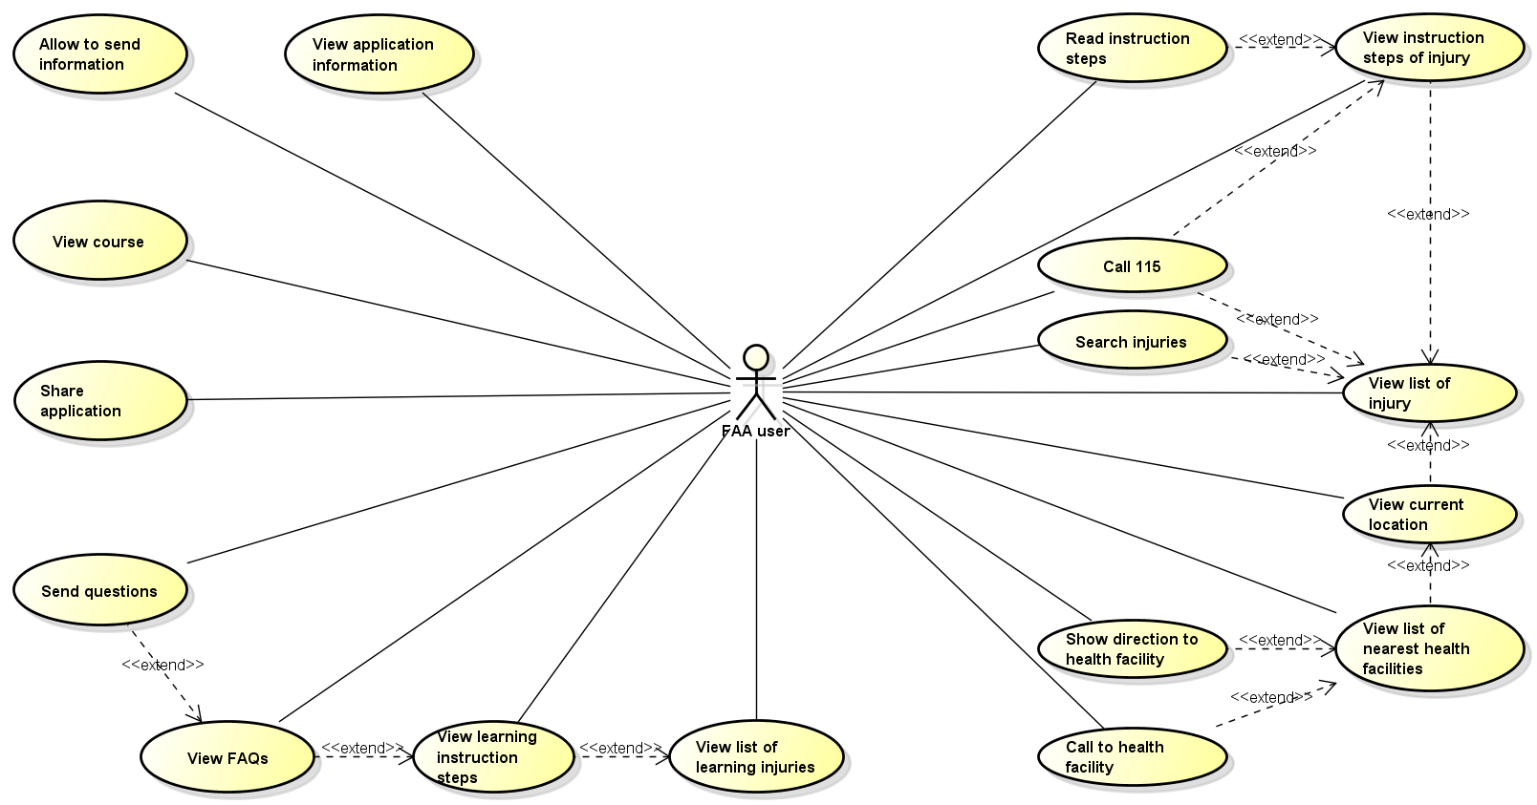

Figure 3‑1: First Aid Application use case

##### Ambulance Application

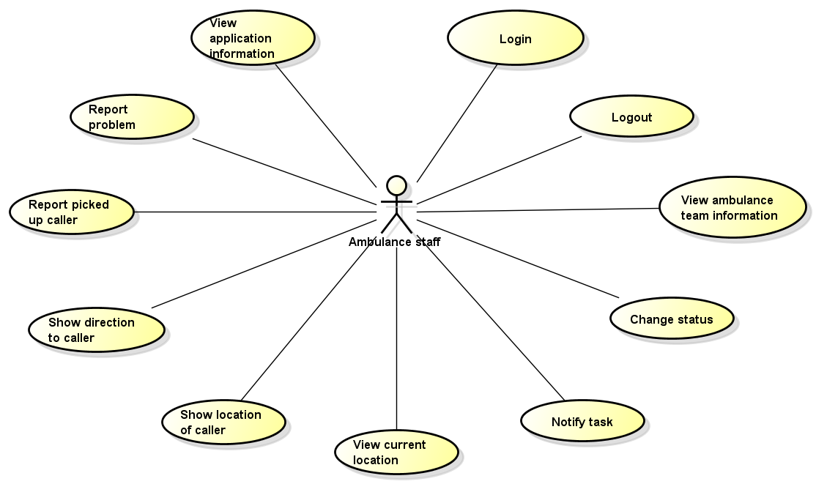

Figure 3‑2: Ambulance Application use case

##### Dispatcher Application

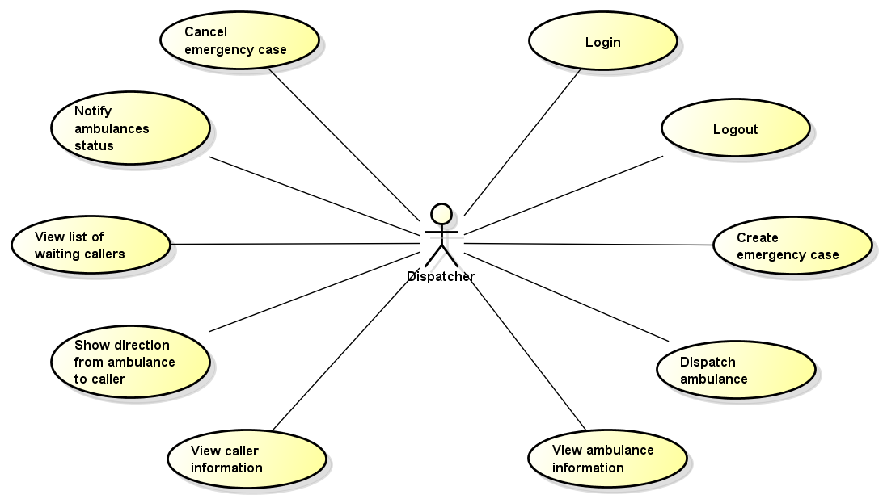

Figure 3‑3: Dispatcher Application use case

##### Admin/Expert Application

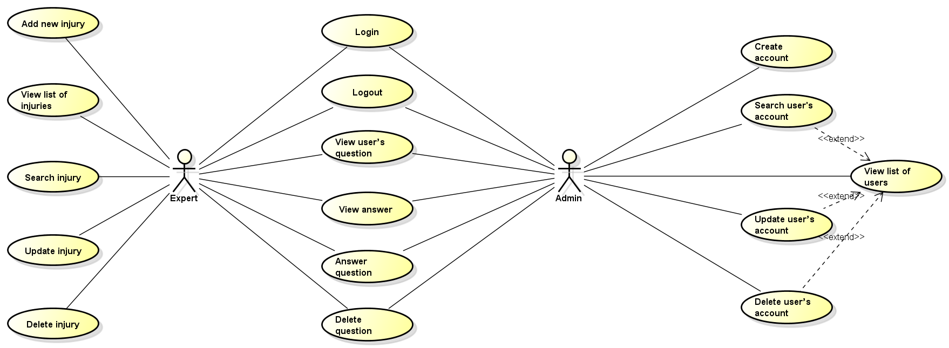

Figure 3‑4: Admin/Expert Application use case

#### Product Features

##### First Aid Application

|  |  |  |  |
| --- | --- | --- | --- |
| UC No. | Group Of Functions | Function | Glossary |
| First Aid Application | | | |
|  | Emergency | View list of injuries |  |
|  | View instruction steps of injury |  |
|  | Search injuries |  |
|  | Call 115 |  |
|  | Read instruction steps |  |
|  | View current location |  |
|  | View list of nearest health facilities |  |
|  | Show direction to health facility |  |
|  | Call to health facility |  |
|  | Learning | View list of learning injuries |  |
|  | View learning instruction steps |  |
|  | View FAQs |  |
|  | More | Send questions |  |
|  | View courses |  |
|  | Share application |  |
|  | Setting | Allow to send information |  |
|  | Information | View application information |  |

Table 3‑2: List of use cases

##### Ambulance Application

|  |  |  |  |  |  |
| --- | --- | --- | --- | --- | --- |
| UC No. | Group Of Functions | | Function | Glossary | |
| Ambulance Application | | | | | |
|  | Common | Login | | |  |
|  | Logout | | |  |
|  | Task | View ambulance team information | | |  |
|  | Change status | | |  |
|  | Notify task | | |  |
|  | View current location | | |  |
|  | Show location of caller | | |  |
|  | Show direction to caller | | |  |
|  | Report picked up caller | | |  |
|  | Report completed task | | |  |
|  | Report problem | | |  |
|  | Information | View application information | | |  |

Table 3‑3: List of use cases

##### Dispatcher Application

|  |  |  |  |  |
| --- | --- | --- | --- | --- |
| UC No. | Group Of Functions | Function | Glossary | |
| Dispatcher Application | | | | |
|  | Common | Login | |  |
|  | Logout | |  |
|  | Dispatch | Create emergency case | |  |
|  | Dispatch ambulance | |  |
|  | View ambulance information | |  |
|  | View caller information | |  |
|  | Show direction from ambulance to caller | |  |
|  | View list of waiting callers | |  |
|  | Notify ambulances status | |  |
|  | Cancel emergency case | |  |

Table 3‑4: List of use cases

##### Admin/Expert Application

|  |  |  |  |  |  |
| --- | --- | --- | --- | --- | --- |
| UC No. | Group Of Functions | | Function | | Glossary |
| Admin/Expert Application | | | | | |
|  | Common | Login | |  | |
|  | Logout | |  | |
|  | Manage user's account | Create account | |  | |
|  | View list of users | |  | |
|  | Search user's account | |  | |
|  | Update user’s account | |  | |
|  | Delete user’s account | |  | |
|  | Manage Q&A | View user’s question | |  | |
|  | View answer | |  | |
|  | Answer question | |  | |
|  | Delete question | |  | |
|  | Manage injury | Add new injury | |  | |
|  | View list of injuries | |  | |
|  | Search injury | |  | |
|  | Update injury | |  | |
|  | Delete injury | |  | |

Table 3‑5: List of use cases

#### User Characteristics

FAS has five objective users:

* **FAA user:** Users uses First Aid application in android mobile.
* **Dispatcher:** Users are offered an account by admin to use Dispatcher website.
* **Ambulance staff:** Users are offered an account by admin to use Ambulance application in tablet.
* **Expert:** Users are offered an account by admin to use First Aid website, they can manage all information about first aid and learning of emergencies, answer the question of FAA users.
* **Admin:** They can manage all information about all user types, answer the question of FAA users.

### Functional Specification

#### Business Rules

|  |  |
| --- | --- |
| No | Description |
|  | Content is limited to 500 characters |
|  | Text field cannot be empty |
|  | Email must content characters ‘@’ and ‘.’ |
|  | Displayed date is yyyy/mm/dd format |

Table 3‑6: Business Rules

#### First Application

##### Emergency Module

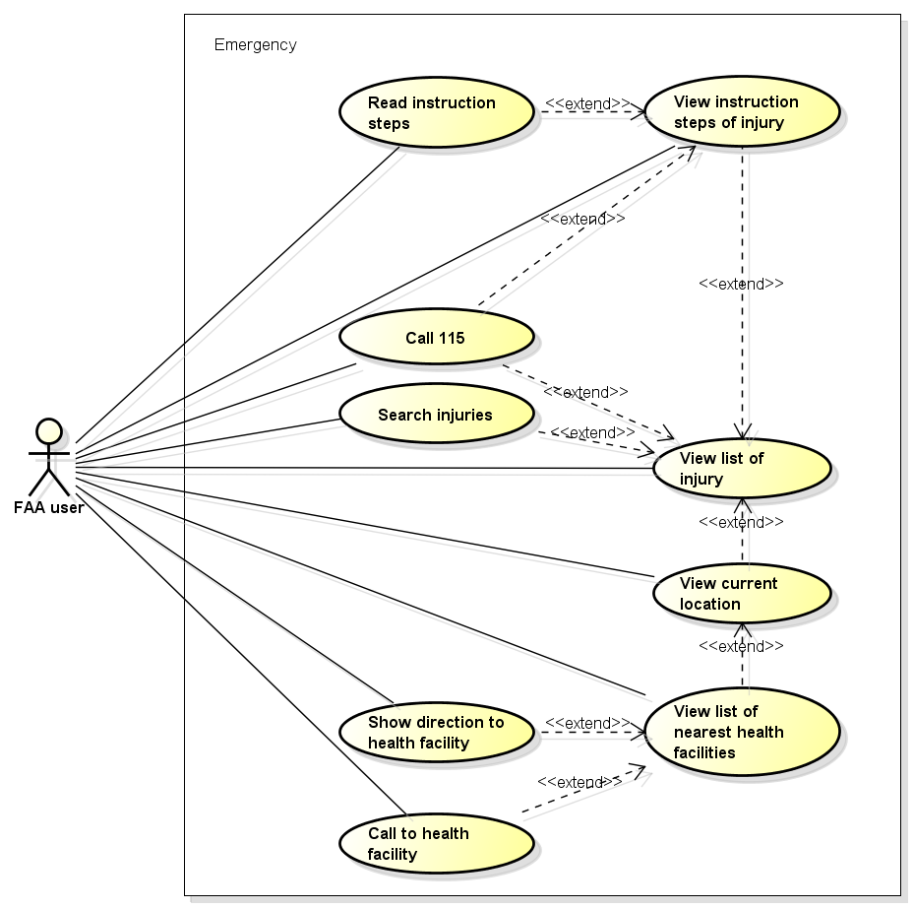

Figure 3‑5: Emergency use case

###### UC001 - View list of injury

|  |  |  |  |  |
| --- | --- | --- | --- | --- |
| Use Case ID | | UC001 | Version | 1.1 |
| Use Case Name | | View list of injury | | |
| Created by: | | AnhND | Date Created: | 24/09/2016 |
| Primary Actor | | FAA user | Secondary Actor |  |
| Description: | | This function allows user to view all injuries need to first aid in First Aid application. | | |
| Preconditions: | | Install First Aid application | | |
| Trigger: | | User launches application | | |
| Post conditions: | | All existing injuries will be displayed in the Emergency screen. | | |
| Normal Flow | | | | |
| Step | Actor | Action | | |
| 1 | FAA user | Launch application | | |
| 2 | FAA | Show all existing injuries | | |
| Alternative Flows: N/A | | | | |
| Exceptions: N/A | | | | |
| Priority | | High | | |
| Frequency of Use: | | High | | |
| Business Rules: | |  | | |
| Other Information: | | N/A | | |

Table 3‑7: View list injuries.

###### UC002 - View instruction steps of injury

|  |  |  |  |  |
| --- | --- | --- | --- | --- |
| Use Case ID | | UC002 | Version | 1.1 |
| Use Case Name | | View instruction steps of injury | | |
| Created by: | | AnhND | Date Created: | 24/09/2016 |
| Primary Actor | | FAA user | Secondary Actor |  |
| Description: | | This function allows user to view first aid instruction step of an injuries. | | |
| Preconditions: | | 1. Install First Aid application 2. User launches application | | |
| Trigger: | | User taps on an injury in the list of injuries that displayed in the Emergency screen. | | |
| Post conditions: | | All first aid instruction step about this injury will be displayed in the Emergency screen. | | |
| Normal Flow | | | | |
| Step | Actor | Action | | |
| 1 | FAA user | Launch application | | |
| 2 | FAA user | Tap on an injury in the list | | |
| 3 | FAA | Show all first aid instruction step | | |
| Alternative Flows: | | | | |
| AT1 | At step 3 in the main flows, if user taps on Back buttons. | | | |
| Step | Actor | Action | | |
| 2.1 | FAA | Redirects user to Emergency screen | | |
| Exceptions: N/A | | | | |
| Priority | | High | | |
| Frequency of Use: | | High | | |
| Business Rules: | |  | | |
| Other Information: | | N/A | | |

Table 3‑8: View instruction step on injury.

###### UC003 - Search injuries

|  |  |  |  |  |
| --- | --- | --- | --- | --- |
| Use Case ID | | UC003 | Version | 1.1 |
| Use Case Name | | Search injuries | | |
| Created by: | | AnhND | Date Created: | 24/09/2016 |
| Primary Actor | | FAA user | Secondary Actor |  |
| Description: | | This function allows user to search an injury exits on FAA by text | | |
| Preconditions: | | 1. Install First Aid application 2. User launches application | | |
| Trigger: | | User taps on Search button, enters search phrase and taps Search | | |
| Post conditions: | | All results that matched with the keyword user enters will be displayed in the Emergency screen. | | |
| Normal Flow | | | | |
| Step | Actor | Action | | |
| 1 | FAA user | Tap on Search button | | |
| 2 | FAA user | Enter search phrase to text box | | |
| 3 | FAA user | Tap Search | | |
| 4 | FAA | List all results that matched with the keyword user entered | | |
| Alternative Flows: | | | | |
| AT1 | At step 2 in the main flows, if user taps on an injury in the list under the text box. | | | |
| Step | Actor | Action | | |
| 2.1 | FAA | Redirects user to first aid instruction step of chosen injury. | | |
| AT2 | At step 2 in the main flows, if user taps on Back button. | | | |
| Step | Actor | Action | | |
| 2.1 | FAA | Redirects user to Emergency screen | | |
| AT3 | At step 3 in the main flows, if user taps on [x] button | | | |
| Step | Actor | Action | | |
| 3.1 | FAA | Redirects user to text box to enters search phrase | | |
| Exceptions: N/A | | | | |
| Priority | | High | | |
| Frequency of Use: | | High | | |
| Business Rules: | |  | | |
| Other Information: | | N/A | | |

Table 3‑9: Search injuries.

###### UC004 - Call 115

|  |  |  |  |  |
| --- | --- | --- | --- | --- |
| Use Case ID | | UC004 | Version | 1.1 |
| Use Case Name | | Call 115 | | |
| Created by: | | AnhND | Date Created: | 24/09/2016 |
| Primary Actor | | FAA user | Secondary Actor |  |
| Description: | | This function allows user to make emergency calls to the 115 center and send user’s information if user allows. | | |
| Preconditions: | | 1. Install First Aid application 2. User launches application | | |
| Trigger: | | User tap on call button in the Emergency screen or user tap on an injury to view instruction steps of injury and tap on call button that below a step. | | |
| Post conditions: | | Call to 115 center. If user allows to send information that set in Setting, FFA will send user’s information (include location and phone number) to Dispatcher application. | | |
| Normal Flow | | | | |
| Step | Actor | Action | | |
| 1 | FAA user | Tap on Call button/ User taps on an injury in the list of injuries then tap on Call 115 button. | | |
| 2 | FAA | Call to 115 and send user’s information if any. | | |
| Alternative Flows: N/A | | | | |
| Exceptions: N/A | | | | |
| Priority | | High | | |
| Frequency of Use: | | High | | |
| Business Rules: | |  | | |
| Other Information: | | N/A | | |

Table 3‑10: Call 115.

###### UC005 - Read instruction steps

|  |  |  |  |  |  |
| --- | --- | --- | --- | --- | --- |
| Use Case ID | |  | UC005 | Version | 1.1 |
| Use Case Name | |  | Read instruction steps | | |
| Created by: | |  | AnhND | Date Created: | 24/09/2016 |
| Primary Actor | |  | FAA user | Secondary Actor |  |
| Description: | |  | This function allows user listening FAA reads an instruction step. | | |
| Preconditions: | |  | 1. Install First Aid application 2. User launches application 3. User chooses an injury that want to see | | |
| Trigger: | |  | User tap on any instruction step. | | |
| Post conditions: | |  | Instruction step is read | | |
|  | | Normal Flow | | | |
| Step | Actor |  | Action | | |
| 1 | FAA user |  | Tap on an instruction step | | |
| 2 | FAA |  | Read instruction step | | |
|  | | Alternative Flows: | | | |
| **AT1** |  | At step 2 in main flow, if user taps again on this instruction step. | | | |
| Step | Actor |  | Action | | |
| 2.1 | FAA |  | Pause reading instruction step | | |
| 2.2 | FAA user |  | Tap again on this instruction step | | |
| 2.3 | FAA |  | Continue to read this instruction step | | |
| 2.4 | FAA user |  | Tap on other instruction step | | |
| 2.5 | FAA |  | Read new instruction step | | |
|  | | Exceptions: N/A | | | |
| Priority | |  | High | | |
| Frequency of Use: | |  | High | | |
| Business Rules: | |  |  | | |
| Other Information: | |  | N/A | | |

Table 3‑11: Read instruction steps.

###### UC006 - View current location

|  |  |  |  |  |
| --- | --- | --- | --- | --- |
| Use Case ID | | UC006 | Version | 1.1 |
| Use Case Name | | View current location | | |
| Created by: | | AnhND | Date Created: | 24/09/2016 |
| Primary Actor | | FAA user | Secondary Actor |  |
| Description: | | This function allows user to locate their current location correctly. | | |
| Preconditions: | | 1. Install First Aid application 2. User launches application | | |
| Trigger: | | User taps on Direct button | | |
| Post conditions: | | The location of user is displayed in the Map | | |
| Normal Flow | | | | |
| Step | Actor | Action | | |
| 1 | FAA user | Tap on Direct button | | |
| 2 | FAA | Displayed the location of user in the Map, include: - Latitude and Longitude - Vicinity (if has internet) | | |
| Alternative Flows: | | | | |
| **AT1** | At step 2 in main flow, if user scrolls in the Map | | | |
| Step | Actor | Action | | |
| 2.1 | FAA | The Map is moved | | |
| 2.2 | FAA user | Tap on Locate button | | |
| 2.3 | FAA | Return to the current location of user | | |
| **AT2** | At step 2 in main flow, if user taps on Back button | | | |
| Step | Actor | Action | | |
| 2.1 | FAA | Redirects user to Emergency screen | | |
| Exceptions: N/A | | | | |
| Priority | | High | | |
| Frequency of Use: | | High | | |
| Business Rules: | |  | | |
| Other Information: | | N/A | | |

Table 3‑12: View current location.

###### UC007 - View list of nearest health facilities

|  |  |  |  |  |
| --- | --- | --- | --- | --- |
| Use Case ID | | UC007 | Version | 1.1 |
| Use Case Name | | View list of nearest health facilities | | |
| Created by: | | AnhND | Date Created: | 24/09/2016 |
| Primary Actor | | FAA user | Secondary Actor |  |
| Description: | | This function allows user to view list of nearest health facilities from their location. | | |
| Preconditions: | | 1. Install First Aid application 2. User launches application 3. User taps on Direct button | | |
| Trigger: | | User taps on “Cơ sở y tế gần đây” button | | |
| Post conditions: | | List of nearest health facilities are displayed | | |
| Normal Flow | | | | |
| Step | Actor | Action | | |
| 1 | FAA user | Tap on “Cơ sở y tế gần đây” button | | |
| 2 | FAA | Show table list of nearest health facilities within a radius 20km, classify in 3 tabs: - “Tất Cả” - “Bệnh Viện” - “Trạm Y Tế” With “Tất Cả” is default tab Content of each tab: - Name - Address or Vicinity - Distance: from user to this health facility, sort from near to far (if has internet) - Button Call: if has phone number of health facility | | |
| Alternative Flows: | | | | |
| **AT1** | At step 2 in main flow, user taps on [x] button | | | |
| Step | Actor | Action | | |
| 2.1 | FAA | Redirect user to the Map | | |
| Exceptions: N/A | | | | |
| Priority | | High | | |
| Frequency of Use: | | High | | |
| Business Rules: | |  | | |
| Other Information: | | N/A | | |

Table 3‑13: View list of nearest health facilities.

###### UC008 - Show direction to health facility

|  |  |  |  |  |
| --- | --- | --- | --- | --- |
| Use Case ID | | UC008 | Version | 1.1 |
| Use Case Name | | Show direction to health facility | | |
| Created by: | | AnhND | Date Created: | 24/09/2016 |
| Primary Actor | | FAA user | Secondary Actor |  |
| Description: | | This function allows user to view the shortest direction from user’s location to a health facility address | | |
| Preconditions: | | 1. Install First Aid application 2. User launches application 3. Mobile has Network 4. User taps on “Cơ sở y tế gần đây” 5. User taps on any health facility | | |
| Trigger: | | User taps on any Direct button | | |
| Post conditions: | | The shortest direction from user’s location to a health facility is displayed | | |
| Normal Flow | | | | |
| Step | Actor | Action | | |
| 1 | FAA user | Tap on Direct button | | |
| 2 | FAA | Show the shortest direction from user’s location to a health facility | | |
| Alternative Flows: | | | | |
| **AT1** | At step 2 in main flow, if user taps on [x] button | | | |
| Step | Actor | Action | | |
| 2.1 | FAA | Clear the direction | | |
| **AT2** | At step 2 in main flow, if user scrolls in the Map | | | |
| Step | Actor | Action | | |
| 2.1 | FAA | The Map is moved | | |
| 2.2 | FAA user | Tap on health facility name | | |
| 2.3 | FAA | Zoom in health facility location | | |
| Exceptions: N/A | | | | |
| Priority | | High | | |
| Frequency of Use: | | High | | |
| Business Rules: | |  | | |
| Other Information: | | N/A | | |

Table 3‑14: Show direction to health facility.

###### UC009 - Call to health facility

|  |  |  |  |  |
| --- | --- | --- | --- | --- |
| Use Case ID | | UC009 | Version | 1.1 |
| Use Case Name | | Call to health facility | | |
| Created by: | | AnhND | Date Created: | 24/09/2016 |
| Primary Actor | | FAA user | Secondary Actor |  |
| Description: | | This function allows user to call to the health facility | | |
| Preconditions: | | 1. Install First Aid application 2. User launches application 3. User taps on “Cơ sở y tế gần đây” 4. Health facility in the list has phone number | | |
| Trigger: | | User taps on Call button | | |
| Post conditions: | | Call to health facility | | |
| Normal Flow | | | | |
| Step | Actor | Action | | |
| 1 | FAA user | Taps on Call button | | |
| 2 | FAA | Call to health facility | | |
| Alternative Flows: N/A | | | | |
| Exceptions: N/A | | | | |
| Priority | | High | | |
| Frequency of Use: | | High | | |
| Business Rules: | |  | | |
| Other Information: | | N/A | | |

Table 3‑15: Call to health facility.

##### Learning Module

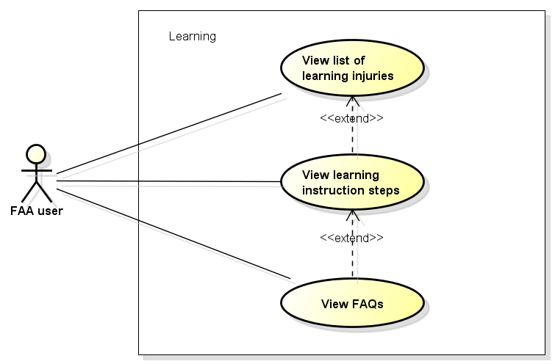

Figure 3‑6: Learning use case

###### UC0010 - View list of learning injuries

|  |  |  |  |  |
| --- | --- | --- | --- | --- |
| Use Case ID | | UC0010 | Version | 1.1 |
| Use Case Name | | View list of learning injuries | | |
| Created by: | | AnhND | Date Created: | 24/09/2016 |
| Primary Actor | | FAA user | Secondary Actor |  |
| Description: | | This function allows user to view all learning about injuries | | |
| Preconditions: | | 1. Install First Aid application 2. User launches application 3. User taps on menu bar | | |
| Trigger: | | User taps on “Tìm Hiểu” tab in menu bar | | |
| Post conditions: | | All learning match with all injuries in Emergency screen will be displayed in the Learning screen. | | |
| Normal Flow | | | | |
| Step | Actor | Action | | |
| 1 | FAA user | Tap on “Tìm Hiểu” tab | | |
| 2 | FAA | Show all learning | | |
| Alternative Flows: N/A | | | | |
| Exceptions: N/A | | | | |
| Priority | | High | | |
| Frequency of Use: | | High | | |
| Business Rules: | |  | | |
| Other Information: | | N/A | | |

Table 3‑16: View list of learning injuries.

###### UC0011 - View learning instruction steps

|  |  |  |  |  |
| --- | --- | --- | --- | --- |
| Use Case ID | | UC0011 | Version | 1.1 |
| Use Case Name | |  | | |
| Created by: | | AnhND | Date Created: | 24/09/2016 |
| Primary Actor | | FAA user | Secondary Actor |  |
| Description: | | This function allows user to view instruction step of a learning case. | | |
| Preconditions: | | 1. Install First Aid application 2. User launches application 3. User taps on “Tìm Hiểu” tab in menu bar | | |
| Trigger: | | User taps on a learning in the list of learning that displayed in the Learning screen. | | |
| Post conditions: | | All instruction step about this learning and detail explain will be displayed in the Learning screen. | | |
| Normal Flow | | | | |
| Step | Actor | Action | | |
| 1 | FAA user | Tap on a learning in the list | | |
| 2 | FAA | Show all instruction step and detail explain | | |
| Alternative Flows: | | | | |
| **AT1** | At step 2 in the main flows, if user taps on Back buttons. | | | |
| Step | Actor | Action | | |
| 2.1 | FAA | Redirects user to Learning screen | | |
| Exceptions: N/A | | | | |
| Priority | | High | | |
| Frequency of Use: | | High | | |
| Business Rules: | |  | | |
| Other Information: | | N/A | | |

Table 3‑17: View learning instruction steps.

###### UC0012 - View FAQs

|  |  |  |  |  |
| --- | --- | --- | --- | --- |
| Use Case ID | | UC0012 | Version | 1.1 |
| Use Case Name | | View FAQs | | |
| Created by: | | AnhND | Date Created: | 24/09/2016 |
| Primary Actor | | FAA user | Secondary Actor |  |
| Description: | | This function allows user to view FAQs about an injury | | |
| Preconditions: | | 1. Install First Aid application 2. User launches application 3. User chooses a learning in Learning screen | | |
| Trigger: | | User taps on “Câu hỏi thường gặp” button | | |
| Post conditions: | | FAQs about an injury is displayed in FAQs screen. | | |
| Normal Flow | | | | |
| Step | Actor | Action | | |
| 1 | FAA user | Tap on “Câu hỏi thường gặp” button | | |
| 2 | FAA | Show FAQs | | |
| Alternative Flows: | | | | |
| **AT1** | At step 2 in the main flows, if user taps on Back buttons. | | | |
| Step | Actor | Action | | |
| 2.1 | FAA | Redirects user to learning instruction steps screen | | |
| **AT2** | At step 2 in the main flows, if user taps on “Đặt câu hỏi cho chúng tôi” buttons. | | | |
| Step | Actor | Action | | |
| 2.1 | FAA | Redirects user to “Ý kiến – Hỏi đáp” screen | | |
| Exceptions: N/A | | | | |
| Priority | | High | | |
| Frequency of Use: | | High | | |
| Business Rules: | |  | | |
| Other Information: | | N/A | | |

Table 3‑18: View FAQs.

##### More Module

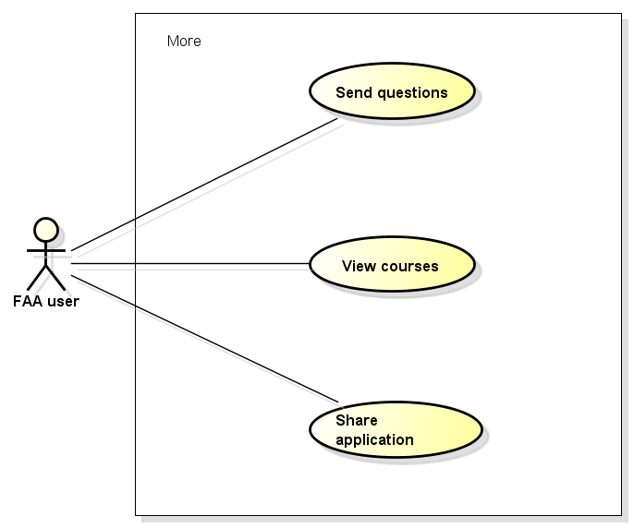

Figure 3‑7: More use cases

###### UC0013 - Send questions

|  |  |  |  |  |
| --- | --- | --- | --- | --- |
| Use Case ID | | UC0013 | Version | 1.1 |
| Use Case Name | | Send questions | | |
| Created by: | | AnhND | Date Created: | 24/09/2016 |
| Primary Actor | | FAA user | Secondary Actor |  |
| Description: | | This function allows user to send questions about injuries or send feedback about application | | |
| Preconditions: | | 1. Install First Aid application 2. User launches application 3. User taps on “Thêm” tab in menu bar | | |
| Trigger: | | User taps on “Ý kiến – Hỏi đáp” item | | |
| Post conditions: | | “Ý kiến – Hỏi đáp” screen is displayed to users fill information and send questions. | | |
| Normal Flow | | | | |
| Step | Actor | Action | | |
| 1 | FAA user | Taps on “Ý kiến – Hỏi đáp” item | | |
| 2 | FAA | Show “Ý kiến – Hỏi đáp” screen, include: - User name edit box - Email edit box - Title radio box - Content edit box | | |
| 3 | FAA  user | Fill information to name, mail, content edit box and choose radio box | | |
| 4 | FAA user | Tap “Gửi” button | | |
| 5 | FAA | Send question | | |
| Alternative Flows: | | | | |
| **AT1** | At step 2 in the main flows, if user taps on Back buttons. | | | |
| Step | Actor | Action | | |
| 2.1 | FAA | Redirects user to More screen | | |
| Exceptions: | | | | |
| **EC1** | At step 2 in the main flows, if required edit box are not entered | | | |
| Step | Actor | Action | | |
| 4.1 | FAA | Notify error message “Chưa nhập tên”, “Chưa nhập mail”, “Chưa nhập nội dung” | | |
| **EC2** | At step 2 in the main flows, if mail text box are entered with wrong type of data | | | |
| Step | Actor | Action | | |
| 4.1 | FAA | Notify error message “Sai định dạng email” | | |
| Priority | | High | | |
| Frequency of Use: | | High | | |
| Business Rules: | | B1, B2, B3 | | |
| Other Information: | | N/A | | |

Table 3‑19: Send questions.

###### UC0014 - View course

|  |  |  |  |  |
| --- | --- | --- | --- | --- |
| Use Case ID | | UC0014 | Version | 1.1 |
| Use Case Name | | View course | | |
| Created by: | | AnhND | Date Created: | 24/09/2016 |
| Primary Actor | | FAA user | Secondary Actor |  |
| Description: | | This function allows user to view first aid courses are organized by the 115 Hanoi center. | | |
| Preconditions: | | 1. Install First Aid application 2. User launches application 3. User taps on “Thêm” tab in menu bar | | |
| Trigger: | | User taps on “Khóa học sơ cấp cứu” item | | |
| Post conditions: | | The information about first aid courses are displayed in Courses screen. | | |
| Normal Flow | | | | |
| Step | Actor | Action | | |
| 1 | FAA user | Tap on “Khóa học sơ cấp cứu” item | | |
| 2 | FAA | Show the The information about first aid courses | | |
| Alternative Flows: | | | | |
| **AT1** | At step 2 in the main flows, if user taps on Back buttons. | | | |
| Step | Actor | Action | | |
| 2.1 | FAA | Redirects user to More screen | | |
| Exceptions: N/A | | | | |
| Priority | | High | | |
| Frequency of Use: | | High | | |
| Business Rules: | |  | | |
| Other Information: | | N/A | | |

Table 3‑20: View course.

###### UC0015 - Share application

|  |  |  |  |  |
| --- | --- | --- | --- | --- |
| Use Case ID | | UC0015 | Version | 1.1 |
| Use Case Name | | Share application | | |
| Created by: | | AnhND | Date Created: | 24/09/2016 |
| Primary Actor | | FAA user | Secondary Actor |  |
| Description: | | This function allows user to share the application through third party applications. | | |
| Preconditions: | | 1. Install First Aid application 2. User launches application 3. User taps on “Thêm” tab in menu bar | | |
| Trigger: | | User taps on “Chia sẻ” item | | |
| Post conditions: | | The application is shared to third party applications. | | |
| Normal Flow | | | | |
| Step | Actor | Action | | |
| 1 | FAA user | Tap on “Chia sẻ” item | | |
| 2 | FAA | Show list of third party applications to share: - Facebook - Message - Zalo - … | | |
| 3 | FAA user | Tap on any third party application | | |
| 4 | FAA user | Tap on Post button | | |
| 5 | FAA | Share FAA to this third party application | | |
| Alternative Flows: N/A | | | | |
| Exceptions: N/A | | | | |
| Priority | | High | | |
| Frequency of Use: | | High | | |
| Business Rules: | |  | | |
| Other Information: | | N/A | | |

Table 3‑21: Share application.

##### Setting Module

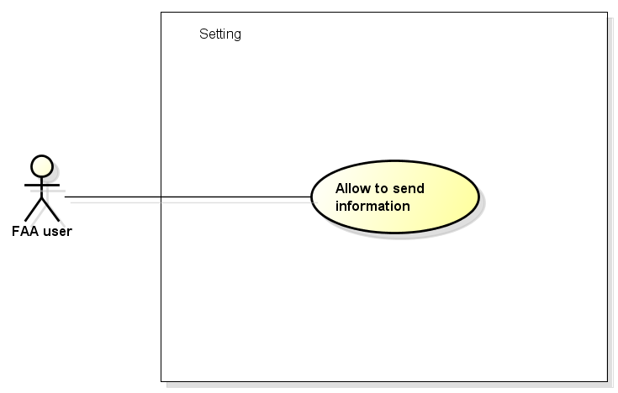

Figure 3‑8: Setting use case

###### UC0016 - Allow to send information

|  |  |  |  |  |
| --- | --- | --- | --- | --- |
| Use Case ID | | UC0016 | Version | 1.1 |
| Use Case Name | | Allow to send information | | |
| Created by: | | AnhND | Date Created: | 24/09/2016 |
| Primary Actor | | FAA user | Secondary Actor |  |
| Description: | | This function allows user to choose that send or not their information include coordinates and phone number to 115 Dispatcher application. | | |
| Preconditions: | | 1. Install First Aid application 2. User launches application 3. User taps on “Cài đặt” tab in menu bar | | |
| Trigger: | | 1. “Đồng ý gửi” switch in “Cài đặt” tab is on 2. User enters their phone number in “Nhập số điện thoại” item and tap OK button | | |
| Post conditions: | | The user’s information include coordinates and phone number will be sent when user calls 115 | | |
| Normal Flow | | | | |
| Step | Actor | Action | | |
| 1 | FAA user | Tap on “Nhập số điện thoại” item | | |
| 2 | FAA | Show “Nhập số điện thoại” | | |
| 3 | FAA user | Enter phone number to | | |
| 4 | FAA user | Tap OK button | | |
| Alternative Flows: N/A | | | | |
| Exceptions: N/A | | | | |
| Priority | | High | | |
| Frequency of Use: | | High | | |
| Business Rules: | |  | | |
| Other Information: | | N/A | | |

Table 3‑22: Allow to send information.

#### Ambulance Application

##### Common Module

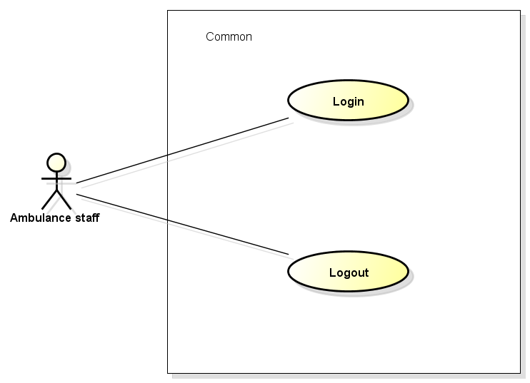

Figure 3‑9: Common use case

###### UC0018 - Login

|  |  |  |  |  |
| --- | --- | --- | --- | --- |
| Use Case ID | | UC0018 | Version | 1.1 |
| Use Case Name | | Login | | |
| Created by: | | AnhND | Date Created: | 25/09/2016 |
| Primary Actor | | Ambulance staff | Secondary Actor |  |
| Description: | | This function allows ambulance staff login to Ambulance application to do tasks. | | |
| Preconditions: | | 1. Install Ambulance application 2. Ambulance staff launches application 3. Mobile device has Network 4. Ambulance staff was provide an account | | |
| Trigger: | | Ambulance staff enters username and password correctly in Login screen | | |
| Post conditions: | | 1. Ambulance staff login to application successful 2. Waiting screen is displayed | | |
| **Normal Flow** | | | | |
| Step | Actor | Action | | |
| 1 | Staff | Launch application | | |
| 2 | AMBA | Display Login screen with following fields: - User name - Password - Login button | | |
| 3 | Staff | Enter user name & password into User name & Password fields | | |
| 4 | Staff | Tap on Login button | | |
| 5 | AMBA | Validate the entered user name & password | | |
| 6 | AMBA | Display Waiting screen | | |
| Alternative Flows: N/A | | | | |
| Exceptions: | | | | |
| **EC1** | At step 3 in the main flows, if required edit box are not entered | | | |
| Step | Actor | Action | | |
| 3.1 | AMBA | Notify error message “Chưa nhập tên”, “Chưa nhập mật khẩu” | | |
| Priority | | High | | |
| Frequency of Use: | | High | | |
| Business Rules: | | B1, B2 | | |
| Other Information: | | N/A | | |

Table 3‑23: Login

###### UC0019 - Logout

|  |  |  |  |  |
| --- | --- | --- | --- | --- |
| Use Case ID | | UC0019 | Version | 1.1 |
| Use Case Name | | Logout | | |
| Created by: | | AnhND | Date Created: | 25/09/2016 |
| Primary Actor | | Ambulance staff | Secondary Actor |  |
| Description: | | This function allows ambulance staff logout to Ambulance application | | |
| Preconditions: | | 1. Install Ambulance application 2. Staff logged in to application | | |
| Trigger: | | User click Logout button in item menu | | |
| Post conditions: | | 1. Log staff out from application. 2. Redirect staff to login screen | | |
| Normal Flow | | | | |
| Step | Actor | Action | | |
| 1 | Staff | Tap on Logout button | | |
| 2 | AMBA | Redirect to login screen | | |
| Alternative Flows: N/A | | | | |
| Exceptions: N/A | | | | |
| Priority | | High | | |
| Frequency of Use: | | High | | |
| Business Rules: | |  | | |
| Other Information: | | N/A | | |

Table 3‑24: Logout.

##### Task Module

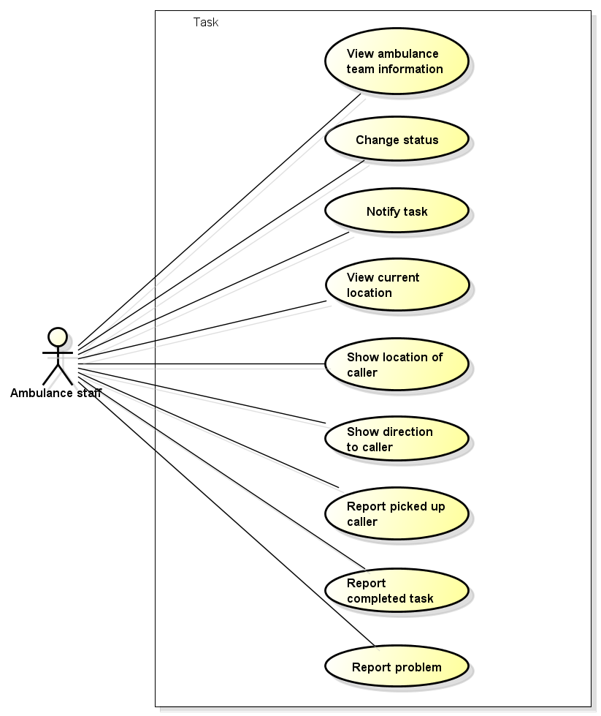

Figure 3‑10: Task use case

###### UC0020 - View ambulance team information

|  |  |  |  |  |
| --- | --- | --- | --- | --- |
| Use Case ID | | UC0020 | Version | 1.1 |
| Use Case Name | | View ambulance team information | | |
| Created by: | | AnhND | Date Created: | 25/09/2016 |
| Primary Actor | | Ambulance staff | Secondary Actor |  |
| Description: | | This function allows ambulance staff to view the information of ambulance team | | |
| Preconditions: | | Install Ambulance application | | |
| Trigger: | | Staff logged in to application | | |
| Post conditions: | | The information of ambulance team is displayed in waiting screen | | |
| Normal Flow | | | | |
| Step | Actor | Action | | |
| 1 | Staff | Login to application | | |
| 2 | AMBA | Show ambulance team information | | |
| Alternative Flows: N/A | | | | |
| Exceptions: N/A | | | | |
| Priority | | High | | |
| Frequency of Use: | | High | | |
| Business Rules: | |  | | |
| Other Information: | | N/A | | |

Table 3‑25: View ambulance team information.

###### UC0021 - Change status

|  |  |  |  |  |
| --- | --- | --- | --- | --- |
| Use Case ID | | UC0021 | Version | 1.1 |
| Use Case Name | | Change status | | |
| Created by: | | AnhND | Date Created: | 25/09/2016 |
| Primary Actor | | Ambulance staff | Secondary Actor |  |
| Description: | | This function allows ambulance staff to change status of ambulance | | |
| Preconditions: | | 1. Install Ambulance application 2. Staff logged in to application | | |
| Trigger: | | Staff taps on “Sẵn sàng” switch | | |
| Post conditions: | | Ready status is changed to Not ready status, waiting screen is dimmed and ambulance does not to receive task | | |
| Normal Flow | | | | |
| Step | Actor | Action | | |
| 1 | Staff | Tap on “Sẵn sàng” switch in waiting screen | | |
| 2 | AMBA | Ready status is changed to Not ready status | | |
| 3 | AMBA | Waiting screen is dimmed | | |
| 4 | AMBA | Does not to receive task | | |
| Alternative Flows: | | | | |
| **AT1** | At step 3 in the main flows, if user taps again on switch. | | | |
| Step | Actor | Action | | |
| 3.1 | AMBA | Not ready status is changed to Ready status | | |
| 3.2 | AMBA | Waiting screen lights up | | |
| 3.3 | AMBA | Ready to receive task | | |
| Exceptions: N/A | | | | |
| Priority | | High | | |
| Frequency of Use: | | High | | |
| Business Rules: | |  | | |
| Other Information: | | N/A | | |

Table 3‑26: Change status.

###### UC0022 - Notify task

|  |  |  |  |  |
| --- | --- | --- | --- | --- |
| Use Case ID | | UC0022 | Version | 1.1 |
| Use Case Name | | Notify task | | |
| Created by: | | AnhND | Date Created: | 25/09/2016 |
| Primary Actor | | Ambulance staff | Secondary Actor |  |
| Description: | | This function allows ambulance staff to receive task | | |
| Preconditions: | | 1. Install Ambulance application 2. Staff logged in to application | | |
| Trigger: | | Ambulance staff receive task automatically when dispatcher click button dispatch | | |
| Post conditions: | | Notification about emergency is display on screen | | |
| Normal Flow | | | | |
| Step | Actor | Action | | |
| 1 | Staff | Login to application | | |
| 2 | Dispatcher | Dispatch ambulance | | |
| 3 | AMBA | Show dialog notify task: - “Từ chối/Chấp nhận” button | | |
| Alternative Flows: | | | | |
| **AT1** | At step 3 in the main flows, if staff taps on “Từ chối” button | | | |
| Step | Actor | Action | | |
| 3.1 | AMBA | Dialog notify task disappear | | |
| 3.2 | AMBA | Redirect to waiting screen and auto change status to Not ready | | |
| **AT2** | At step 3 in the main flows, if staff taps on “Chấp nhận” button | | | |
| Step | Actor | Action | | |
| 3.1 | AMBA | Redirect to Task screen | | |
| 3.2 | AMBA | Locate the caller’s location in map and show table “Thông tin” of caller | | |
| Exceptions: N/A | | | | |
| Priority | | High | | |
| Frequency of Use: | | High | | |
| Business Rules: | |  | | |
| Other Information: | | N/A | | |

Table 3‑27: Notify task.

###### UC0023 - View current location

|  |  |  |  |  |
| --- | --- | --- | --- | --- |
| Use Case ID | | UC0023 | Version | 1.1 |
| Use Case Name | | View current location | | |
| Created by: | | AnhND | Date Created: | 25/09/2016 |
| Primary Actor | | Ambulance staff | Secondary Actor |  |
| Description: | | This function allows ambulance staff to locate the ambulance’s location in map | | |
| Preconditions: | | 1. Install Ambulance application 2. Staff accepts task | | |
| Trigger: | | Staff taps on Locate button in Task screen | | |
| Post conditions: | | The current ambulance’s location is displayed in map | | |
| Normal Flow | | | | |
| Step | Actor | Action | | |
| 1 | Staff | Tap on Locate button | | |
| 2 | AMBA | Display the current location of ambulance | | |
| Alternative Flows: | | | | |
| **AT1** | At step 2 in main flow, if staff scrolls in the Map | | | |
| Step | Actor | Action | | |
| 2.1 | AMBA | The Map is moved | | |
| 2.2 | Staff | Tap on Locate button | | |
| 2.3 | AMBA | Return to the current location of ambulance | | |
| Exceptions: N/A | | | | |
| Priority | | High | | |
| Frequency of Use: | | High | | |
| Business Rules: | |  | | |
| Other Information: | | N/A | | |

Table 3‑28: View current location.

###### UC0024 - Show location of caller

|  |  |  |  |  |
| --- | --- | --- | --- | --- |
| Use Case ID | | UC0024 | Version | 1.1 |
| Use Case Name | | Show location of caller | | |
| Created by: | | AnhND | Date Created: | 25/09/2016 |
| Primary Actor | | Ambulance staff | Secondary Actor |  |
| Description: | | This function allows ambulance staff to show the location of caller | | |
| Preconditions: | | 1. Install Ambulance application 2. Staff accepts task 3. Staff scrolls in the Map | | |
| Trigger: | | Ambulance staff taps on Locate caller button | | |
| Post conditions: | | The current location of caller is located | | |
| Normal Flow | | | | |
| Step | Actor | Action | | |
| 1 | Staff | Scroll in the Map | | |
| 2 | Staff | Tap on Locate caller button in table “Thông tin” | | |
| 3 | AMBA | Return to the current location of caller | | |
| Alternative Flows: N/A | | | | |
| Exceptions: N/A | | | | |
| Priority | | High | | |
| Frequency of Use: | | High | | |
| Business Rules: | |  | | |
| Other Information: | | N/A | | |

Table 3‑29: Show location of caller.

###### UC0025 - Show direction to caller

|  |  |  |  |  |
| --- | --- | --- | --- | --- |
| Use Case ID | | UC0025 | Version | 1.1 |
| Use Case Name | | Show direction to caller | | |
| Created by: | | AnhND | Date Created: | 25/09/2016 |
| Primary Actor | | Ambulance staff | Secondary Actor |  |
| Description: | | This function allows ambulance staff to see the direction to caller | | |
| Preconditions: | | 1. Install Ambulance application 2. Staff accepts task | | |
| Trigger: | | Ambulance staff taps on Direct button in table “Thông tin” | | |
| Post conditions: | | The direction from ambulance to caller is displayed | | |
| Normal Flow | | | | |
| Step | Actor | Action | | |
| 1 | Staff | Tap on Direct button in table “Thông tin” | | |
| 2 | AMBA | Show the direction to caller | | |
| Alternative Flows: N/A | | | | |
| Exceptions: N/A | | | | |
| Priority | | High | | |
| Frequency of Use: | | High | | |
| Business Rules: | |  | | |
| Other Information: | | N/A | | |

Table 3‑30: Show direction to caller.

###### UC0026 - Report picked up caller

|  |  |  |  |  |
| --- | --- | --- | --- | --- |
| Use Case ID | | UC0026 | Version | 1.1 |
| Use Case Name | | Report picked up caller | | |
| Created by: | | AnhND | Date Created: | 25/09/2016 |
| Primary Actor | | Ambulance staff | Secondary Actor |  |
| Description: | | This function allows ambulance staff to report when picked up caller to dispatcher | | |
| Preconditions: | | 1. Install Ambulance application 2. Staff accepts task | | |
| Trigger: | | Ambulance staff taps on Picked up button in table “Thông tin” | | |
| Post conditions: | | Dialog confirm to picked up caller is displayed and send report to dispatcher | | |
| Normal Flow | | | | |
| Step | Actor | Action | | |
| 1 | Staff | Tap on Pickep up botton in table “Thông tin” | | |
| 2 | AMBA | Show dialog confirm to picked up caller: - “Hủy/Ok” button | | |
| 3 | Staff | Tap on Ok button | | |
| 4 | AMBA | Dialog confirm is disappeared and send report to dispatcher | | |
| Alternative Flows: | | | | |
| **AT1** | At step 2 in main flow, if staff taps on “Hủy” button | | | |
| Step | Actor | Action | | |
| 2.1 | AMBA | Dialog confirm is disappeared and not send report to dispatcher | | |
| Exceptions: N/A | | | | |
| Priority | | High | | |
| Frequency of Use: | | High | | |
| Business Rules: | |  | | |
| Other Information: | | N/A | | |

Table 3‑31: Report picked up caller.

###### UC0027 - Report completed task

|  |  |  |  |  |
| --- | --- | --- | --- | --- |
| Use Case ID | | UC0027 | Version | 1.1 |
| Use Case Name | | Report completed task | | |
| Created by: | | AnhND | Date Created: | 25/09/2016 |
| Primary Actor | | Ambulance staff | Secondary Actor |  |
| Description: | | This function allows ambulance staff to report when completed task to dispatcher | | |
| Preconditions: | | 1. Install Ambulance application 2. Staff accepts task | | |
| Trigger: | | Ambulance staff taps on “Kết thúc” button | | |
| Post conditions: | | Dialog “Kết thúc nhiệm vụ” is displayed | | |
| Normal Flow | | | | |
| Step | Actor | Action | | |
| 1 | Staff | Tap on “Kết thúc” button | | |
| 2 | AMBA | Show dialog “Kết thúc nhiệm vụ”, content includes: - Checkbox: “Sẵn sàng làm nhiệm vụ tiếp theo”, default checked - No / Yes button | | |
| Alternative Flows: | | | | |
| **AT1** | At step 2 in main flow, if staff unchecks and taps on Yes button | | | |
| Step | Actor | Action | | |
| 2.1 | AMBA | Redirect to waiting screen, auto Not Ready status, waiting screen is dimmed | | |
| **AT2** | At step 2 in main flow, if staff checks and taps on Yes button | | | |
| Step | Actor | Action | | |
| 2.1 | AMBA | Redirect to waiting screen, auto Ready status, waiting screen lights up | | |
| **AT3** | At step 2 in main flow, if staff taps on No button | | | |
| Step | Actor | Action | | |
| 2.1 | AMBA | Dialog “Kết thúc nhiệm vụ” is disappeared, task is continued | | |
| Exceptions: N/A | | | | |
| Priority | | High | | |
| Frequency of Use: | | High | | |
| Business Rules: | |  | | |
| Other Information: | | N/A | | |

Table 3‑32: Report completed task.

###### UC0028 - Report problem

|  |  |  |  |  |
| --- | --- | --- | --- | --- |
| Use Case ID | | UC0028 | Version | 1.1 |
| Use Case Name | | Report problem | | |
| Created by: | | AnhND | Date Created: | 25/09/2016 |
| Primary Actor | | Ambulance staff | Secondary Actor |  |
| Description: | | This function allows ambulance staff to report that they have problem to dispatcher | | |
| Preconditions: | | 1. Install Ambulance application 2. Staff accepts task | | |
| Trigger: | | Ambulance staff taps on “Báo sự cố” button | | |
| Post conditions: | | Make a call to the hotline of dispatcher | | |
| Normal Flow | | | | |
| Step | Actor | Action | | |
| 1 | Staff | Tap on “Báo sự cố” button | | |
| 2 | AMBA | Call to the hotline of dispatcher | | |
| Alternative Flows: N/A | | | | |
| Exceptions: N/A | | | | |
| Priority | | High | | |
| Frequency of Use: | | High | | |
| Business Rules: | |  | | |
| Other Information: | | N/A | | |

Table 3‑33: Report problem.

##### Information Module.

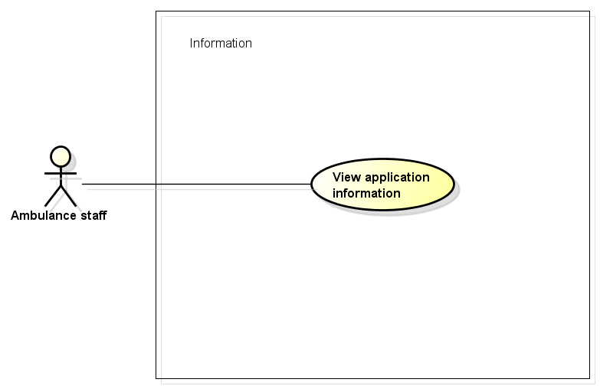

Figure 3‑11: Information use case

###### UC0029 - View application information

|  |  |  |  |  |
| --- | --- | --- | --- | --- |
| Use Case ID | | UC0029 | Version | 1.1 |
| Use Case Name | | View application information | | |
| Created by: | | AnhND | Date Created: | 25/09/2016 |
| Primary Actor | | Ambulance staff | Secondary Actor |  |
| Description: | | This function allows ambulance staff to view the application information include terms of use, version of app, member of develop team. | | |
| Preconditions: | | 1. Install Ambulance application 2. Ambulance staff launches application | | |
| Trigger: | | Ambulance staff taps on “Thông tin phần mềm” item in item menu | | |
| Post conditions: | | All information about AMBA will be displayed on information screen | | |
| Normal Flow | | | | |
| Step | Actor | Action | | |
| 1 | Staff | Tap on “Thông tin phần mềm” item in item menu | | |
| 2 | AMBA | Show information about AMBA include: - Terms of use - Version - Develop team | | |
| Alternative Flows: N/A | | | | |
| Exceptions: N/A | | | | |
| Priority | | High | | |
| Frequency of Use: | | High | | |
| Business Rules: | |  | | |
| Other Information: | | N/A | | |

Table 3‑34: View application information.

#### Dispatcher Application

##### Common Module

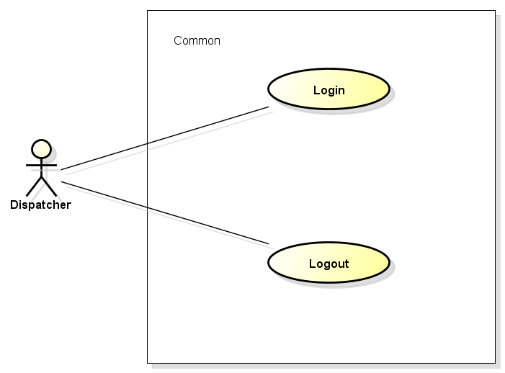

Figure 3‑12: Common use case

###### UC0030 - Login

|  |  |  |  |  |
| --- | --- | --- | --- | --- |
| Use Case ID | | UC0030 | Version | 1.1 |
| Use Case Name | | Login | | |
| Created by: | | AnhND | Date Created: | 26/09/2016 |
| Primary Actor | | Dispatcher | Secondary Actor |  |
| Description: | | This function allows dispatcher login to Dispatcher web application to do tasks. | | |
| Preconditions: | | 1. Dispatcher web app is available 2. Dispatcher access Dispatcher web site 3. Dispatcher was provide an account | | |
| Trigger: | | Dispatcher enters username and password correctly in Login page | | |
| Post conditions: | | 1. Dispatcher login to web application successful 2. Main screen is displayed | | |
| Normal Flow | | | | |
| Step | Actor | Action | | |
| 1 | Dispatcher | Access to Dispatcher web site | | |
| 2 | DPA | Display Login page with following fields: - User name - Password - Login button | | |
| 3 | Dispatcher | Enter user name & password into User name & Password fields | | |
| 4 | Dispatcher | Tap on Login button | | |
| 5 | DPA | Validate the entered user name & password | | |
| 6 | DPA | Display main screen, order from left to right: - “Điều phối” slidebar - Map - “Trường hợp khẩn cấp” slidebar, include: + “Đội cứu thương” tab + “Đang đợi” tab | | |
| Alternative Flows: N/A | | | | |
| Exceptions: N/A | | | | |
| **EC1** | At step 3 in the main flows, if required text box are not entered | | | |
| Step | Actor | Action | | |
| 3.1 | DPA | Notify error message “Chưa nhập tên” or “Chưa nhập mật khẩu” | | |
| **EC2** | At step 3 in the main flows, if user entered wrong User name or Password | | | |
| Step | Actor | Action | | |
| 3.1 | DPA | Notify error message “Nhập sai tên” or “Nhập sai mật khẩu” | | |
| Priority | | High | | |
| Frequency of Use: | | High | | |
| Business Rules: | |  | | |
| Other Information: | | N/A | | |

Table 3‑35: Login.

###### UC0031 - Logout

|  |  |  |  |  |
| --- | --- | --- | --- | --- |
| Use Case ID | | UC0031 | Version | 1.1 |
| Use Case Name | | Logout | | |
| Created by: | | AnhND | Date Created: | 26/09/2016 |
| Primary Actor | | Dispatcher | Secondary Actor |  |
| Description: | | This function allows dispatcher logout to web site | | |
| Preconditions: | | 1. Dispatcher web app is available 2. Dispatcher access Dispatcher web site 3. Dispatcher logged in to web site | | |
| Trigger: | | Dispatcher click Logout button in item menu | | |
| Post conditions: | | 1. Log dispatcher out from web site. 2. Redirect dispatcher to login page. | | |
| Normal Flow | | | | |
| Step | Actor | Action | | |
| 1 | Dispatcher | Tap on Logout button | | |
| 2 | DPA | Redirect to login page | | |
| Alternative Flows: N/A | | | | |
| Exceptions: N/A | | | | |
| Priority | | High | | |
| Frequency of Use: | | High | | |
| Business Rules: | |  | | |
| Other Information: | | N/A | | |

Table 3‑36: Logout.

##### Dispatch Module

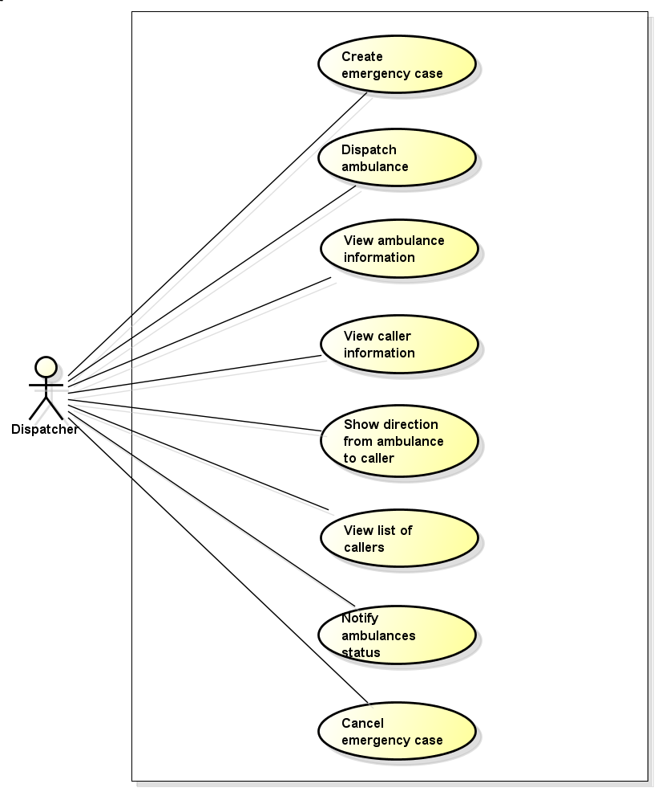

Figure 3‑13: Dispatch use case

###### UC0032 - Create emergency case

|  |  |  |  |  |
| --- | --- | --- | --- | --- |
| Use Case ID | | UC0032 | Version | 1.1 |
| Use Case Name | | Create emergency case | | |
| Created by: | | AnhND | Date Created: | 26/09/2016 |
| Primary Actor | | Dispatcher | Secondary Actor |  |
| Description: | | This function allows dispatcher create an emergency case need to ambulance | | |
| Preconditions: | | 1. Dispatcher web app is available 2. Dispatcher access Dispatcher web site 3. Dispatcher logged in to web site | | |
| Trigger: | | Dispatcher receives an emergency call from user uses First Aid application and has their information include coordinates and phone number. | | |
| Post conditions: | | User’s information is entered in “Điều phối” | | |
| Normal Flow | | | | |
| Step | Actor | Action | | |
| 1 | Dispatcher | Receive an emergency call from FAA user | | |
| 2 | DPA | Fill coordinates and phone number to “Điều phối” | | |
| 3 | Dispatcher | Enter victim’s status | | |
| Alternative Flows: N/A | | | | |
| Exceptions: N/A | | | | |
| Priority | | High | | |
| Frequency of Use: | | High | | |
| Business Rules: | |  | | |
| Other Information: | | N/A | | |

Table 3‑37: Create emergency case.

###### UC0033 - Dispatch ambulance

|  |  |  |  |  |
| --- | --- | --- | --- | --- |
| Use Case ID | | UC0033 | Version | 1.1 |
| Use Case Name | | Dispatch ambulance | | |
| Created by: | | AnhND | Date Created: | 26/09/2016 |
| Primary Actor | | Dispatcher | Secondary Actor |  |
| Description: | | This function allows dispatcher to dispatch an ambulance for emergency case | | |
| Preconditions: | | 1. Dispatcher web app is available 2. Dispatcher access Dispatcher web site 3. Dispatcher logged in to web site 4. Created an emergency case | | |
| Trigger: | | Dispatcher clicks on “Điều phôi xe” button | | |
| Post conditions: | | Dispatcher system will automatically choose the nearest available ambulance and dispatch to caller | | |
| Normal Flow | | | | |
| Step | Actor | Action | | |
| 1 | Dispatcher | Click on “Điều phối xe” button | | |
| 2 | DPA | Send notify task to the nearest available ambulance | | |
| Alternative Flows: N/A | | | | |
| Exceptions: N/A | | | | |
| Priority | | High | | |
| Frequency of Use: | | High | | |
| Business Rules: | |  | | |
| Other Information: | | N/A | | |

Table 3‑38: Dispatch ambulance.

###### UC0034 - View ambulance information

|  |  |  |  |  |
| --- | --- | --- | --- | --- |
| Use Case ID | | UC0034 | Version | 1.1 |
| Use Case Name | | View ambulance information | | |
| Created by: | | AnhND | Date Created: | 26/09/2016 |
| Primary Actor | | Dispatcher | Secondary Actor |  |
| Description: | | This function allows dispatcher to view the information of ambulance team include name, current location and status. | | |
| Preconditions: | | 1. Dispatcher web app is available 2. Dispatcher access Dispatcher web site | | |
| Trigger: | | Dispatcher logged in to web site | | |
| Post conditions: | | The information of ambulance team is displayed in “Đội cứu thương” tab in “Trường hợp khẩn cấp” slidebar | | |
| Normal Flow | | | | |
| Step | Actor | Action | | |
| 1 | Dispatcher | Login to web site | | |
| 2 | DPA | Show the information of ambulance team in “Đội cứu thương” tab | | |
| Alternative Flows: N/A | | | | |
| Exceptions: N/A | | | | |
| Priority | | High | | |
| Frequency of Use: | | High | | |
| Business Rules: | |  | | |
| Other Information: | | N/A | | |

Table 3‑39: View ambulance information.

###### UC0035 - View caller information

|  |  |  |  |  |
| --- | --- | --- | --- | --- |
| Use Case ID | | UC0035 | Version | 1.1 |
| Use Case Name | | View caller information | | |
| Created by: | | AnhND | Date Created: | 26/09/2016 |
| Primary Actor | | Dispatcher | Secondary Actor |  |
| Description: | | This function allows dispatcher to view the information of caller include phone number, injury status, location when they called. | | |
| Preconditions: | | 1. Dispatcher web app is available 2. Dispatcher access Dispatcher web site 3. Dispatcher logged in to web site 4. At least one emergency case is pending ambulance | | |
| Trigger: | | Dispatcher clicks on an emergency case is displayed in map | | |
| Post conditions: | | The information of caller is filled to text box in “Điều phối” slidebar | | |
| Normal Flow | | | | |
| Step | Actor | Action | | |
| 1 | Dispatcher | Click on an emergency case in map | | |
| 2 | DPA | Fill the information of caller to text box in “Điều phối” slidebar | | |
| Alternative Flows: N/A | | | | |
| Exceptions: N/A | | | | |
| Priority | | High | | |
| Frequency of Use: | | High | | |
| Business Rules: | |  | | |
| Other Information: | | N/A | | |

Table 3‑40: View caller information.

###### UC0036 - Show direction from ambulance to caller

|  |  |  |  |  |
| --- | --- | --- | --- | --- |
| Use Case ID | | UC0036 | Version | 1.1 |
| Use Case Name | | Show direction from ambulance to caller | | |
| Created by: | | AnhND | Date Created: | 26/09/2016 |
| Primary Actor | | Dispatcher | Secondary Actor |  |
| Description: | | This function allows dispatcher to show the direction from dispatched ambulance to caller | | |
| Preconditions: | | 1. Dispatcher web app is available 2. Dispatcher access Dispatcher web site 3. Dispatcher logged in to web site 4. At least one emergency case is pending ambulance | | |
| Trigger: | | Dispatcher clicks on an busy ambulance in “Đội cứu thương” tab | | |
| Post conditions: | | The direction from this dispatched ambulance to caller is displayed | | |
| Version | | | | |
| Version | Version | Version | | |
| 1 | Dispatcher | Clicks on an busy ambulance in “Đội cứu thương” tab | | |
| 2 | DPA | Show the direction from this ambulance to caller | | |
| Alternative Flows: N/A | | | | |
| Exceptions: N/A | | | | |
| Priority | | High | | |
| Frequency of Use: | | High | | |
| Business Rules: | |  | | |
| Other Information: | | N/A | | |

Table 3‑41: Show direction from ambulance to caller.

###### UC0037 - View list of waiting callers

|  |  |  |  |  |
| --- | --- | --- | --- | --- |
| Use Case ID | | UC0037 | Version | 1.1 |
| Use Case Name | | View list of waiting callers | | |
| Created by: | | AnhND | Date Created: | 26/09/2016 |
| Primary Actor | | Dispatcher | Secondary Actor |  |
| Description: | | This function allows dispatcher to view list of waiting callers | | |
| Preconditions: | | 1. Dispatcher web app is available 2. Dispatcher access Dispatcher web site 3. Dispatcher logged in to web site | | |
| Trigger: | | All ambulance team is busy | | |
| Post conditions: | | Dispatcher clicks on “Đang đợi” tab in “Trường hợp khẩn cấp” slidebar | | |
| Normal Flow | | | | |
| Step | Actor | Action | | |
| 1 | Dispatcher | Clicks on “Đang đợi” tab | | |
| 2 | DPA | Show callers is waiting for ambulance | | |
| Alternative Flows: N/A | | | | |
| Exceptions: N/A | | | | |
| Priority | | High | | |
| Frequency of Use: | | High | | |
| Business Rules: | |  | | |
| Other Information: | | N/A | | |

Table 3‑42: View list of waiting callers.

###### UC0038 - Notify ambulances status

|  |  |  |  |  |
| --- | --- | --- | --- | --- |
| Use Case ID | | UC0038 | Version | 1.1 |
| Use Case Name | | Notify ambulances status | | |
| Created by: | | AnhND | Date Created: | 26/09/2016 |
| Primary Actor | | Dispatcher | Secondary Actor |  |
| Description: | | This function allows dispatcher receives notify when an ambulance change status | | |
| Preconditions: | | 1. Dispatcher web app is available 2. Dispatcher access Dispatcher web site 3. Dispatcher logged in to web site | | |
| Trigger: | | An ambulance report their status for dispatcher | | |
| Post conditions: | | Dispatcher receives notify in main screen | | |
| Normal Flow | | | | |
| Step | Actor | Action | | |
| 1 | Staff | Report or change status | | |
| 2 | DPA | Show notify about status in main screen | | |
| Alternative Flows: N/A | | | | |
| Exceptions: N/A | | | | |
| Priority | | High | | |
| Frequency of Use: | | High | | |
| Business Rules: | |  | | |
| Other Information: | | N/A | | |

Table 3‑43: Notify ambulances status.

###### UC0039 - Cancel emergency case

|  |  |  |  |  |
| --- | --- | --- | --- | --- |
| Use Case ID | | UC0039 | Version | 1.1 |
| Use Case Name | | Cancel emergency case | | |
| Created by: | | AnhND | Date Created: | 26/09/2016 |
| Primary Actor | | Dispatcher | Secondary Actor |  |
| Description: | | This function allows dispatcher cancel an emergency case when the caller doesn’t need ambulance | | |
| Preconditions: | | 1. Dispatcher web app is available 2. Dispatcher access Dispatcher web site 3. Dispatcher logged in to web site | | |
| Trigger: | | Dispatcher clicks on caller who doesn’t need ambulance and click “Hủy” | | |
| Post conditions: | | The emergency case is canceled | | |
| Normal Flow | | | | |
| Step | Actor | Action | | |
| 1 | Dispatcher | Clicks on caller | | |
| 2 | DPA | Fill the information of caller to text box in “Điều phối” slidebar | | |
| 3 | Dispatcher | Click “Hủy” | | |
| 4 | DPA | Cancel emergency case | | |
| Alternative Flows: N/A | | | | |
| Exceptions: N/A | | | | |
| Priority | | High | | |
| Frequency of Use: | | High | | |
| Business Rules: | |  | | |
| Other Information: | | N/A | | |

Table 3‑44: Cancel emergency case.

#### Admin/Expert Application

##### Common Module

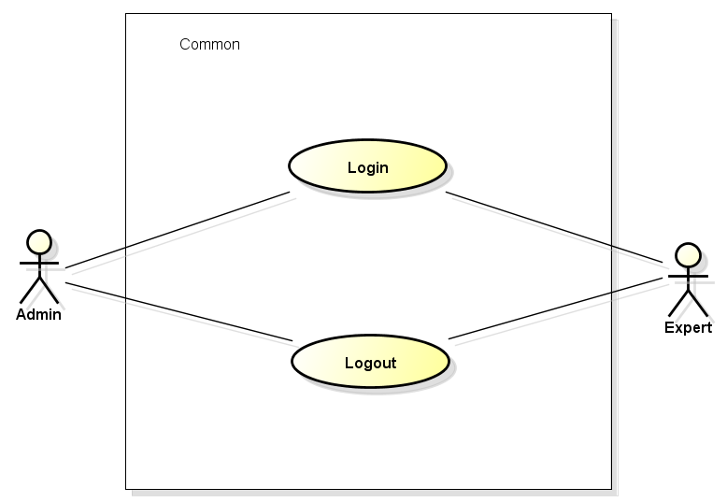

Figure 3‑14: Common use case

###### UC0040 - Login

|  |  |  |  |  |  |
| --- | --- | --- | --- | --- | --- |
| Use Case ID | | | UC0040 | Version | 1.1 |
| Use Case Name | | | Login | | |
| Created by: | | | AnhND | Date Created: | 27/09/2016 |
| Primary Actor | | | Admin/Expert | Secondary Actor |  |
| Description: | | | This function allows admin or expert login to Admin/Expert web application to do tasks. | | |
| Preconditions: | | | 1. Admin/Expert web app is available 2. Admin or expert access Admin/Expert web site 3. Expert was provide an account | | |
| Trigger: | | | Admin/Expert enters username and password correctly in Login page | | |
| Post conditions: | | | 1. Admin or expert login to web application successful 2. Main screen is displayed | | |
| Normal Flow | | | | | |
| Step | Actor | | Action | | |
| 1 | Admin/Expert | | Access to Admin/Expert web site | | |
| 2 | AEA | | Display Login page with following fields: - User name - Password - Login button | | |
| 3 | Admin/Expert | | Enter user name & password into User name & Password fields | | |
| 4 | Admin/Expert | | Tap on Login button | | |
| 5 | AEA | | Validate the entered user name & password | | |
| 6 | AEA | | Display main screen | | |
| Alternative Flows: N/A | | | | | |
| Exceptions: N/A | | | | | |
| **EC1** | | At step 3 in the main flows, if required text box are not entered | | | |
| Step | | Actor | Action | | |
| 3.1 | | AEA | Notify error message “Chưa nhập tên” or “Chưa nhập mật khẩu” | | |
| **EC2** | | At step 3 in the main flows, if user entered wrong User name or Password | | | |
| Step | | Actor | Action | | |
| 3.1 | | AEA | Notify error message “Nhập sai tên” or “Nhập sai mật khẩu” | | |
| Priority | | | High | | |
| Frequency of Use: | | | High | | |
| Business Rules: | | |  | | |
| Other Information: | | | N/A | | |

Table 3‑45: Login.

###### UC0041 - Logout

|  |  |  |  |  |
| --- | --- | --- | --- | --- |
| Use Case ID | | UC0041 | Version | 1.1 |
| Use Case Name | | Logout | | |
| Created by: | | AnhND | Date Created: | 27/09/2016 |
| Primary Actor | | Admin/Expert | Secondary Actor |  |
| Description: | | This function allows Admin or expert logout to web site | | |
| Preconditions: | | 1. Admin/Expert web app is available 2. Admin or expert access Admin/Expert web site 3. Expert was provide an account | | |
| Trigger: | | Admin or expert click Logout button in item menu | | |
| Post conditions: | | 1. Log Admin or expert out from web site. 2. Redirect Admin or expert to login page. | | |
| Normal Flow | | | | |
| Step | Actor | Action | | |
| 1 | Admin or expert | Tap on Logout button | | |
| 2 | AEA | Redirect to login page | | |
| Alternative Flows: N/A | | | | |
| Exceptions: N/A | | | | |
| Priority | | High | | |
| Frequency of Use: | | High | | |
| Business Rules: | |  | | |
| Other Information: | | N/A | | |

Table 3‑46: Logout.

##### Manage user's account Module

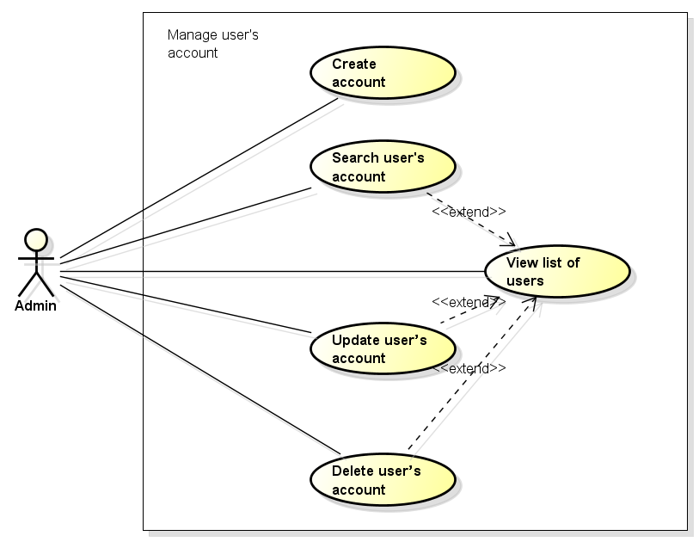

Figure 3‑15: Manage user's account use cases

###### UC0042 - Create account

|  |  |  |  |  |
| --- | --- | --- | --- | --- |
| Use Case ID | | UC0042 | Version | 1.1 |
| Use Case Name | | Create account | | |
| Created by: | | AnhND | Date Created: | 27/09/2016 |
| Primary Actor | | Admin | Secondary Actor |  |
| Description: | | This function allows admin to create user’s account | | |
| Preconditions: | | 1. Admin/Expert web app is available 2. Admin access Admin/Expert web site 3. Admin clicks on “Thêm người dùng” page | | |
| Trigger: | | Admin clicks on “Thêm người dùng” button | | |
| Post conditions: | | New user’s account is created | | |
| Normal Flow | | | | |
| Step | Actor | Action | | |
| 1 | Admin | Click on “Thêm người dùng” page | | |
| 2 | AEA | “Thêm người dùng” page is displayed | | |
| 3 | Admin | Enter all information about user: - Name - Role - Phone number - Address - User name - Password | | |
| 4 | Admin | Click on “Thêm người dùng” button | | |
| Alternative Flows: N/A | | | | |
| Exceptions: N/A | | | | |
| Priority | | High | | |
| Frequency of Use: | | High | | |
| Business Rules: | |  | | |
| Other Information: | | N/A | | |

Table 3‑47: Create account.

###### UC0043 - View list of users

|  |  |  |  |  |
| --- | --- | --- | --- | --- |
| Use Case ID | | UC0043 | Version | 1.1 |
| Use Case Name | | View list of users | | |
| Created by: | | AnhND | Date Created: | 27/09/2016 |
| Primary Actor | | Admin | Secondary Actor |  |
| Description: | | This function allows admin to view list of users in the system | | |
| Preconditions: | | 1. Admin/Expert web app is available 2. Admin access Admin/Expert web site | | |
| Trigger: | | Admin clicks on “Người dùng” tab in slidebar left | | |
| Post conditions: | | List of all users is displayed in main screen | | |
| Normal Flow | | | | |
| Step | Actor | Action | | |
| 1 | Admin | Click on “Người dùng” tab | | |
| 2 | AEA | Show list of all users | | |
| Alternative Flows: N/A | | | | |
| Exceptions: N/A | | | | |
| Priority | | High | | |
| Frequency of Use: | | High | | |
| Business Rules: | |  | | |
| Other Information: | | N/A | | |

Table 3‑48: View list of users.

###### UC0044 - Search user's account

|  |  |  |  |  |
| --- | --- | --- | --- | --- |
| Use Case ID | | UC0044 | Version | 1.1 |
| Use Case Name | | Search user's account | | |
| Created by: | | AnhND | Date Created: | 27/09/2016 |
| Primary Actor | | Admin | Secondary Actor |  |
| Description: | | This function allows admin to search user’s account in the system | | |
| Preconditions: | | 1. Admin/Expert web app is available 2. Admin access Admin/Expert web site | | |
| Trigger: | | Admin enters key word in search box and clicks on “Tìm Kiếm” button | | |
| Post conditions: | | All results that matched with the keyword admin enters will be displayed | | |
| Normal Flow | | | | |
| Step | Actor | Action | | |
| 1 | Admin | Enter key word in search box | | |
| 2 | Admin | Click on “Tìm Kiếm” button | | |
| 3 | AEA | Show all results that matched with the keyword | | |
| Alternative Flows: N/A | | | | |
| Exceptions: N/A | | | | |
| Priority | | High | | |
| Frequency of Use: | | High | | |
| Business Rules: | |  | | |
| Other Information: | | N/A | | |

Table 3‑49: Search user's account.

###### UC0045 - Update user’s account

|  |  |  |  |  |
| --- | --- | --- | --- | --- |
| Use Case ID | | UC0045 | Version | 1.1 |
| Use Case Name | | Update user's account | | |
| Created by: | | AnhND | Date Created: | 27/09/2016 |
| Primary Actor | | Admin | Secondary Actor |  |
| Description: | | This function allows admin to update information of user’s account | | |
| Preconditions: | | 1. Admin/Expert web app is available 2. Admin access Admin/Expert web site 3. Admin clicks on “Người dùng” tab | | |
| Trigger: | | Admin clicks on Edit button, changes information and clicks Ok | | |
| Post conditions: | | The information of user has been changed | | |
| Normal Flow | | | | |
| Step | Actor | Action | | |
| 1 | Admin | Clicks on “Người dùng” tab | | |
| 2 | AEA | Show List of all users | | |
| 3 | Admin | Admin clicks on Edit button | | |
| 4 | AEA | Show update page | | |
| 5 | Admin | Change information | | |
| 6 | Admin | Click Ok button | | |
| 7 | AEA | Update information of users | | |
| Alternative Flows: N/A | | | | |
| Exceptions: N/A | | | | |
| Priority | | High | | |
| Frequency of Use: | | High | | |
| Business Rules: | |  | | |
| Other Information: | | N/A | | |

Table 3‑50: Update user’s account.

###### UC0046 - Delete user’s account

|  |  |  |  |  |
| --- | --- | --- | --- | --- |
| Use Case ID | | UC0046 | Version | 1.1 |
| Use Case Name | | Delete user’s account | | |
| Created by: | | AnhND | Date Created: | 27/09/2016 |
| Primary Actor | | Admin | Secondary Actor |  |
| Description: | | This function allows admin to delete user’s account | | |
| Preconditions: | | 1. Admin/Expert web app is available 2. Admin access Admin/Expert web site 3. Admin clicks on “Người dùng” tab | | |
| Trigger: | | Admin clicks on Delete button | | |
| Post conditions: | | Admin clicks on Ok button | | |
| Normal Flow | | | | |
| Step | Actor | Action | | |
| 1 | Admin | Click on “Người dùng” tab | | |
| 2 | AEA | Show List of all users | | |
| 3 | Admin | Click on Delete button | | |
| 4 | AEA | Show dialog “Bạn có muốn xóa người dùng này” | | |
| 5 | Admin | Click on Ok | | |
| 6 | AEA | Delete user’s account | | |
| Alternative Flows: N/A | | | | |
| Exceptions: N/A | | | | |
| Priority | | High | | |
| Frequency of Use: | | High | | |
| Business Rules: | |  | | |
| Other Information: | | N/A | | |

Table 3‑51: Delete user’s account.

##### Manage Q&A Module

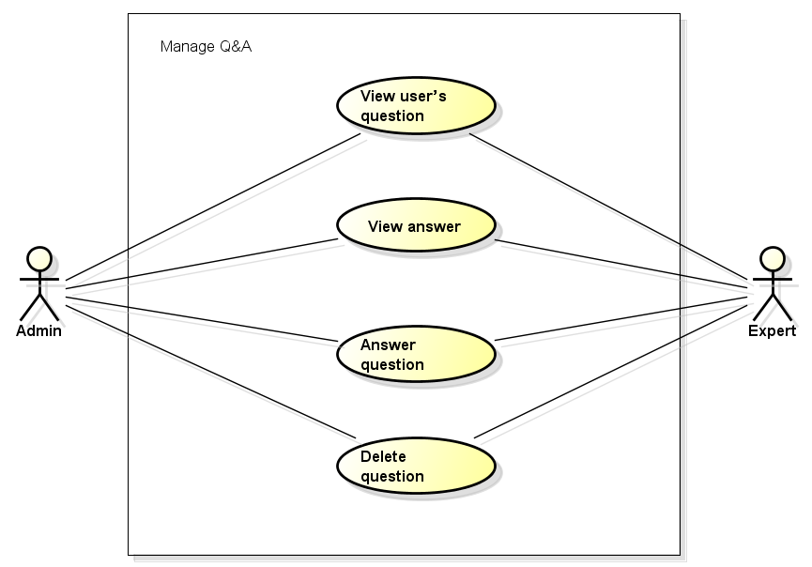

Figure 3‑16: Manage Q&A use cases

###### UC0047 - View user’s question

|  |  |  |  |  |
| --- | --- | --- | --- | --- |
| Use Case ID | | UC0047 | Version | 1.1 |
| Use Case Name | | View user’s question | | |
| Created by: | | AnhND | Date Created: | 27/09/2016 |
| Primary Actor | | Admin/Expert | Secondary Actor |  |
| Description: | | This function allows admin or expert to view all user’s question and feedback | | |
| Preconditions: | | 1. Admin/Expert web app is available 2. Admin or expert access Admin/Expert web site 3. Expert was provide an account | | |
| Trigger: | | Admin or expert clicks on “Hỏi đáp/Ý kiến” tab | | |
| Post conditions: | | Show all question and feedback of users | | |
| Normal Flow | | | | |
| Step | Actor | Action | | |
| 1 | Admin or expert | Click on “Hỏi đáp/Ý kiến” tab | | |
| 2 | AEA | Show all question and feedback | | |
| Alternative Flows: N/A | | | | |
| Exceptions: N/A | | | | |
| Priority | | High | | |
| Frequency of Use: | | High | | |
| Business Rules: | |  | | |
| Other Information: | | N/A | | |

Table 3‑52: View user’s question.

###### UC0048 - View answer

|  |  |  |  |  |
| --- | --- | --- | --- | --- |
| Use Case ID | | UC0048 | Version | 1.1 |
| Use Case Name | | View answer | | |
| Created by: | | AnhND | Date Created: | 27/09/2016 |
| Primary Actor | | Admin/Expert | Secondary Actor |  |
| Description: | | This function allows admin or expert to view answer of other admin or expert | | |
| Preconditions: | | 1. Admin/Expert web app is available 2. Admin or expert access Admin/Expert web site 3. Expert was provide an account 4. Admin or expert clicks on “Hỏi đáp/Ý kiến” tab | | |
| Trigger: | | Admin or expert clicks on an old question or feedback | | |
| Post conditions: | | View answer of this question. | | |
| Normal Flow | | | | |
| Step | Actor | Action | | |
| 1 | Admin or expert | Click on “Hỏi đáp/Ý kiến” tab | | |
| 2 | AEA | Show all question and feedback | | |
| 3 | Admin or expert | Click on an old question or feedback | | |
| 4 | AEA | Show answer of this question | | |
| Alternative Flows: N/A | | | | |
| Exceptions: N/A | | | | |
| Priority | | High | | |
| Frequency of Use: | | High | | |
| Business Rules: | |  | | |
| Other Information: | | N/A | | |

Table 3‑53: View answer.

###### UC0049 - Answer question

|  |  |  |  |  |
| --- | --- | --- | --- | --- |
| Use Case ID | | UC0049 | Version | 1.1 |
| Use Case Name | | Answer question | | |
| Created by: | | AnhND | Date Created: | 27/09/2016 |
| Primary Actor | | Admin/Expert | Secondary Actor |  |
| Description: | | This function allows admin or expert to view answer of other admin or expert | | |
| Preconditions: | | 1. Admin/Expert web app is available 2. Admin or expert access Admin/Expert web site 3. Expert was provide an account 4. Admin or expert clicks on “Hỏi đáp/Ý kiến” tab 5. Admin or expert clicks on an question or feedback | | |
| Trigger: | | Enter content of answer to textbox and click “Trả lời” | | |
| Post conditions: | | The answer is sent to user | | |
| Normal Flow | | | | |
| Step | Actor | Action | | |
| 1 | Admin or expert | Click on “Hỏi đáp/Ý kiến” tab | | |
| 2 | AEA | Show all question and feedback | | |
| 3 | Admin or expert | Click on an question or feedback | | |
| 4 | AEA | Show answer page of this question | | |
| 5 | Admin or expert | Enter content of answer to textbox and | | |
| 6 | Admin or expert | Click “Trả lời” button | | |
| 7 | AEA | Send the answer to user | | |
| Alternative Flows: N/A | | | | |
| Exceptions: N/A | | | | |
| Priority | | High | | |
| Frequency of Use: | | High | | |
| Business Rules: | |  | | |
| Other Information: | | N/A | | |

Table 3‑54: Answer question.

###### UC0050 - Delete question

|  |  |  |  |  |
| --- | --- | --- | --- | --- |
| Use Case ID | | UC0050 | Version | 1.1 |
| Use Case Name | | Delete question | | |
| Created by: | | AnhND | Date Created: | 27/09/2016 |
| Primary Actor | | Admin/Expert | Secondary Actor |  |
| Description: | | This function allows admin or expert to view answer of other admin or expert | | |
| Preconditions: | | 1. Admin/Expert web app is available 2. Admin or expert access Admin/Expert web site 3. Expert was provide an account 4. Admin or expert clicks on “Hỏi đáp/Ý kiến” tab 5. Admin or expert clicks on an question or feedback | | |
| Trigger: | | Admin or expert clicks on Delete button and clicks Ok | | |
| Post conditions: | | An answer is deleted | | |
| Normal Flow | | | | |
| Step | Actor | Action | | |
| 1 | Admin or expert | Click on an question or feedback | | |
| 2 | Admin or expert | Click on Delete button | | |
| 3 | AEA | Delete question | | |
| Alternative Flows: N/A | | | | |
| Exceptions: N/A | | | | |
| Priority | | High | | |
| Frequency of Use: | | High | | |
| Business Rules: | |  | | |
| Other Information: | | N/A | | |

Table 3‑55: Delete question.

##### Manage injury Module

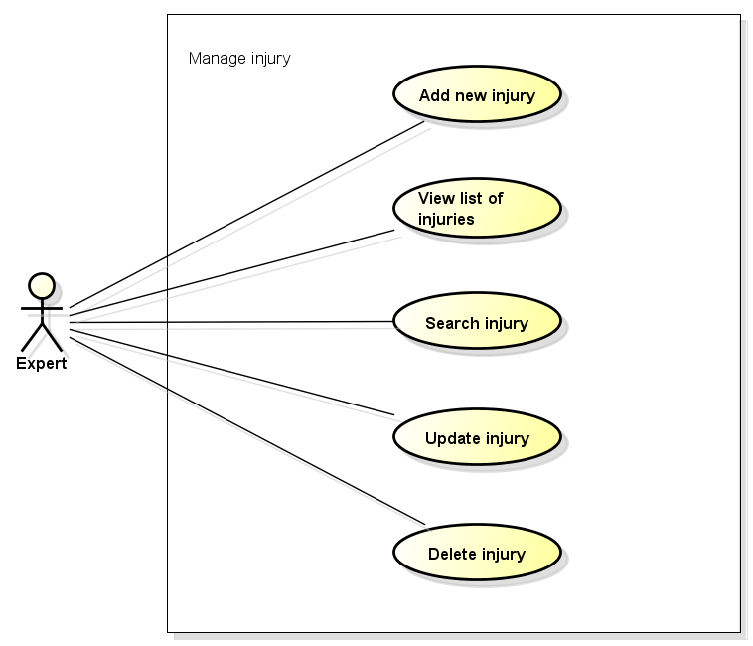

Figure 3‑17: Manage injury use cases

###### UC0051 - Add new injury

|  |  |  |  |  |
| --- | --- | --- | --- | --- |
| Use Case ID | | UC0051 | Version | 1.1 |
| Use Case Name | | Add new injury | | |
| Created by: | | AnhND | Date Created: | 27/09/2016 |
| Primary Actor | | Expert | Secondary Actor |  |
| Description: | | This function allows expert to add new injury for FAA | | |
| Preconditions: | | 1. Admin/Expert web app is available 2. Expert access Admin/Expert web site 3. Expert was provide an account | | |
| Trigger: | | Expert click on “Chấn thương” tab | | |
| Post conditions: | | Expert click on “Thêm Chấn thương” button | | |
| Normal Flow | | | | |
| Step | Actor | Action | | |
| 1 | Expert | Click on “Chấn thương” tab | | |
| 2 | AEA | “Chấn thương” page is displayed | | |
| 3 | Expert | Enter all information about an injury | | |
| 4 | Expert | Click on “Thêm chấn thương” button | | |
| 5 | AEA | Create new injury | | |
| Alternative Flows: N/A | | | | |
| Exceptions: N/A | | | | |
| Priority | | High | | |
| Frequency of Use: | | High | | |
| Business Rules: | |  | | |
| Other Information: | | N/A | | |

Table 3‑56: Add new injury.

###### UC0052 - View list of injuries

|  |  |  |  |  |
| --- | --- | --- | --- | --- |
| Use Case ID | | UC0052 | Version | 1.1 |
| Use Case Name | | View list of injuries | | |
| Created by: | | AnhND | Date Created: | 27/09/2016 |
| Primary Actor | | Expert | Secondary Actor |  |
| Description: | | This function allows to view list of injuries in FAA | | |
| Preconditions: | | 1. Admin/Expert web app is available 2. Expert access Admin/Expert web site 3. Expert was provide an account | | |
| Trigger: | | Expert clicks on “Chấn thương” tab | | |
| Post conditions: | | List of all injuries is displayed | | |
| Normal Flow | | | | |
| Step | Actor | Action | | |
| 1 | Expert | Click on “Chấn thương” tab | | |
| 2 | AEA | Show all injuries | | |
| Alternative Flows: N/A | | | | |
| Exceptions: N/A | | | | |
| Priority | | High | | |
| Frequency of Use: | | High | | |
| Business Rules: | |  | | |
| Other Information: | | N/A | | |

Table 3‑57: View list of injuries.

###### UC0053 - Search injury

|  |  |  |  |  |
| --- | --- | --- | --- | --- |
| Use Case ID | | UC0053 | Version | 1.1 |
| Use Case Name | | Search injury | | |
| Created by: | | AnhND | Date Created: | 27/09/2016 |
| Primary Actor | | Expert | Secondary Actor |  |
| Description: | | This function allows expert to search an injury | | |
| Preconditions: | | 1. Admin/Expert web app is available 2. Expert access Admin/Expert web site 3. Expert was provide an account 4. Expert clicks on “Chấn thương” tab | | |
| Trigger: | | Expert enters key word in search box and clicks on “Tìm Kiếm” button | | |
| Post conditions: | | All results that matched with the keyword admin enters will be displayed | | |
| Normal Flow | | | | |
| Step | Actor | Action | | |
| 1 | Expert | Enter key word in search box | | |
| 2 | Expert | Clicks on “Tìm Kiếm” button | | |
| 3 | AEA | Show all results that matched with the keyword | | |
| Alternative Flows: | | | | |
| **AT1** |  | | | |
| Step | Actor | Action | | |
|  |  |  | | |
| Exceptions: N/A | | | | |
| Priority | | High | | |
| Frequency of Use: | | High | | |
| Business Rules: | |  | | |
| Other Information: | | N/A | | |

Table 3‑58: Search injury.

###### UC0054 - Update injury

|  |  |  |  |  |
| --- | --- | --- | --- | --- |
| Use Case ID | | UC0054 | Version | 1.1 |
| Use Case Name | | Update injury | | |
| Created by: | | AnhND | Date Created: | 27/09/2016 |
| Primary Actor | | Expert | Secondary Actor |  |
| Description: | | This function allows update information about an injury | | |
| Preconditions: | | 1. Admin/Expert web app is available 2. Expert access Admin/Expert web site 3. Expert was provide an account 4. Expert clicks on “Chấn thương” tab | | |
| Trigger: | | Expert clicks on Edit button, changes information and clicks Ok | | |
| Post conditions: | | The information of an injury has been changed | | |
| Normal Flow | | | | |
| Step | Actor | Action | | |
| 1 | Expert | Clicks on “Chấn thương” tab | | |
| 2 | AEA | Show list of all injury | | |
| 3 | Expert | Expert clicks on Edit button | | |
| 4 | AEA | Show update page | | |
| 5 | Expert | Change information | | |
| 6 | Expert | Click Ok button | | |
| 7 | AEA | Update information of an injury | | |
| Alternative Flows: N/A | | | | |
| Exceptions: N/A | | | | |
| Priority | | High | | |
| Frequency of Use: | | High | | |
| Business Rules: | |  | | |
| Other Information: | | N/A | | |

Table 3‑59: Update injury.

###### UC0055 - Delete injury

|  |  |  |  |  |
| --- | --- | --- | --- | --- |
| Use Case ID | | UC0055 | Version | 1.1 |
| Use Case Name | | Delete injury | | |
| Created by: | | AnhND | Date Created: | 27/09/2016 |
| Primary Actor | | Expert | Secondary Actor |  |
| Description: | | This function allows | | |
| Preconditions: | | 1. Admin/Expert web app is available 2. Expert access Admin/Expert web site 3. Expert was provide an account 4. Expert clicks on “Chấn thương” tab | | |
| Trigger: | | Expert clicks on Delete button and clicks Ok | | |
| Post conditions: | | An injury is deleted | | |
| Normal Flow | | | | |
| Step | Actor | Action | | |
| 1 | Expert | Click on Delete button | | |
| 2 | Expert | Click Ok | | |
| 3 | AEA | Delete an injury | | |
| Alternative Flows: N/A | | | | |
| Exceptions: N/A | | | | |
| Priority | | High | | |
| Frequency of Use: | | High | | |
| Business Rules: | |  | | |
| Other Information: | | N/A | | |

Table 3‑60: Delete injury.

### Non-Functional Specification

#### Reliability

* Mean time between failures: The mean time between each failure is expected to be about 480 hours of using.
* The maximum bugs per function are 2 bugs/a function when user uses software within 2 months. The average number of bugs in the software during system testing is about to be around 1 bugs/KLOC.
* The database must be backed up daily and can be recovered if necessary

#### Performance Requirements

##### Availability

The application must be available 95% of time. Users can access to it everywhere from their Web browser with internet connection.

##### Response time

In term of response time, waiting time of processing will be 2 to 5 seconds; time to process any functions will not exceed 7 seconds.

#### Maintainability

* **Coding standards and naming conventions:**
  + Output of the project must include coding standards and naming conventions documentations. Implementation code must be easy to maintain.
  + If some components are reused, the documentations of those components must also be included.
* **Design:**
  + The design of the system must be loosely coupled that chances on some module will not affect others.
* **Logging:**
  + All the errors should be logged, supporting for bug fixing and maintenance.
  + All strange or sensitive situations should also be logged.
* **Mean time to repair**:
  + Immediately when Administrator finds out problem or website is attacked/ hacked by someone. Average 1 day.

#### Usability

* Usability Requirements support the following from the perspective of its primary users: **Efficiency of use:** user can complete each function in less than 12 actions
* **Intuitiveness:** User can understand approximately 90% help/ error messages

#### Security Requirements

In order to avoid unwanted access by strangers, the security implemented in various ways:

* **User authorize**: Ambulance, Dispatcher and administrator must log in to use the functions and web services.
* **Manage Data Layer**: Only Administrator can modify database system.

#### Hardware/Software Requirements

* + **Hardware requirement:**

**- Server:** Ubuntu 16.04, Apache2.

**- Client:** PC/Laptop (window 7, window 8)

* + **Software requirements:**

**-** Web browser (Chrome 40.0, Firefox 30.0) with internet connection.

**-** Android 5.0 or higher.

# SOFTWARE DESIGN

## Introduction

### Purpose

This chapter is design document to guide the development team of what the system’s architect, how to implement functions.

This section includes four main parts:

* Architecture Design.
* Detail Design.
* Database design.
* Screen design.

### Definitions, Acronyms, Abbreviations

|  |  |  |
| --- | --- | --- |
| Acronym | Definition | Note |
| FAVN | First Aid Vietnam |  |
| FAA | First Aid Application |  |
| MVC | Model view control |  |
| REST | Representational state transfer |  |
| API | Application Programming Interface |  |
| Faq | Frequently Asked Questions |  |

Table 4‑1: Definitions and Acronyms

## Architecture design

### Choice of Architecture Design

#### MVC Model

The purpose of FAVN is developing a system of first aid supporting and other emergency features. The system of FAVN is structured based on MVC combined with layered architecture.

##### MVC Model Overview

The model-view-controller or MVC is software architecture commonly used for creating web or software applications. In other words, it's a structure for applications to follow in order to ensure efficiency and consistency.

The Model-View-Controller (MVC) architectural pattern separates an application into three main components: the model, the view, and the controller. The model consists of application data, business rules, logic and functions. A view can be any output representation of data. The controller mediates input, converting it to commands for the model or view.

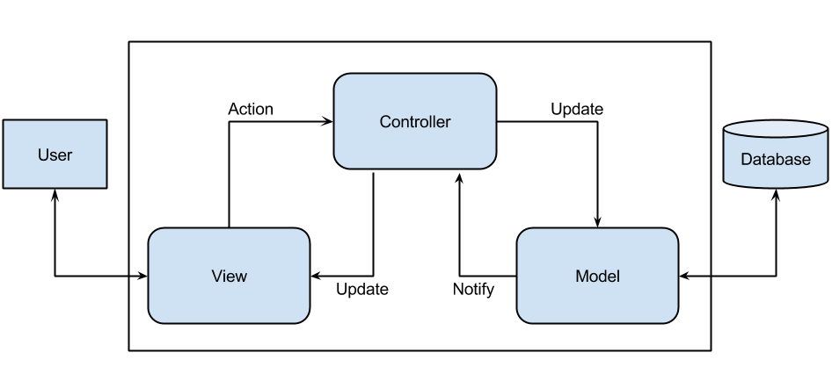

Figure 4‑1: MVC Model

More detail about each component is divided by the MVC pattern:

* **Model:** Model represents an object carrying data. It can also have logic to update controller if its data changes.
* **View:** View represents the visualization of the data that model contains.
* **Controller:** Controller acts on both model and view. It controls the data flow into model object and updates the view whenever data changes. It keeps view and model separate.

##### Advantages and disadvantages of MVC Model

* **Advantages:**
* **Faster development process:** MVC supports rapid and parallel development.
* **Ability to provide multiple views:** In the MVC Model, you can create multiple views for a model.
* **Support for asynchronous technique:** MVC also supports asynchronous technique, which helps developers to develop an application that loads very fast.
* **Modification does not affect the entire model:** Modification does not affect the entire model because model part does not depend on the views part.
* **MVC model returns the data without formatting:** MVC pattern returns data without applying any formatting so the same components can be used and called for use with any interface.
* **Disadvantages:**
* **Time consuming in small project development process:** for small projects that apply MVC model caused cumbersome.
* **Increased complexity.**
* **Not suitable for agent-oriented applications:** such as interactive mobile and robotics applications.
* **Data model change expensive:** multiple pairs of controllers and views based on the same data model.
* **Knowledge on multiple technologies is required.**

##### The reasons for choosing MVC Model

* MVC makes parts of system can be developed individually and simultaneously to reduce developing time.
* It is good support for application built by project team has many developers and designers but still managed application features.
* Better support for test-driven development.
* Tools is useful and documentary source is large makes MVC is easy to develop.
* FAVN system is not complete system, now. We built the system that towards extensibility and maintainability in the future.

#### Android

##### Android Overview

Android is an open source and Linux-based Operating System for mobile devices such as smartphones and tablet computers. Android was developed by the Open Handset Alliance, led by Google, and other companies.

Android offers a unified approach to application development for mobile devices which means developers need only develop for Android, and their applications should be able to run on different devices powered by Android.

##### Advantages and disadvantages of Android platform

* **Advantages**
* Open source.
* Larger developer and community reach.
* Increased marketing.
* Inter app integration.
* Reduced cost of development.
* Higher success ratio.
* Rich development environment.
* **Disadvantages**
* Multitude of devices to take care of, and not just different screen sizes, but different resolutions too. This makes the app design, as well as UI development much harder.
* Quality of apps on the Play Store is much worse than those on the App Store. This is primarily because of Apple's stringent review policies. They do not allow low quality apps to be published.

##### The reasons for choosing Android platform

* Most people uses android handheld devices especially android phone.
* Android is a powerful operating system and supports great features.
* There are many plugins, resources and documents which support creating an android application.

#### Laravel

##### Laravel Overview

Laravel is referred to as a “full stack” framework because it handles everything from web serving to database management right down to HTML generation. A vertically integrated web development environment can provide a better experience for the developer.

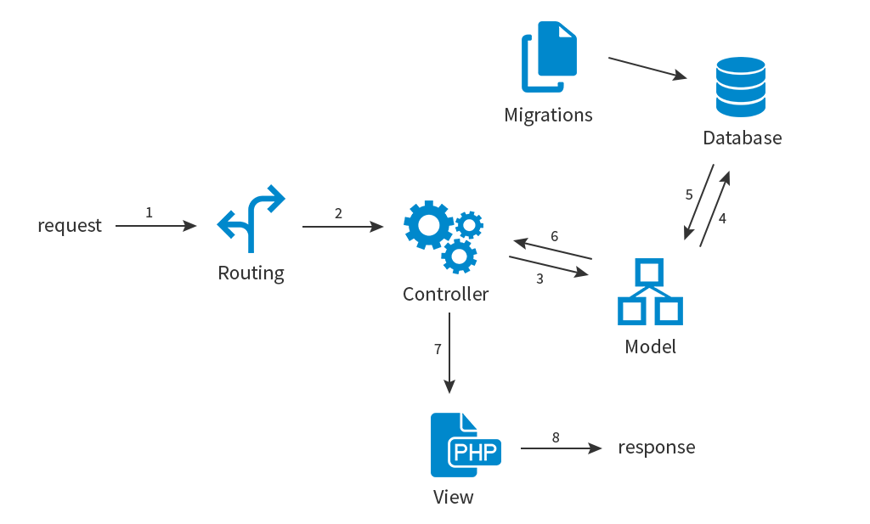

Figure 4‑2: Laravel Architechture

* **Features:**
* Bundles provide a modular packaging system, with bundled features already available for easy addition to applications. Furthermore, Laravel uses Composer as a dependency manager to add framework-agnostic and Laravel-specific PHP packages available from the Packagist repository.
* Eloquent ORM (object-relational mapping) is an advanced PHP implementation of the active record pattern, providing at the same time internal methods for enforcing constraints on the relationships between database objects. Following the active record pattern, Eloquent ORM presents database tables as classes, with their object instances tied to single table rows.
* Query builder, provides a more direct database access alternative to the Eloquent ORM. Instead of requiring SQL queries to be written directly, Laravel's query builder provides a set of classes and methods capable of building queries programmatically. It also allows selectable caching of the results of executed queries.
* Application logic is an integral part of developed applications, implemented either by using controllers or as part of the route declarations.
* Reverse routing defines a relationship between the links and routes, making it possible for later changes to routes to be automatically propagated into relevant links.
* Restful controllers provide an optional way for separating the logic behind serving HTTP GET and POST requests.
* Class auto loading provides automated loading of PHP classes without the need for manual maintenance of inclusion paths.
* View composers serve as customizable logical code units that can be executed when a view is loaded.
* Blade templating engine combines one or more templates with a data model to produce resulting views.
* Migrations provide a version control system for database schemas, making it possible to associate changes in the applications codebase and required changes in the database layout.
* Unit testing is provided as an integral part of Laravel.
* Automatic pagination simplifies the task of implementing pagination, replacing the usual manual implementation approaches with automated methods integrated into Laravel.
* Form request is a feature of Laravel 5 that serves as the base for form input validation by internally binding event listeners, resulting in automated invoking of the form validation methods and generation of the actual form.

##### Advantages and disadvantages of Laravel

* **Advantages:**
* It uses a blade template engine to speed up compiling tasks, and users can include latest features so easily.
* “Bundled modularity” enables code reusing without much hassle.
* An outstanding Artisan CLI comprising advanced tools to do tasks, and migrations.
* Splendid documentation, and an added feature of reverse routing.
* **Disadvantages:**
* Amateur developers face problems while extending codes and classes.
* Many methods included in the reverse routing are complex.

##### The reason for choosing Laravel

* **Open Source:** It is a free open-source PHP web application framework which has easy process of building complex and large web applications with code maintainability. Provide a more fluid user experience akin to a desktop application.
* **MVC Architecture Support:** It follows the MVC pattern, ensuring the transparency between logic and presentation.
* **Libraries and configuration:** It supports many development environments and adjusts itself based on the appropriate platform where app is running.

### Architecture Representation

We follow MVC architecture to implement the FAVN system.

#### First Aid Application

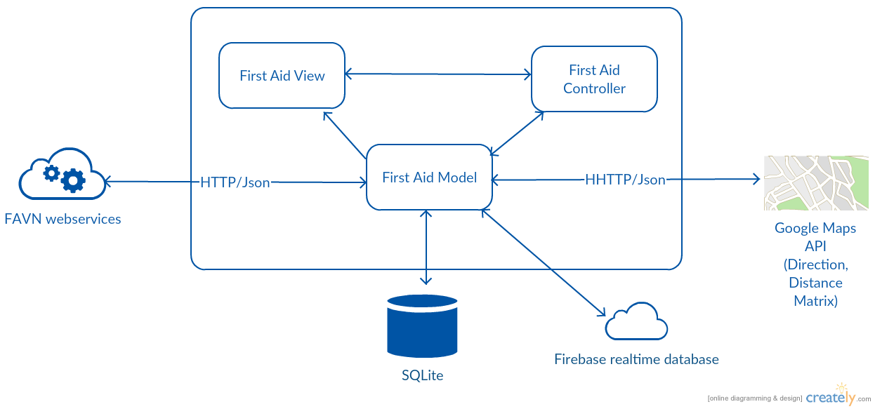

Figure 4‑3: First Aid Application System Overview

**Model** is data layer, responsible for managing the business logic and handling web service or database API.

**View** is UI layer, a visualization of the data from the Model.

**Controller** is logic layer, gets notified of the user’s behavior and updates the Model as needed.

#### Ambulance Application

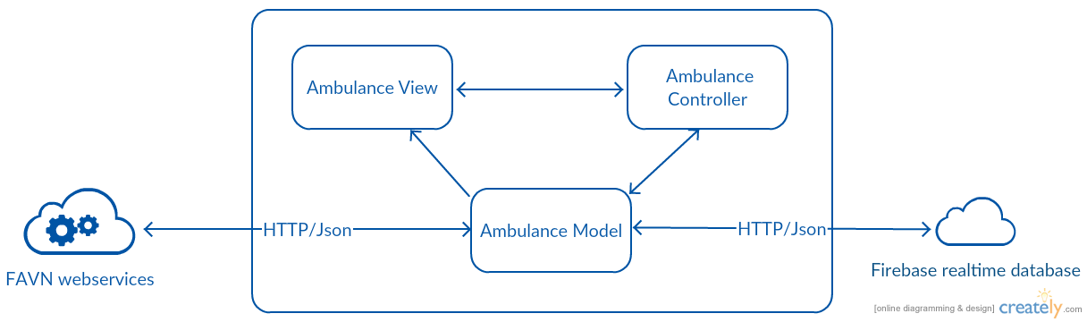

Figure 4‑4: Ambulance Application System Overview

Similar to the First Aid Application's architecture, we also use MVC architecture for Ambulance application development.

#### Dispatcher Application

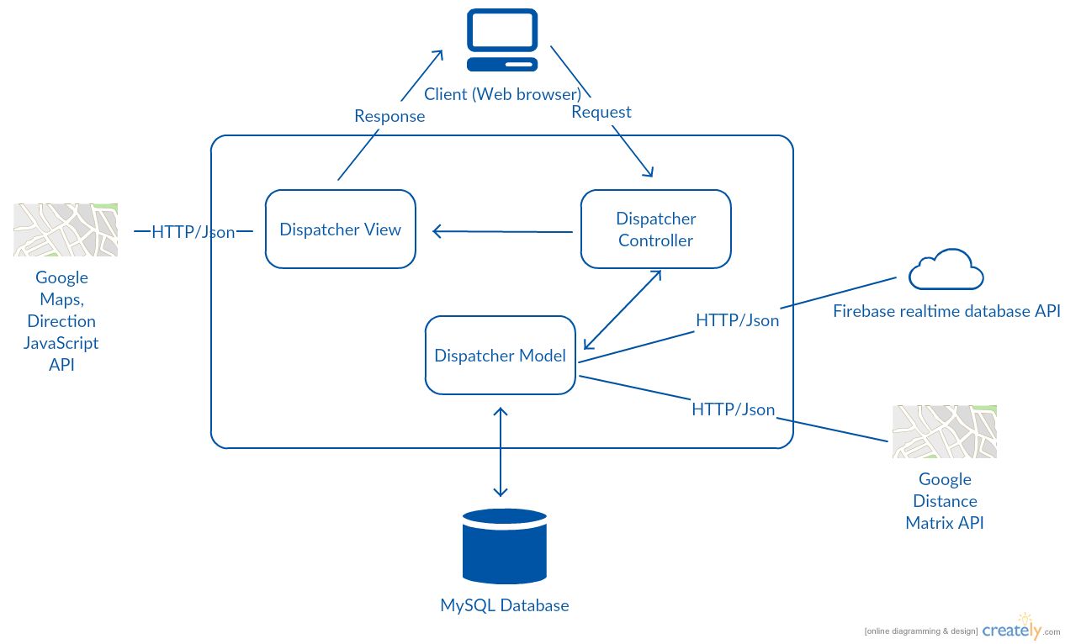

Figure 4‑5: Dispatcher Application System Overview

**Model** is where the application’s data objects are stored. A model object is in charge of encapsulating application state and one object could be related to other objects establishing a one-to-one or one-to-many relationship. The model object does not talk directly to a View, instead is made available to a controller, which accesses it when needed. When a model changes, typically it will notify its observers that a change has occurred.

**View** is what is presented to the users and how users interact with the system. The view is expected to render the model in a meaningful way to the user. In Dispatcher website, the view is made with .blade.php file including css, JavaScript or jQuery, it sends user gestures to controller and allows controller to select view.

**Controller** is the decision maker and the glue between the model and view; it handles user actions and gestures, and responds to user events. For example, in case a dispatcher needs to dispatch a car to a caller, when the dispatcher clicks “caller phone number” list item to create a new caller, the controller for that action is invoked. The controller will get an instant object of caller with data from database through caller model. The controller will then return view with that caller object to display, so that dispatcher can view the caller information.

#### Admin/Expert Application

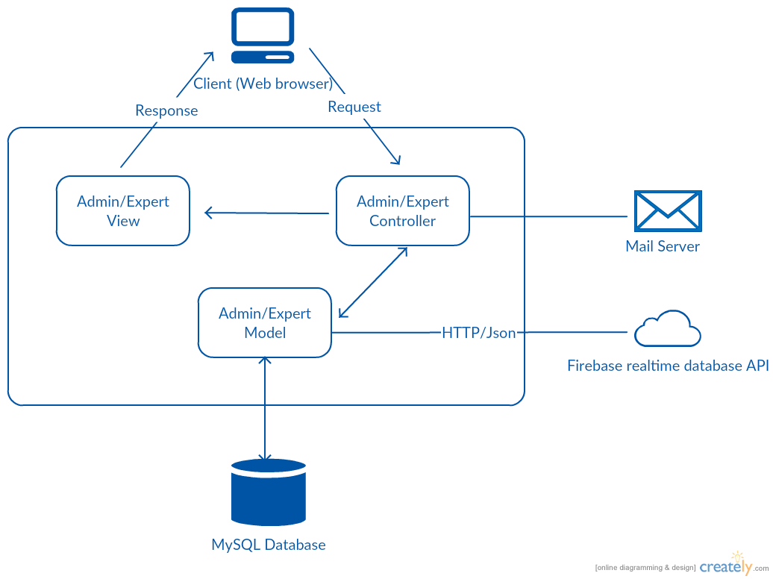

Figure 4‑6: Admin/Expert Application System Overview

Similar to the Dispatcher Application's architecture, we also use MVC architecture for Admin/Expert application development.

### Architectural Goals and Constraints

* **Availability:**
* The According to common sense. We expect the system to be available 95% FAVN time. In case of necessity, users just install the application and setting up network to use the emergency services.
* **Maintainability:**
  + Coding standards and naming conventions:
    - Output of the project must include coding standards and naming conventions documentations. Implementation code must be easy to maintain.
    - All code must be clearly commented, including class, method documentations.
    - If some components are reused, the documentations of those components must also be included.
* Design:
  + - The design of the system must be loosely coupled that chances on some module will not affect others.
* Logging:
  + - All the errors should be logged, supporting for bug fixing and maintenance.
    - All strange or sensitive situations should also be logged.
* **Usability:**
  + Intuitiveness: all help/error messages are simple to understand; user can know exactly how to do each feature after one time using it.
* **Capacity and scalability:**
  + Throughput, storage and growth requirements.

### Logical View

#### Overview

Logical view is a logical way of view of elements in FAVN system as well as the relationships between them. It includes Package diagram and Class diagram. Package diagram describes the organization of packages and elements. Class Diagram provides an overview of the target system by describing the objects and classes inside the system and the relationships between them. It provides a wide variety of usages; from modeling the domain-specific data structure to detailed design of the target system.

* + **Controller contain the interface between:**
    - Associated models
    - Associated views
    - The input devices (e.g., keyboard, pointing device, time).
    - Send commands to the model to update the model's state.
  + **Model is:**
    - the domain-specific software simulation
    - Or implementation of the application's central structure.
  + **View:** 
    - deal with everything graphical:
    - Requests data from their model
    - Display the data.
  + **Repository:** 
    - Create queries to DB.
    - Process data.
    - Return to controller.

#### Architecturally Significant Design Packages

##### First Aid Application

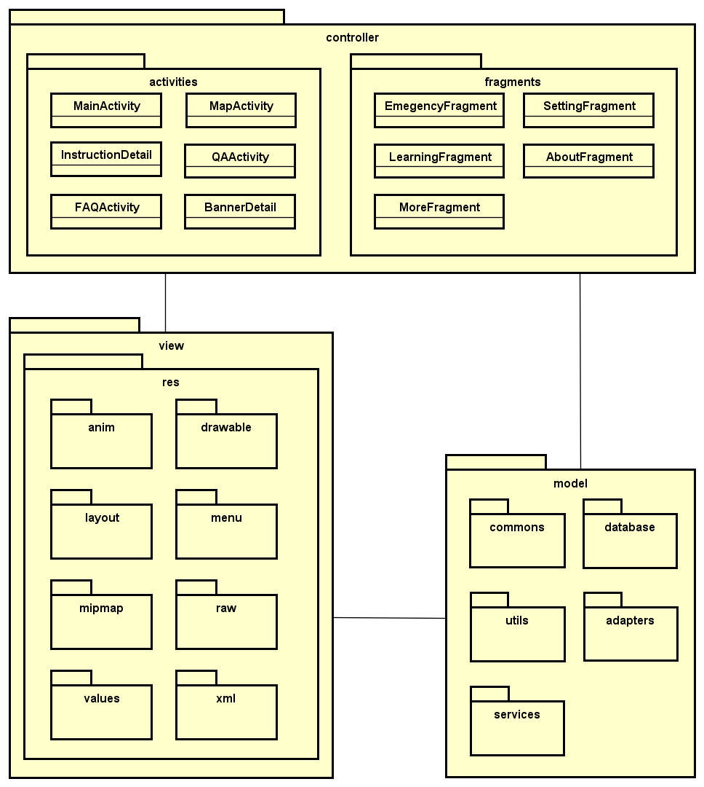

Figure 4‑7: First Aid Application Package Diagram

* **Model:**

|  |  |  |
| --- | --- | --- |
| No | Model class | Role |
|  | commons | Description entity of common’s class in sourcecode |
|  | databases | Description entity of database’s class in sourcecode |
|  | utils | Description entity of util’s class in sourcecode |
|  | adapters | Description entity of adapter’s class in sourcecode |
|  | services | Description entity of service’s class in sourcecode |

Table 4‑2: First Aid Application Model list

* **Controller:**

|  |  |  |
| --- | --- | --- |
| No | Controller class | Role |
|  | MainActivity | Performs actions functions: emergency, learning, more, setting, about. |
|  | MapActivity | Performs actions functions: map, search health facilities, direction. |
|  | InstructionDetail | * Performs actions functions: view detail, view faq |
|  | QAActivity | * Performs actions function send question |
|  | FAQActivity | * Performs actions function view list faq of an injury |
|  | CourseActivity | * Performs actions function view information of courses |
|  | EmergencyFragment | * Performs actions functions: view injuries, call 115, search, show map |
|  | LearningFragment | * Performs actions functions: view learning injuries, view courses |
|  | MoreFragment | * Performs actions functions: share, send question, view courses |
|  | SettingFragment | * Performs actions function allow to send information |
|  | AboutFragment | * Performs actions function view information of application |

Table 4‑3: First Aid Application Controller list

* **View:**

Include many .xml file

##### Ambulance Application

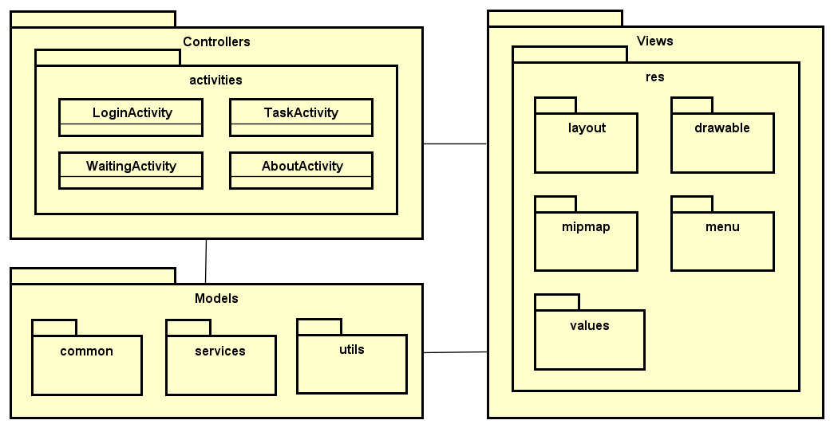

Figure 4‑8: Ambulance Application Package Diagram

* **Model:**

|  |  |  |
| --- | --- | --- |
| No | Model class | Role |
|  | common | Description entity of common’s class in sourcecode |
|  | services | Description entity of service’s class in sourcecode |
|  | utils | Description entity of util’s class in sourcecode |

Table 4‑4: Ambulance Application Model list

* **Controller:**

|  |  |  |
| --- | --- | --- |
| No | Controller class | Role |
|  | LoginActivity | * Performs actions function login to application |
|  | TaskActivity | * Performs actions functions: view caller’s information, view caller’s location, direct to caller, close task. |
|  | WaittingActivity | * Performs actions functions: change status, accept/decline task, logout, view information of application |
|  | AboutActivity | * View information of application |

Table 4‑5: Ambulance Application Controller list

* **View:**

Include many .xml file

##### Dispatcher Application

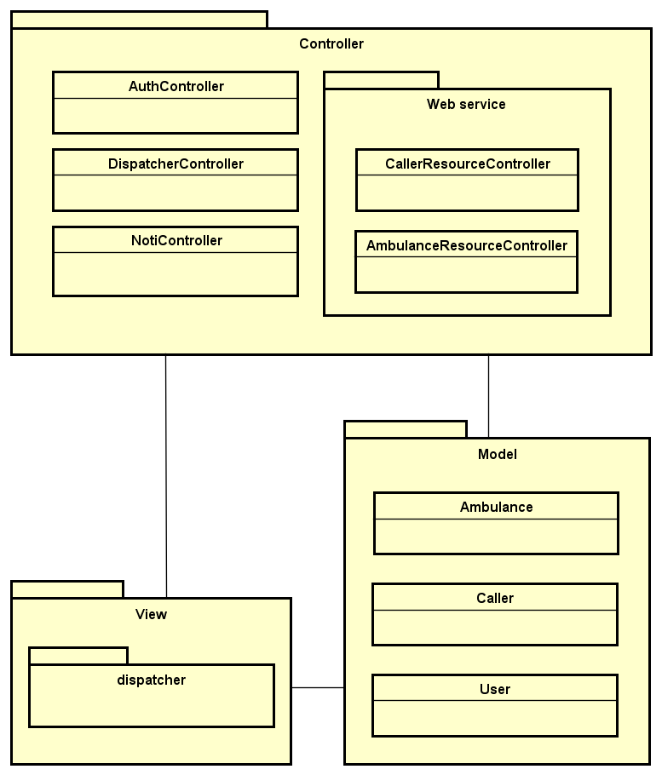

Figure 4‑9: Dispatcher Application Package Diagram

* **Model:**

|  |  |  |
| --- | --- | --- |
| No | Model class | Role |
|  | Ambulance | Description entity of Ambulance in database |
|  | Caller | Description entity of Caller in database |
|  | User | Description entity of User in database |

Table 4‑6: Dispatcher Application Model list

* **Controller:**

|  |  |  |
| --- | --- | --- |
| No | Controller class | Role |
|  | AuthController | * Receive request login, logout from client. * Call method login, logout. * Respond login view and login, logout status. |
|  | DispatcherController | * Receive request to dispatch ambulance for a caller from client (dispatcher). * Call methods to handle match an ambulance with a caller. * Respond data back to Dispatcher view. |
|  | NotiController | * Receive request to push notification between ambulance, caller and dispatcher. * Hander request and return data. |
|  | CallerResourceController | RESTful controller that handles basic functionality for Caller table. (Create, read, update and delete records). |
|  | AmbulanceResourceController | RESTful controller that handles basic functionality for Ambulance table. (Create, read, update and delete records). |

Table 4‑7: Dispatcher Application Controller list

* **View:**

Include many .blade.php file

##### Admin/Expert Application

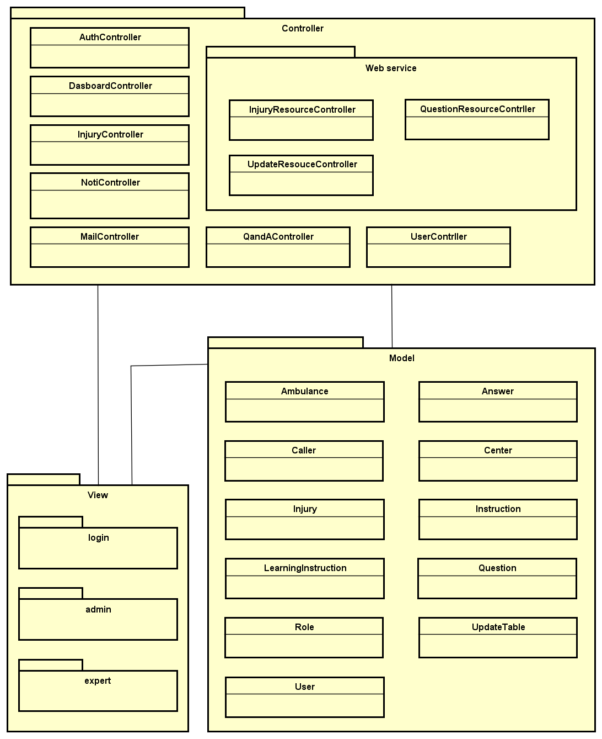

Figure 4‑10: Admin/Expert Application Package Diagram

* **Model:**

|  |  |  |
| --- | --- | --- |
| No | Model class | Role |
|  | Ambulance | Description entity of Ambulance in database |
|  | Answer | Description entity of Answer in database |
|  | Caller | Description entity of Caller in database |
|  | Center | Description entity of Center in database |
|  | Injury | Description entity of Injury in database |
|  | Instruction | Description entity of Instruction in database |
|  | LearningIntruction | Description entity of Learning Instruction in database |
|  | Question | Description entity of Question in database |
|  | Role | Description entity of Role in database |
|  | UpdateTable | Description entity of Update Table in database |
|  | User | Description entity of User in database |

Table 4‑8: Admin/Expert Application Model list

* **Controller:**

|  |  |  |
| --- | --- | --- |
| No | Controller class | Role |
|  | AuthController | * Receive request login, logout from client. * Call method login, logout. * Respond login view and login, logout status. |
|  | DasboardController | * Receive request to show common information. * Call methods to handle. * Respond data back to view. |
|  | InjuryController | * Receive request to show, insert, delete, update, search injuries. * Hander request and return data. |
|  | NotiController | * Receive request to push notification between ambulance, caller and dispatcher. * Hander request and return data. |
|  | MailController | * Receive request to send mail from admin/expert to Fist Aid user. * Call methods to handle send mail. * Respond data back to view. |
|  | QandAController | * Receive request to show, reply or delete questions from Fist Aid user. * Call methods to handle.   Respond data back to view. |
|  | UserContrller | Receive request to show, insert, delete or update users. Call methods to handle. Respond data back to view. |
|  | InjuryResourceController | RESTful controller that handles basic functionality for Injury table. (Create, read, update and delete records). |
|  | UpdateResouceController | RESTful controller that handles basic functionality for Update table. (Create, read, update and delete records). |
|  | QuestionResourceContrller | RESTful controller that handles basic functionality for Question table. (Create, read, update and delete records). |

Table 4‑9: Admin/Expert Application Controller list

* **View:**

Include many .blade.php file

### Process view

#### First Aid Application

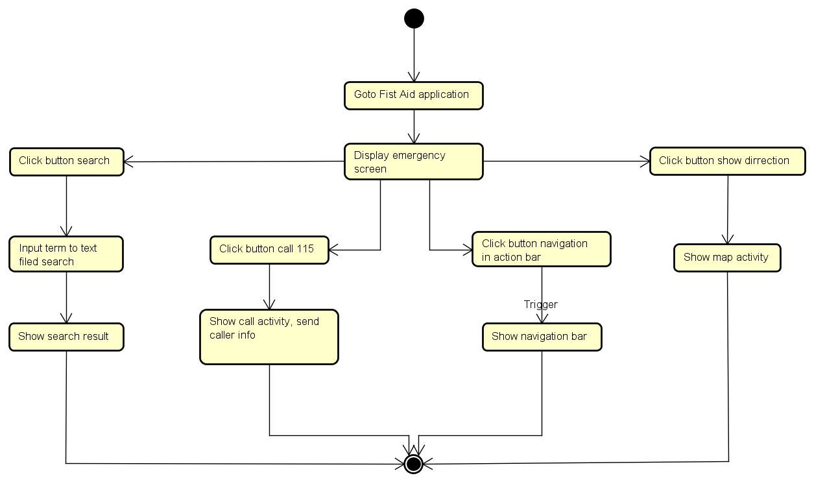

Table 4‑10: First Aid State Machine

#### Ambulance Application

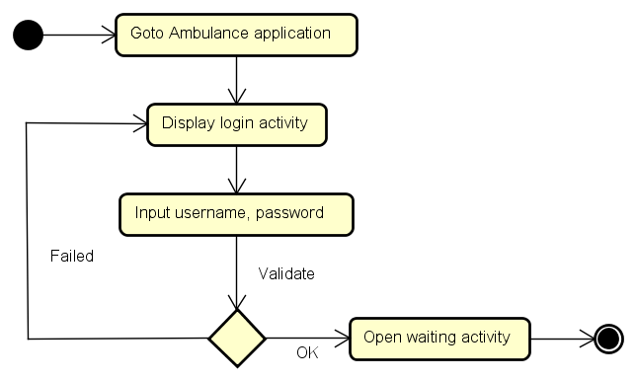

Table 4‑11: Login State Machine

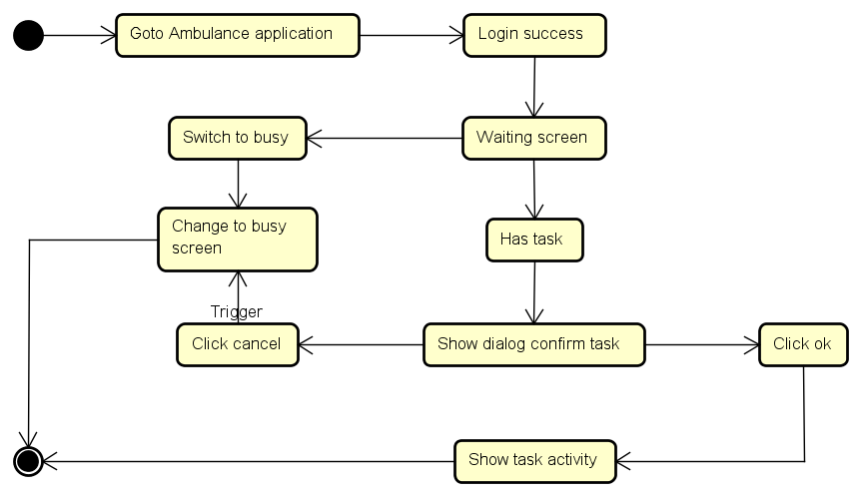

Table 4‑12: Main State Machine

#### Dispatcher Application

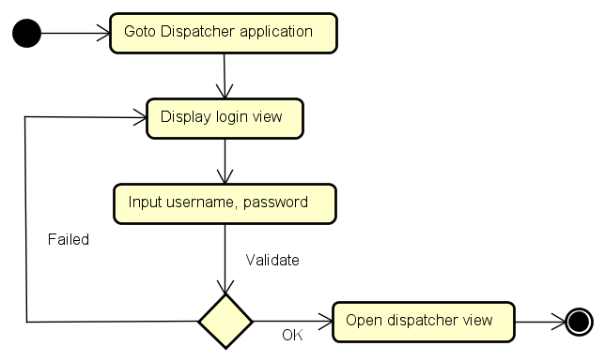

Table 4‑13: Login State Machine

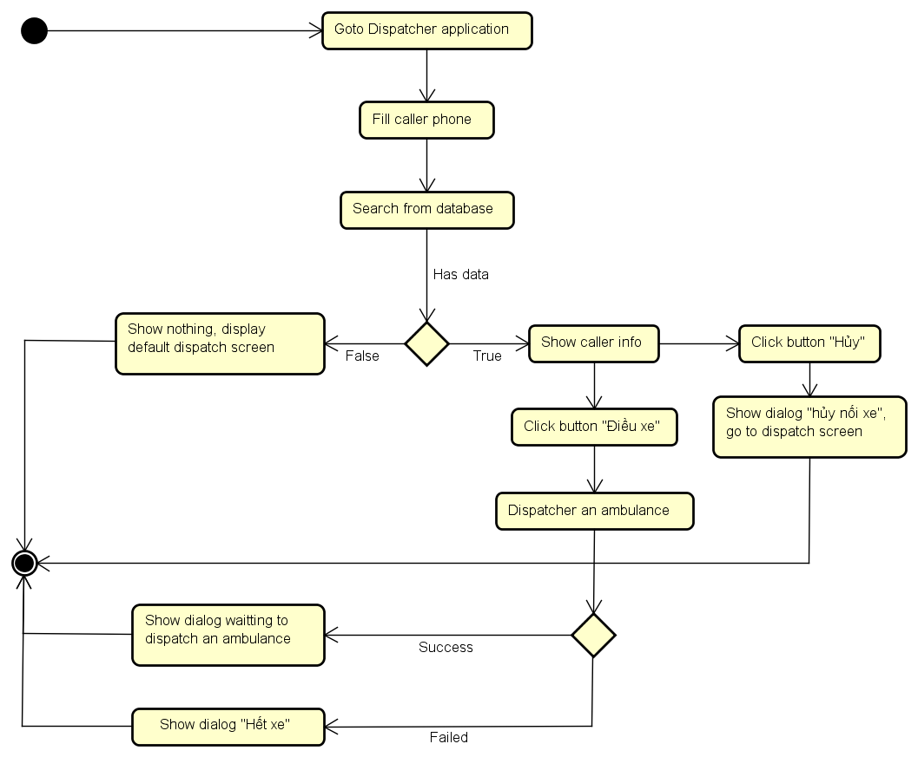

Table 4‑14: Main State Machine

#### Admin Application

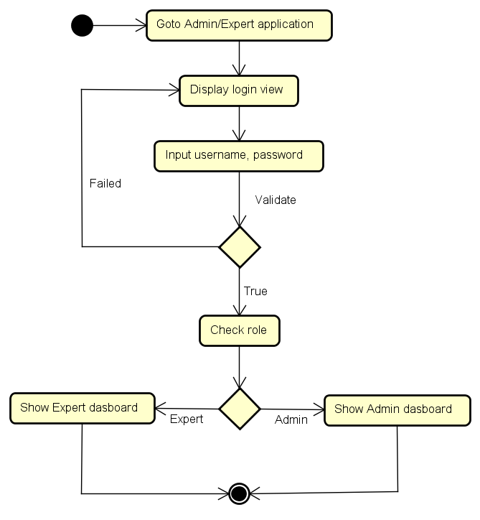

Table 4‑15: Admin/Expert Application State Machine

### Deployment View

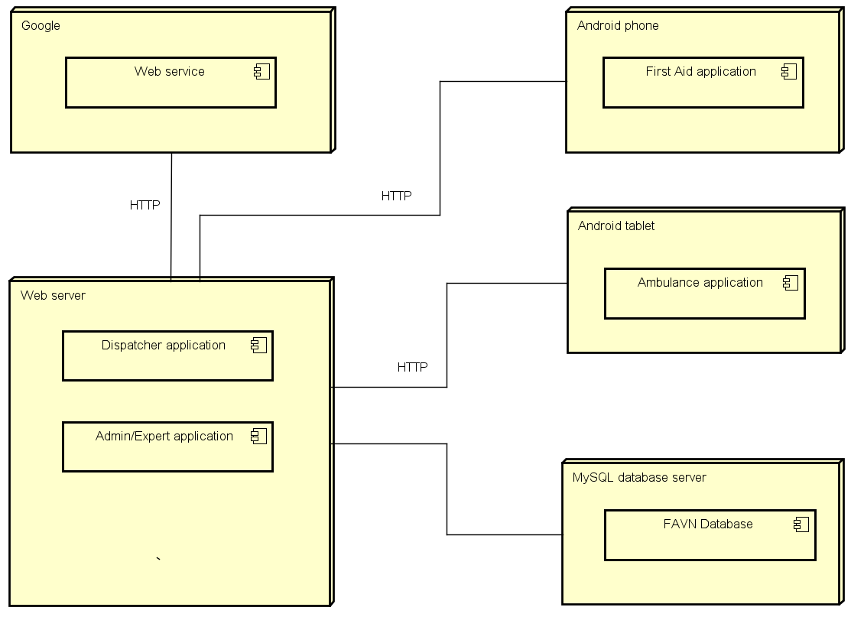

Table 4‑16: FAVN System Deployment View

## Detail Design

### Package

#### Package Diagram

##### First Aid Application



Figure 4‑11: First Aid Application Package Diagram

##### Ambulance Application



Figure 4‑12: Ambulance Application Package Diagram

##### Dispatcher Application



Figure 4‑13: Dispatcher Application Package Diagram

##### Admin/Expertm Application



Figure 4‑14: Admin/Expert Application Package Diagram

### Function

#### First Aid Application

##### Emergency

###### Class Diagram

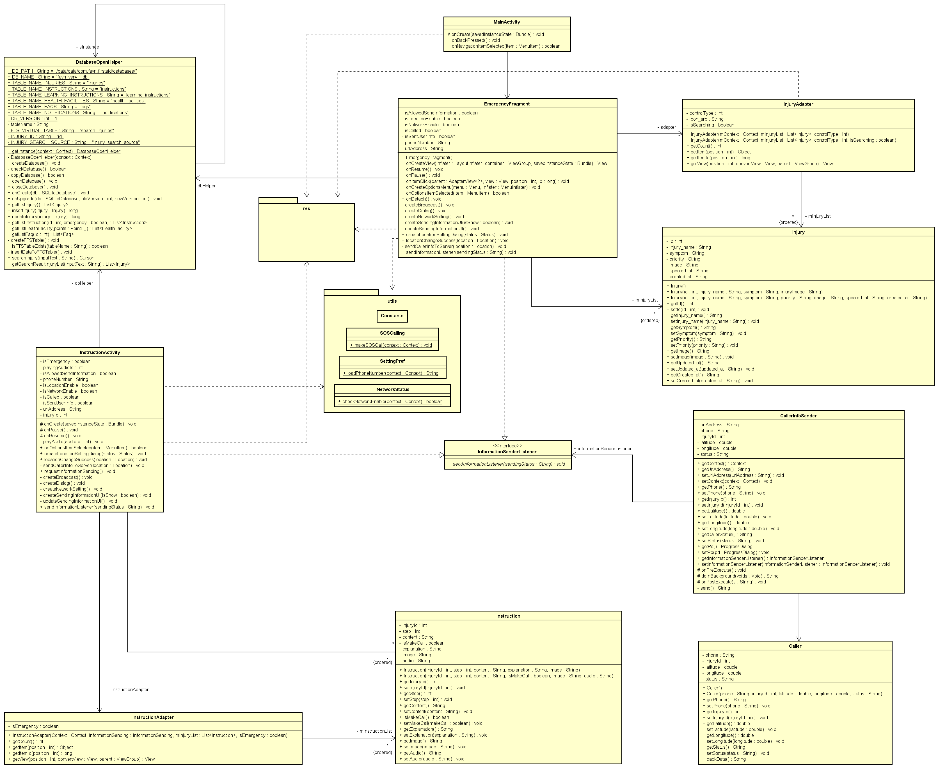

Figure 4‑15: Emergency class diagram for UC 1-5

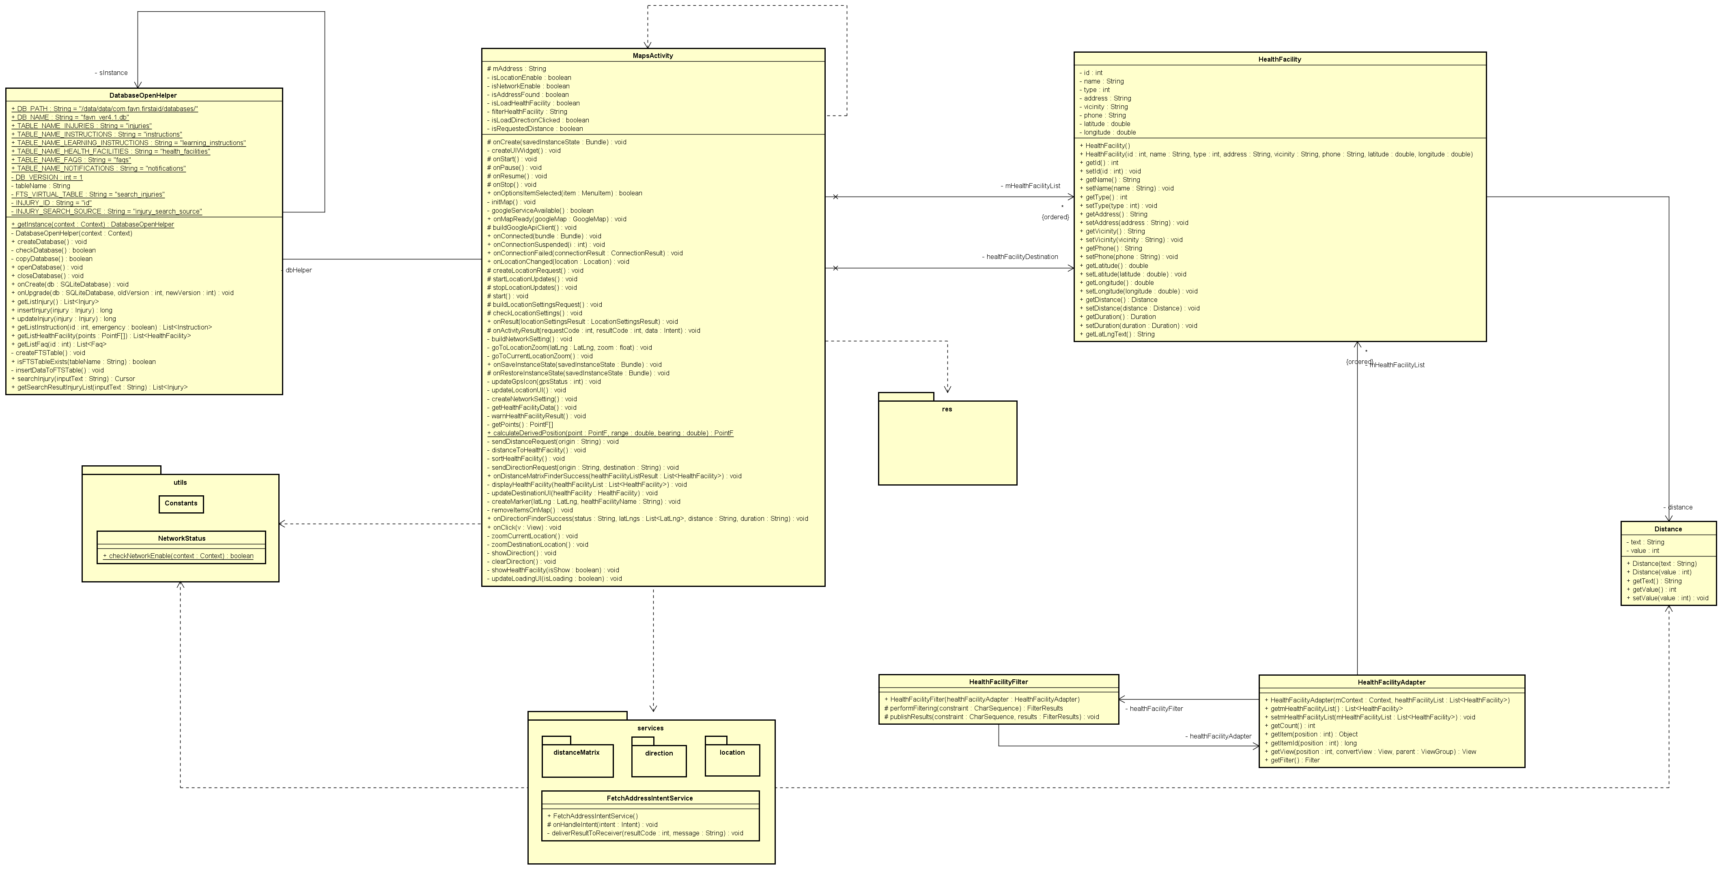

Figure 4‑16: Emergency class diagram for UC 6-9

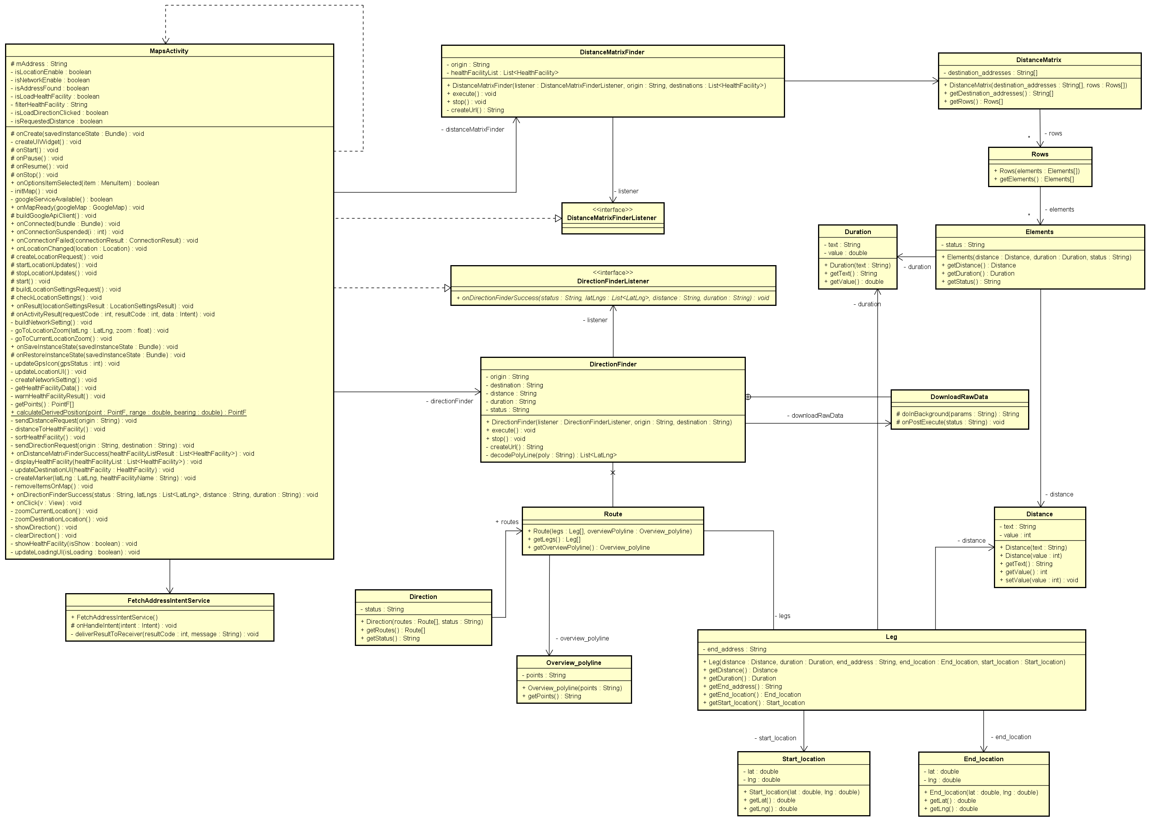

Figure 4‑17: Class diagram for getting distance matrix and direction

###### Sequence Diagram

View list of injuries

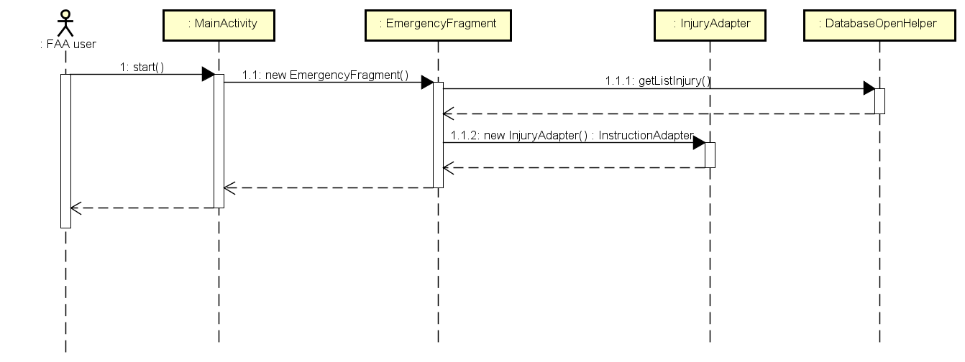

Figure 4‑18: View list of injuries sequence diagram

View instruction steps of injury

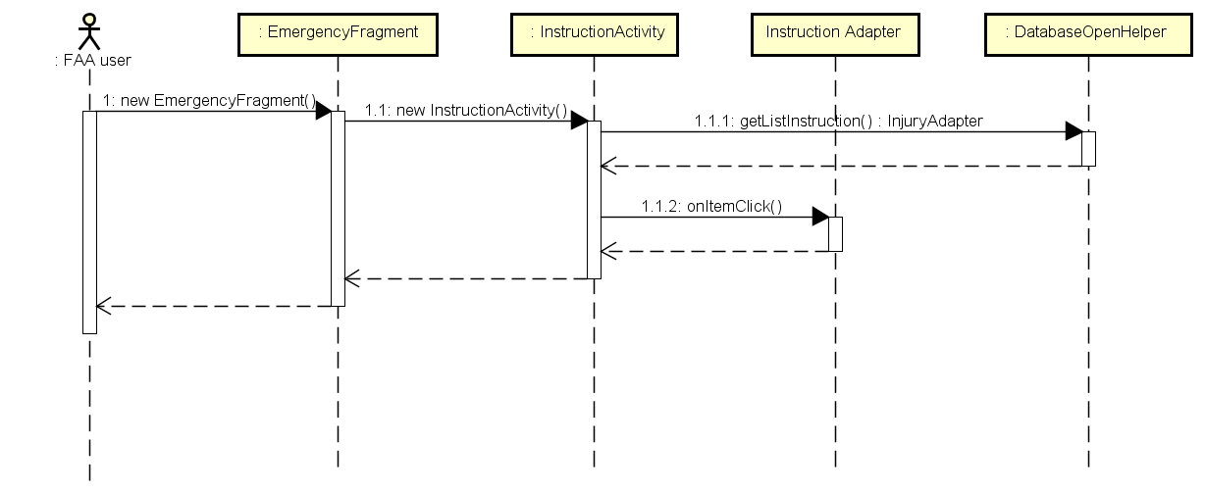

Figure 4‑19: View instruction steps of injury sequence diagram

Search injuries

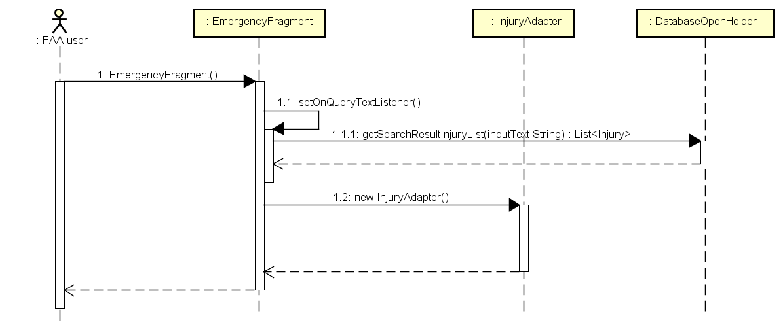

Figure 4‑20: Search injuries sequence diagram

Call 115

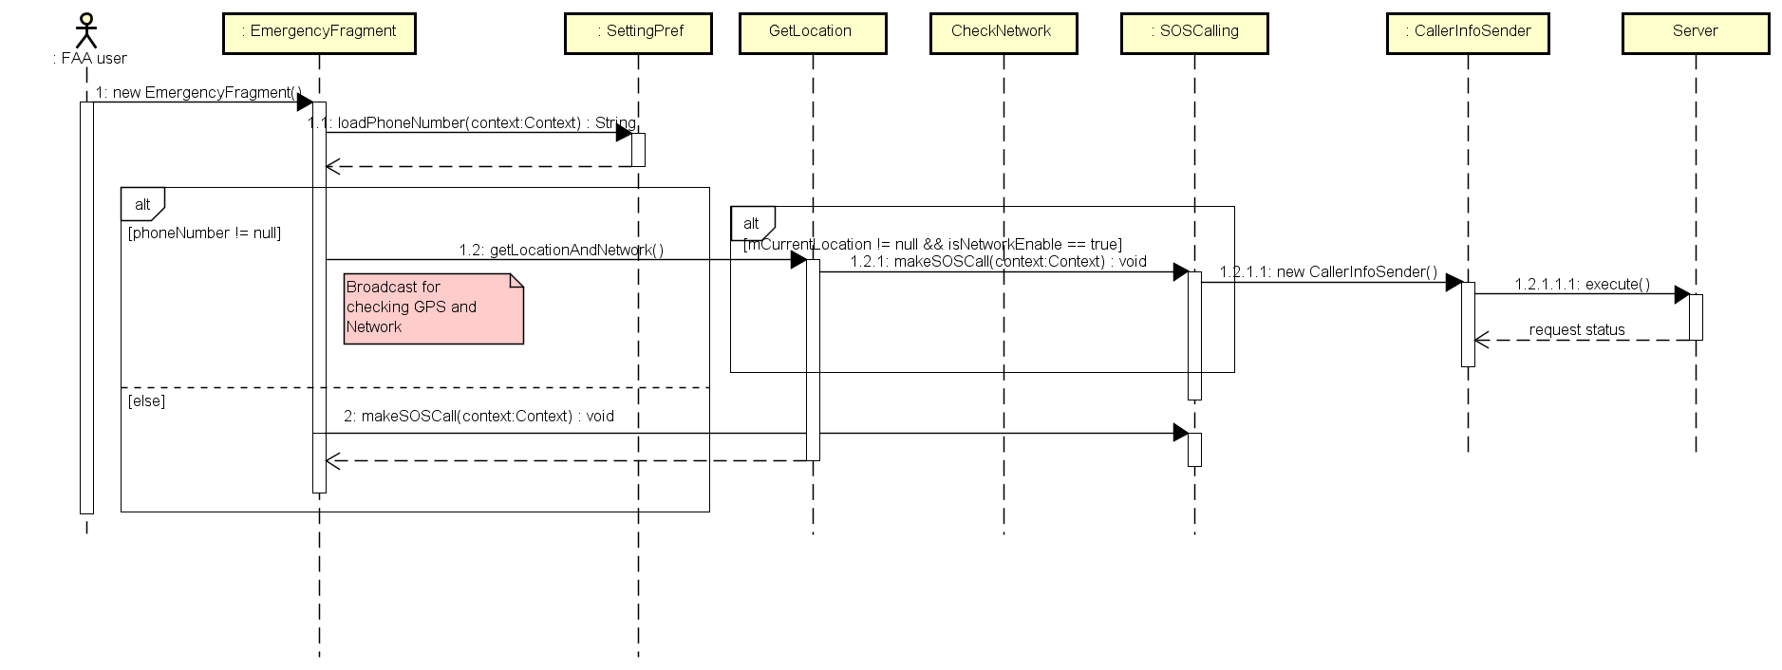

Figure 4‑21: Call 115 sequence diagram

Broadcast is Refer to Sequence diagram for checking GPS and Network

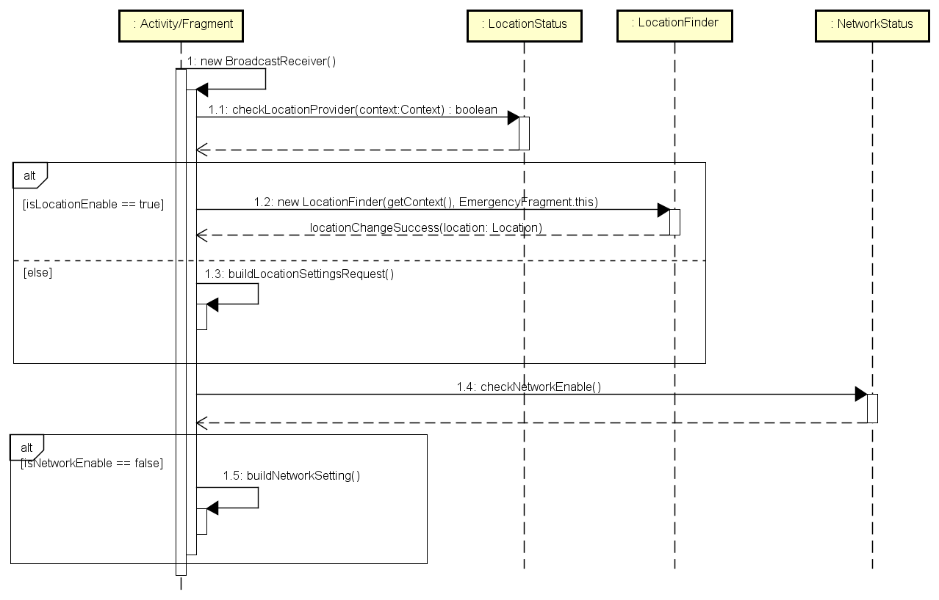

Figure 4‑22: Sequence diagram for checking GPS and Network

Read instruction steps

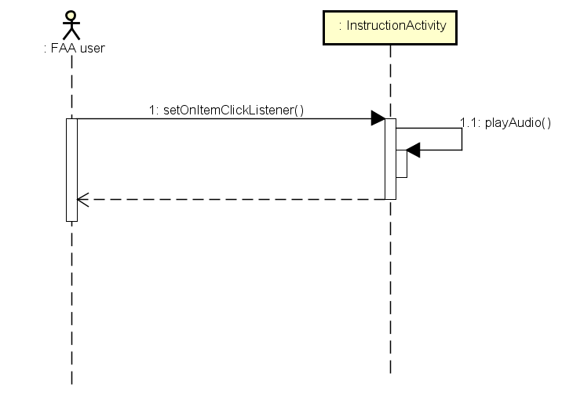

Figure 4‑23: Read instruction steps sequence diagram

View current location

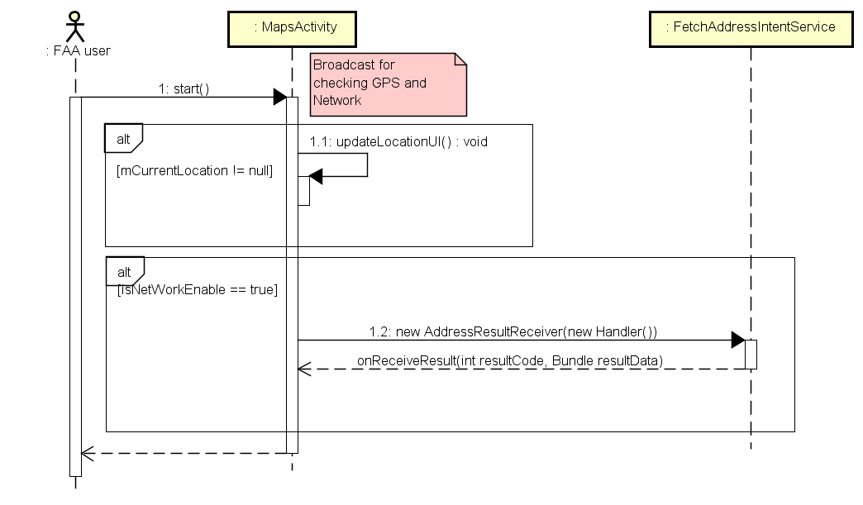

Figure 4‑24: View current location

Broadcast is Refer to Sequence diagram for checking GPS and Network

View list of nearest health facilities

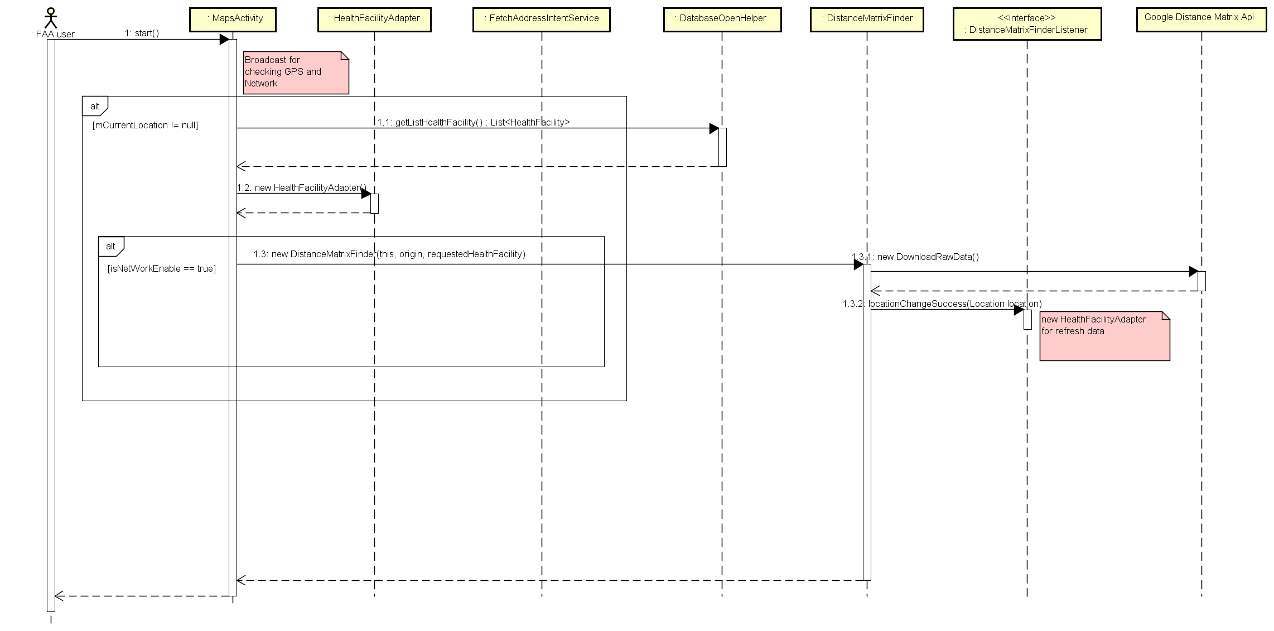

Figure 4‑25: View list of nearest health facilities

Broadcast is Refer to Sequence diagram for checking GPS and Network

Show direction to health facility

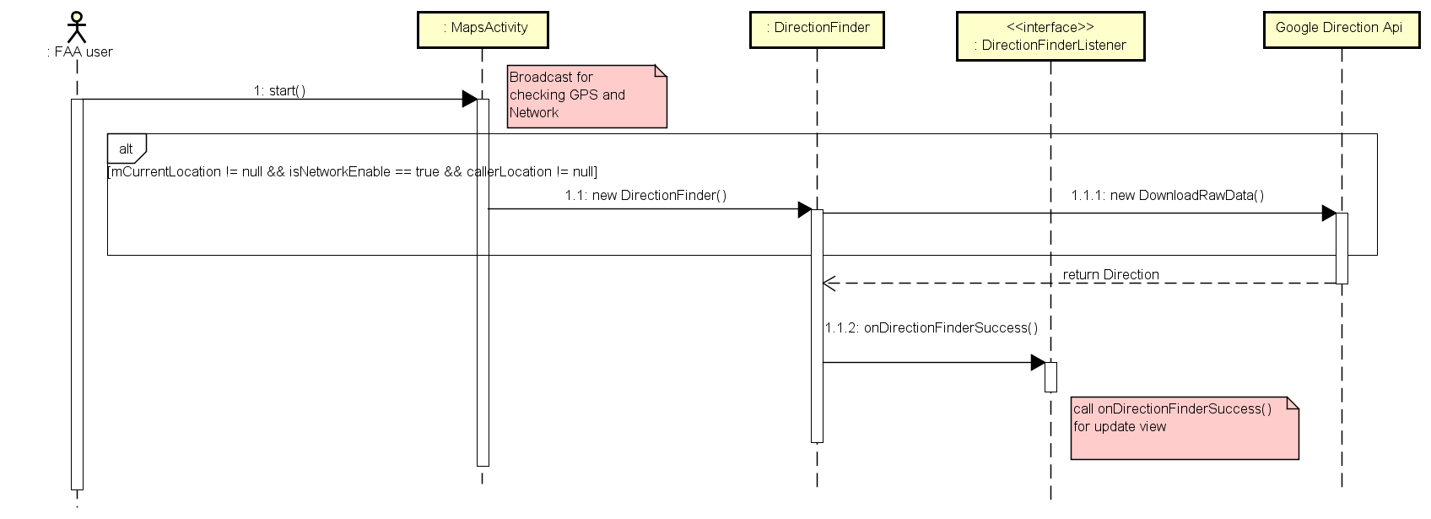

Figure 4‑26: Show direction to health facility

Broadcast is Refer to Sequence diagram for checking GPS and Network

Call to health facility

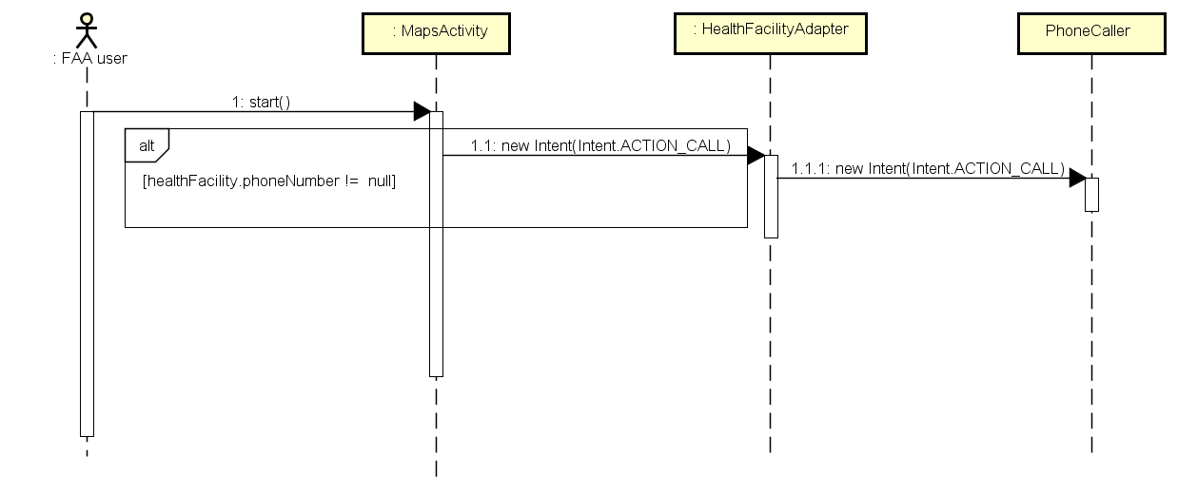

Figure 4‑27: Call to health facility

##### Learning

###### Class Diagram

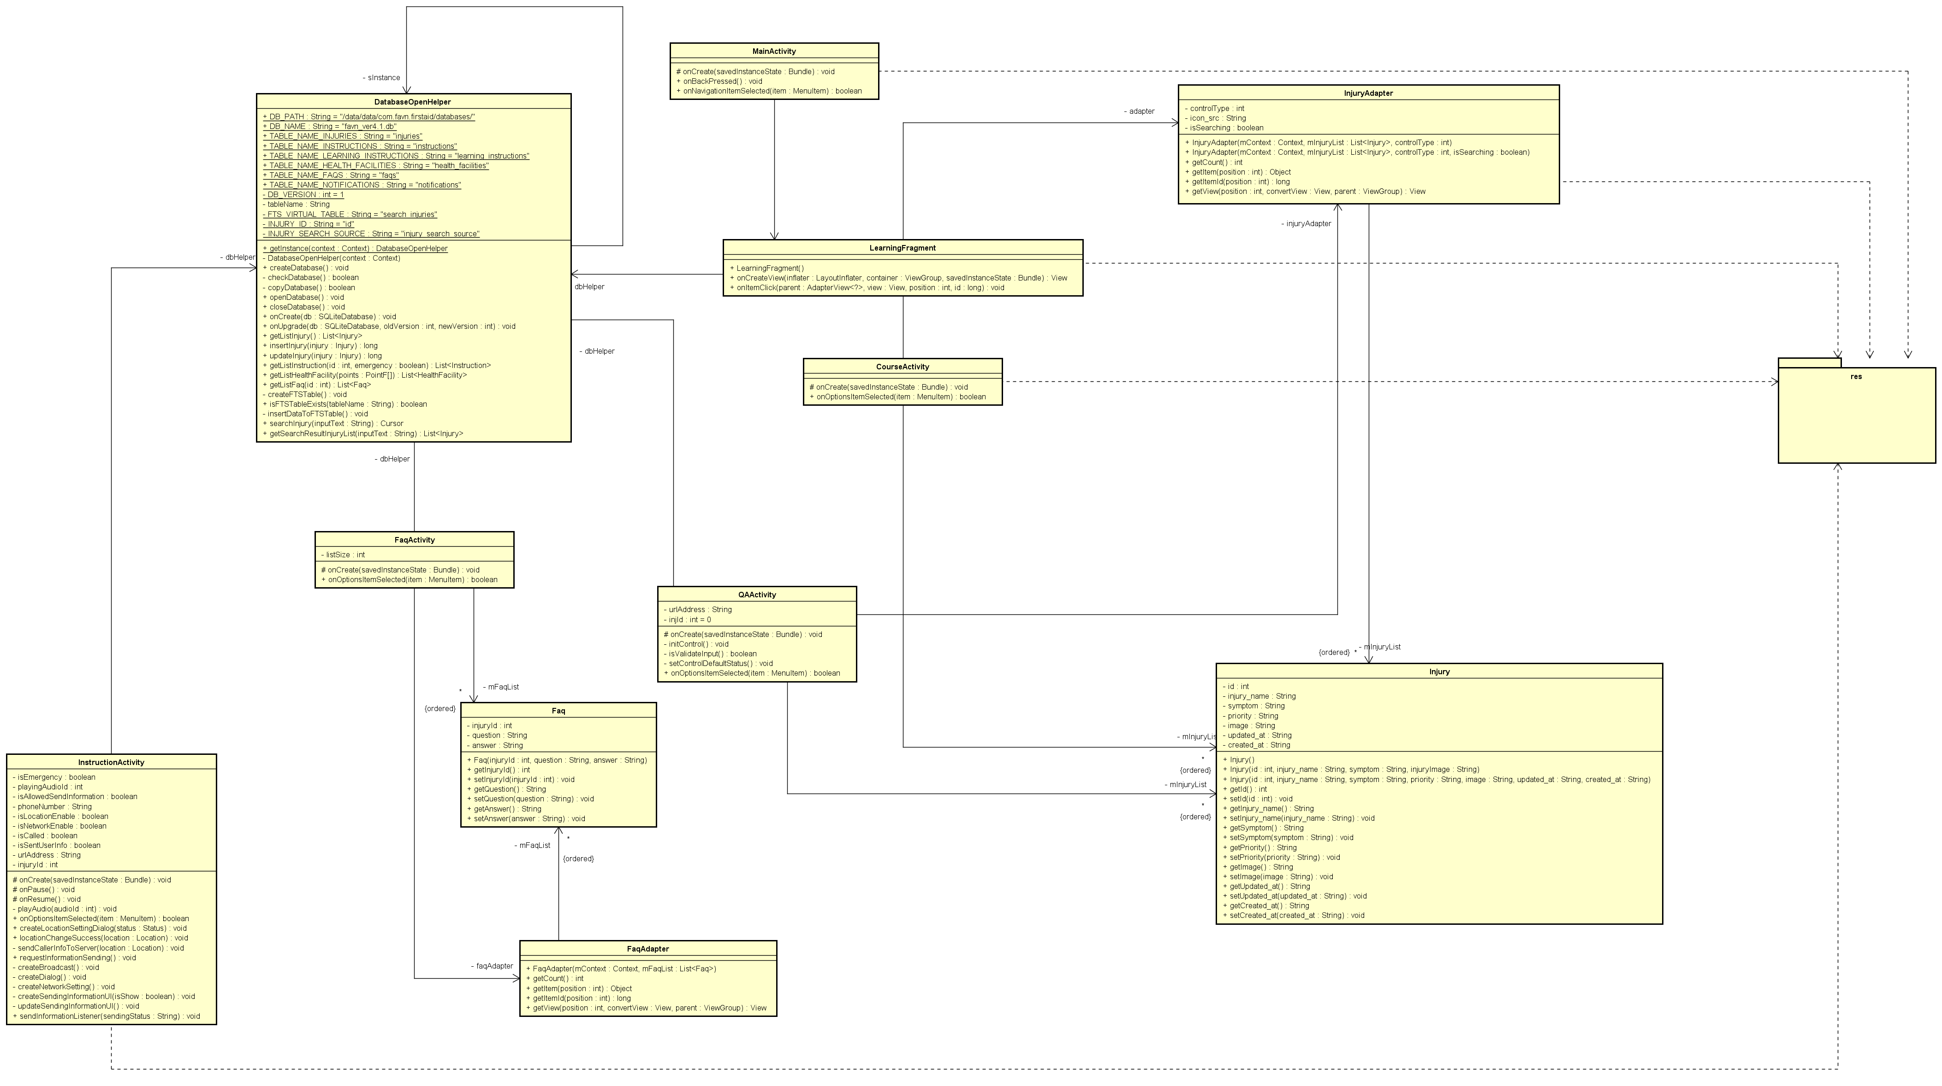

Figure 4‑28: Learning class diagram

###### Sequence Diagram

View list of learning injuries

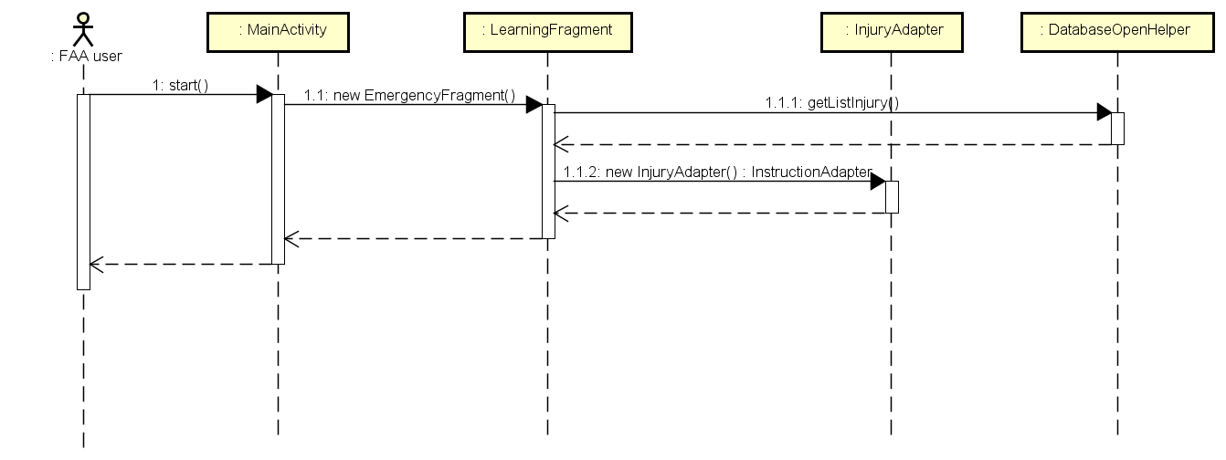

Figure 4‑29: View list of learning injuries

View learning instruction steps

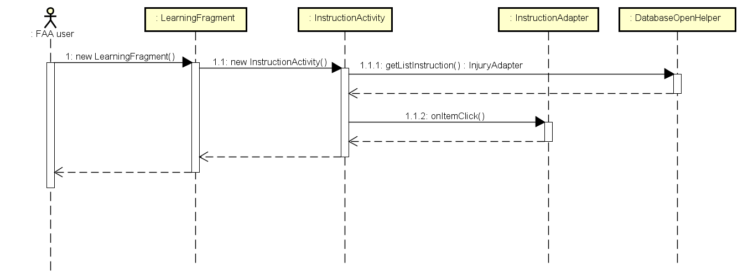

Figure 4‑30: View learning instruction steps

View FAQs

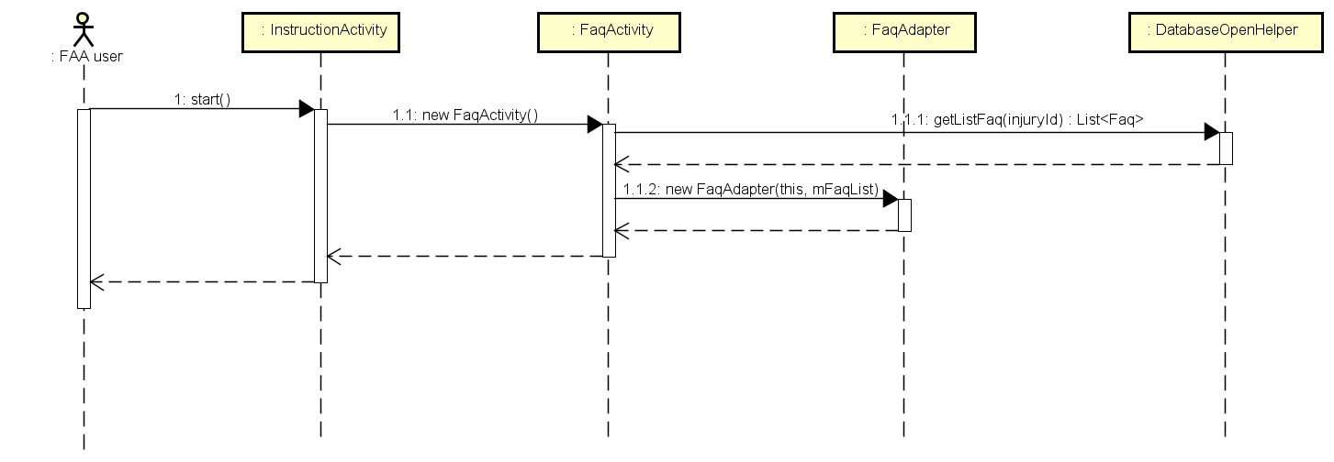

Figure 4‑31: View FAQs

##### More

###### Class Diagram

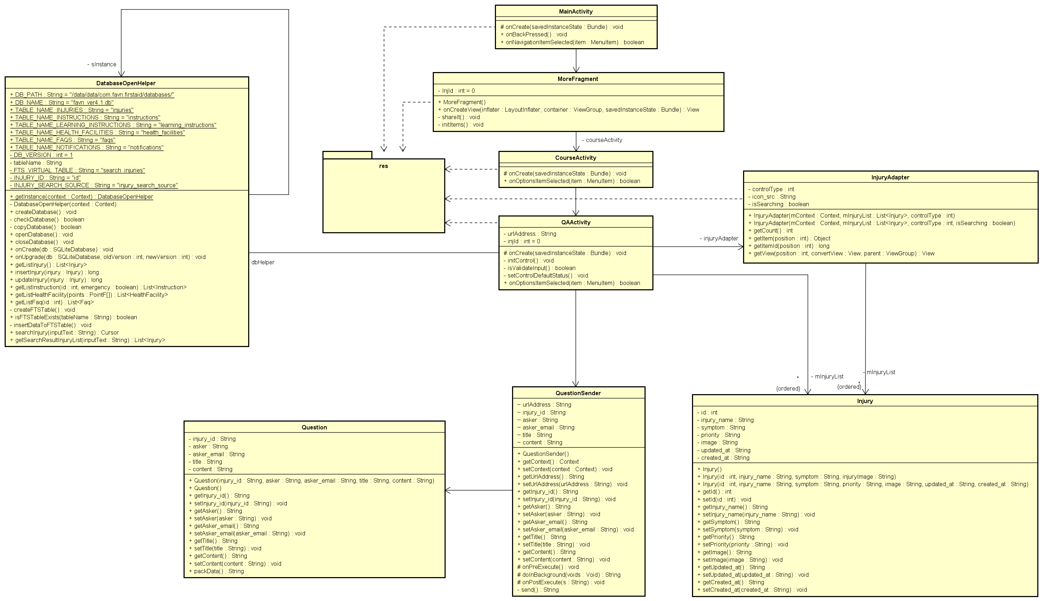

Figure 4‑32: Learning class diagram

###### Sequence Diagram

Send questions

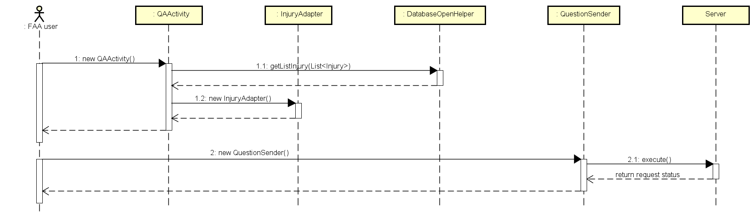

Figure 4‑33: Send questions

View course

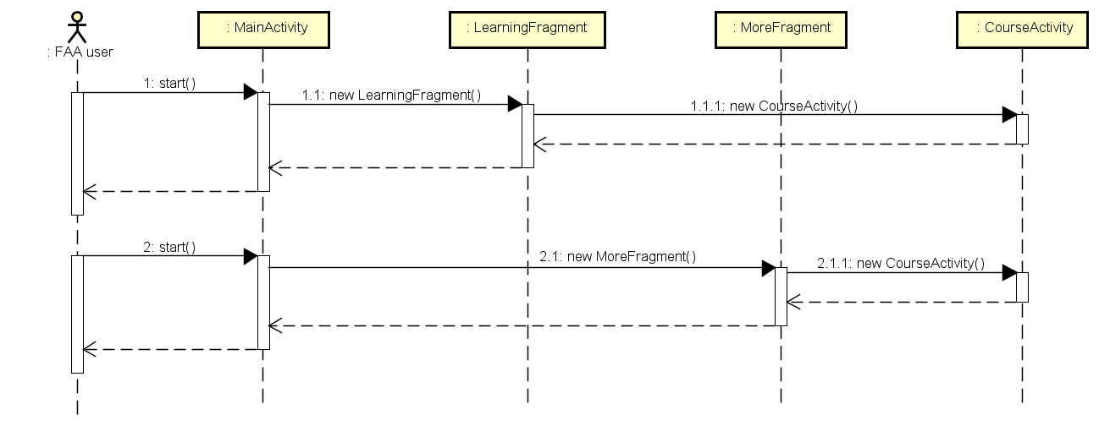

Figure 4‑34: View courses

Share application

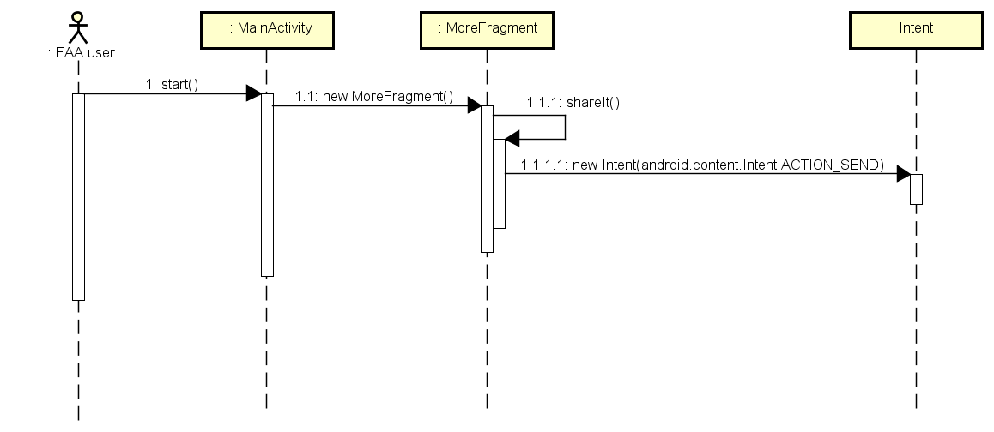

Figure 4‑35: Share application

##### Setting

###### Class Diagram

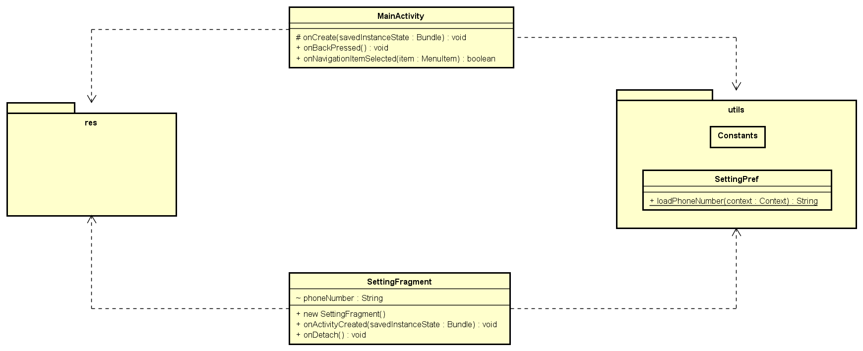

Figure 4‑36: Setting class diagram

###### Sequence Diagram

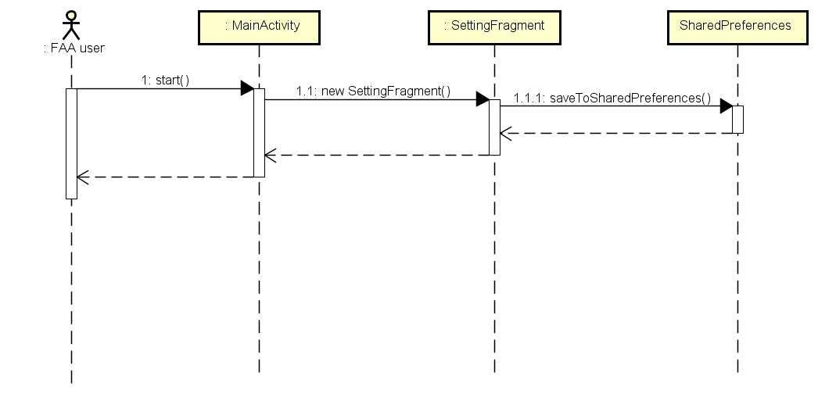

Figure 4‑37: Setting sequence diagram

##### Information

###### Class Diagram

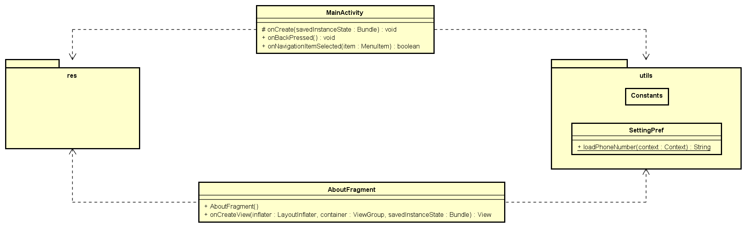

Figure 4‑38: Information class diagram

###### Sequence Diagram

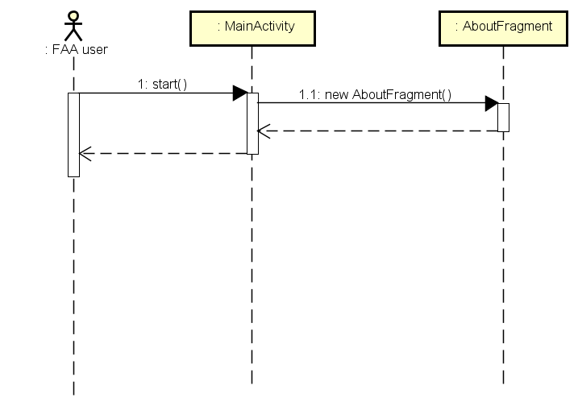

Figure 4‑39: View application information

#### Ambulance Application

##### Common

###### Class Diagram

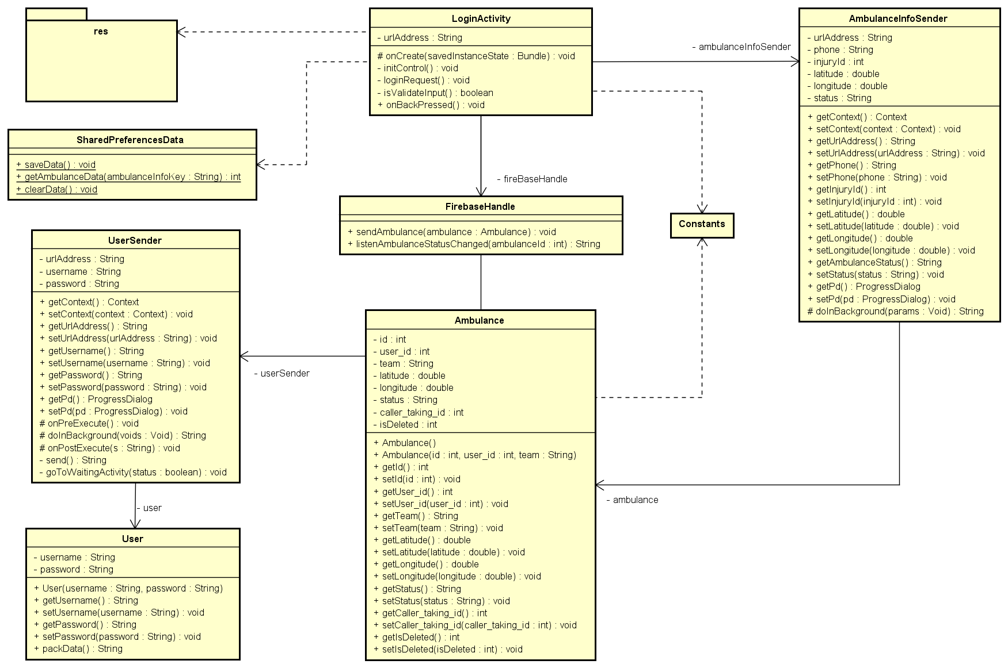

Figure 4‑40: Common class diagram

###### Sequence Diagram

Login Sequence diagram

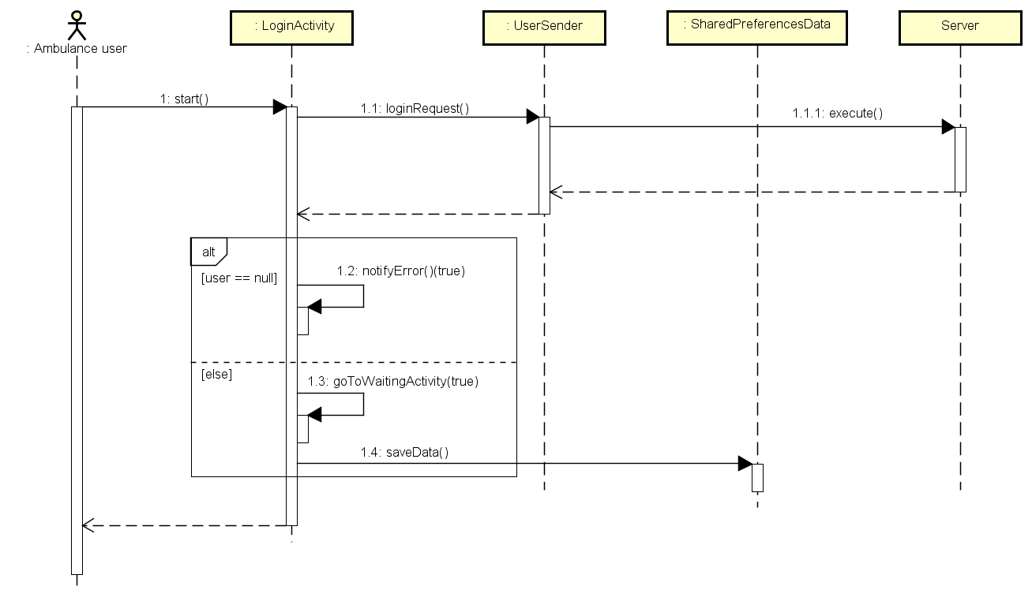

Figure 4‑41: Login sequence diagram

Logout Sequence diagram

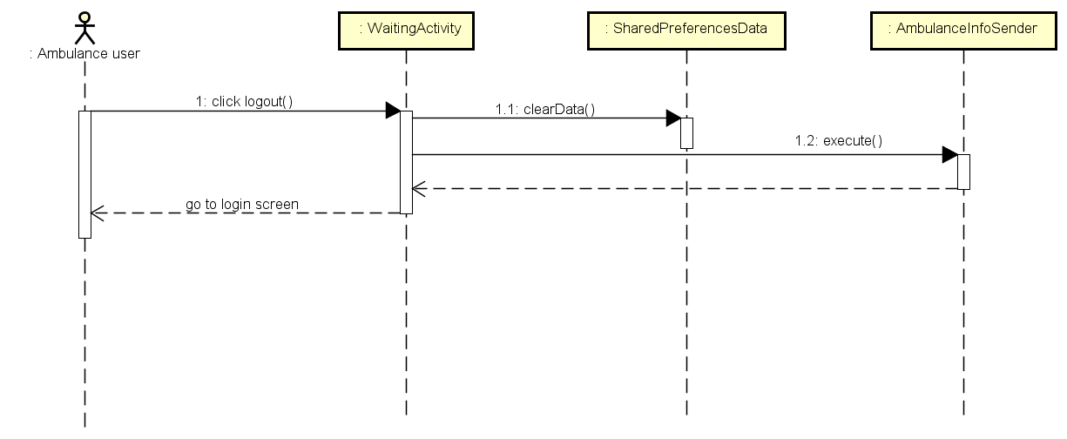

Figure 4‑42: Logout sequence diagram

##### Task

###### Class Diagram

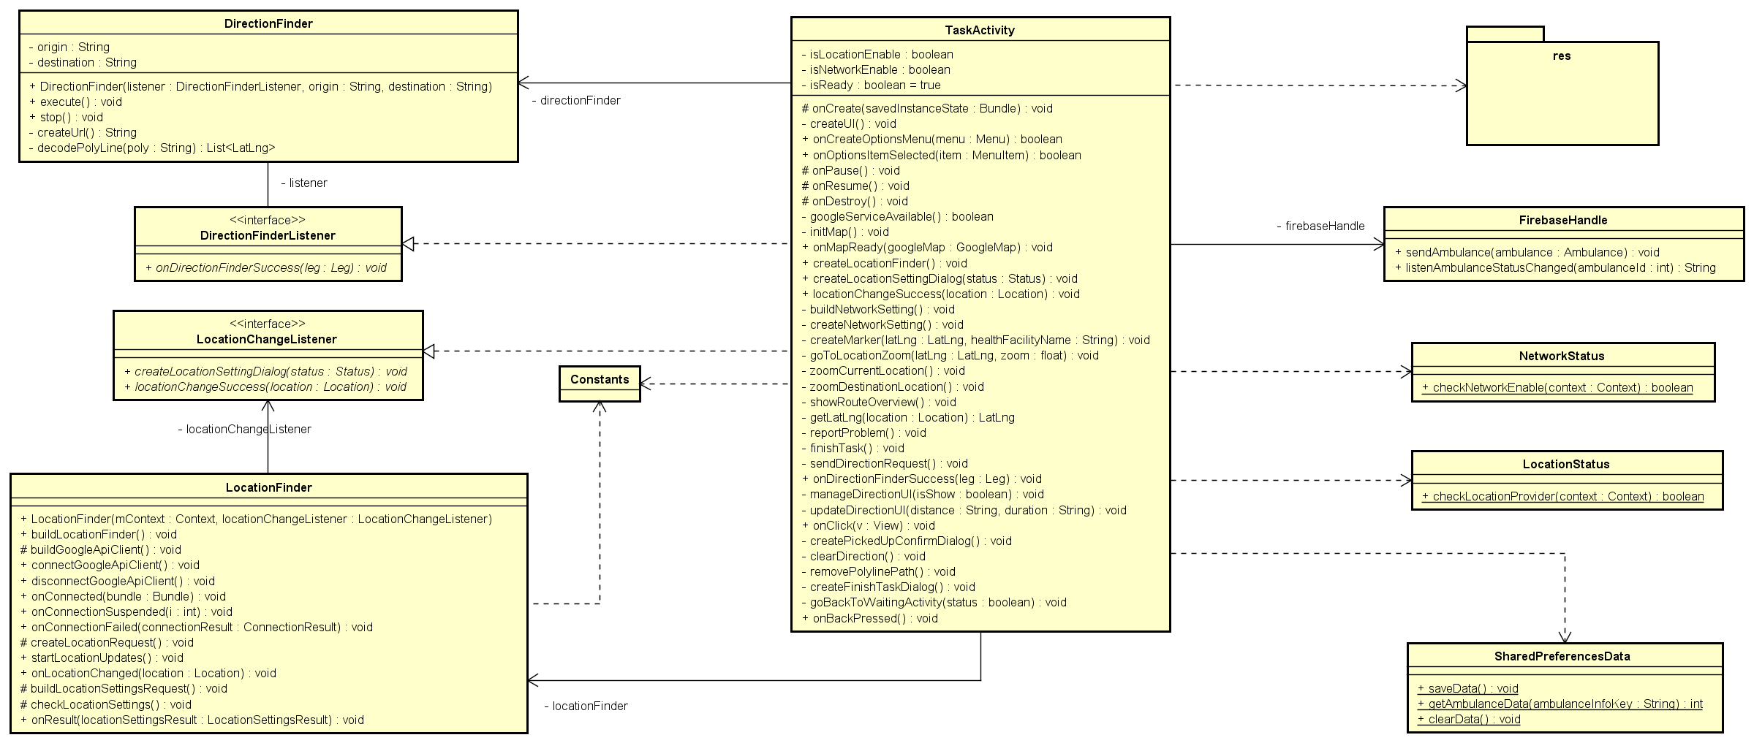

Figure 4‑43: Task class diagram

###### Sequence Diagram

View ambulance team information sequence diagram

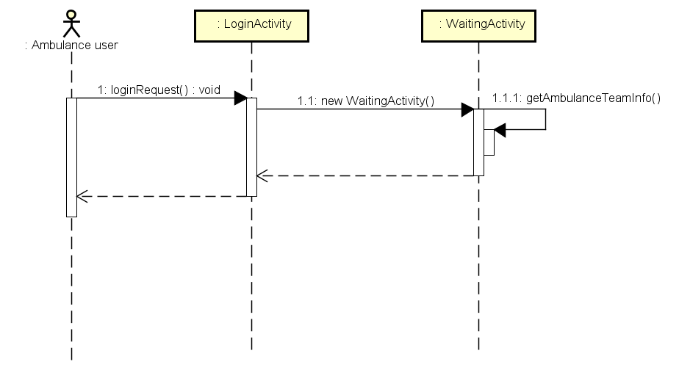

Change status sequence diagram

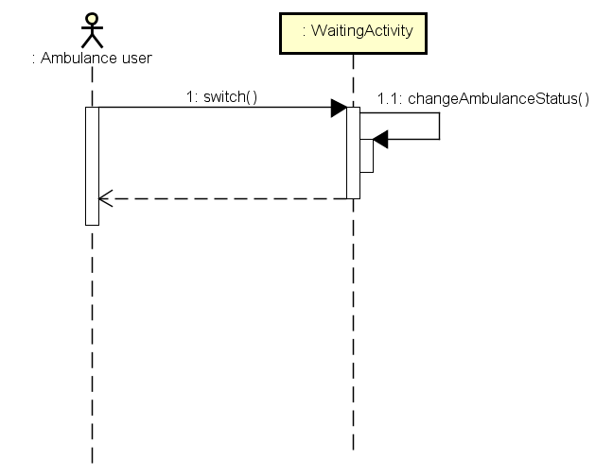

Notify task sequence diagram

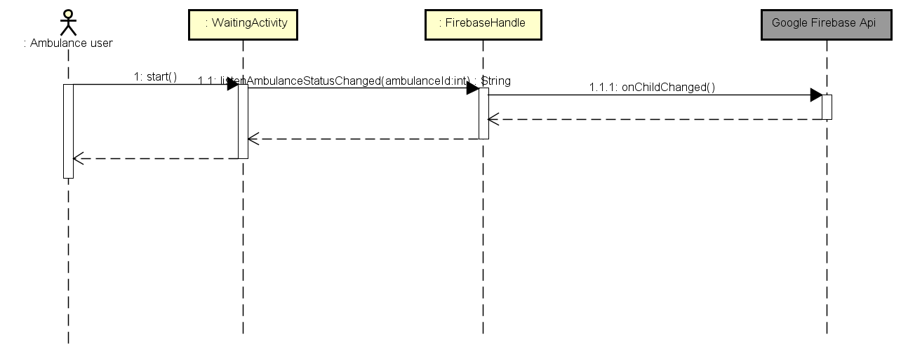

View current location sequence diagram

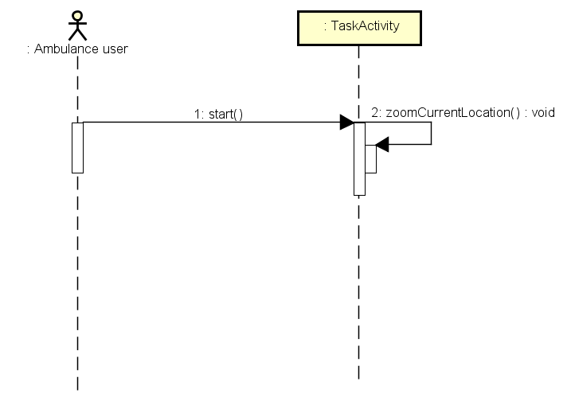

Show location of caller sequence diagram

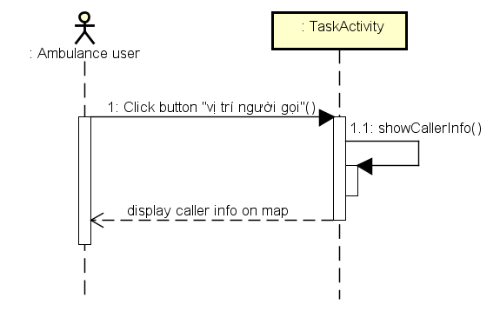

Show direction to caller sequence diagram

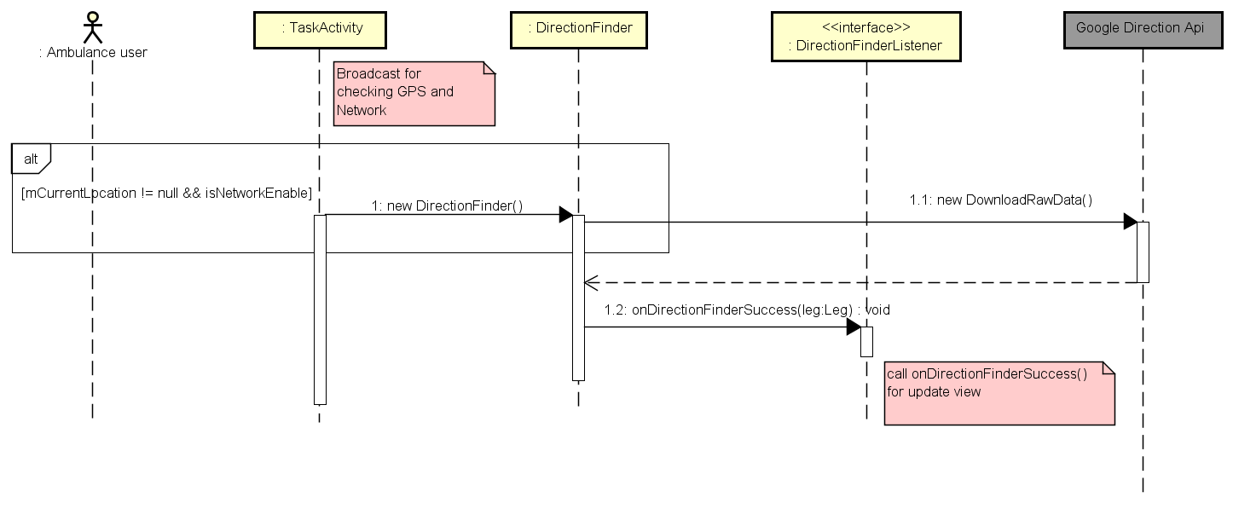

Report picked up victim sequence diagram

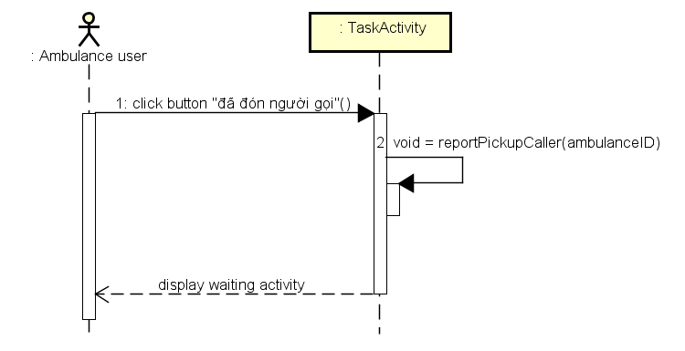

Report completed task sequence diagram

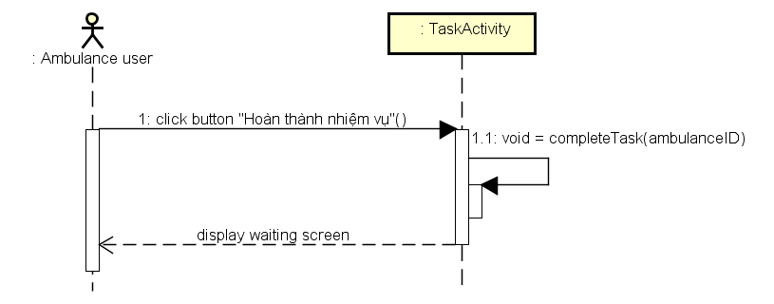

Report problem sequence diagram

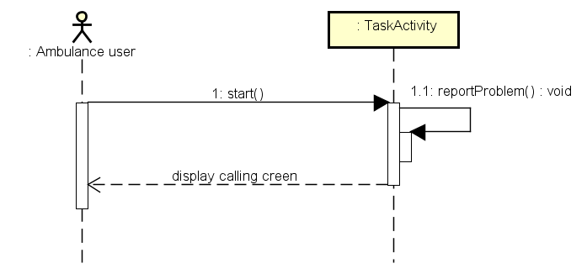

##### Information

###### Class Diagram

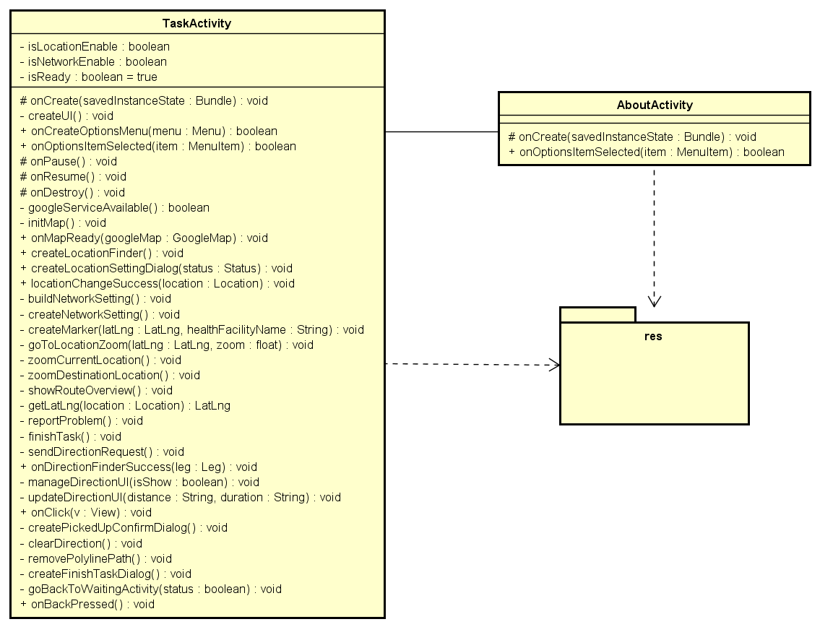

###### Sequence Diagram

View application information sequence diagram

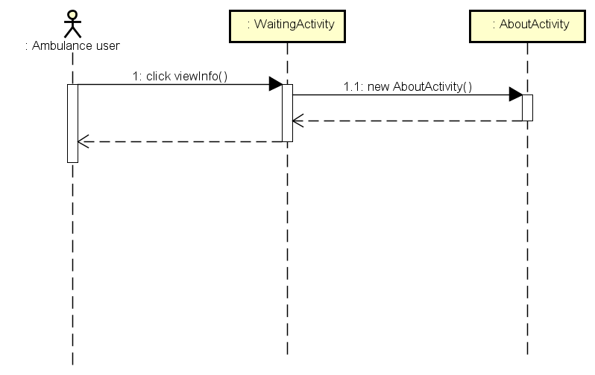

#### Dispatcher Application

##### Common

###### Class diagram

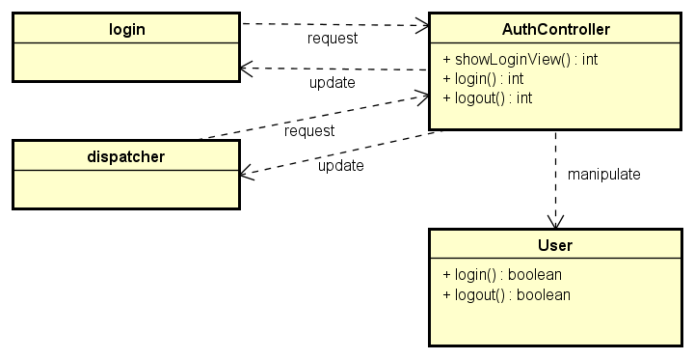

Figure 4‑44: Common Class Diagram

###### Sequence diagram

Refer to 3.4.1.2 of this document with classes above to handle sequence

##### Create emergency case

###### Class diagram

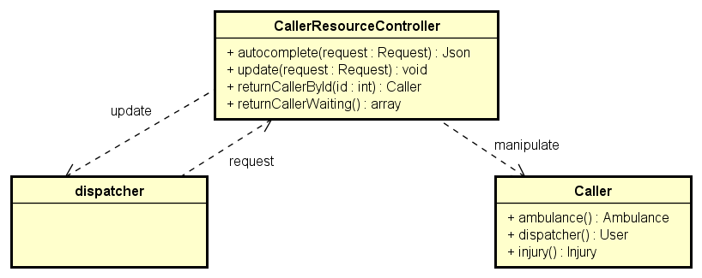

Figure 4‑45: Create Emergency Case Class Diagram

###### Sequence diagram

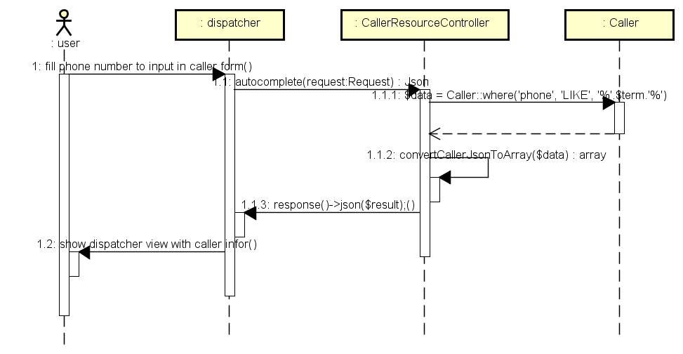

Figure 4‑46: Create Emergency Case Sequence Diagram

##### Dispatch ambulance

###### Class diagram

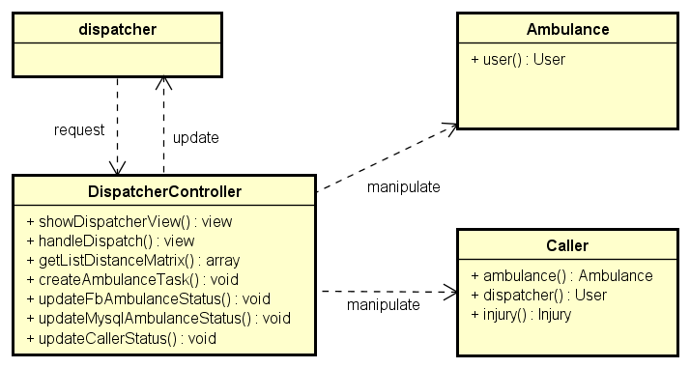

Figure 4‑47: Dispatch Ambulance Class Diagram

###### Sequence diagram

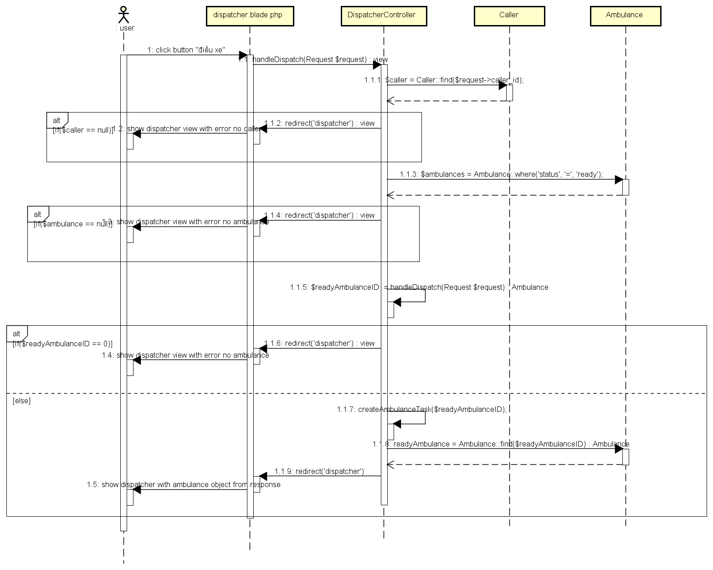

Figure 4‑48: Dispatch Ambulance Class Diagram

##### View ambulance information

###### Class diagram

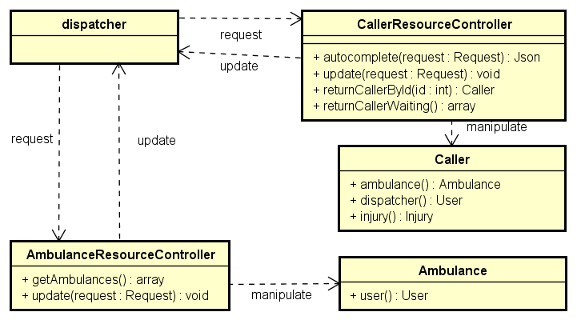

Figure 4‑49: View Ambulance Information Class Diagram

###### Sequence diagram

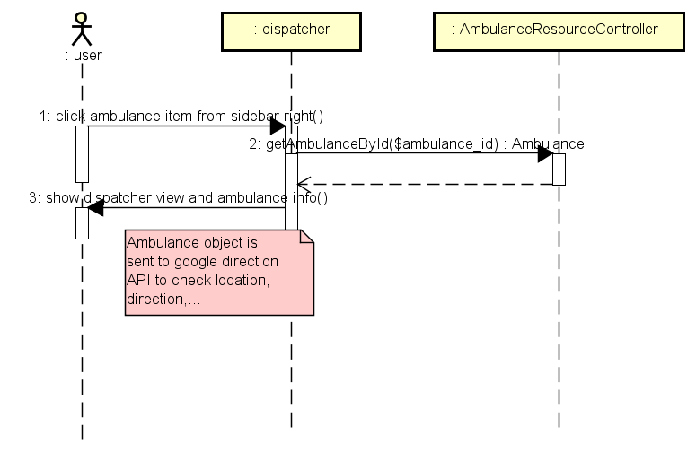

Figure 4‑50: View Ambulance Information Sequence Diagram

#### Admin/Expert Application

##### Common

###### Class diagram

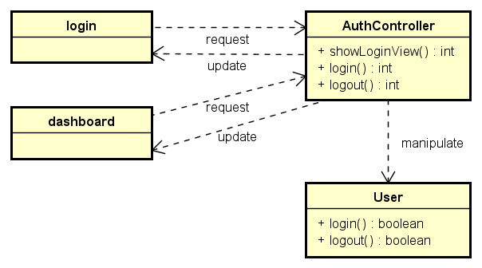

###### Sequence diagram

Login

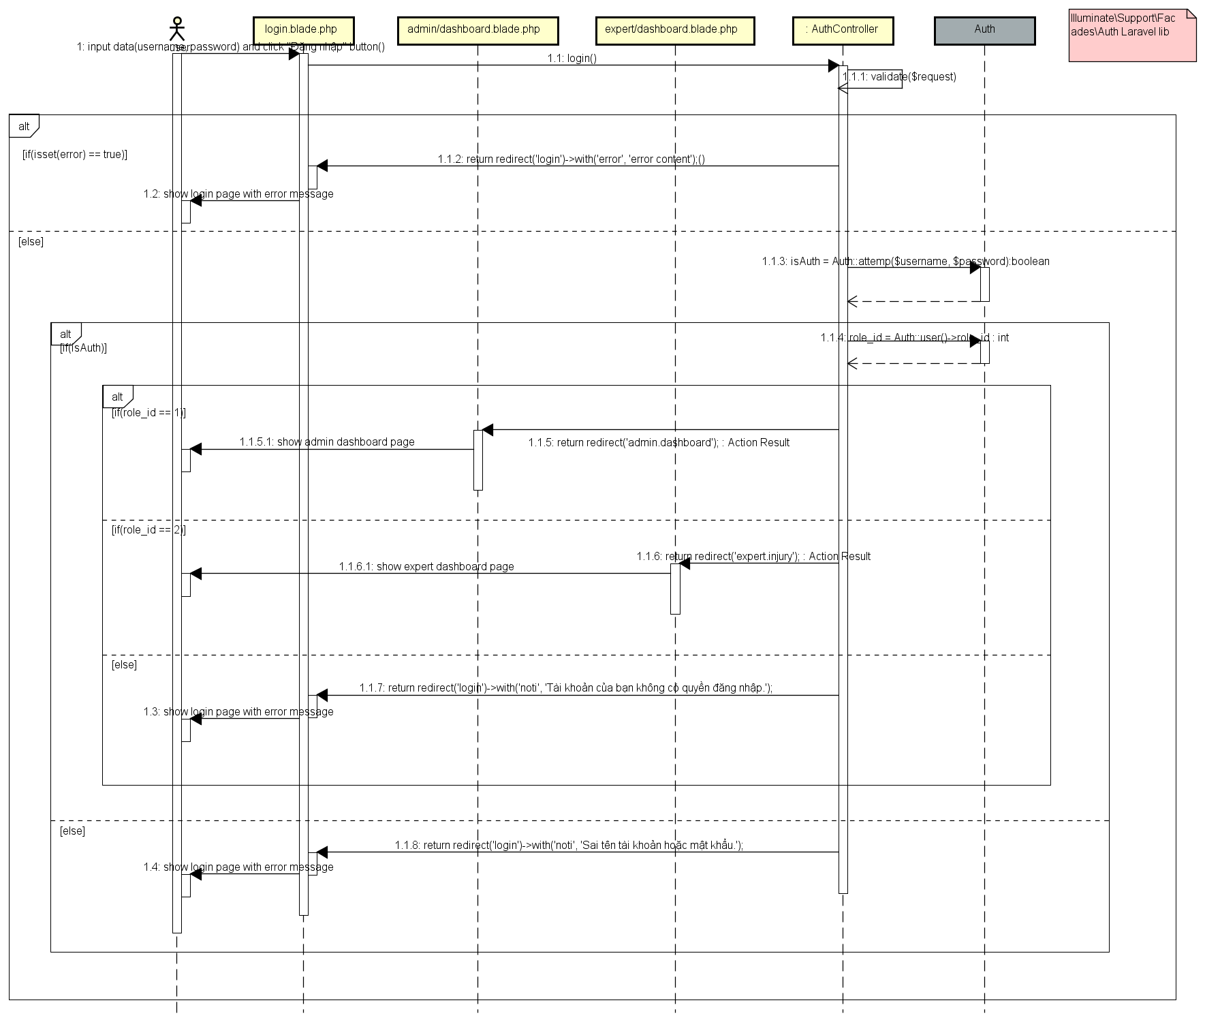

##### Manage user’s account

###### Class diagram

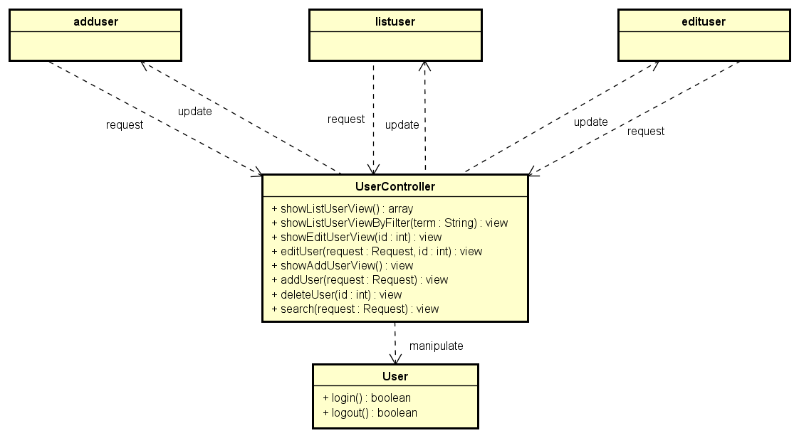

###### Sequence diagram

Refer to 3.4.4.2 of this document with classes above to handle sequence .

##### Manage Q&A

###### Class diagram

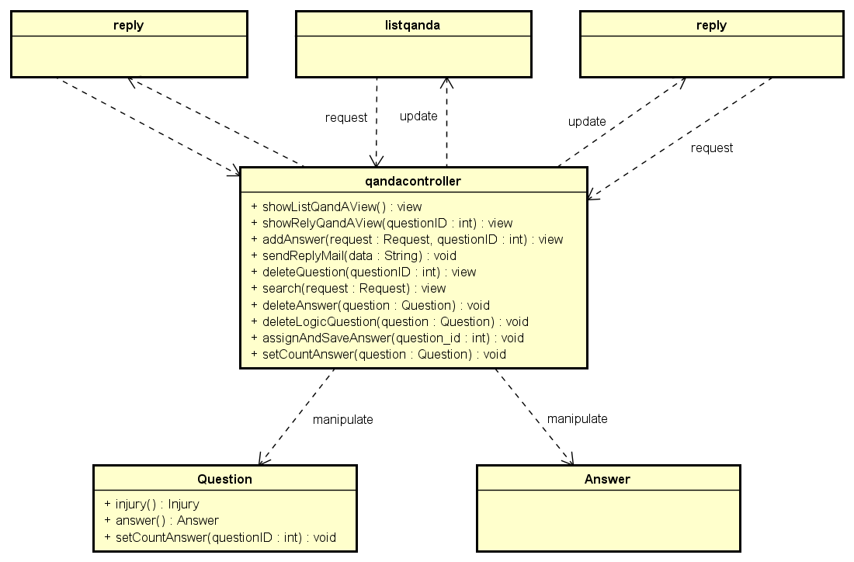

###### Sequence diagram

Answer question

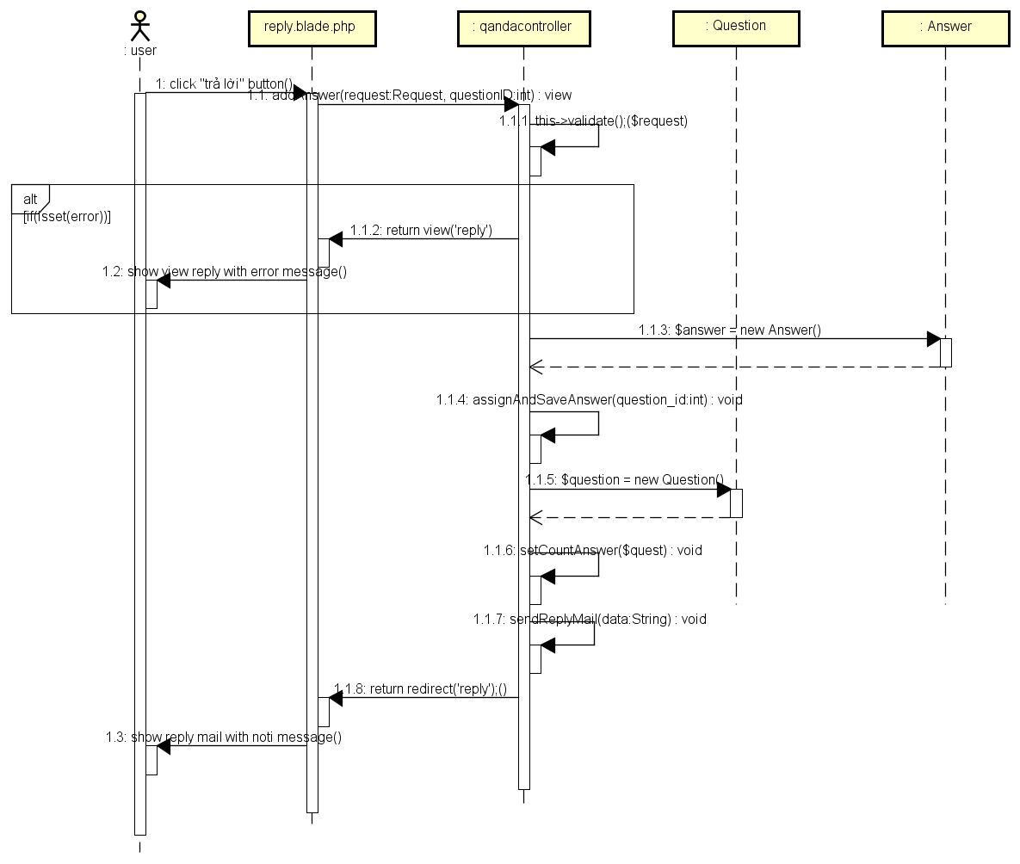

Delete question

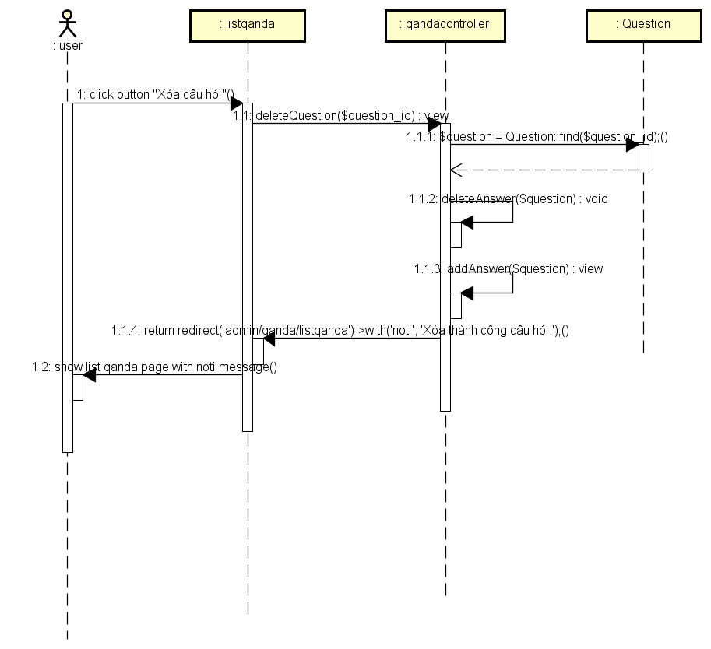

##### Manage injury

###### Class diagram

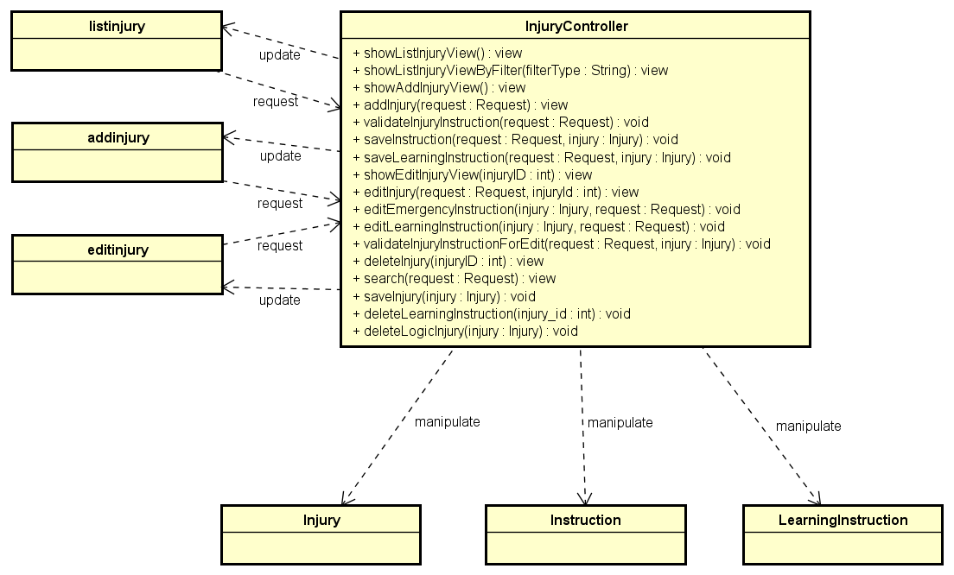

###### Sequence diagram

Add new injury

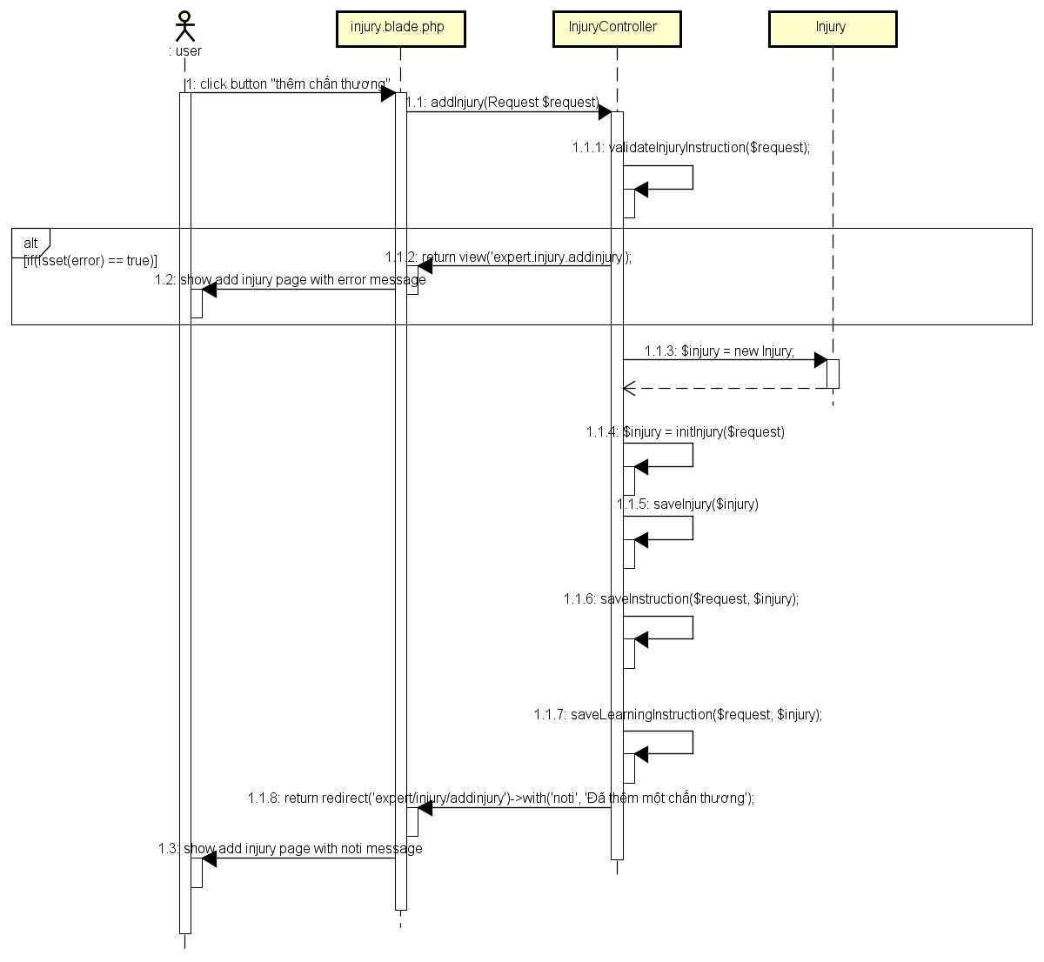

View list of injuries

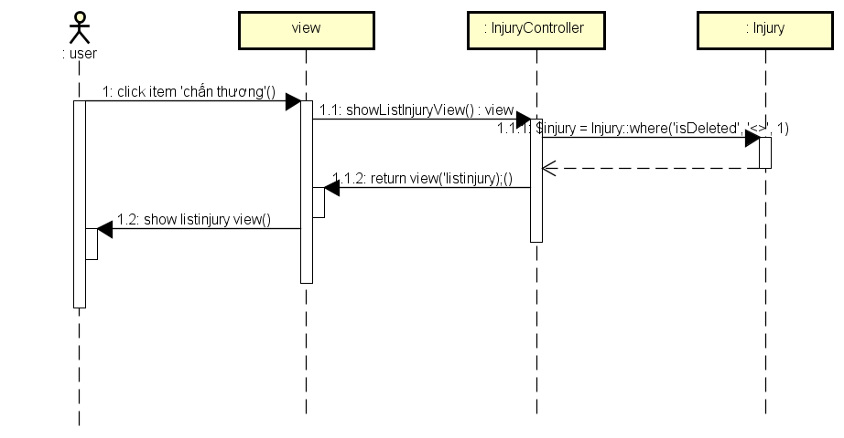

Search injury

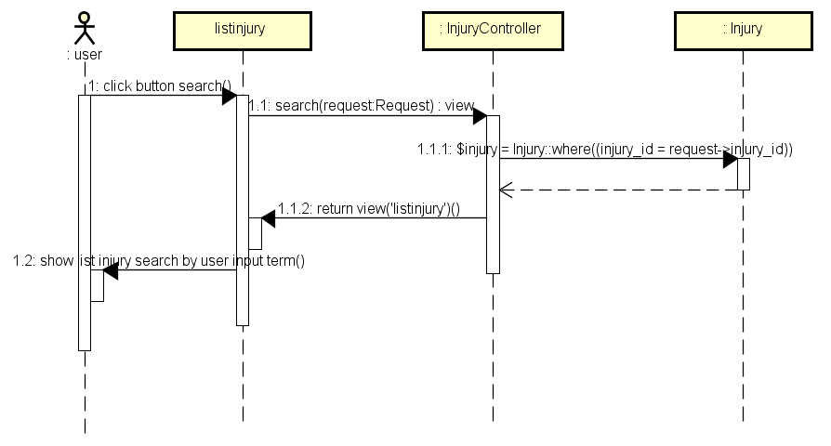

Update injury

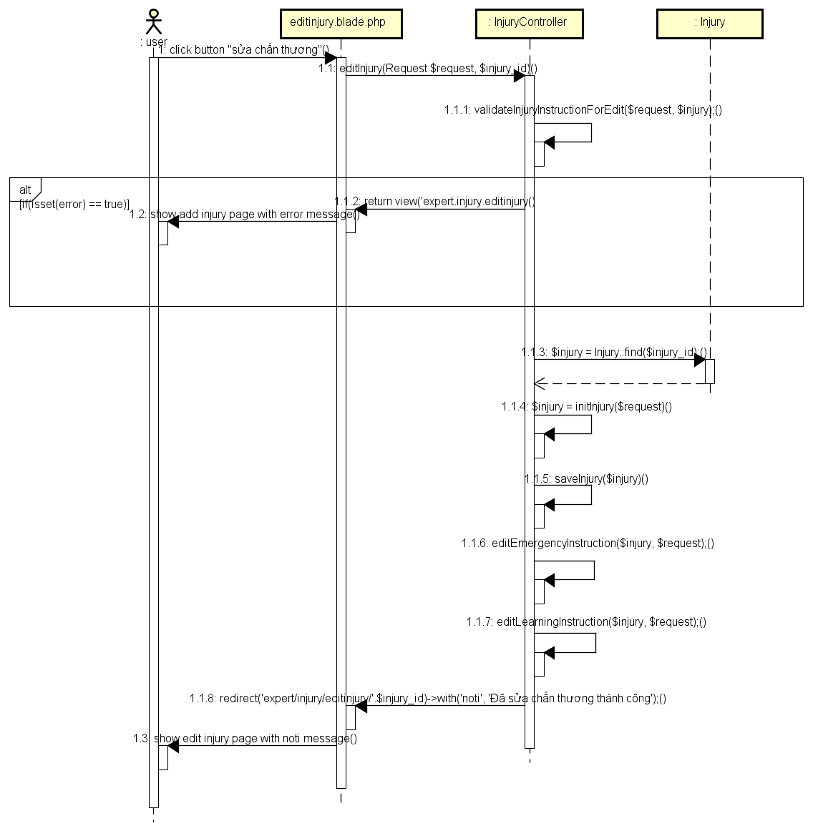

Delete injury

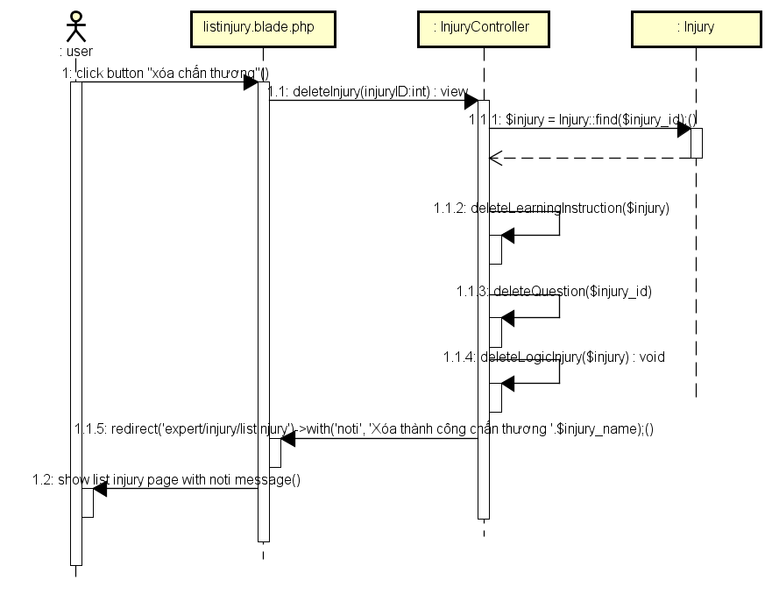

## Data design

### Entity Relationship Diagram



Figure 4‑51: Entity Relationship Diagram

#### Entity description

|  |  |  |
| --- | --- | --- |
| No | Entity | Description |
|  | Admin | An Admin who manage all registered user |
|  | FAA User | A FAA User who using FA application |
|  | Dispatcher | A Dispatcher who using Dispatcher web |
|  | Caller | A Caller who calls 115 |
|  | Ambulance Team | An Ambulance Team who control a ambulance car |
|  | Medical Center | A Medical Center which 115 center in the different city |
|  | Faq | A Faq which question of user for a injury |
|  | Injury | An Injury which |
|  | Instruction | An Instruction which content of a emergency situation |
|  | Learning Instructions | A Learning Instruction which content of a learning information |
|  | Health Facility | A Health Facility which hospital or medicine center |
|  | Expert | An Expert who answers the questions of user |

Table 4‑17: Entity description

#### Relationship

|  |  |  |  |  |  |
| --- | --- | --- | --- | --- | --- |
| No | Relation | Properties | From | To | Description |
|  | Has | None | Medical Center | Ambulance Team | A medical center has many ambulance |
|  | Look for | None | FAA User | Health Facility | A FAA’s user looks for many health facility |
|  | Has | None | Injury | Faq | An Injury has many faq or not |
|  | Answer | None | Expert | Faq | An expert can answers many faq |
|  | Has | None | Medical Center | Dispatcher | A medical center has many dispatchers |
|  | Dispatch | None | Dispatcher | Ambulance Team | A dispatcher dispatchs many ambulances |
|  | Emergency Request | None | Caller | Dispatcher | A caller has emergency request for dispatcher |
|  | Has | None | FAA User | Faq | A FAA’s user creates many faqs or not, a faq created by 1 or many FAA’s user s |
|  | Has | None | Caller | Injury | A caller has many injuries or not |
|  | Has | None | Injury | Instruction | An injury has many instructions |
|  | Has | None | Injury | Learning Instruction | An injury has many learn informations |
|  | Manage Account | None | Admin | Ambulance Team | Admin manages many ambulance team’s account |
|  | Manage Account | None | Admin | Dispatcher | Admin manages many dispatcher’s account |
|  | Create | None | Expert | Instruction | An expert creates many instruction |
|  | Create | None | Expert | Learning Instruction | An expert creates many learning instruction |
|  | Create | None | Expert | Injury | An expert creates many injuries |

Table 4‑18: Relationship description

### Table Diagram

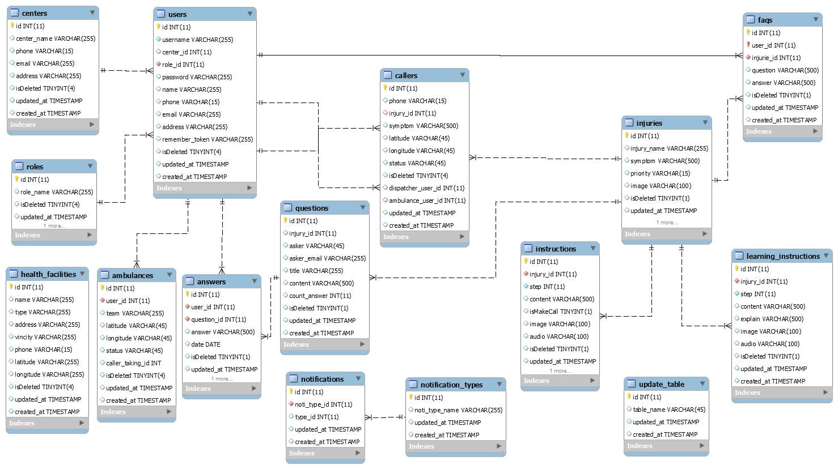

Figure 4‑52: Table Diagram

#### Users table

|  |  |  |  |  |
| --- | --- | --- | --- | --- |
| No | Field Name | Type | Allow Null | Description |
|  | id | int | No | User’s ID |
|  | username | varchar | No | User’s name |
|  | center_id | varchar |  | User’s password |
|  | role_id | int |  | User’s centerID |
|  | password | int | No | User’s roleID |
|  | name | varchar |  | User’s real name |
|  | phone | varchar |  | User’s phone number |
|  | email | varchar |  | User’s email address |
|  | address | varchar |  | User’ address |
|  | remember_token | varchar |  | User’s |
|  | isDeleted | int |  | User’s delete status |
|  | updated_at | TIMESTAMP |  | User’s updated time |
|  | created_at | TIMESTAMP |  | User’s created time |

Table 4‑19: User table

#### Ambulances table

|  |  |  |  |  |
| --- | --- | --- | --- | --- |
| No | Field Name | Type | Allow Null | Description |
|  | id | int | No | Ambulance’s ID |
|  | user_id | int | No | Ambulance’s userID |
|  | team | varchar |  | Ambulance’s team |
|  | latitude | varchar |  | Ambulance’s latitude |
|  | longitude | varchar |  | Ambulance’s longitude |
|  | status | varchar |  | Ambulance’s status |
|  | caller_taking_id | int | No | Ambulance’s caller taking id |
|  | isDeleted | int |  | Ambulance’s delete status |
|  | updated_at | TIMESTAMP |  | Ambulance’s updated time |
|  | created_at | TIMESTAMP |  | Ambulance’s created time |

Table 4‑20: Ambulances table

#### HealthFacilities table

|  |  |  |  |  |
| --- | --- | --- | --- | --- |
| No | Field Name | Type | Allow Null | Description |
|  | id | int | No | HealthFacility’s ID |
|  | name | varchar |  | HealthFacility’s name |
|  | type | int |  | HealthFacility’s type |
|  | address | int |  | HealthFacility’s address |
|  | vincity | varchar |  | HealthFacility’s vincity |
|  | phone | varchar |  | HealthFacility’s phone number |
|  | latitude | varchar |  | HealthFacility’s latitude |
|  | longitude | varchar |  | HealthFacility’s longitude |
|  | isDeleted | int |  | HealthFacility’s delete status |
|  | updated_at | TIMESTAMP |  | HealthFacility’s updated time |
|  | created_at | TIMESTAMP |  | HealthFacility’s created time |

Table 4‑21: HealthFacilities table

#### Faqs table

|  |  |  |  |  |
| --- | --- | --- | --- | --- |
| No | Field Name | Type | Allow Null | Description |
|  | id | int | No | Faq’s ID |
|  | user_id | int | No | Faq’s userID |
|  | injurie_id | int | No | Faq’s injuryID |
|  | question | varchar |  | Faq’s question |
|  | answer | varchar |  | Faq’s answer |
|  | isDeleted | int |  | Faq’s delete status |
|  | updated_at | TIMESTAMP |  | Faq’s updated time |
|  | created_at | TIMESTAMP |  | Faq’s created time |

Table 4‑22: Faqs table

#### Roles table

|  |  |  |  |  |
| --- | --- | --- | --- | --- |
| No | Field Name | Type | Allow Null | Description |
|  | id | int | No | Role’s ID |
|  | role_name | varchar |  | Role’s name |
|  | isDeleted | int |  | Role’s delete status |
|  | updated_at | TIMESTAMP |  | Role’s updated time |
|  | created_at | TIMESTAMP |  | Role’s created time |

Table 4‑23: Roles table

#### Centers table

|  |  |  |  |  |
| --- | --- | --- | --- | --- |
| No | Field Name | Type | Allow Null | Description |
|  | id | int | No | Center’s ID |
|  | center_name | varchar |  | Center’s name |
|  | phone | varchar |  | Center’s phone number |
|  | email | varchar |  | Center’s email address |
|  | address | varchar |  | Center’s address |
|  | isDeleted | int |  | Center’s delete status |
|  | updated_at | TIMESTAMP |  | Center’s updated time |
|  | created_at | TIMESTAMP |  | Center’s created time |

Table 4‑24: Centers table

#### ReportProject table

|  |  |  |  |  |
| --- | --- | --- | --- | --- |
| No | Field Name | Type | Allow Null | Description |
|  | ReportID | int | No | Report ’s ID |
|  | ProjectID | int | No | Report ’s project id |
|  | ReporterID | int | No | Report ’s user id, who report project |
|  | Subject | String |  | Report ’s subject |
|  | ReportContent | String |  | Report ’s report content |
|  | ReportedDate | datetime |  | Report ’s report date |
|  | Status | String |  | Report’s status |

Table 4‑25: ReportPost table

#### Injuries table

|  |  |  |  |  |
| --- | --- | --- | --- | --- |
| No | Field Name | Type | Allow Null | Description |
|  | id | int | No | Injury’s ID |
|  | injury_name | varchar |  | Injury’s name |
|  | symptom | varchar |  | Injury’s symptom |
|  | priority | varchar |  | Injury’s priority |
|  | image | varchar |  | Injury’s image |
|  | isDeleted | int |  | Injury’s delete status |
|  | updated_at | TIMESTAMP |  | Injury’s updated time |
|  | created_at | TIMESTAMP |  | Injury’s created time |

Table 4‑26: Injuries table

#### Answers table

|  |  |  |  |  |
| --- | --- | --- | --- | --- |
| No | Field Name | Type | Allow Null | Description |
|  | id | int | No | Answer’s ID |
|  | user_id | int | No | Answer’s userID |
|  | question_id | int | No | Answer’s questionID |
|  | answer | varchar |  | Answer’s answer |
|  | date | Date |  | Answer’s date |
|  | isDeleted | int |  | Answer’s delete status |
|  | updated_at | TIMESTAMP |  | Answer’s updated time |
|  | created_at | TIMESTAMP |  | Answer’s created time |

Table 4‑27: Answers table

#### Questions table

|  |  |  |  |  |
| --- | --- | --- | --- | --- |
| No | Field Name | Type | Allow Null | Description |
|  | question_id | int | No | Question’s ID |
|  | injury_id | int |  | Question’s injuryID |
|  | asker | varchar |  | Question’s asker name |
|  | asker_email | varchar |  | Question’s asker email address |
|  | title | varchar |  | Question’s title |
|  | content | varchar |  | Question’s content |
|  | count_answer | int |  | Question’s countAnswer |
|  | isDeleted | int |  | Question’s delete status |
|  | updated_at | TIMESTAMP |  | Question’s updated time |
|  | created_at | TIMESTAMP |  | Question’s created time |

Table 4‑28: Questions table

#### Update table

|  |  |  |  |  |
| --- | --- | --- | --- | --- |
| No | Field Name | Type | Allow Null | Description |
|  | id | int |  | Update’s ID |
|  | table_name | varchar |  | Update’s table name |
|  | updated_at | TIMESTAMP |  | Update’s updated time |
|  | created_at | TIMESTAMP |  | Update’s created time |

Table 4‑29: Update table

#### Notifications table

|  |  |  |  |  |
| --- | --- | --- | --- | --- |
| No | Field Name | Type | Allow Null | Description |
|  | id | int | No | Notification’s ID |
|  | noti_type_id | int | No | Notification’s notification type ID |
|  | type_id | int |  | Notification’s typeID |
|  | updated_at | TIMESTAMP |  | Notification’s updated time |
|  | created_at | TIMESTAMP |  | Notification’s created time |

Table 4‑30: Notifications table

#### Callers table

|  |  |  |  |  |
| --- | --- | --- | --- | --- |
| No | Field Name | Type | Allow Null | Description |
|  | id | int | No | Caller’s ID |
|  | injury_id | int |  | Caller’s injuryID |
|  | phone | varchar |  | Caller’s phone number |
|  | symptom | varchar |  | Caller’s symptom |
|  | latitude | varchar |  | Caller’s latitude |
|  | longitude | varchar |  | Caller’s longitude |
|  | status | varchar |  | Caller’s status |
|  | dispatcher_user_id | int |  | Caller’s dispatcher user ID |
|  | ambulance_user_id | int |  | Caller’s ambulance user ID |
|  | isDeleted | int |  | Caller’s delete status |
|  | updated_at | TIMESTAMP |  | Caller’s updated time |
|  | created_at | TIMESTAMP |  | Caller’s created time |

Table 4‑31: Callers table

#### Instructions table

|  |  |  |  |  |
| --- | --- | --- | --- | --- |
| No | Field Name | Type | Allow Null | Description |
|  | id | int | No | Instruction’s ID |
|  | injury_id | int | No | Instruction’s injuryID |
|  | step | int | No | Instruction’s step |
|  | content | varchar |  | Instruction’s content |
|  | isMakeCall | int |  | Instruction’s make call status |
|  | image | varchar |  | Instruction’s image |
|  | audio | varchar |  | Instruction’s audio |
|  | isDeleted | int |  | Instruction’s delete status |
|  | updated_at | TIMESTAMP |  | Instruction’s updated time |
|  | created_at | TIMESTAMP |  | Instruction’s created time |

Table 4‑32: Instructions table

#### LearningInstructions table

|  |  |  |  |  |
| --- | --- | --- | --- | --- |
| No | Field Name | Type | Allow Null | Description |
|  | id | int | No | LearningInstruction’s ID |
|  | injury_id | int | No | LearningInstruction’s injury ID |
|  | step | int | No | LearningInstruction’s step |
|  | content | varchar |  | LearningInstruction’s content |
|  | explain | varchar |  | LearningInstruction’s explain |
|  | image | varchar |  | LearningInstruction’s image |
|  | audio | varchar |  | LearningInstruction’s audio |
|  | isDeleted | int |  | LearningInstruction’s delete status |
|  | updated_at | TIMESTAMP |  | LearningInstruction’s updated time |

Table 4‑33: LearningInstructions table

#### NotificationTypes table

|  |  |  |  |  |
| --- | --- | --- | --- | --- |
| No | Field Name | Type | Allow Null | Description |
| 1 | id | int | No | NotificationType’s ID |
| 2 | noti_type_name | varchar |  | NotificationType’s name |
| 3 | updated_at | TIMESTAMP |  | NotificationType’s updated time |
| 4 | created_at | TIMESTAMP |  | NotificationType’s created time |

Table 4‑34: NotificationTypes table

## Screen Design

### First Aid

#### Screen flow

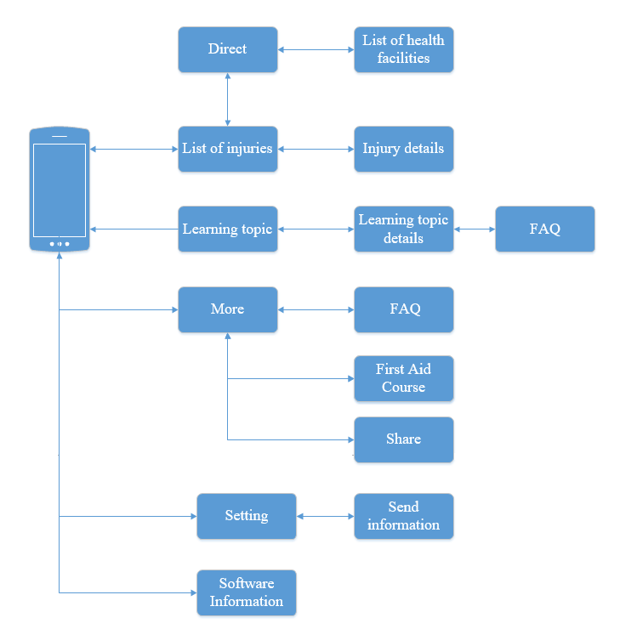

Figure 4‑53: First Aid screen flow

#### Emergency Screen

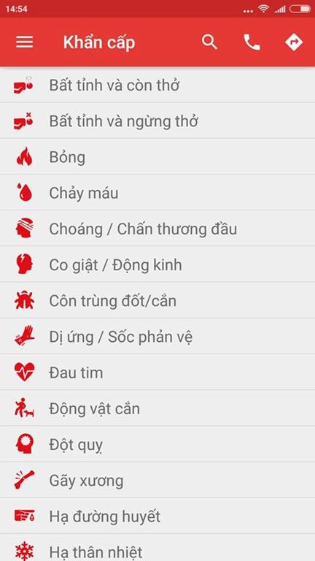

Figure 4‑54: Emergency Screen

|  |  |  |  |  |  |  |  |
| --- | --- | --- | --- | --- | --- | --- | --- |
| No | Field name | Field name in Vietnamese | Type | Require | Mandatory | Max-Length | Description |
|  | Menu Bar | Menu | Button | Tap on | Y |  | Show list of screen |
|  | Search | Tìm Kiếm | Icon | Tap on | Y |  | Show textbox to input characters |
|  | Call | Gọi | Icon | Tap on | Y |  | Auto dialing 115 |
|  | Direct | Chỉ đường | Icon | Tap on | Y |  | Move to screen Direct. |
|  | List of injuries | Danh sách các trường hợp khẩn cấp | List |  | Y |  | Show list of emergency. |

Table 4‑35: Emergency Screen

##### Emergency Details

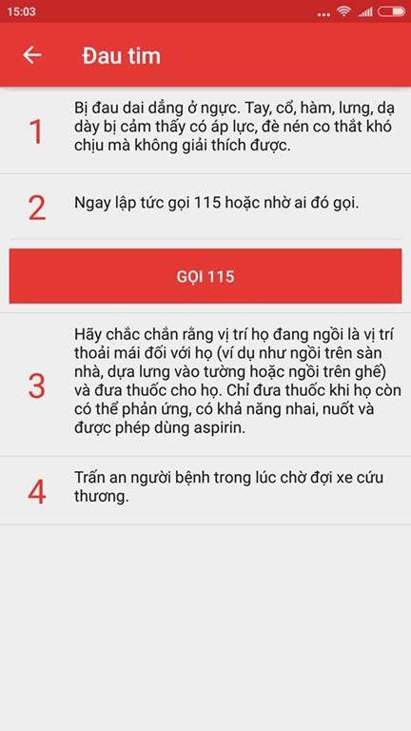

Figure 4‑55: Emergency Details

|  |  |  |  |  |  |  |  |
| --- | --- | --- | --- | --- | --- | --- | --- |
| No | Field name | Field name in Vietnamese | Type | Require | Mandatory | Max-Length | Description |
|  | Back button | Nút quay lại | Button |  | Tap on | Y |  |
|  | Call 115 | Gọi 115 | Button |  | Tap on | Y |  |

Table 4‑36: Emergency Details

##### Direct screen

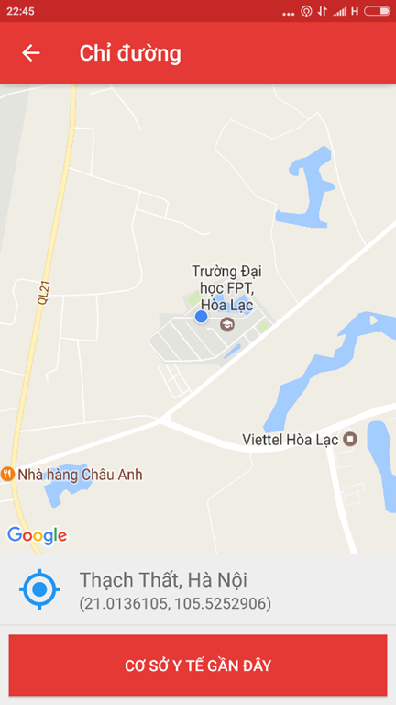

Figure 4‑56: Direct screen

|  |  |  |  |  |  |  |  |
| --- | --- | --- | --- | --- | --- | --- | --- |
| No | Field name | Field name in Vietnamese | Type | Require | Mandatory | Max-Length | Description |
| 1 | Current location | Vị trí hiện tại | Button | Tap on | Y |  | Focus to current location |
| 2 | Nearly health facilities | Cơ sở y tế gần đây | Button | Tap on | Y |  | Show the list of 20 nearest health facilites |
| 2 | Back button | Nút quay lại | Button | Tap on | Y |  | Back to the previous screen |
| 3 | Current location | Vị trí hiện tại | Button | Tap on | Y |  | Focus to current location |

Table 4‑37: Direct screen

##### List of health facilities screen

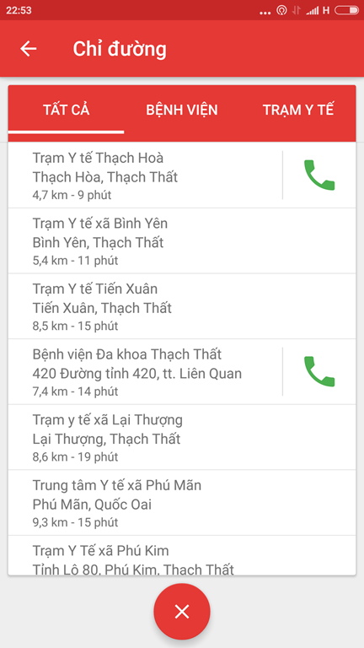

Figure 4‑57: List of health facilities screen

|  |  |  |  |  |  |  |  |
| --- | --- | --- | --- | --- | --- | --- | --- |
| No | Field name | Field name in Vietnamese | Type | Require | Mandatory | Max-Length | Description |
| 1 | List of health facilities | Danh sách các cơ sở y tế | List |  | Y |  | List health facilities |
| 2 | Close | Tắt | Button | Tap on | Y |  | Turn off the list of health facilities |
| 3 | Hospital | Bệnh viện | Button | Tap on | Y |  | Show list of hospitals |
| 4 | Medicine Center | Trạm Y Tế | Button | Tap on | Y |  | Show list of medicine center |

Table 4‑38: List of health facilities screen

#### Learning Screen

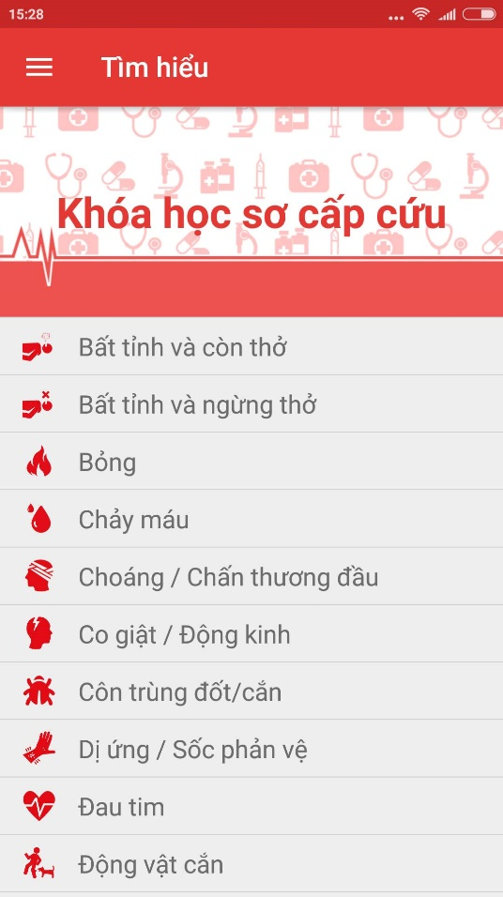

Figure 4‑58: Learning Screen

|  |  |  |  |  |  |  |  |
| --- | --- | --- | --- | --- | --- | --- | --- |
| No | Field name | Field name in Vietnamese | Type | Require | Mandatory | Max-Length | Description |
| 1 | List of learning topic | Danh sách các chủ đề tìm hiểu | List |  | Y |  | Display list of learning topic |
| 2 | First Aid Course | Các khóa học sơ cứu | Image link | Tap on | Y |  | Show the list of First Aid Course |

Table 4‑39: Learning Screen

##### Learning topic details screen

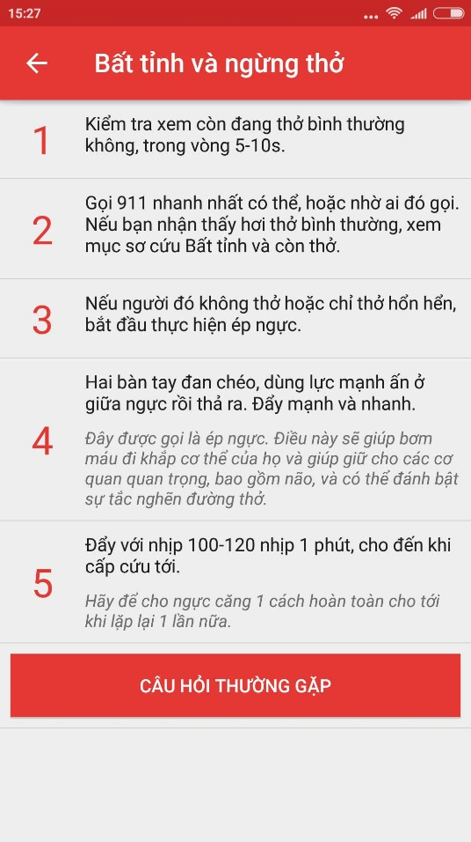

Figure 4‑59: Learning topic details screen

|  |  |  |  |  |  |  |  |
| --- | --- | --- | --- | --- | --- | --- | --- |
| No | Field name | Field name in Vietnamese | Type | Require | Mandatory | Max-Length | Description |
| 1 | Back Button | Nút quay lại | Button | Tap on | Y |  | Back to Learning screen |
| 2 | Step | Bước làm | Button | Tap on |  |  | Read the content of step |
| 3 | FAQ | Câu hỏi thường gặp | Button | Tap on | Y |  | Show the list of FAQ |

Table 4‑40: Learning topic details screen

##### FAQ screen

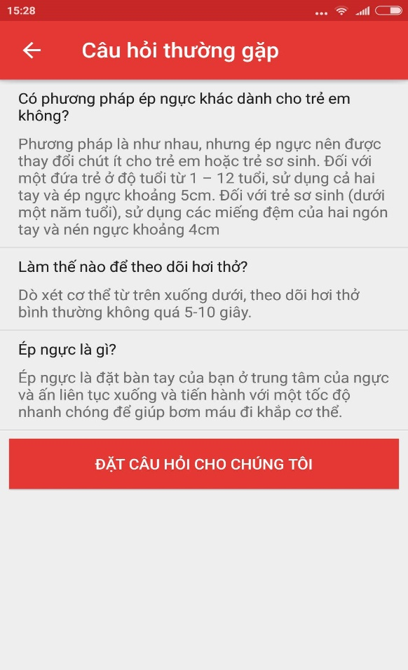

Figure 4‑60: FAQ screen

|  |  |  |  |  |  |  |  |
| --- | --- | --- | --- | --- | --- | --- | --- |
| No | Field name | Field name in Vietnamese | Type | Require | Mandatory | Max-Length | Description |
| 1 | Back button | Nút quay lại | Button | Tap on | Y |  | Back to Learning Topic Details screen |
| 2 | List of question and answers | Danh sách các câu hỏi và câu trả lời | List |  | Y |  | Show list of FAQ |
| 3 | Button Ask a question | Đặt câu hỏi cho chúng tôi | Button | Tap on | Y |  | Move to screen to send the questions. |

Table 4‑41: FAQ screen

##### Send question screen

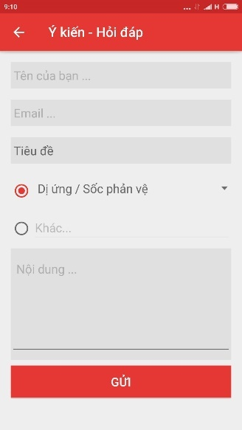

Figure 4‑61: Send question screen

|  |  |  |  |  |  |  |  |
| --- | --- | --- | --- | --- | --- | --- | --- |
| No | Field name | Field name in Vietnamese | Type | Require | Mandatory | Max-Length | Description |
| 1 | Your name | Tên của bạn | Textfield | Tap on | Y |  | Display text |
| 2 | Email | Thư điện tử | Textfield | Tap on | Y |  | Display text |
| 3 | Title | Tiêu đề | Button | Tap on | Y |  | Display tittle |
| 4 | Content | Nội dung | Textfield | Tap on | Y |  | Display text |
| 5 | Send | Gửi | Button | Tap on |  |  | Send question to system |
| 6 | Back | Quay lại | Button | Tap on | Y |  | Back to previous screen |

Table 4‑42: Send question screen

#### More Screen

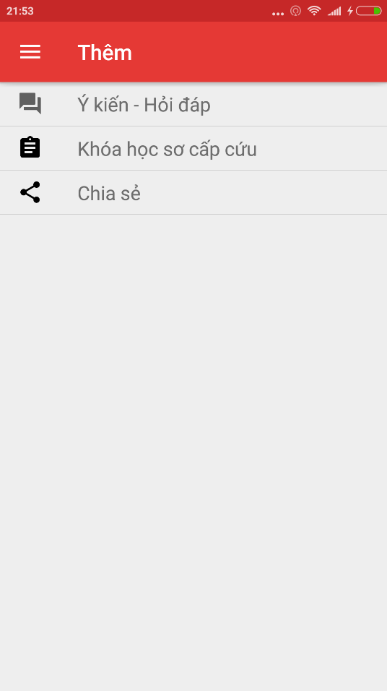

Figure 4‑62: More screen

|  |  |  |  |  |  |  |  |
| --- | --- | --- | --- | --- | --- | --- | --- |
| No | Field name | Field name in Vietnamese | Type | Require | Mandatory | Max-Length | Description |
| 1 | FAQ | Ý Kiến – Hỏi Đáp | Button |  | Y |  | Move to FAQ screen |
| 2 | First Aid Courses | Các khóa học sơ cứu | Button |  | Y |  | Move to list of First Aid Courses |
| 3 | Share | Chia sẻ | Label |  | Y |  | Share application on communication social network |

Table 4‑43: More screen

##### Send question screen



Figure 4‑63: Send question screen

|  |  |  |  |  |  |  |  |
| --- | --- | --- | --- | --- | --- | --- | --- |
| No | Field name | Field name in Vietnamese | Type | Require | Mandatory | Max-Length | Description |
| 1 | Your name | Tên của bạn | Textfield | Tap on | Y |  | Display text |
| 2 | Email | Thư điện tử | Textfield | Tap on | Y |  | Display text |
| 3 | Title | Tiêu đề | Button | Tap on | Y |  | Display tittle |
| 4 | Content | Nội dung | Textfield | Tap on | Y |  | Display text |
| 5 | Send | Gửi | Button | Tap on | Y |  | Send question to system |
| 6 | Back | Quay lại | Button | Tap on | Y |  | Back to previous screen |

Table 4‑44: Send question screen

##### First Aid Courses screen

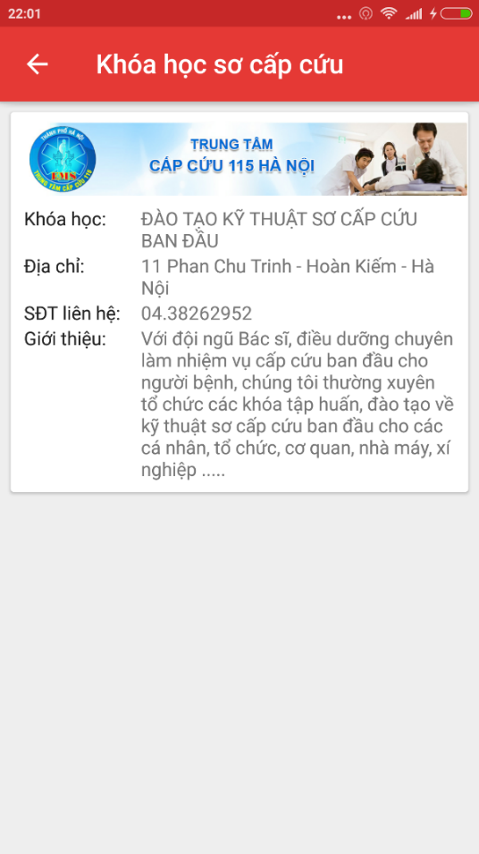

Figure 4‑64: First Aid Courses screen

|  |  |  |  |  |  |  |  |
| --- | --- | --- | --- | --- | --- | --- | --- |
| No | Field name | Field name in Vietnamese | Type | Require | Mandatory | Max-Length | Description |
| 1 | List of First Aid Courses | Danh sách khóa học sơ cứu | Card view |  | Y |  | Display text |

Table 4‑45: First Aid Courses screen

#### Software information screen

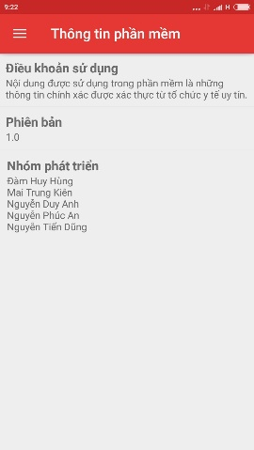

Figure 4‑65: Software information screen

|  |  |  |  |  |  |  |  |
| --- | --- | --- | --- | --- | --- | --- | --- |
| No | Field name | Field name in Vietnamese | Type | Require | Mandatory | Max-Length | Description |
| 1 | Term of use | Điều khoản sử dụng | Card view |  | Y |  | Show term of use |
| 2 | Version | Phiên bản | Card view |  | Y |  | Show the version of software |
| 3 | Name of developers | Tên nhà phát triển | Card view |  | Y |  | Show the name of developers. |

Table 4‑46: Software information screen

### Ambulance



Figure 4‑66: Admin screen flow

#### Screen flow

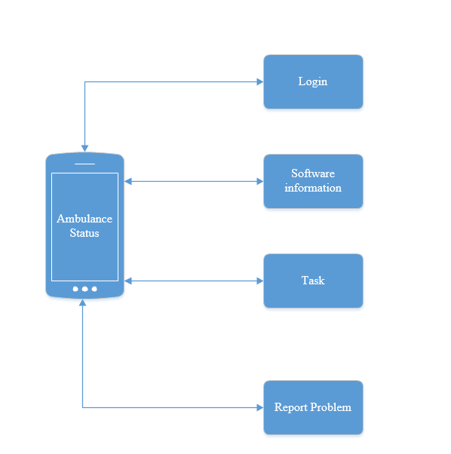

Figure 4‑67: Ambulance screen flow

#### **Login screen**

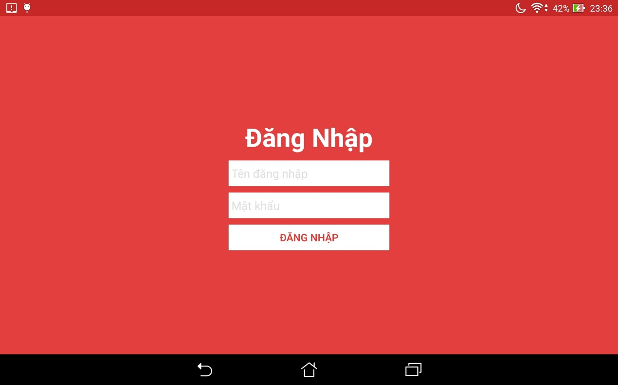

Figure 4‑68: Login screen

|  |  |  |  |  |  |  |  |
| --- | --- | --- | --- | --- | --- | --- | --- |
| No | Field name | Field name in Vietnamese | Type | Require | Mandatory | Max-Length | Description |
| 1 | Login | Đăng Nhập | Button | Click on | Y |  | Login |
| 2 | User name | Tên đăng nhập | Textfield | Click on | Y |  | Fill the user name |
| 3 | Password | Mật Khẩu | Textfield | Click on | Y |  | Fill the password |

Table 4‑47: Login screen

#### **Waitting screen**

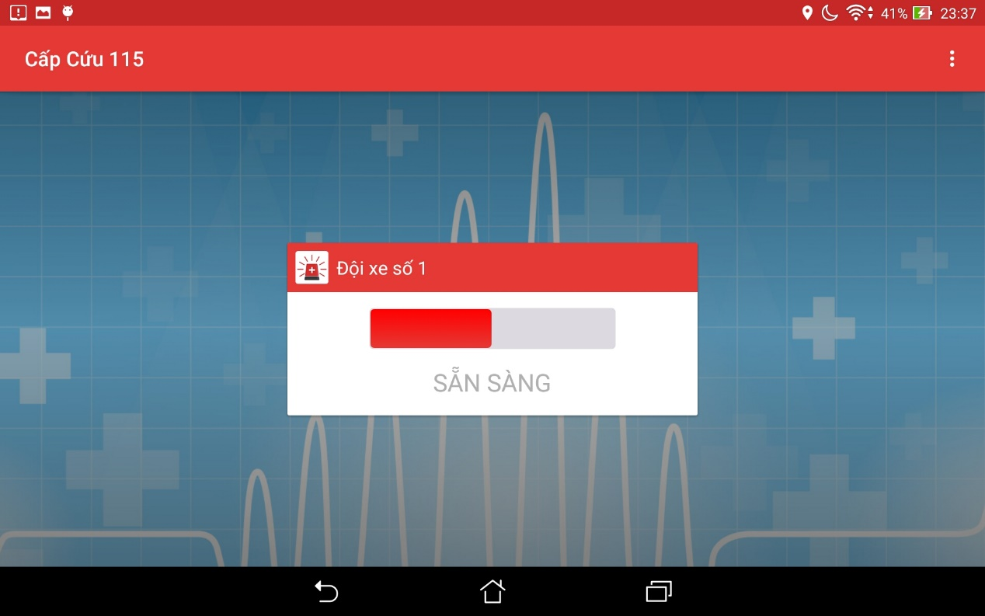

Figure 4‑69: Waiting Screen

|  |  |  |  |  |  |  |  |
| --- | --- | --- | --- | --- | --- | --- | --- |
| No | Field name | Field name in Vietnamese | Type | Require | Mandatory | Max-Length | Description |
| 1 | Ready to take the task | Sẵn sàng nhận nhiệm vụ | Switch | Tap on | Y |  | Show the status of user ready to take the task or not |
| 2 | Menu | Tùy Chọn | Dropdown list | Tap on | Y |  | Show two button [Đăng Xuất] and [Thông tin phần mềm |

Table 4‑48: Waiting Screen

#### **Task screen**

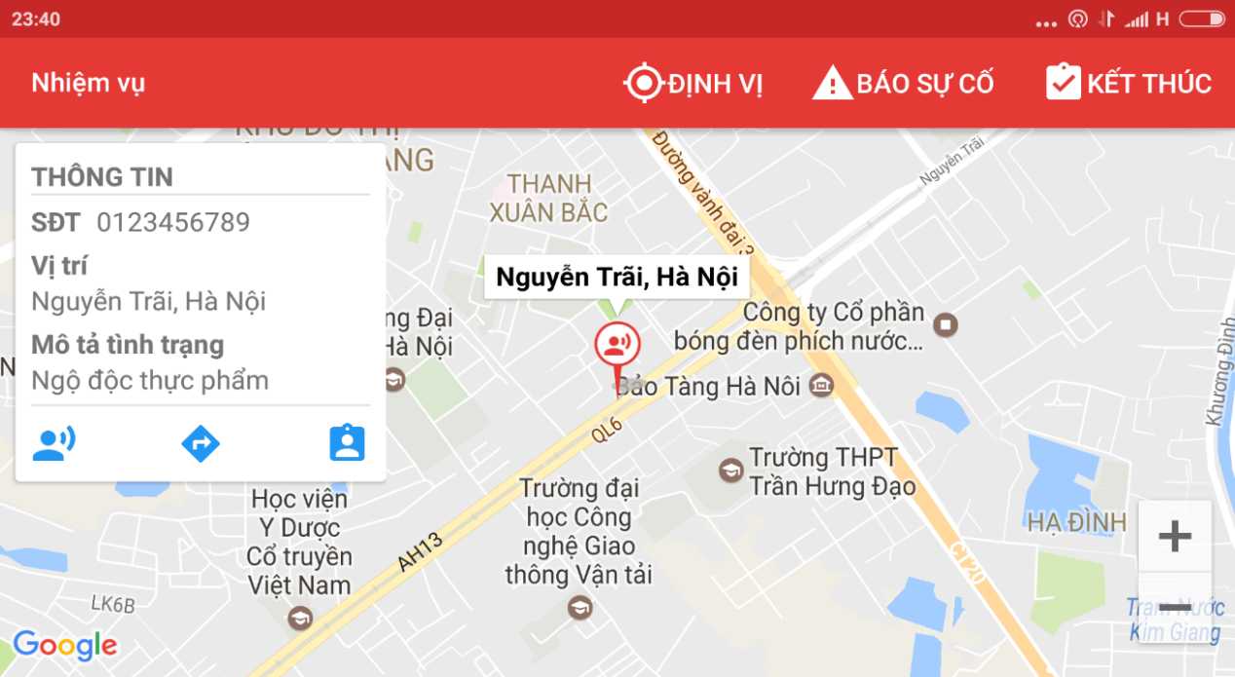

Figure 4‑70: Task screen

|  |  |  |  |  |  |  |  |
| --- | --- | --- | --- | --- | --- | --- | --- |
| No | Field name | Field name in Vietnamese | Type | Require | Mandatory | Max-Length | Description |
| 1 | Task | Nhiệm vụ | Label |  | Y |  | Name of screen |
| 2 | Locate | Định vị | Icon | Tap on | Y |  | Locate position of ambulance team |
| 3 | Information board | Bảng thông tin | Text |  | Y |  | Show the information of victims |
| 4 | Victim current position | Vị trí hiện tại của nạn nhân | Icon | Tap on | Y |  | Location position of victim |
| 5 | Direct | Chỉ Đường | Icon | Tap on | Y |  | Show the direct from ambulance team to the victim, include distance |
| 6 | Report problem | Báo Cáo Sự Cố | Icon | Tap on | Y |  | Call the center to report problem |
| 7 | Finish | Kết thúc | Icon | Tap on | Y |  | Report that mission completed or cancel |

Table 4‑49: Task screen

### Dispatcher

#### Screen flow

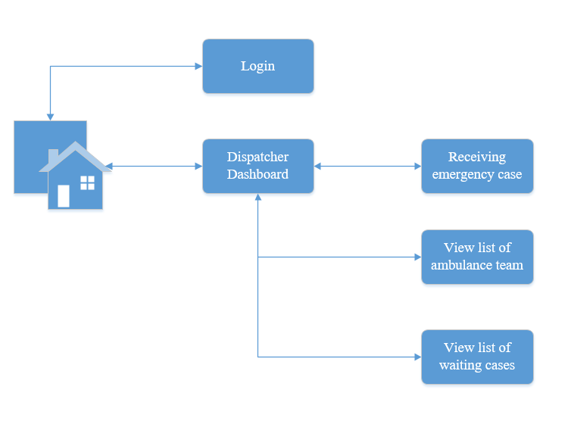

Figure 4‑71: Dispatcher screen flow

#### Login screen



Figure 4‑72: Login screen

|  |  |  |  |  |  |  |  |
| --- | --- | --- | --- | --- | --- | --- | --- |
| No | Field name | Field name in Vietnamese | Type | Require | Mandatory | Max-Length | Description |
| 1 | Login | Đăng Nhập | Button | Click on | Y |  | Login to the dispatcher dashboard page |
| 2 | User name | Tên đăng nhập | Textfield | Click on | Y |  | Fill the user name |
| 3 | Password | Mật Khẩu | Textfield | Click on | Y |  | Fill the password |

Table 4‑50: Login screen

#### Dispatcher’s Dashboard

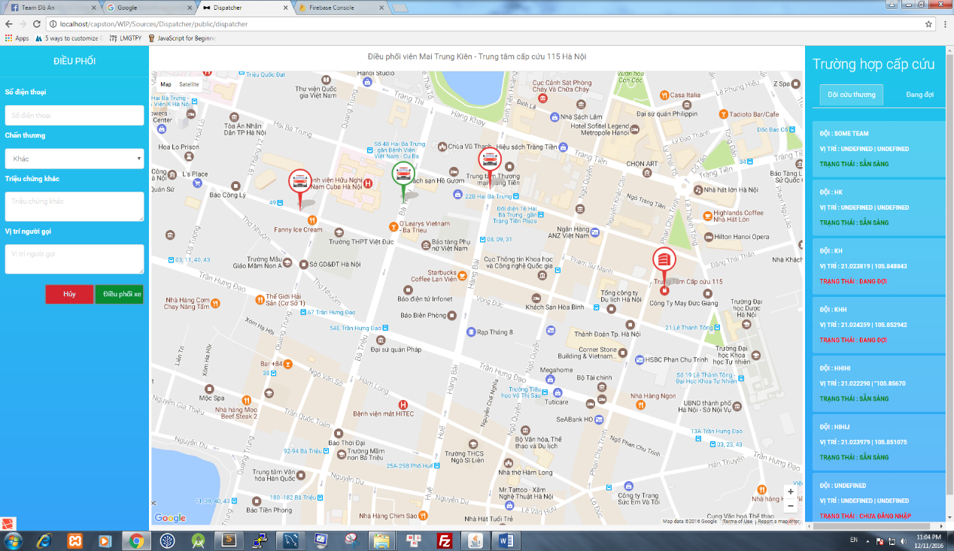

Figure 4‑73: Dispatcher’s Dashboard

|  |  |  |  |  |  |  |  |
| --- | --- | --- | --- | --- | --- | --- | --- |
| No | Field name | Field name in Vietnamese | Type | Require | Mandatory | Max-Length | Description |
| 1 | Phone number | Số Điện Thoại | Text field | Click on | Phone number | Số Điện Thoại | Text field |
| 2 | Injury | Chấn Thương | Dropdown list | Click on | Injury | Chấn Thương | Dropdown list |
| 3 | Caller’s Position | Vị trí người gọi | Text field | Click on | Caller’s Position | Vị trí người gọi | Text field |
| 4 | Other injuries | Chấn Thương khác | Text field | Click on | Other injuries | Chấn Thương khác | Text field |
| 5 | Dispatch | Điều phối xe | Button | Click on | Dispatch | Điều phối xe | Button |
| 6 | Cancel | Hủy | Button | Click on | Cancel | Hủy | Button |
| 7 | Ambulance Team | Đội cứu thương | Button | Click on | Ambulance Team | Đội cứu thương | Button |
| 8 | Waiting | Đang đợi | Button | Click on | Waiting | Đang đợi | Button |

Table 4‑51: Dispatcher’s Dashboard

### Admin

#### Screen flow

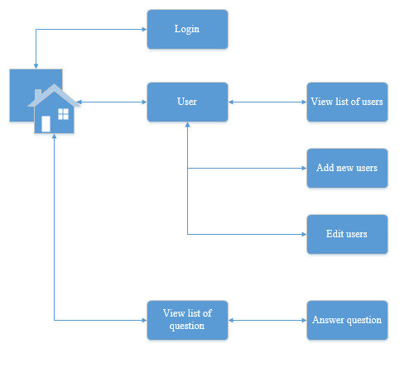

Figure 4‑74: Admin screen flow

#### Login screen

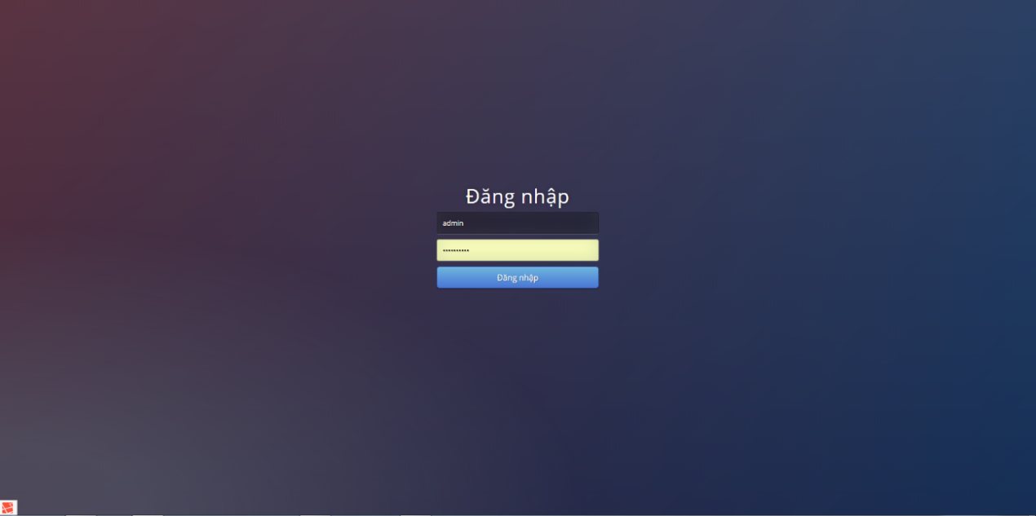

Figure 4‑75: Login screen

|  |  |  |  |  |  |  |  |
| --- | --- | --- | --- | --- | --- | --- | --- |
| No | Field name | Field name in Vietnamese | Type | Require | Mandatory | Max-Length | Description |
| 1 | Login | Đăng Nhập | Button | Click on | Y |  | Login to the admin dashboard page |
| 2 | User name | Tên đăng nhập | Textfield | Click on | Y |  | Fill the user name |
| 3 | Password | Mật Khẩu | Textfield | Click on | Y |  | Fill the password |

Table 4‑52: Login screen

#### Manage user account

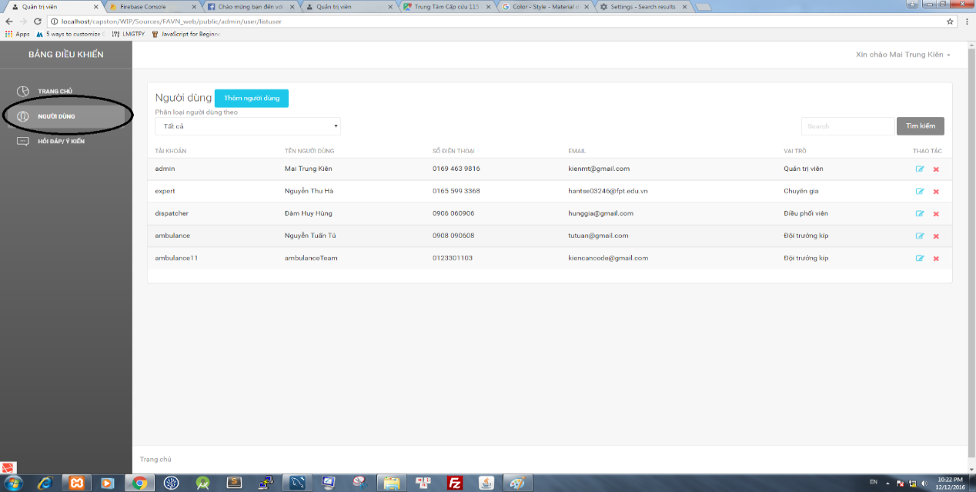

Figure 4‑76: Manage user account screen

|  |  |  |  |  |  |  |  |
| --- | --- | --- | --- | --- | --- | --- | --- |
| No | Field name | Field name in Vietnamese | Type | Require | Mandatory | Max-Length | Description |
| 1 | Add new user | Thêm người dùng | Button | Click on | Y |  | Move to add new user page |
| 2 | Edit | Sửa người dùng | Icon | Click on | Y |  | Move to edit user page |
| 3 | Delete | Xóa người dùng | Icon | Click on | Y |  | Delete user |
| 4 | User Classification | Phân loại người dùng | Dropdownlist | Click on | Y |  | Classification user by role |
| 5 | Search textbox | Ô tìm kiếm | Textbox | Click on | Y |  | Input characters to search users |
| 6 | Search button | Nút tìm kiếm | Button | Click on | Y |  | Search users |

Table 4‑53: Manage user account screen

##### Add user screen

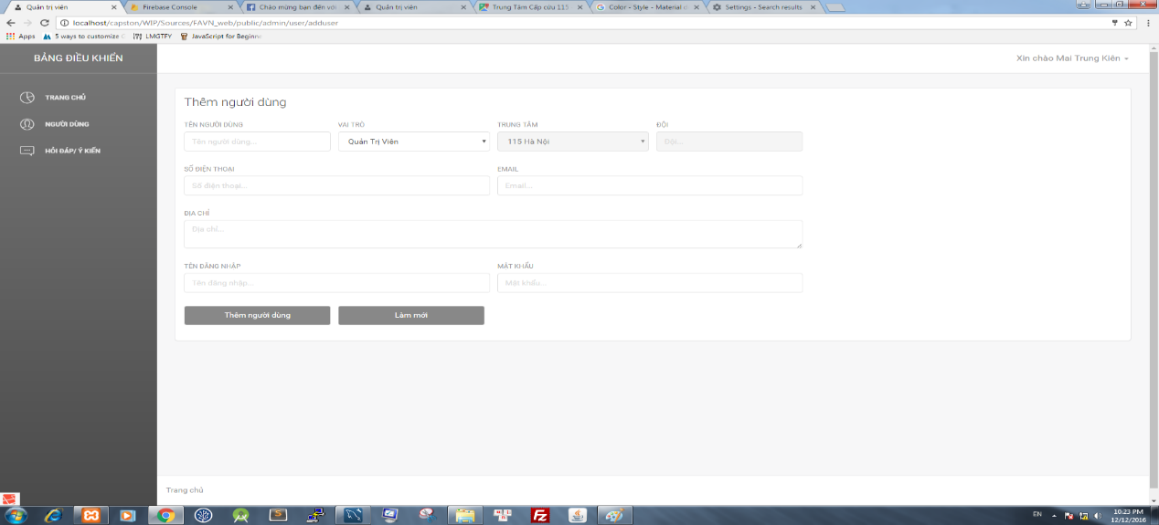

Figure 4‑77: Add user screen

|  |  |  |  |  |  |  |  |
| --- | --- | --- | --- | --- | --- | --- | --- |
| No | Field name | Field name in Vietnamese | Type | Require | Mandatory | Max-Length | Description |
| 1 | User name | Tên người dùng | Textfield | Click on | Y |  | Fill name of user |
| 2 | Role | Vai trò | Dropdownlist | Click on | Y |  | Select role of user |
| 3 | Center | Trung Tâm | Dropdownlist | Click on | Y |  | Select center |
| 4 | Team | Đội | Textfield | Click on | Y |  | Fill name of ambulance team |
| 5 | Phone number | Số Điện Thoại | Textfield | Click on | Y |  | Fill phone number of user |
| 6 | Email | Thư điện tử | Text field | Click on | Y |  | Fill email of user |
| 7 | Address | Địa chỉ | Text field | Click on | Y |  | Fill address of user |
| 8 | Login name | Tên đăng nhập | Text field | Click on | Y |  | Fill login name of user |
| 9 | Password | Mật Khẩu | Text  field | Click on | Y |  | Fill password of user |
| 10 | Add new user | Thêm người dung | Button | Click on | Y |  | Add new user |
| 11 | Reset | Làm mới | Button | Click on | Y |  | Reset all text field |

Table 4‑54: Add user screen

##### Edit user screen

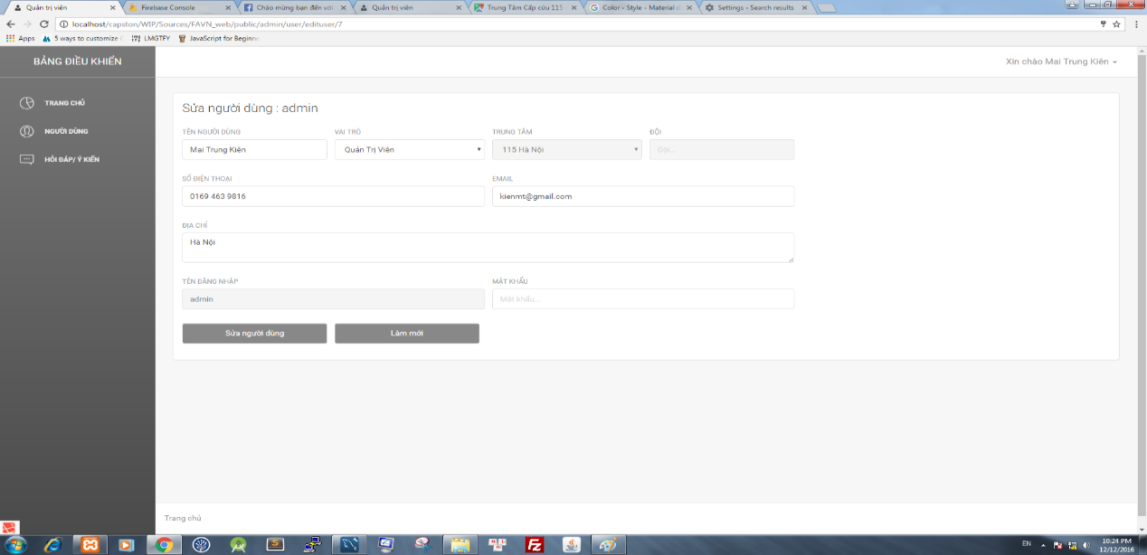

Figure 4‑78: Edit user screen

|  |  |  |  |  |  |  |  |
| --- | --- | --- | --- | --- | --- | --- | --- |
| No | Field name | Field name in Vietnamese | Type | Require | Mandatory | Max-Length | Description |
| 1 | User name | Tên người dùng | Textfield | Click on | Y |  | Edit name of user |
| 2 | Role | Vai trò | Dropdownlist | Click on | Y |  | Select role of user |
| 3 | Center | Trung Tâm | Dropdownlist | Click on | Y |  | Select center |
| 4 | Team | Đội | Textfield | Click on | Y |  | Edit name of ambulance team |
| 5 | Phone number | Số Điện Thoại | Textfield | Click on | Y |  | Edit phone number of user |
| 6 | Email | Thư điện tử | Text field | Click on | Y |  | Edit email of user |
| 7 | Address | Địa chỉ | Text field | Click on | Y |  | Edit address of user |
| 8 | Login name | Tên đăng nhập | Text field | Click on | Y |  | Edit login name of user |
| 9 | Password | Mật Khẩu | Text  field | Click on | Y |  | Edit password of user |
| 10 | Add new user | Thêm người dung | Button | Click on | Y |  | Add new user |
| 11 | Reset | Làm mới | Button | Click on | Y |  | Reset all text field |

Table 4‑55: Edit user screen

#### QA screen

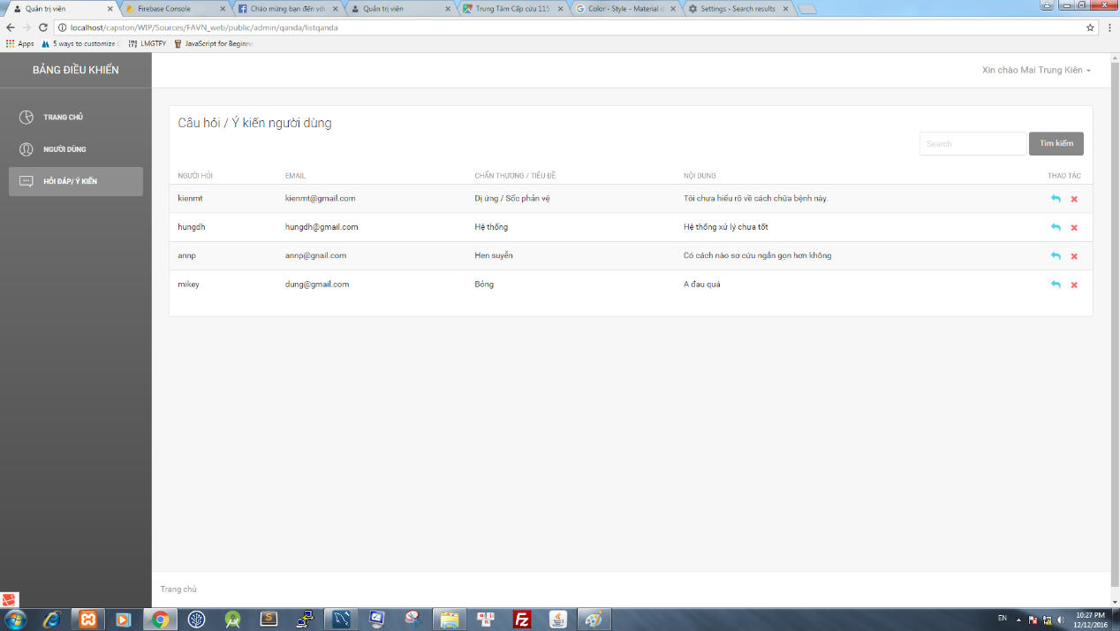

Figure 4‑79: QA screen

|  |  |  |  |  |  |  |  |
| --- | --- | --- | --- | --- | --- | --- | --- |
| No | Field name | Field name in Vietnamese | Type | Require | Mandatory | Max-Length | Description |
| 1 | Answer Question | Trả lời câu hỏi | Icon | Click on | Y |  | Move to edit answer question page |
| 2 | Delete | Xóa câu hỏi | Icon | Click on | Y |  | Delete question |
| 3 | Search textbox | Ô tìm kiếm | Textbox | Click on | Y |  | Input characters to search users |
| 4 | Search button | Nút tìm kiếm | Button | Click on | Y |  | Search question |

Figure 4‑80: QA screen

# SOFTWARE TESTING

## Introduction

### Purpose

This is the comprehensive test plan of the FAVN project. The purpose of this chapter describes scopes of test and activities which need to be taken during test process of project. It addresses the following items: Scopes of Testing, Requirements for Testing, Test Strategy, Test Resources, Test Environment, Test Milestones and Deliverables.

### Definitions and Acronyms

This section describes the definitions, terms, and acronyms that are used in software requirements specification.

|  |  |  |
| --- | --- | --- |
| Acronym | Definition | Note |
| FAVN | First Aid Vietnam |  |
| UT | Unit Test |  |
| GUI | Graphic User Interface |  |

1. Definitions and Acronyms

### Scope of testing

* FAVN will be tested by 4 phases:

**Phase 1: Unit testing**

* Unit testing will be done by developers
* Developers use While Box Testing technique to do
* When executing unit testing, if any bugs are found, developers have to log bug on “Defect Log Management” file and fix it until it is correct.

*Rule for filling test result:*

|  |  |
| --- | --- |
| Test result pass | Pass |
| Test result fail | Fail |
| Do not test | Untested |
| Cannot test | N/A (Not available) |

**Phase 2: Integration testing**

* After finishing component testing, integration testing will be performed by testers.
* Material are integration test cases, high- level design
* Do test by flow of functions and items which have relation.
* When executing integration testing, if any bugs are found, testers have to log on “Defect Log Management” file and assign to developer fix it and redo this process until it is correct.

*Rule for filling test result:*

|  |  |
| --- | --- |
| Test result pass | Pass |
| Test result fail | Fail |
| Do not test | Untested |
| Cannot test | N/A (Not available) |

**Phase 3: System testing**

* After finishing integration testing and developers collect all functions and items, testers will be performed system testing, it means doing test whole system.
* Material area system test case, SRS
* If any bugs are found, developers have to fix and testers will verify them. System test is ended only when test cases are passed and no bug is found.

*Rule for filling test result:*

|  |  |
| --- | --- |
| Test result pass | Pass |
| Test result fail | Fail |
| Do not test | Untested |
| Cannot test | N/A (Not available) |

**Phase 4: Acceptance testing**

* Base on customer/user requirement specification, system is tested again, for ensure there is not lacking or mistake any requirement.
* If there is any problem, developers have to fix/update and tester will verify them.
* Acceptance testing is ended only when whole system met requirement specification.

### Constraints

* There are only 2 testers and tester don’t have experience in testing.
* Time of Testing is short.
* Have a lot of environments should be tested: Android 4.4.2 and above… and more browsers: Firefox, IE, Chrome … But Test team cannot cover all

## Test plan

### Test type

#### Function Testing

* Functional testing is a type of software testing whereby the system is tested against the functional require specifications.
* Functions are tested by feeding them input and examining the output. Functional testing ensure that the requirements are properly satisfied by the website and mobile application. This type of testing is not concerned with how processing occurs, but rather, with the results of processing.
* During functional testing, [Black Box Testing](http://softwaretestingfundamentals.com/black-box-testing/) technique is used in which the internal logic of the system being tested is not known to the tester.

|  |  |
| --- | --- |
| Test Objective: | The type of this test is to ensure proper target-of-test functionality, including user interaction, all function defined in specification document implemented correctly. |
| Technique: | Executing each use case, use-case flow, or function, using valid and invalid data, to verify the following:  - The expected results occur when valid data is used.  - The appropriate error or warning messages are displayed when invalid data is used.  - Each business rule is properly applied. |
| Completion Criteria: | - All planned tests have been executed.  - All identified defects have been addressed and closed. |
| Special Considerations: | Testing may be stopped when  Time runs out  A certain number of defects found  Test coverage > 97%  Stop when testing becomes unproductive |

1. Function Testing

#### User Interface Testing

GUI testing is the process of ensuring proper functionality of the GUI for a given web and making sure it conforms to its written specifications.

GUI testing evaluates design elements such as layout, colors, fonts, font sizes, labels, text boxes, text formatting, captions, buttons, lists, icons, links, content and more.

|  |  |
| --- | --- |
| Test Objective: | Verify the following:  - Navigation through the target-of-test properly reflects business functions and requirements, including window-to-window, field-to-field, and use of access methods (tab keys, mouse movements, accelerator keys)  - Window objects and characteristics, such as menus, size, position, state, and focus conform to standards. |
| Technique: | Create or modify tests for each window to verify proper navigation and object states for each application window and objects. |
| Completion Criteria: | Each window successfully verified to remain consistent with benchmark version or within acceptable standard |
| Special Considerations: | Not all properties for custom and third party objects can be accessed. |

1. GUI Testing

### Test stages

Clearly state the stage in which the test will be executed. Identified below are the stages in which common test are executed

| Type of Tests | Stage of Test | | | |
| --- | --- | --- | --- | --- |
| Unit | Integration | System | Acceptance |
| Function Testing | X | X | X | X |
| User Interface Testing | X |  | X | X |

1. Test stages

### Test model

FAVN follows V-Model process:



1. V-model process

Testing progress is divided to 4 phases include: Unit test, Integration test, System test and Acceptance test

* Unit test:
* Unit testing is used to verify a single minimal unit of source code. The purpose of unit testing is to isolate the smallest testable parts of FAVN and verify that they function properly in isolation.
* Unit testing is the first level of testing and is perform prior to component testing
* Unit testing will be done by developer.
* Integration test:
* Integration testing is a level of the software testing process where individual units or component are combined and tested as a group.
* The purpose is to expose faults in the interaction between integrated units.
* Integration testing is performed after component testing
* Integration testing will be done by tester
* System test:
* System Testing is a level of the software testing process where a complete, integrated system is tested
* The purpose is to evaluate the system’s compliance with the specified requirements
* System testing is performed after integration testing
* System testing will be done by tester
* Acceptance test:
* Acceptance testing is performed after system testing
* Acceptance testing will be performed by the test leader and team leader.
  + The acceptance test will be done for a period of 1 weeks after completion of the system test process.

### Acceptance test criteria.

* Criteria for Unit test of Development team, for Test team accepts to start testing:
  + Number of TC/KLOC: 10TC/KLOC
  + Number defects/KLOC: 3-4 defects/KLOC
  + Statement coverage: 100%
  + Branch coverage: 100%
  + Path coverage: 100%
* Criteria for Integration test:
  + Number of TC/KLOC: 30 TC/KLOC
  + Number defects/KLOC: 2-3 defects/KLOC
* Criteria for System test:
  + Number of TC/KLOC: 20 TC/KLOC
  + Number defects/KLOC: 4-6 defects/KLOC
* Criteria for Acceptance test:
  + Number defects/KLOC: 1-2 defects/KLOC

### Resources

#### Human resource

|  |  |  |
| --- | --- | --- |
| Worker/Doer | Role | Specific Responsibilities/Comments |
| AnNP | Test Leader | * Manage Test Resource and assign test tasks. * Create and review Test Plan. * Create and review Test Case. * Execute test. * Create and review Test Report * Ensures the overall success of the test cycles * Coordinate weekly meetings and will communicate the testing status to the project team |
| AnhND | Tester | * Create and review Test Case. * Execute test. * Create Test view points * Create and review Test Report * Responsible for performing the actual system testing |

1. Human resource

#### Test Environment

##### Hardware

|  |  |  |
| --- | --- | --- |
| Name | Purpose | Detail |
| Laptop Dell | Device for create and execute test | Window 10 Education core i5 |
| Laptop Dell | Device for create and execute test | Window 10 professional core i7 |
| Sony Xperia Z3 compact | Device for create and execute test | Android 5.0.1 |
| MI Note 3 | Device for create and execute test | Android 5.0.2 |

1. Hardware

##### Software

|  |  |  |
| --- | --- | --- |
| Name | Purpose | Detail |
| Test Plan | Managing test | Microsoft Word 2016 |
| Test case | Executing test | Microsoft Excel 2016 |
| Test report, Test checklist | Tracking test | Microsoft Excel 2016 |
| Chrome, CocCoc | Executing test | Chrome 35.0, CocCoc 35.0 |

1. Software

##### Infrastructure

|  |  |  |  |  |
| --- | --- | --- | --- | --- |
| Name | Purpose | Detail | Vendor/In-house | Version |
| FAVN_Defect Log Management_v1.0_EN | Tracking bug during testing time | Microsoft Excel 2016 | FPT-University | v1.0 |
| Test Effort | Effort execute test | Microsoft Excel 2016 | FPT-University | v1.0 |

1. Infrastructure

### Test milestones

|  |  |  |  |
| --- | --- | --- | --- |
| Milestone Task | Effort (pd) | Start Date | End Date |
| Create Test Plan | 6 | 21/10/2015 | 23/10/2015 |
| Review & Update Test Plan | 2 | 26/12/2015 | 27/12/2015 |
| Create Integration Test case | 2 | 06/11/2015 | 10/11/2015 |
| Review & Update Integration Test Case | 2 | 11/11/2015 | 12/11/2015 |
| Create System Test case | 6 | 30/10/2015 | 05/11/2015 |
| Review & Update System Test Case | 2 | 04/11/2015 | 05/11/2015 |
| Execute Integration test phase 1 | 2 | 13/11/2015 | 17/11/2015 |
| Execute Integration test phase 2 | 2 | 24/11/2015 | 26/11/2015 |
| Execute Integration test phase 3 | 2 | 03/12/2015 | 05/12/2015 |
| Execute System test phase 1 | 4 | 18/11/2015 | 20/11/2015 |
| Execute System test phase 2 | 4 | 27/11/2015 | 01/12/2015 |
| Execute System test phase 3 | 4 | 06/12/2015 | 09/12/2015 |
| Create Test Plan | 6 | 21/10/2015 | 23/10/2015 |
| Review & Update Test Plan | 2 | 26/12/2015 | 27/12/2015 |

1. Test milestones

### Deliverables

| No | Deliverables | Responsibilities | Delivered Date |
| --- | --- | --- | --- |
| 1 | Test Plan | English | 6/10/2016 |
| 2 | Integration Test case | English | 24/11/2016 |
| 3 | System Test case | English | 24/11/2016 |
| 4 | Defect Log Management | English | 26/11/2016 |
| 5 | Test report | English | 24/11/2016 |

1. Deliverables

## Test case

Refer to:

* + Dispatcher_Integration-Test-Case_v1.0_EN. xlsx
  + Ambulance_Integration Test Case_v1.0_EN.xlsx
  + FA_Integration-Test-Case_v1.0_EN. xlsx
  + Admin/Expert_Integration-Test-Case_v1.0_EN. xlsx
  + FAVN_System-Test-Case_v1.0_EN. xlsx
  + FAVN_UnitTestCase_FirstAidApplication_v1.0.xlsx

## Test Report

### Test report

|  |  |  |  |  |  |  |
| --- | --- | --- | --- | --- | --- | --- |
| No | Module Code | Round 1 | | Round 2 | | Final |
| Pass | Fail | Pass | Fail |
| 1 | Unit Test | 61 | 0 | 61 | 0 | 61 |
| 2 | Integration Test | 1090 | 40 | 1134 | 0 | 1134 |
| 3 | System Test | 59 | 0 | 65 | 0 | 65 |
|  | Total | 1209 | 40 | 1260 | 0 | 1260 |

1. Test Report

### Defect report

|  |  |  |  |  |
| --- | --- | --- | --- | --- |
| Defects | Logged | %Closed | %Invalid | %Open |
| **Critical** | 0 | 0% | 0% | 0% |
| **High** | 10 | 0% | 0% | 0% |
| **Medium** | 10 | 100% | 0% | 0% |
| **Low** | 20 | 100% | 0% | 0% |
| **Total** | 40 | 100% | 0% | 0% |

Table 5‑13: Defect report

# USER MANUAL

## Introduction

### Purpose

This document contains guidelines step by step to deploy FAVN system. This user's manual has been developed to help users better understand the requirements that may apply to use this system by providing them simple step by step tutorials. This manual is intended to help make system's functions more accessible and their associated requirements more understandable to users.

### Environment

Following are the software required to start the First Aid system:

For First Aid Application and Ambulance Application:

**Operating System:** Android 5.0 or higher.

**Database**: SQLite

For Dispatcher Application and Admin/Expert Application:

**Operating System:** Windows 7, Windows 8, Window 10

**Browsers:** Firefox 40, Chrome 44 or higher.

**Database:** MySQL

## Installation Guideline

### Install First Aid Application

Step 1: Go to web browser on smart phone (ex: Chrome)



Figure 6‑1: First Aid step 1

Step 2: Go to url: <https://www.mediafire.com/file/5kt341rkmbg4a8r/FA.apk>

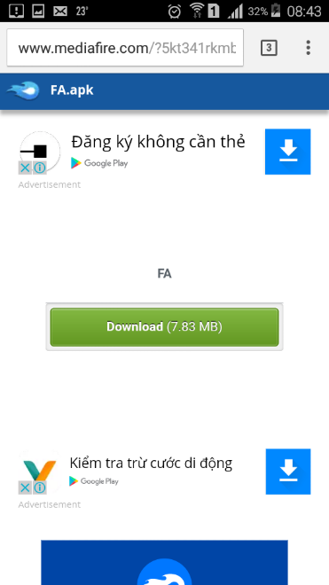

Figure 6‑2: First Aid step 2

Step 3: Tap on Download button to download file FA.apk and run

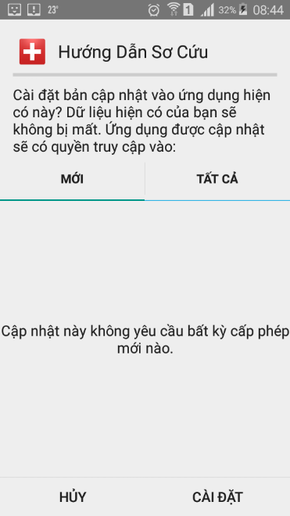

Figure 6‑3: First Aid step 3

Step 4: Finally, tap on First Aid icon to run application



Figure 6‑4: First Aid step 4

### Install Ambulance Application

Step 1: Go to web browser on tablet (ex: Chrome)

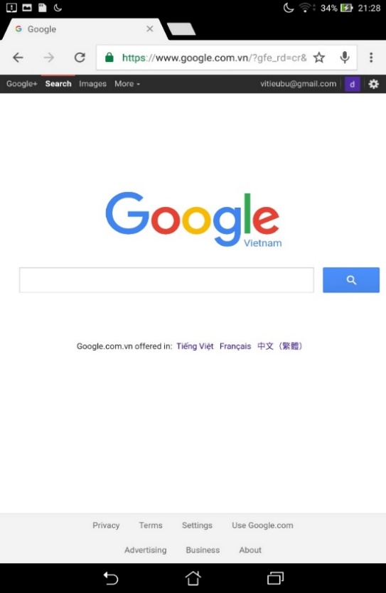

Figure 6‑5: Ambulance step 1

Step 2: Go to url <https://www.mediafire.com/file/ww2jnon8q8j80mj/ambulance.apk>

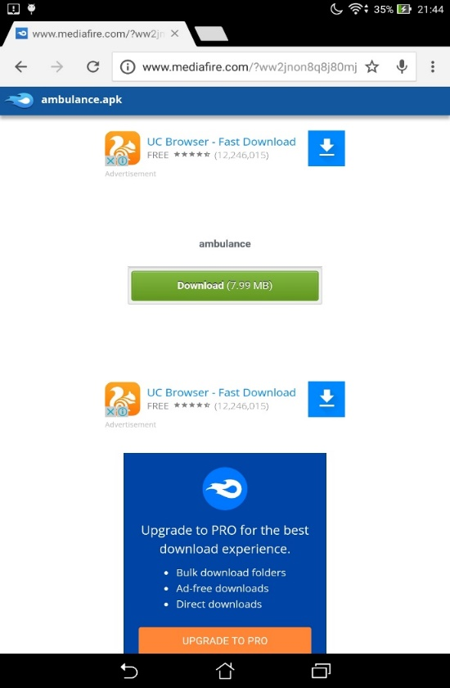

Figure 6‑6: Ambulance step 2

Step 3: Tap on Download button to download file ambulance.apk and run

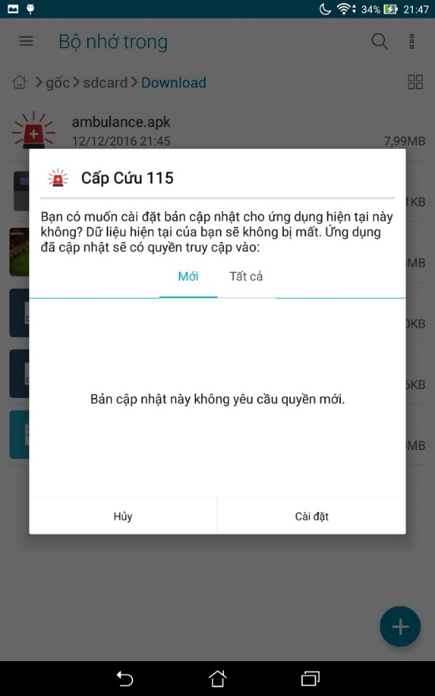

Figure 6‑7: Ambulance step 3

Step 4: Finally, tap on Ambulance icon to run application



Figure 6‑8: Ambulance step 4

### Install Dispatcher Application

In this guideline we install dispatcher Laravel application on Ubuntu 16.04.

#### Setup environment

* Step 1: Install PHP 5.6

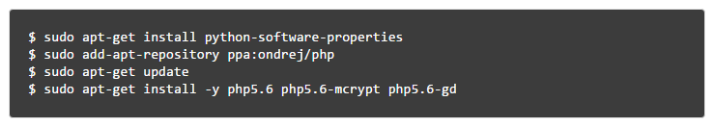

* Step 2: Install Apache2



* Step 3: Install MySQL



* Step 4: Install phpMyAdmin

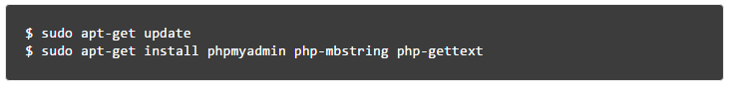

* Step 5: Install Composer

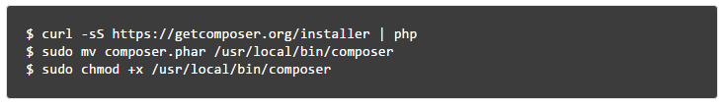

#### Install application

* Step 1: Clone source code from github directory

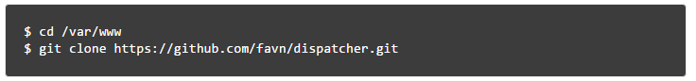

* Step 2: Use composer to install all dependencies required for Laravel framework.

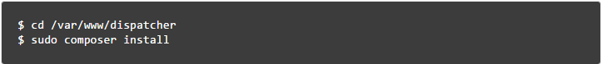

* Step 3: Set proper permissions on files.

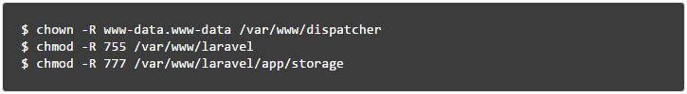

* Step 4: Create Apache VirtualHost



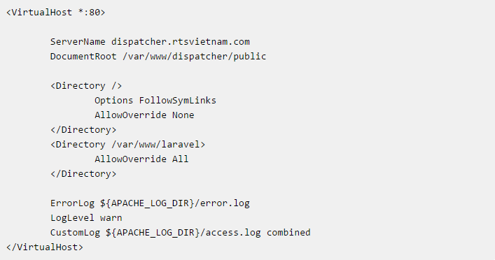

#### Database configuration

* Step1 : Create FAVN database

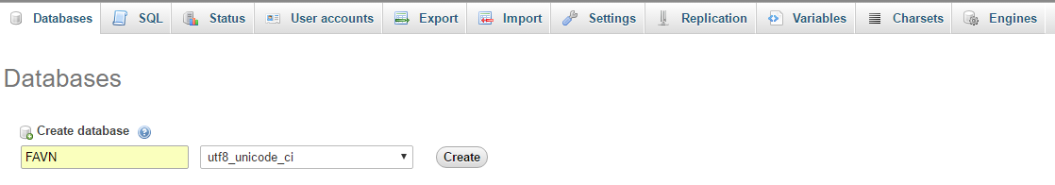

* Step 2: Import FAVN database

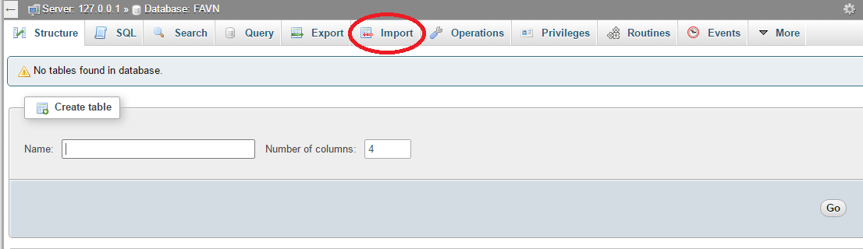

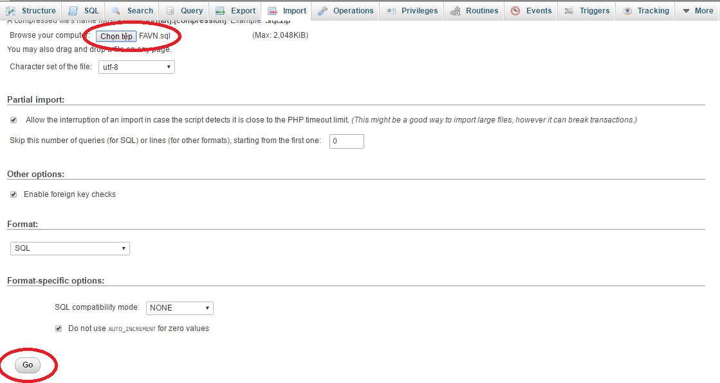

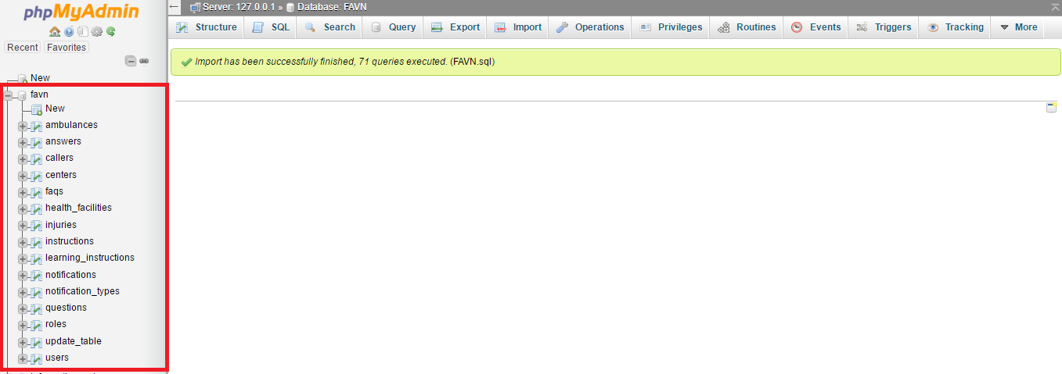

* Step 3: Setting .EVN file

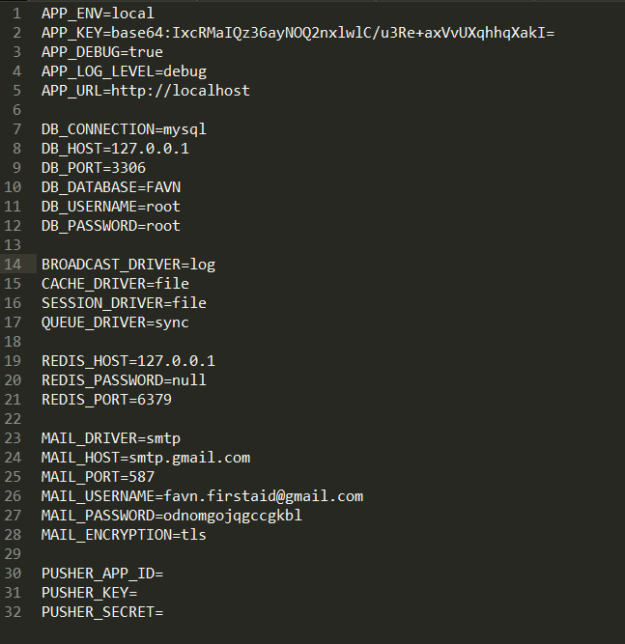

### Install Admin/Expert Application

#### Setup environment

Refer to 2.3.1 of this document.

#### Install application

* Step 1: Clone source code from github directory

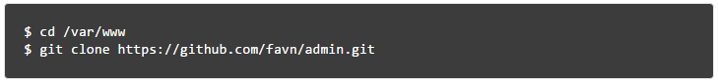

* Step 2: Use composer to install all dependencies required for Laravel framework.

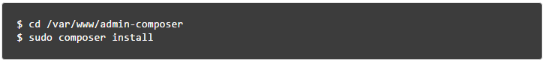

* Step 3: Set proper permissions on files.

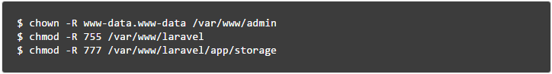

* Step 4: Create Apache VirtualHost



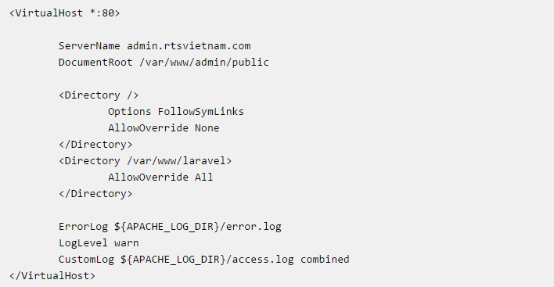

#### Database configuration

Refer to 2.3.3 of this document.

## User Guideline

### First Aid

This is the first screen which user will see. From this screen the user can go to every screen they want to use features.

To use this application, the users do the steps below:

Step 1: Download and install application

Step 2: Launch application

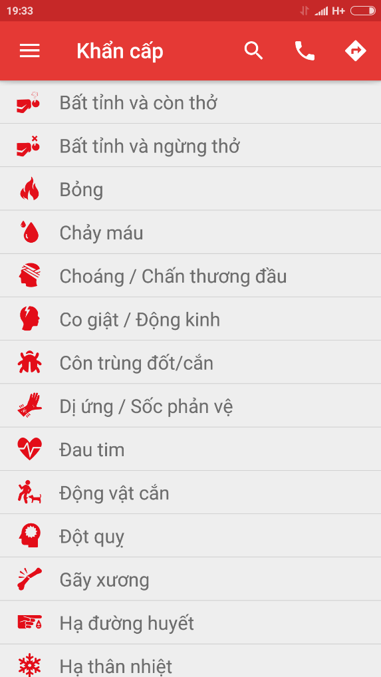

Figure 6‑9 Emergency screen

#### Emergency Details

To see the details of emergency, users do the steps below:

Step 1: Launch application

Step 2: Tap on one random emergency case

Step 3: Screen displayed the details of emergency case

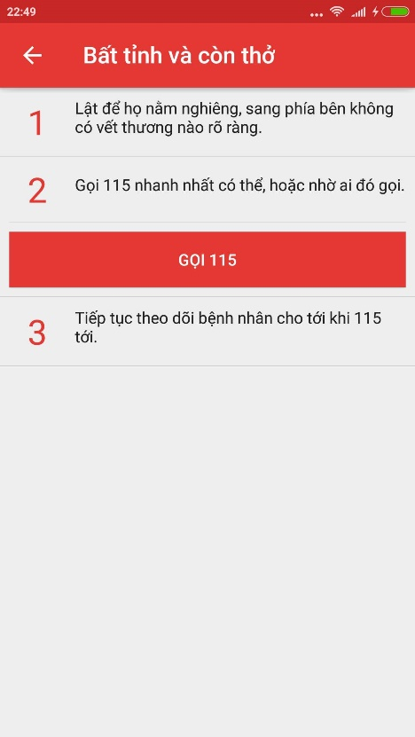

Figure 6‑10 Emergency details screen

#### Search emergency case

To search emergency case, the users do the steps below:

Step 1: Launch application

Step 2: Click on button search of “Hướng dẫn sơ cứu” screen

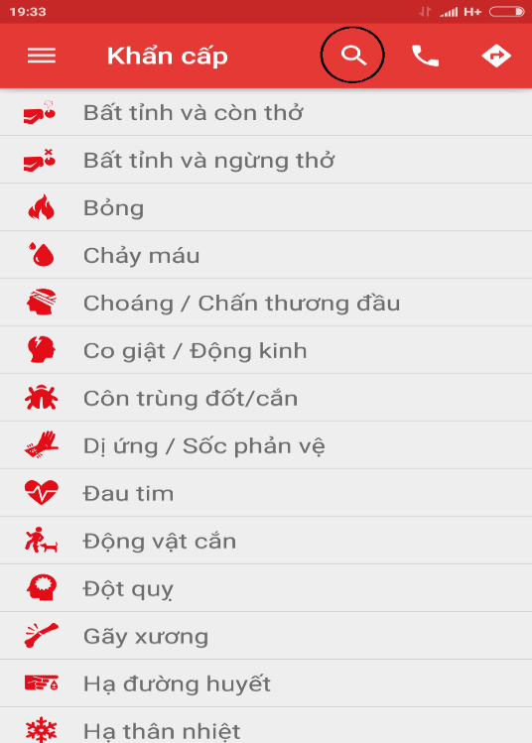

Figure 6‑11: Search icon

Step 3: Input the characters you want to search in textfield

Step 4: Screen display the result

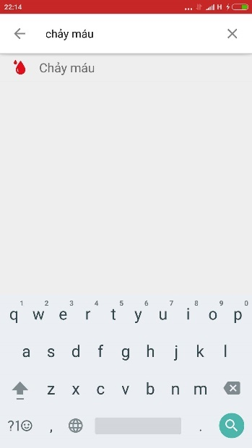

Figure 6‑12: Search result screen

#### Call 115

To use Call 115 function on this application, the users do the steps below:

Step 1: In “Khẩn Cấp” screen, tap on icon “Call”

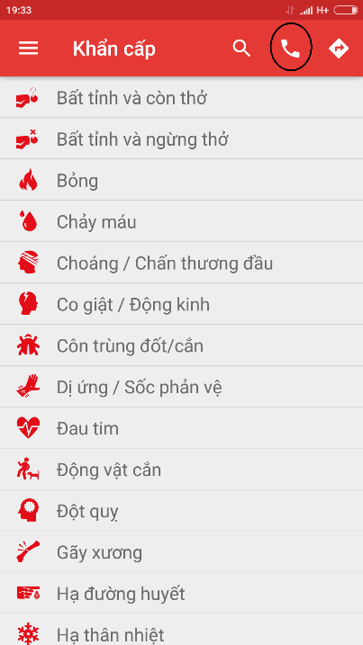

Figure 6‑13 Icon Call

Step 2: Call 115 screen is displayed

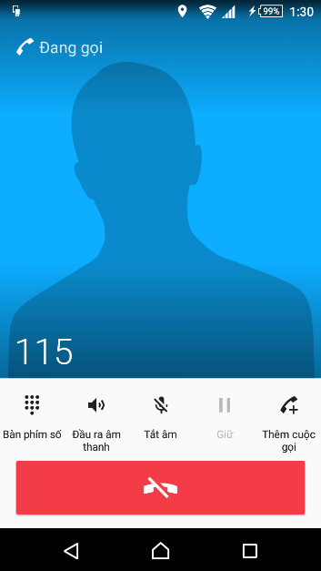

Figure 6‑14: Call 115 screen

#### Direct

In this function, user can know about current position, 20 nearest health facilities, direct from current position to selected health facility.

Step 1: Launch Application

Step 2: Click on icon direct

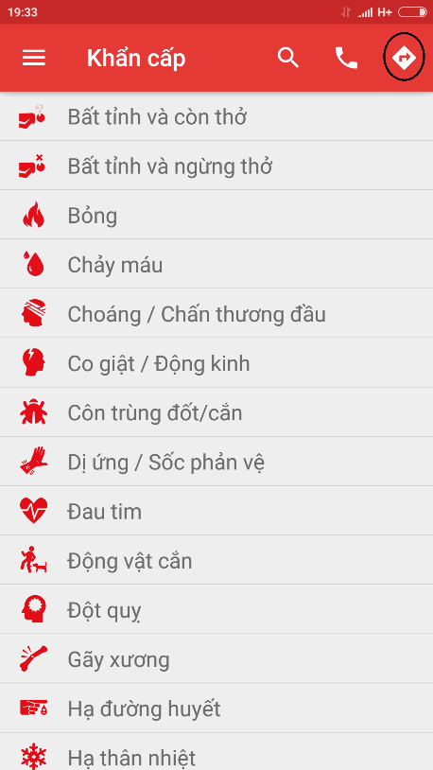

Figure 6‑15 Icon Direct

Step 3: Screen displayed map and current position, tap on button “Cơ sở y tế gần đây” to see the list of nearest health facilities

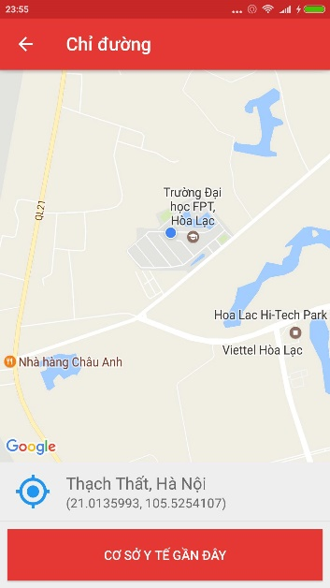

Figure 6‑16 Direct screen

Step 4: Select one of health facilities list (figure 2-9) , then tap on button direct ( figure 2-10 )

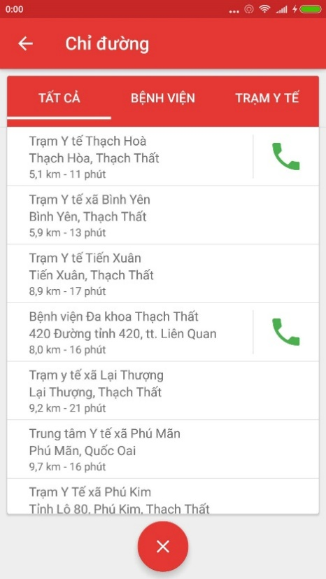

Figure 6‑17: List of health facilities

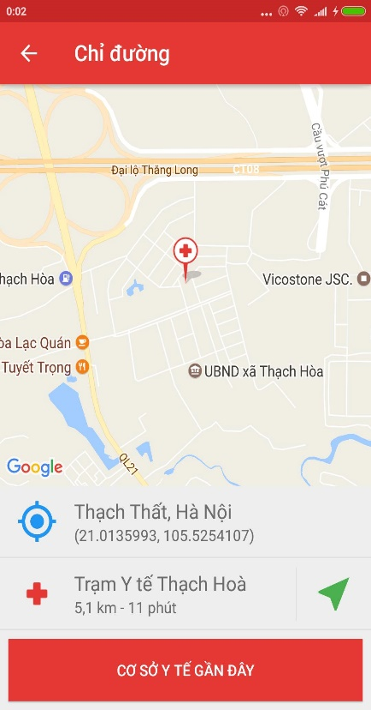

Figure 6‑18: Button Direct

Step 5: Tap on button direct, screen show the direct from current postion to the selected health facility

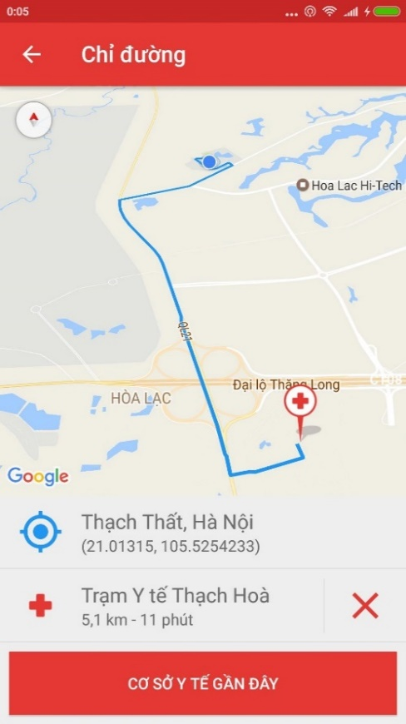

Figure 6‑19: Direct from current position to the emegency case

#### Learning

In this screen, users can view the detail of learning topic, view the list of “câu hỏi thường gặp”, can send the question to the system. To use those feature, user do as step belows:

Step 1: Launch application

Step 2: Tap on icon Menu

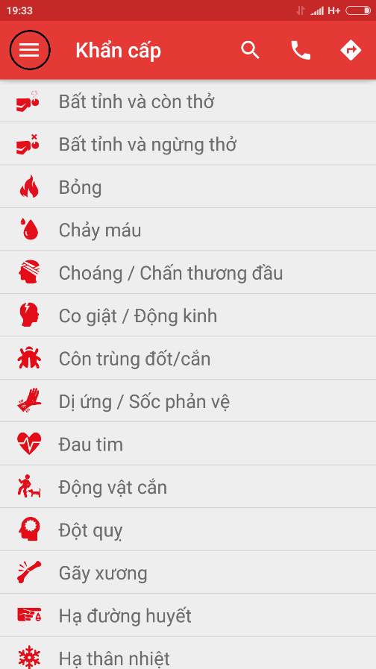

Figure 6‑20: Icon menu

Step 3: Tap on icon Tìm Hiểu

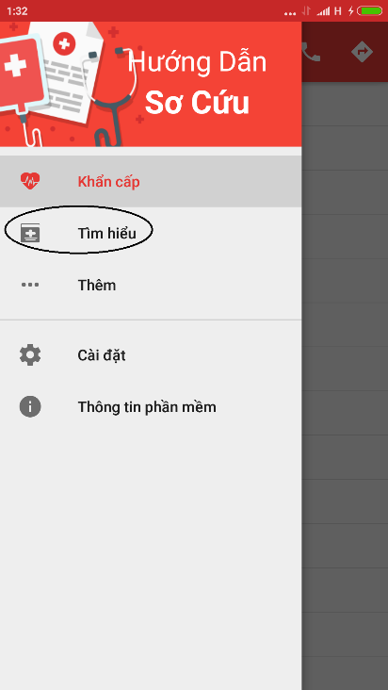

Figure 6‑21: Learning Icon

Step 4: Screen displayed list of learning topic

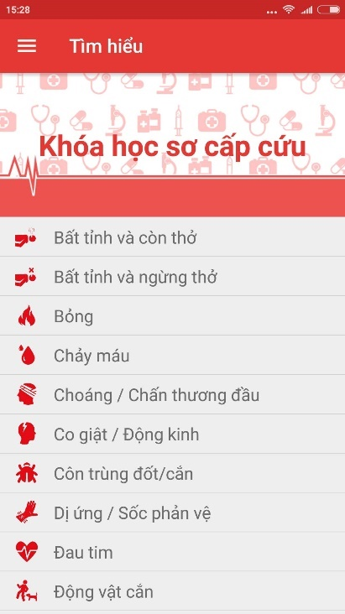

Figure 6‑22: Learning screen

Step 5: Tap on random topic

Step 6: Screen displayed details of selected topic

Step 7 : Tap on button “ Câu hỏi thường gặp” to view the list of FAQ

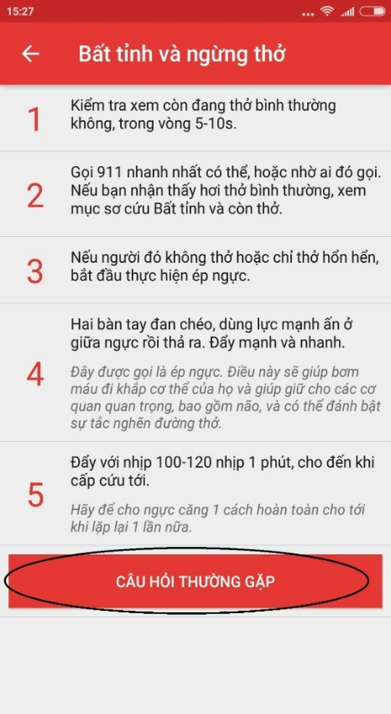

Figure 6‑23: FAQ button

Step 8: Screen displayed list of FAQ

Step 9: Tap on button “ Đặt câu hỏi cho chúng tôi” to send question to system

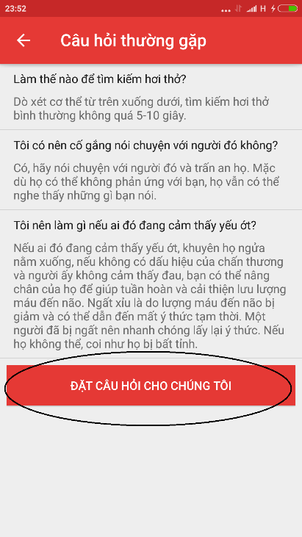

Figure 6‑24: Send question button

Step 10: Fill all field and tap on button “ Gửi”

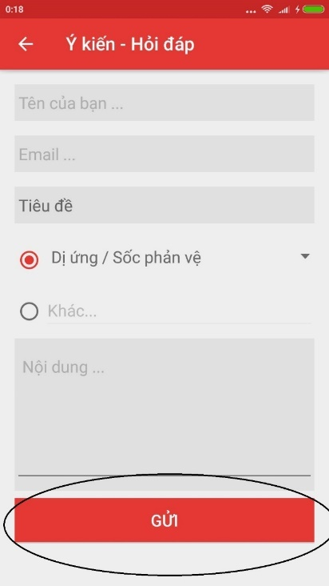

Figure 6‑25: Send button

#### Setting

In this screen, you can setting to send or not send your location and phone number. To use features in this function, users do the steps below:

Step 1: Launch app

Step 2: Tap on icon Menu and select Setting

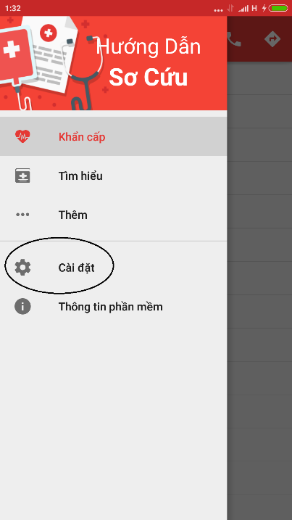

Figure 6‑26: Setting icon

Step 3: If you want to send information, tap on button “Đồng Ý Gửi” (ảnh)

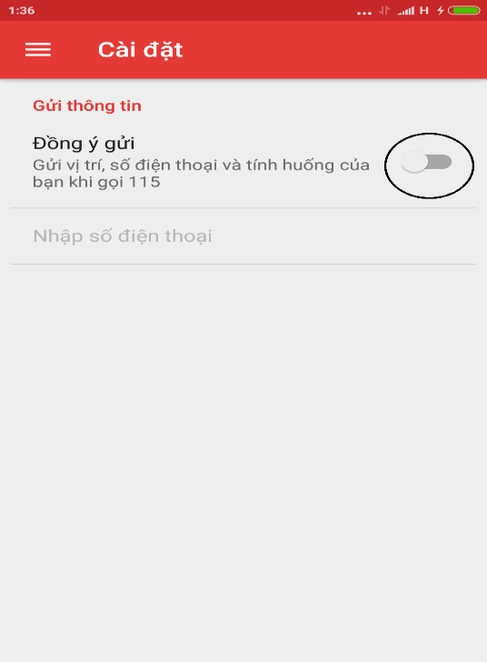

Figure 6‑27: Allow to send information switch

Step 4: Tap on “Nhập số điện thoại” to input your phone number

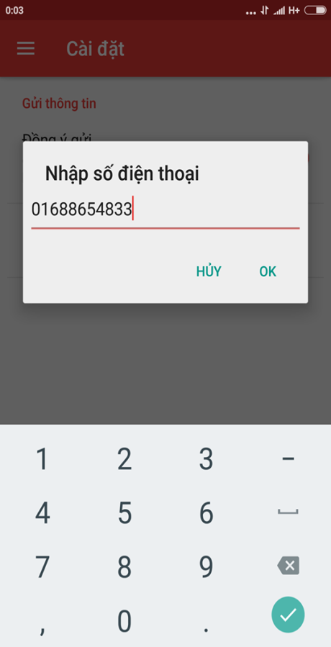

Figure 6‑28: Fill phone number dialog

Step 5: Tap on button OK, your phone number displayed on the screen

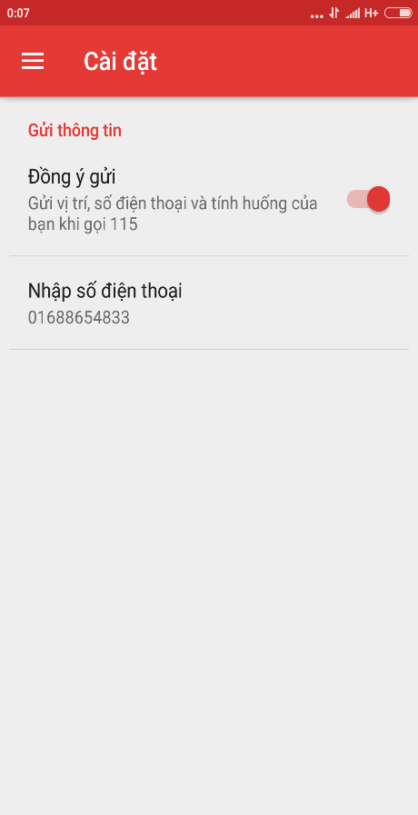

Figure 6‑29: Phone number display on screen

#### Software information

In this screen, you can view the information of software like version, term of use, information of developers.

Step 1: Launch application.

Step 2: Tap on icon Menu then select “Thông Tin Phần Mềm”.

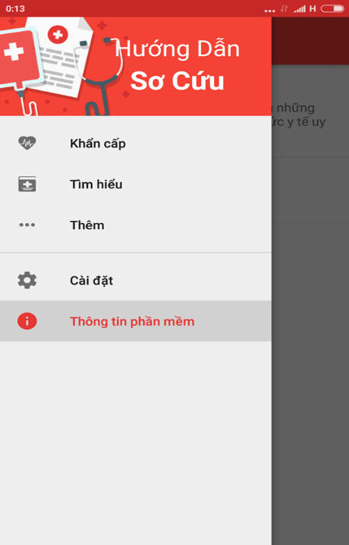

Figure 6‑30: Software information icon

Step 3: Screen displayed information of software.

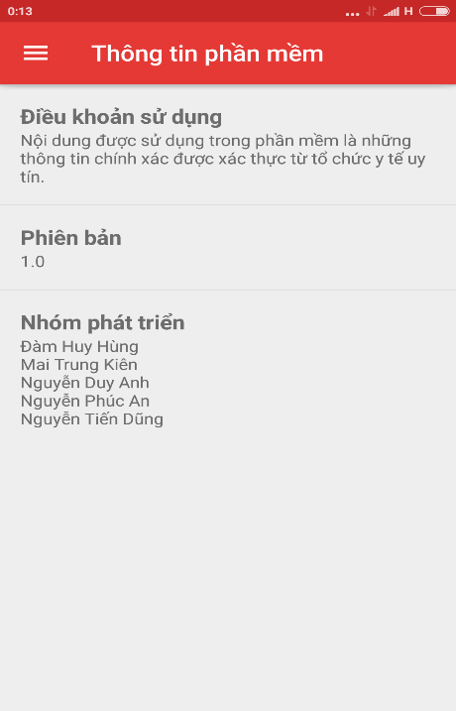

Figure 6‑31: Software information screen

### Ambulance

This is the first screen which user will see. From this screen the user can go to every screen they want to use features.

Step 1: Download and install application

Step 2: Launch application and login

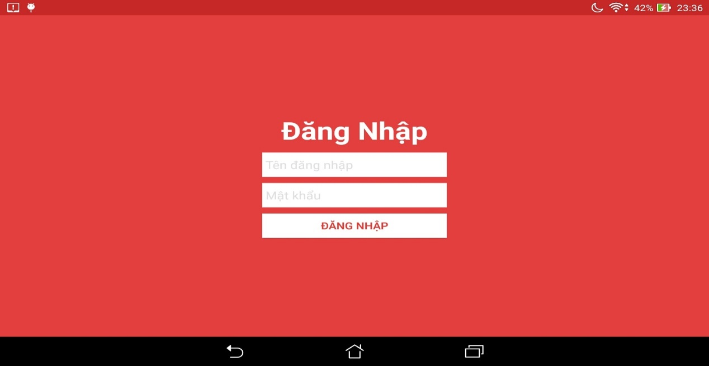

Figure 6‑32: Login screen

#### Logout

To logout application users follow these steps:

Step 1: Tap the icon on the left side of the screen [Menu]

Step 2: Tap on button “ Đăng Xuất”

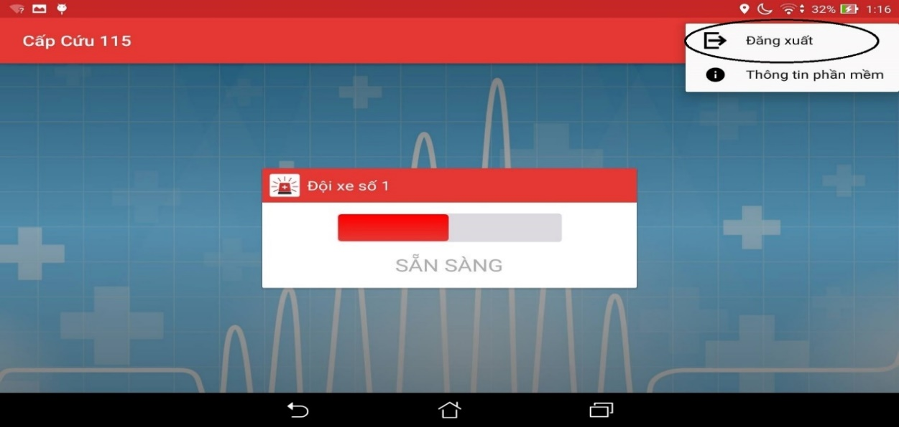

Figure 6‑33: Logout button

#### Ready/Not ready to take the task

Users depending on their current state can decide to take the task or not

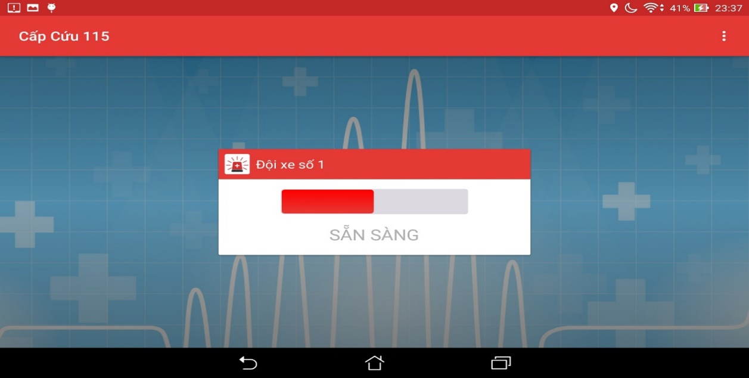

Figure 6‑34: Ambulance status

#### Software information

To see the information about this application, the users do the steps below: ( ảnh)

Step 1: Tap on menu icon at the top right at screen

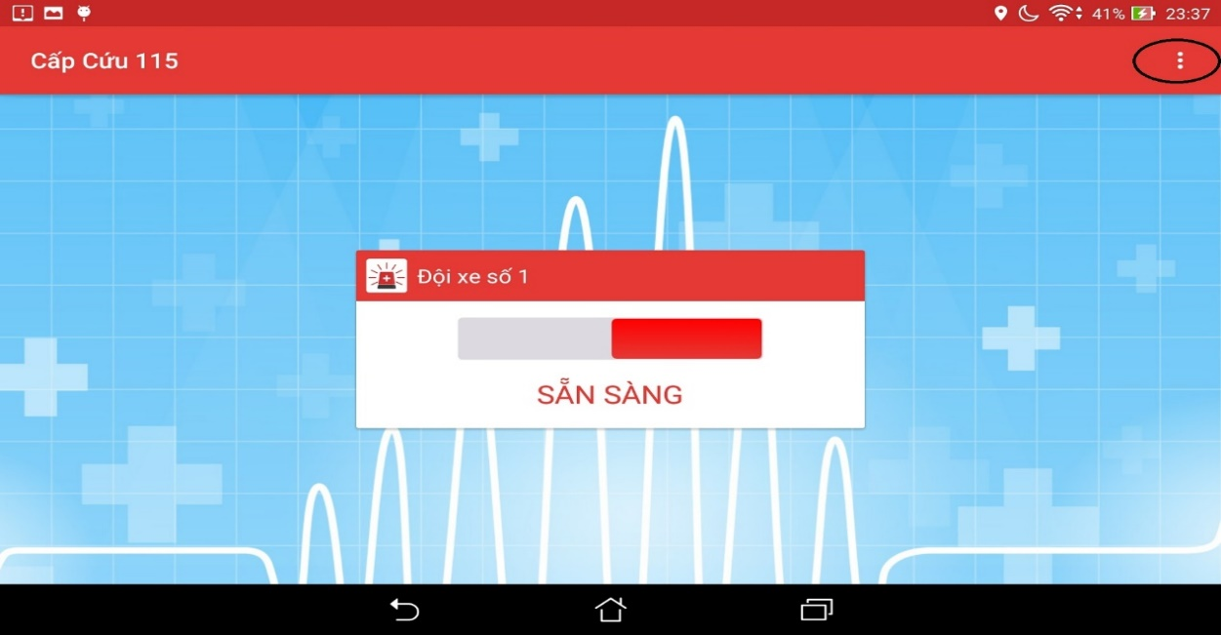

Figure 6‑35: Menu Icon

Step 2: Tap on button software information

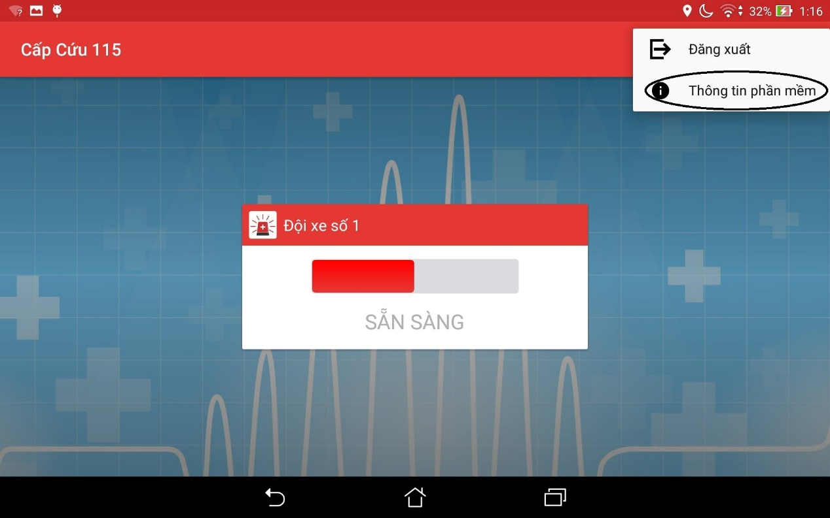

Figure 6‑36: Software information button

Step 3: Move to software information screen

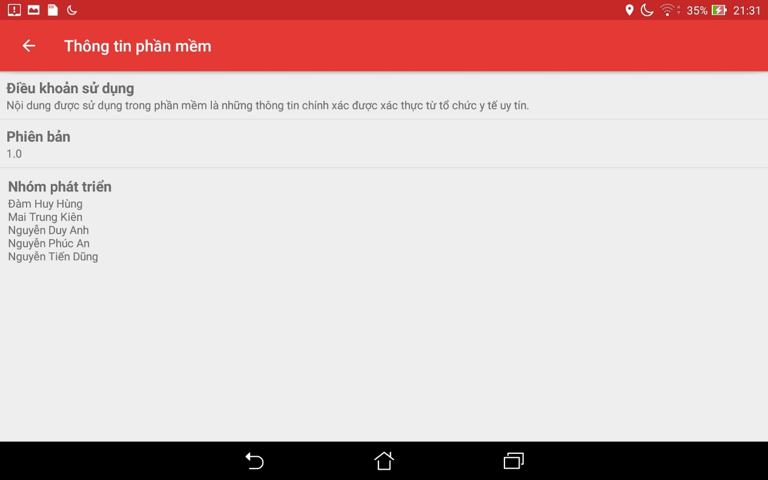

Figure 6‑37: Software information screen

#### Locate

When users want to locate current location, do the steps below:

Step 1: Login the application and take the task

Step 2: Tap on button “Định Vị”

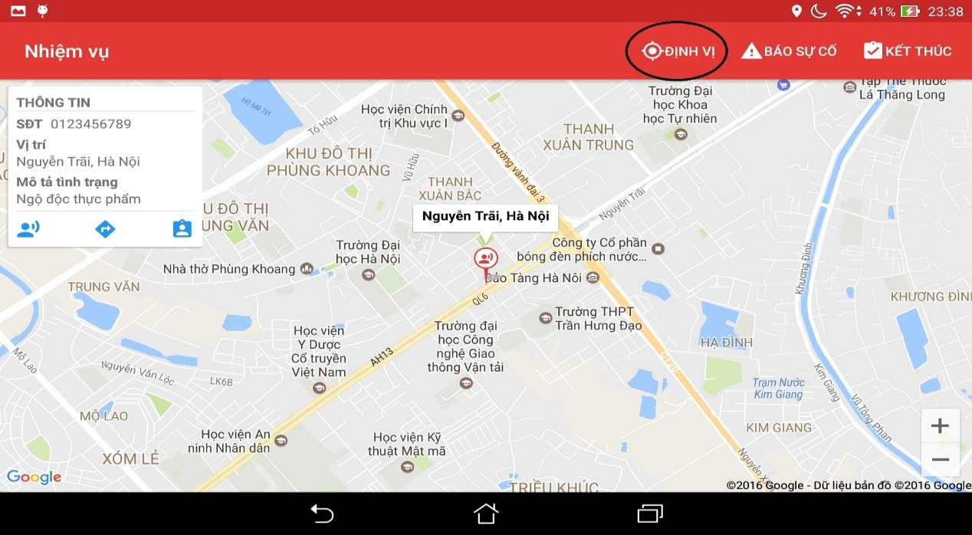

Figure 6‑38: Locate ambulance position’s button

When users want to locate current location of victims, do the steps below:

Step 1: Login the application and take the task

Step 2: Tap on icon victim

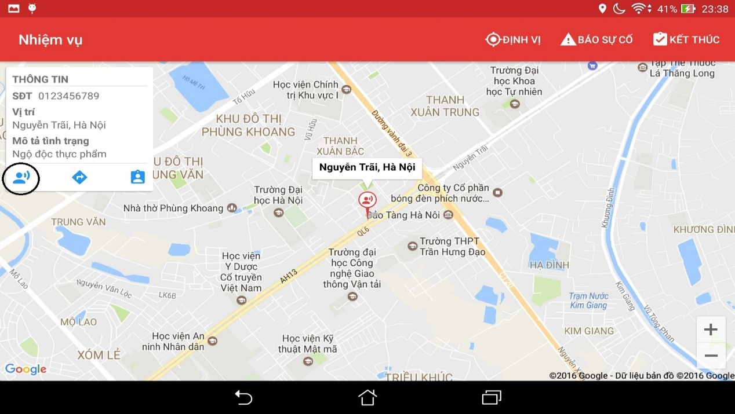

Figure 6‑39: Locate victim’s position button

#### Direct

When users want to view direct from ambulance to the victim position, do the steps below:

Step 1 : Tap on button direct, screen will show the direct

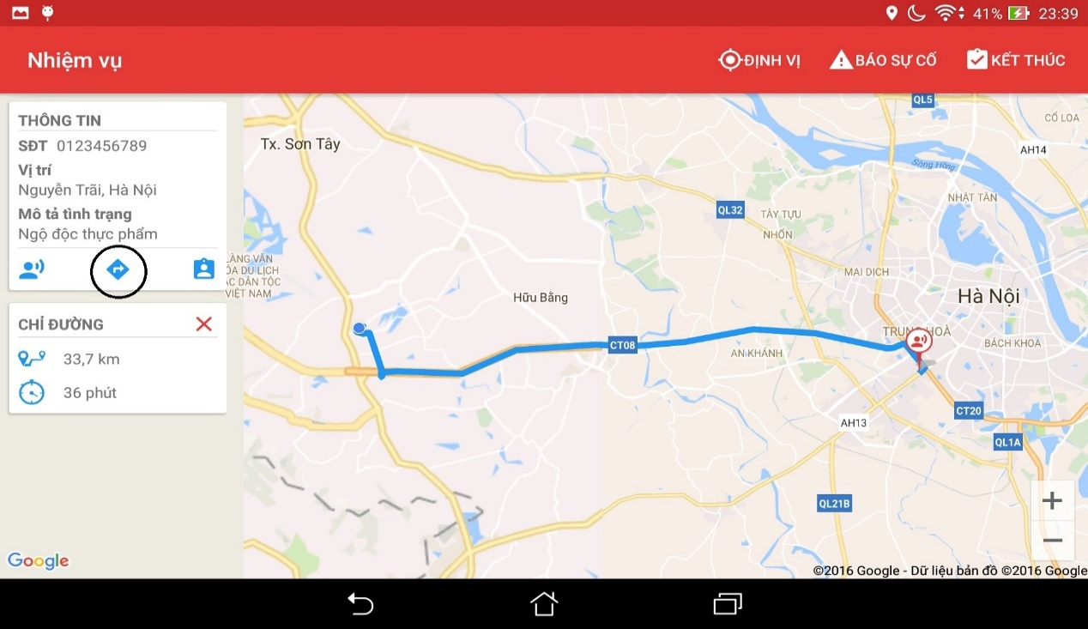

Figure 6‑40: Direct button

#### Picked up victim

When picked up victim, report to the center by the steps below:

Step 1 : Tap on button pick up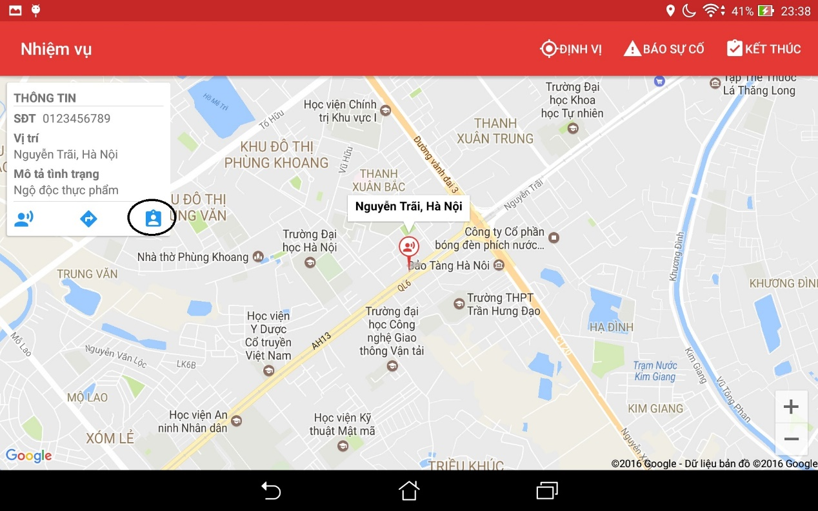

Figure 6‑41: Picked up victim button

#### Report problem

When users have problem, to report to dispatcher, users do the step below:

Step 1: Tap on button “Báo cáo sự cố”

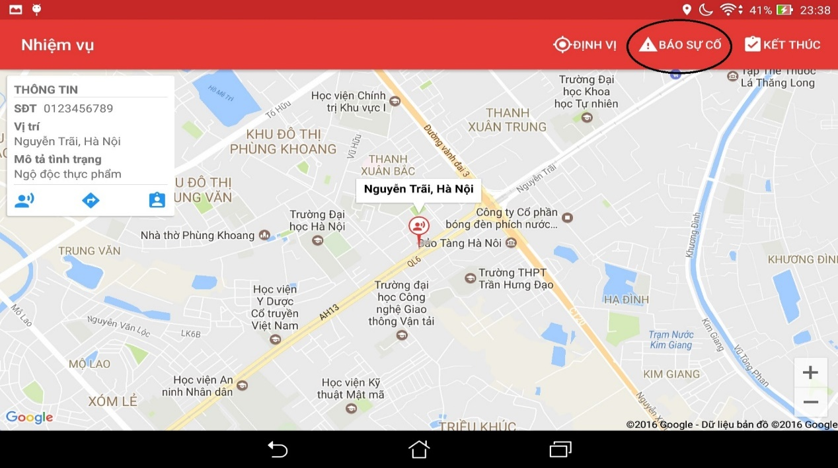

Figure 6‑42: Picked up victim button

#### Finish the mission

When users want to finish their mission, do the step bellows:

Step 1: Tap on the button Finish

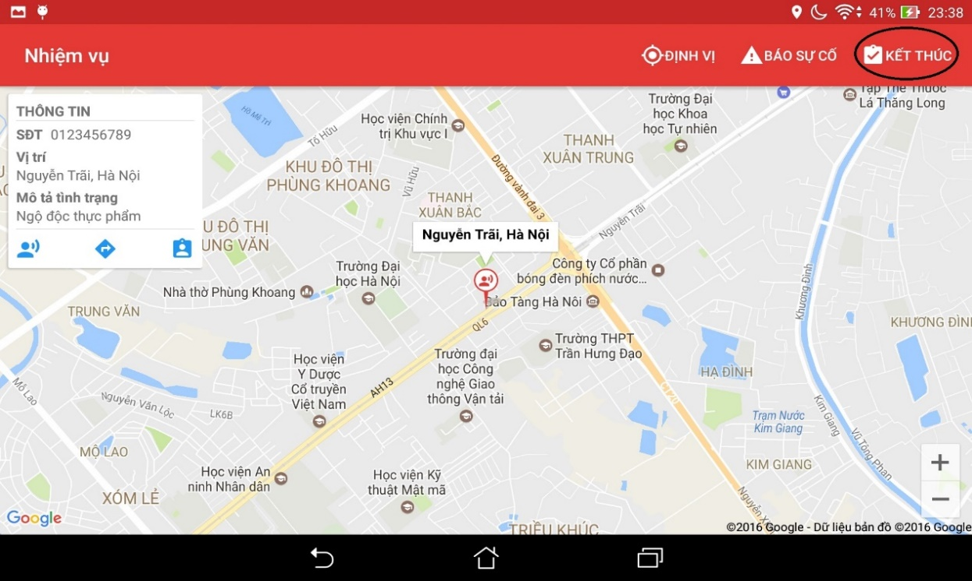

Figure 6‑43: Finish button

### Admin

In this web application, registered users can add new users with role, edit information of users, delete users, view information of users, classify users by role, search users.

#### Login & Logout

##### Login

To use features of this web application, users follow the steps belows :

Step 1: Open browser and enter to the address bar: <http://admin.rtsvietnam.com/>

Login page is displayed



Figure 6‑44: Admin login page

Step 2: Login with the administration account. Users will go to the Home page. In this page, registered users can go to all of other page.

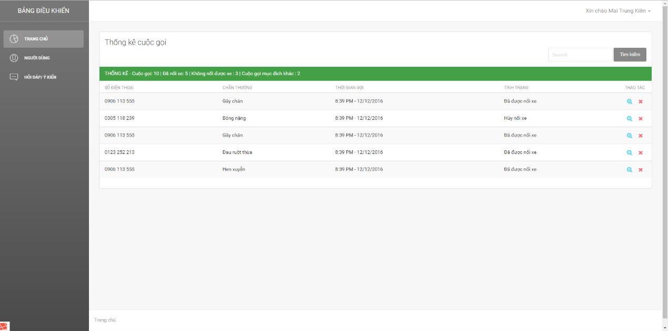

Figure 6‑45: Admin dashboard

##### Logout

Step 1: On the Home page, click on name of users at the top right of page, then click button “Logout”

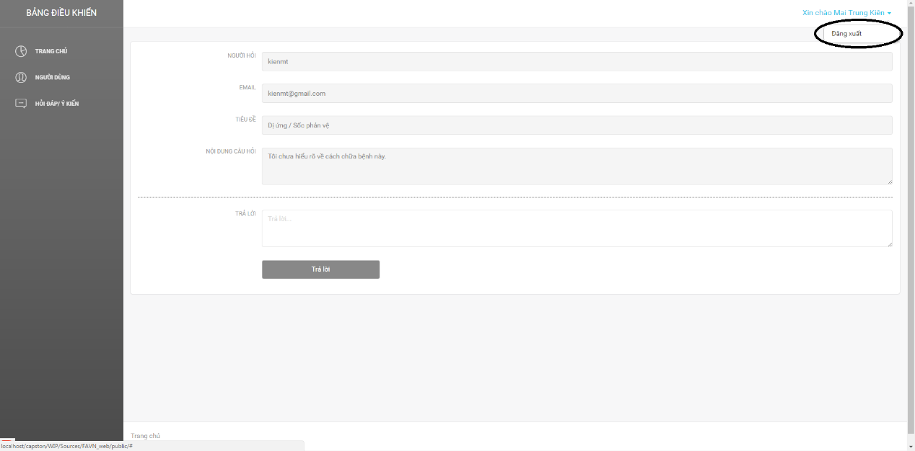

Figure 6‑46: Logout button

Step 2: Users will go to the login page

#### Add new users

To add new users, user do the steps belows:

Step 1: Click on button Users on the menu bar at the left of page

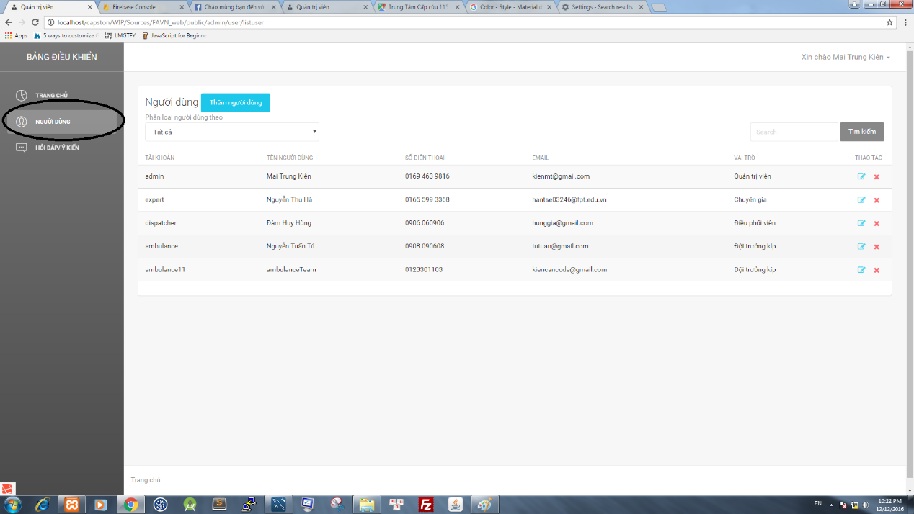

Figure 6‑47: User button

Step 2: Click on button Add New Users

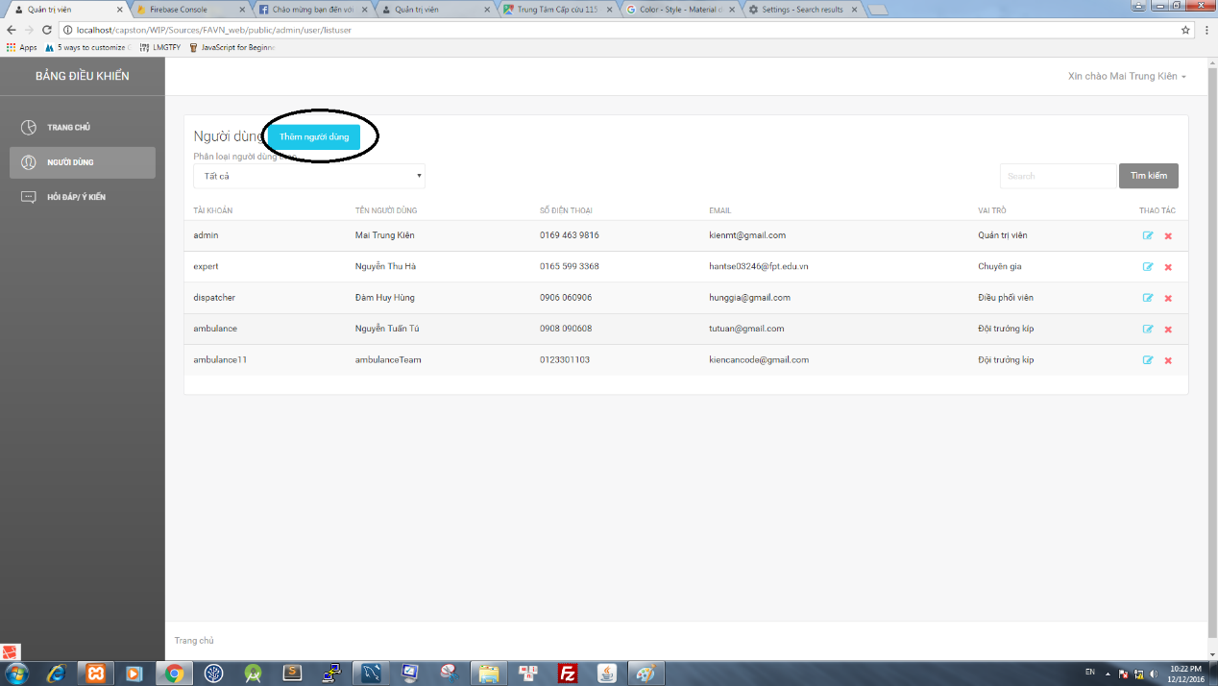

Figure 6‑48: User button

Step 3: Users wil go to the add new users page

Step 4: Fill validate data on all textfield, then click button Add new user, page will go to the page users, and display messege: “Add new users successfull”

To reset data all of all field, click on button reset all field will be default

#### Classify users by role

To classify users by role, user do the step below:

Step 1: Click on button Users on the menu bar at the left of page

Step 2: Click on the dropdown list belows label “Classify users by” and choose a role

Step 3: Page will display the list of users classify by role

#### Search users

To search users, user do the step below:

Step 1: Click on search textbox

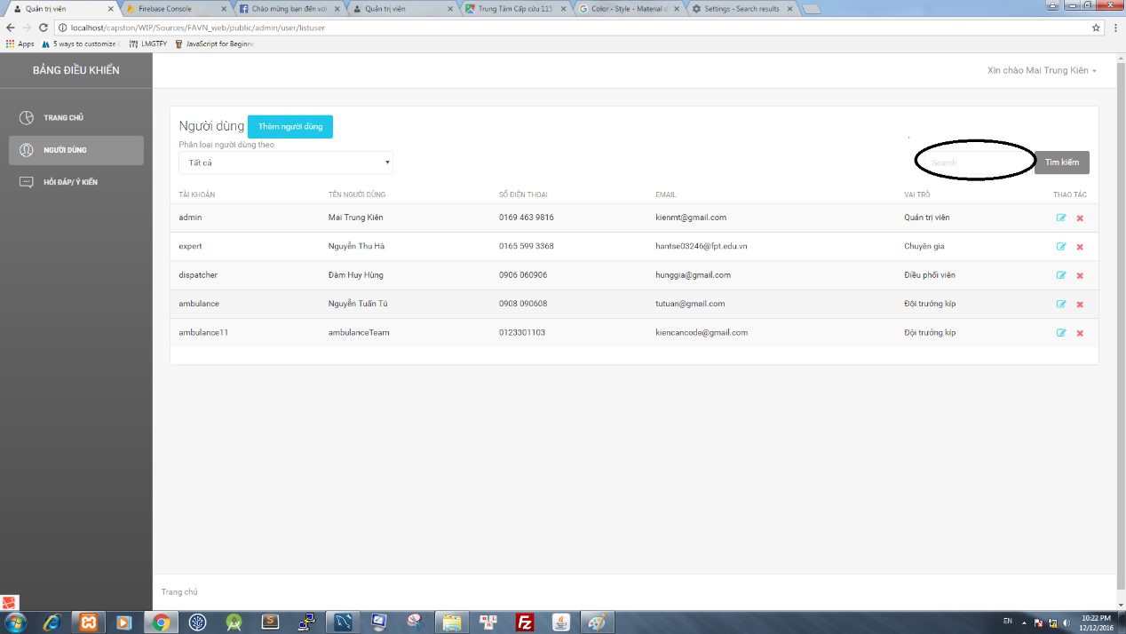

Figure 6‑49: Search Textbox

Step 2: Input characters then click on button search

Step 3: Page will display the list of result

#### Edit users information

To edit users information, users do the step below:

Step 1: Click on icon Edit page will go to the edit users page

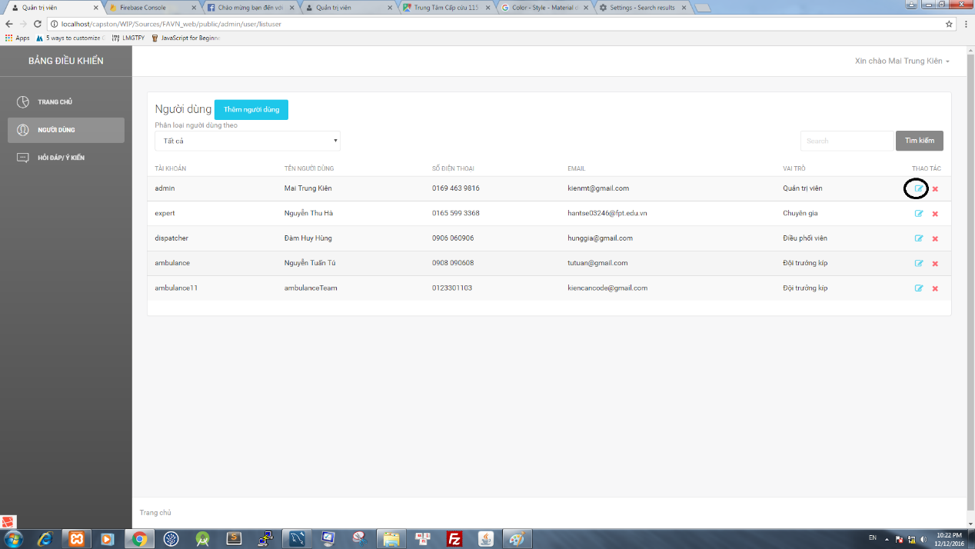

Figure 6‑50: Edit Icon

Step 2: Edit information of users

Step 3: Click on button Edit, page will display messege : “Chỉnh sửa thông tin thành công”

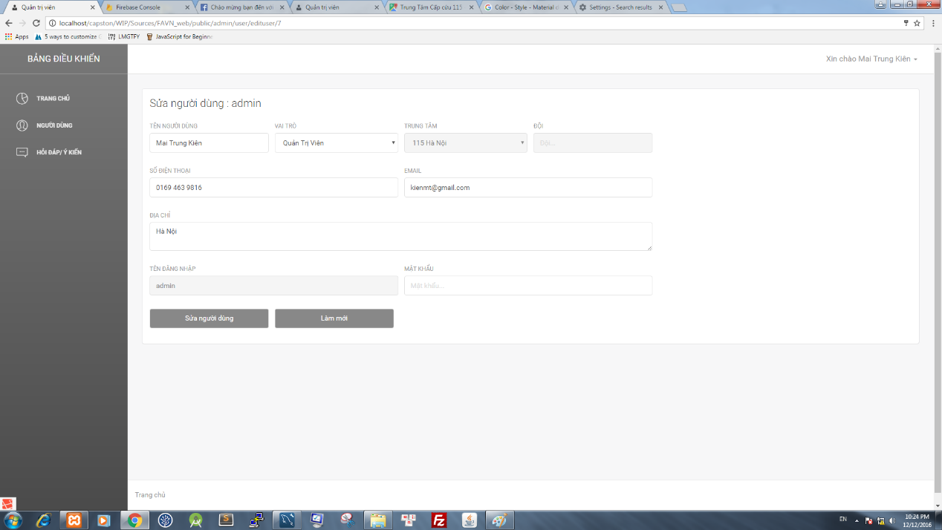

Figure 6‑51: Edit screen

To reset data all of all field, click on button reset (ảnh), all field will be default

#### Delete users

To delete users, user do the step belows:

Step 1: Click on icon delete users, a confirm dialog will display

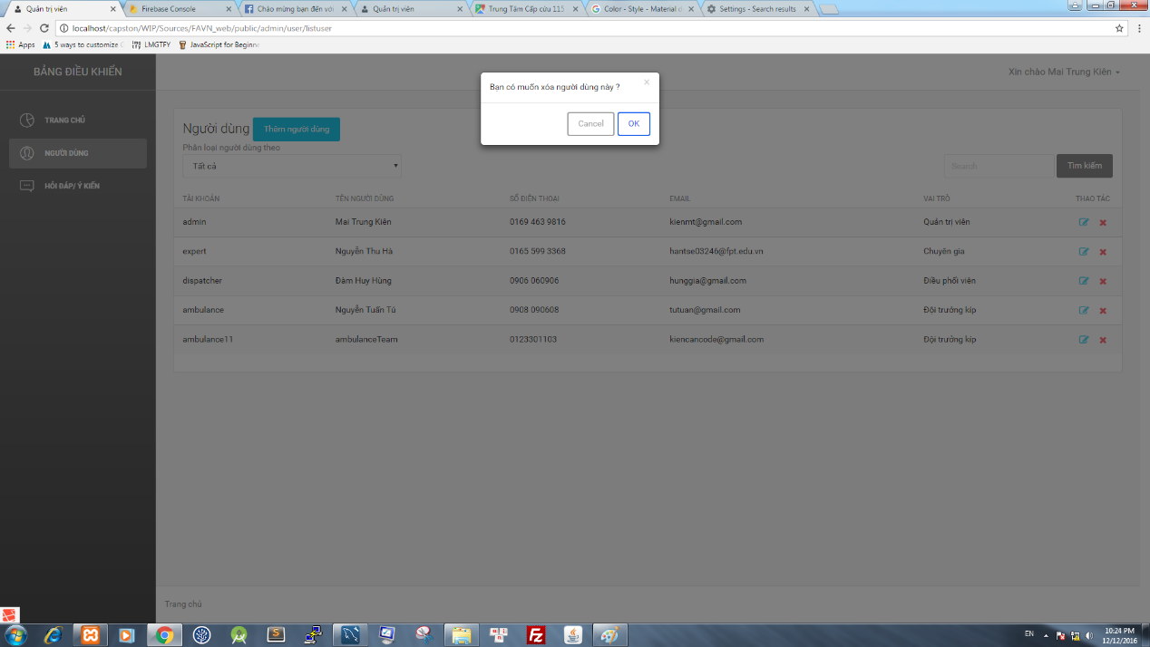

Figure 6‑52: Confirm delete user dialog

Step 2: Click on button OK, users will be deleted

#### Question – Answers.

To use this feature, user do the step belows:

##### Answer the question

Step 1: Click on button “Question- Answers “ on the menu bar at the left of screen

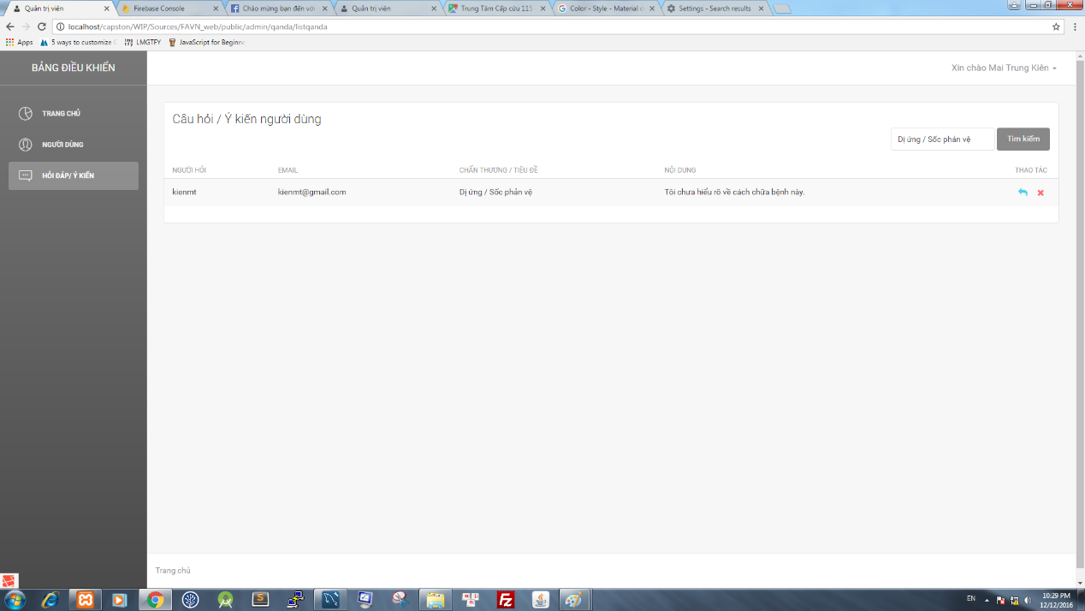

Figure 6‑53: Question-Answer screen

Step 2: Page will go to the page “Question-Answers”, show the list of question

Step 3: Click on icon answers to answers the question, page will be move to answer question

Step 4: After fill all field, click on button send

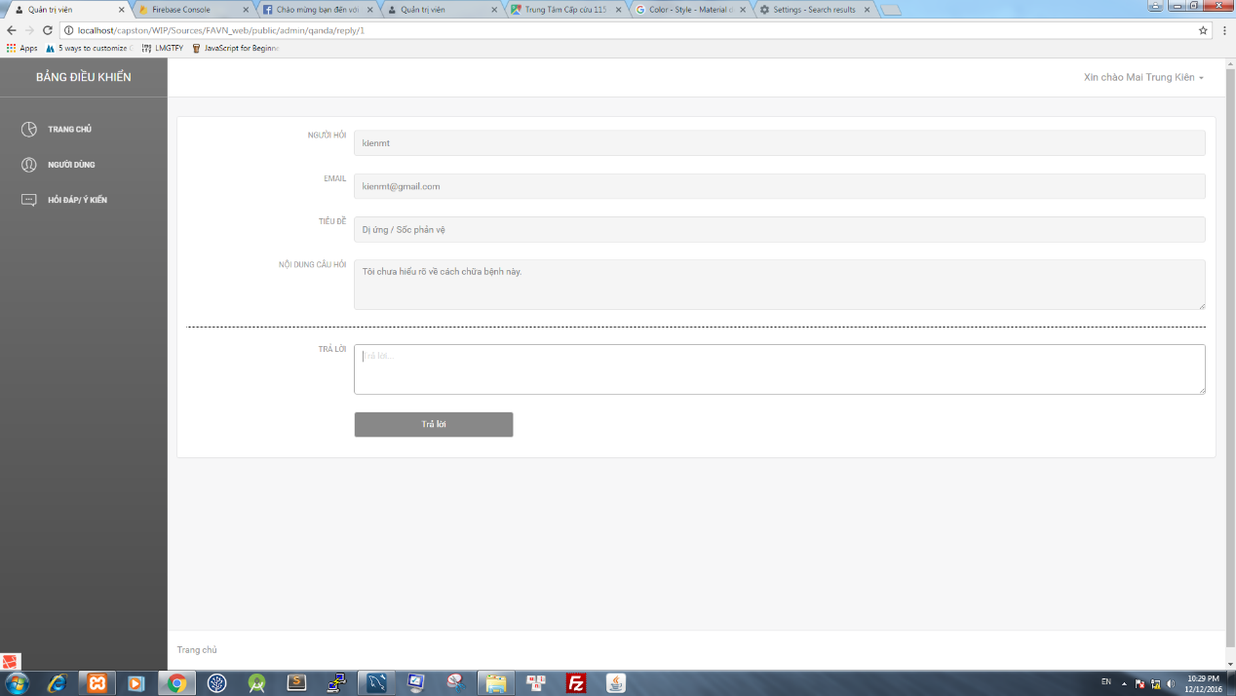

Figure 6‑54: Answer screen

##### Delete the question

Step 1: Click on button “Question- Answers “ on the menu bar at the left of screen

Step 2: Page will go to the page “Question-Answers”, show the list of question

Step 3: Click on icon delete, a confirm dialog will be display

Step 4: Click on button OK, Question will be deleted

### Dispatcher

In this web application, registered users can receive emergency cases, view the list of ambulance with their information like status, position. Morever, registered users can dispatch ambulance to the emergency case, manage ambulance team.

#### Login

To use features of this web application, users follow the steps belows :

Step 1: Open browser and enter to the address bar: <http://dispatcher.rtsvietnam.com/>.

Login page is displayed

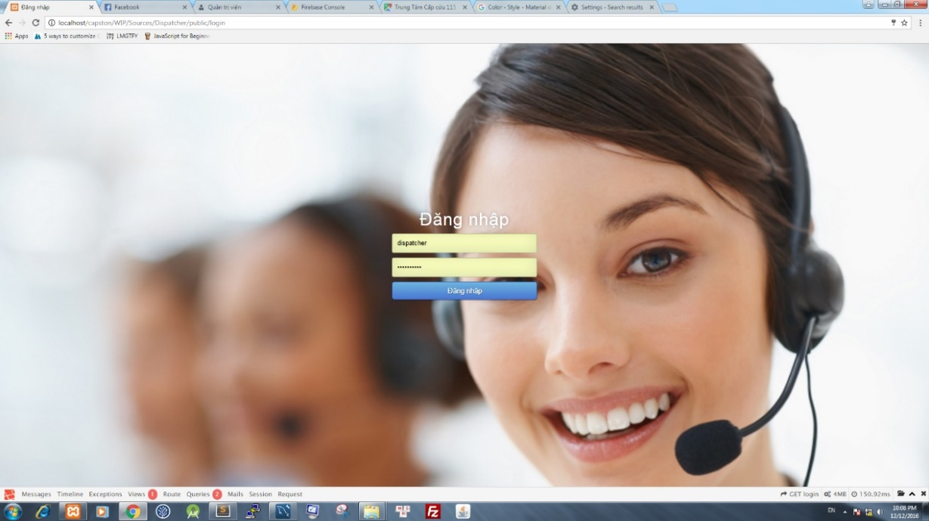

Figure 6‑55: Answer screen

Step 2: Login with the dispatcher account. Users will go to the Home page. In this page, registered users can go to all of other page.

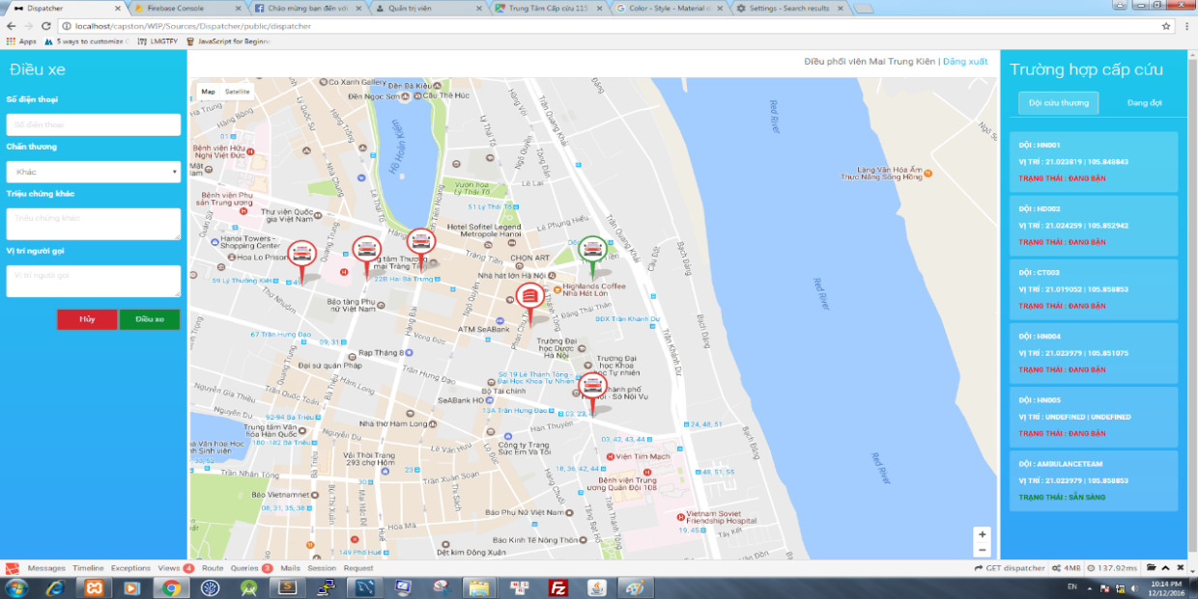

Figure 6‑56: Dispatcher screen

#### Log out

To use this features, user do the steps below:

Step 1: Click on button “ Đăng Xuất”

Step 2: Click on button “OK”

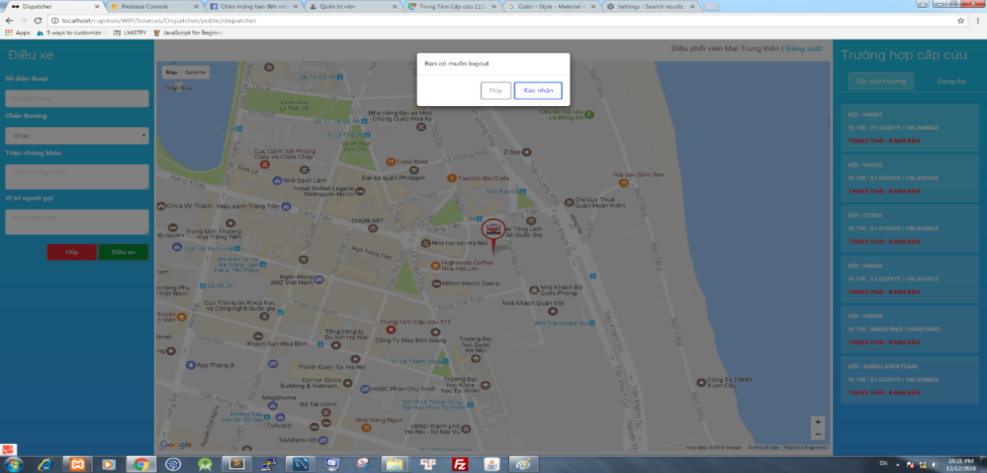

Figure 6‑57: Confirm Logout Dialog

#### Receive emergency case

To use this features, user do the steps below:

Step 1: Login with the dispatcher account.

Step 2 : When dispatcher receive an emegency case, fill all information in the corresponding fields

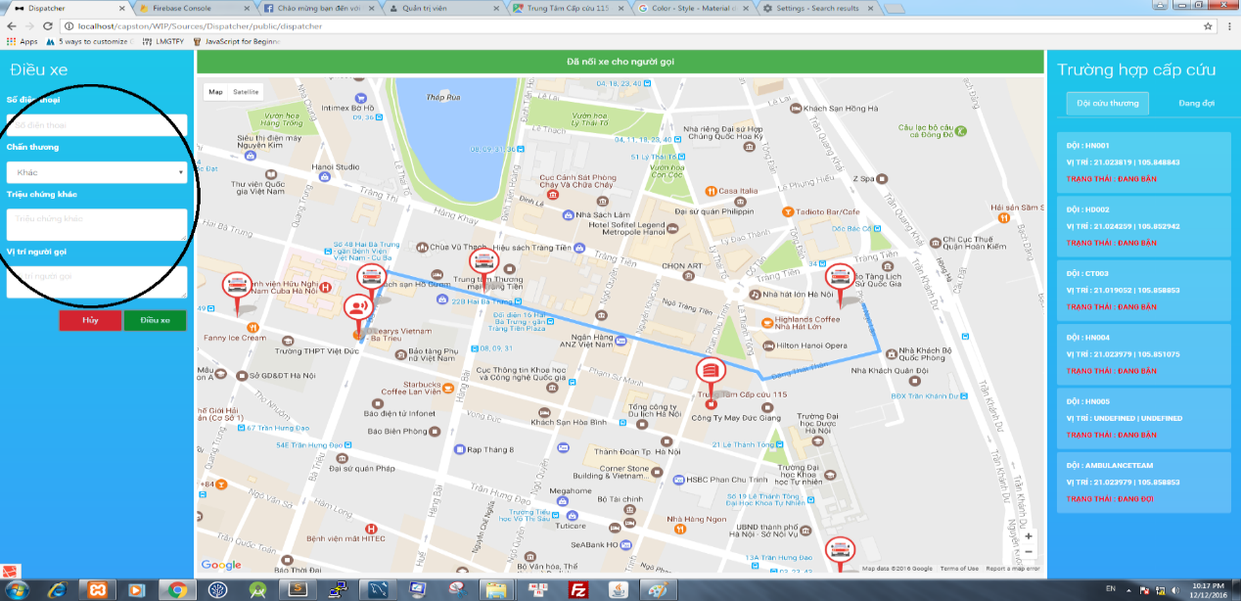

Figure 6‑58: Caller form

Step 3: Click button “ Điều phối”, ambulance will be dispatched, in the case of unavaible ambulance the notification " Đã hết xe " will be shown on the screen

#### Because of the problem, have cancel ambulance

If the dispatcher setups an ambulance, but on the way to perform the tasks, the ambulance gets problem and can not do continuously the tasks, the dispatcher use this function

Step 1: Click on the ambulance having trouble

Step 2: Information of emergency cases will be shown on the left screen

Step 3: Press the Hủy button, the confirm by click on button OK an emergency case will be canceled.

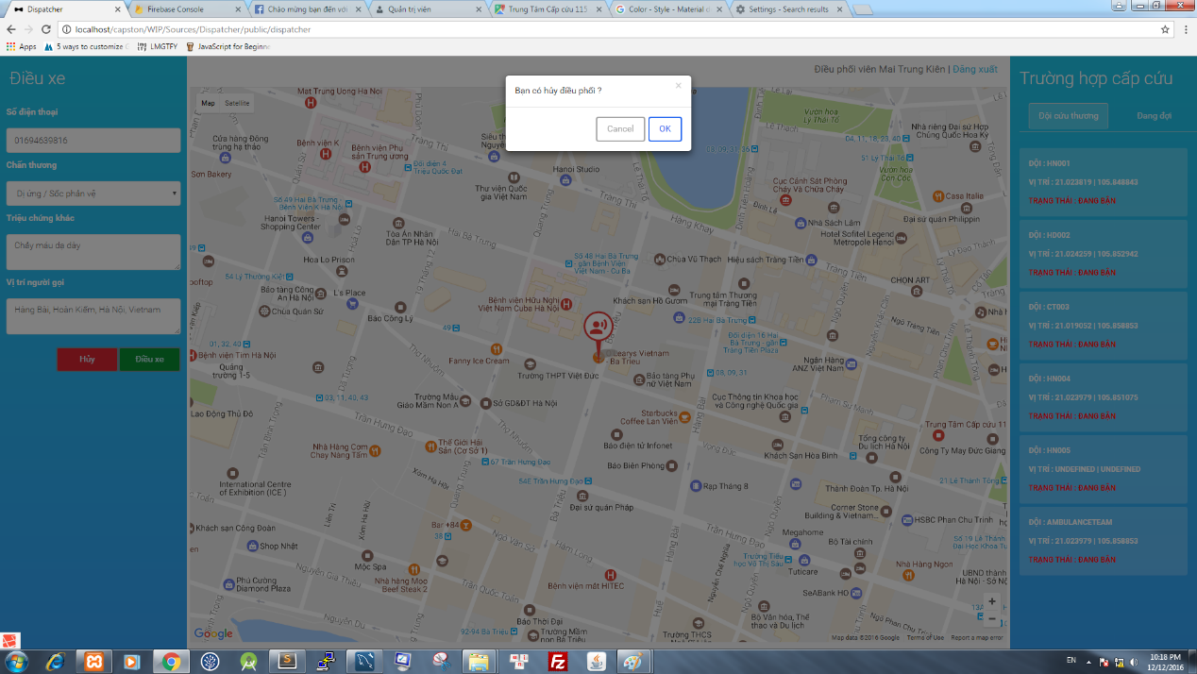

Figure 6‑59: Confirm Cancel dialog

# PROJECT RESULT REPORT

## Product Judging

### Advantage of First Aid system

The idea of First Aid project is to develop a system including First Aid Application, Ambulance Application, Dispatcher Application and Admin/Expert Application to support and guide the implementation of first aid and emergency assistance. We want to equip you with knowledge to protect yourself and others.

As the goals that we have set before started project, the First Aid system has been developed in right direction. And what it provides to users is listed below:

* **First Aid user**: Can perform instructions, easy to understand, easy to do. Call 115 and look for nearest health facility.
* **Ambulance user**: Can see victim’s information, their location and direction to them.
* **Dispatcher:** Victim assistance quickly with automated systems, can manage ambulance.
* **Admin/Expert:** Admin can manage users account, projects in system. Expert can answer questions of First Aid users.

### Current Limitations

* The system only supports look for health facility in Hanoi area.
* Application not support multi-language.
* Application only supports for Android.

### Expectation in Future

* Support multi-language to tourists also can use our application.
* Support look for all health facility in Vietnam.
* App for Window Phone and IOS.

## Project Summary

|  |  |  |  |  |
| --- | --- | --- | --- | --- |
| Project Title | | **FIRST AID** | | |
| Project Supervisor | | Nguyễn Văn Sang | | |
| Committers (5) | | | | |
| 1 | Project Manager | Đàm Huy Hùng | [hungdhse03431@fpt.edu.vn](mailto:hungdhse03431@fpt.edu.vn) | |
| 2 | Team member | Mai Trung Kiên | [kienmtse02994@fpt.edu.vn](mailto:kienmtse02994@fpt.edu.vn) | |
| 3 | Team member | Nguyễn Tiến Dũng | [dungntse03272@fpt.edu.vn](mailto:dungntse03272@fpt.edu.vn) | |
| 4 | Team member | Nguyễn Duy Anh | [anhnd01525@fpt.edu.vn](mailto:anhnd01525@fpt.edu.vn) | |
| 5 | Team member | Nguyễn Phúc An | [annpse03118@fpt.edu.vn](mailto:annpse03118@fpt.edu.vn) | |
| Main objective | | Develop an application on smartphone to instruct how to do in emergency first aid situations: Content is simple, easy to understand and implement; Support to find hospitals nearly.  Develop a supported emergency system conveniently, fastly. | | |
| Purpose | | Provide a health support system. | | |
| Source Repository | | https://github.com/sangnvus/201609JS03.git | | |
|  | | **Plan** | | **Actual** |
| Start Date | | 05/09/2016 | | 05/09/2016 |
| End Date | | 16/12/2014 | | 16/12/2015 |
| Releases version | | 1.0 | | 1.0 |
| Duration | | 75 | | 75 |
| Effort (person-day) | | 375 | | 375 |
| Test cases | | 1600 | | 1623 |
| Defects | | 200-300 | | 66 |
| Document pages | | ~ 3000 pages | | ~ 3500 pages |
| Lines of code (PHP) | | ~ 8000 | | ~ 6000 |
| Lines of code (HTML) | | ~ 8000 | | ~ 7000 |
| Lines of code (Android) | | ~ 10000 | | ~ 12000 |
| LOC (Total) | | ~ 26000 | | ~ 25000 |

1. Project summary

Knowledge:

* Work process to develop a project.
* Putting the learned knowledge into practice.
* Improve skills: teamwork, leader-ship, research and self-study, plan and manage time.
* Technical: Android, PHP, laravel, firebase, SQLite, MySQL, HTML5 & CSS3.
* Tools: Android Studio, GitHub, SourceTree, Office tools, Just In Mind, Trello, XAMPP...

## Lesson Learnt

* Together with leadership skills, the project manager needs to be aware of the strengths and weaknesses of his/her staff, so that the talents are harnessed and the shortfalls downplayed for the benefit of the project.
* The success of a project is largely dependent on the skills and strengths of the people involved. Therefore, a project needs to have a dedicated, talented set of individuals working towards a common goal.
* If you have the knowledge and experience to make a decision, then you should go ahead and so, without expecting leader to assign you task at every turn.
* Procrastination does not work. After assimilating the relevant information, decisions need to be made. Wrong decisions can be salvaged, if discovered early; but right decisions cannot be postponed.
* Be open to change. Sometimes, you may find that the things you knew along may not be correct at this given time, under these specific conditions.
* Good communication is that which will stop mistakes from becoming failures.
* Please think carefully before making a decision because if the wrong decisions you'll have to redo it from scratch.

# REFERENCES

* FAVN_ Software Requirements Specification_v1.0_EN.docx
* FAVN_Data Design_v1.0_EN.docx
* <https://www.tutorialspoint.com/>
* https://en.wikipedia.org
* Software Architecture Design Illuminated Book
* FAVN_ProjectPlan_v1.0_EN.docx